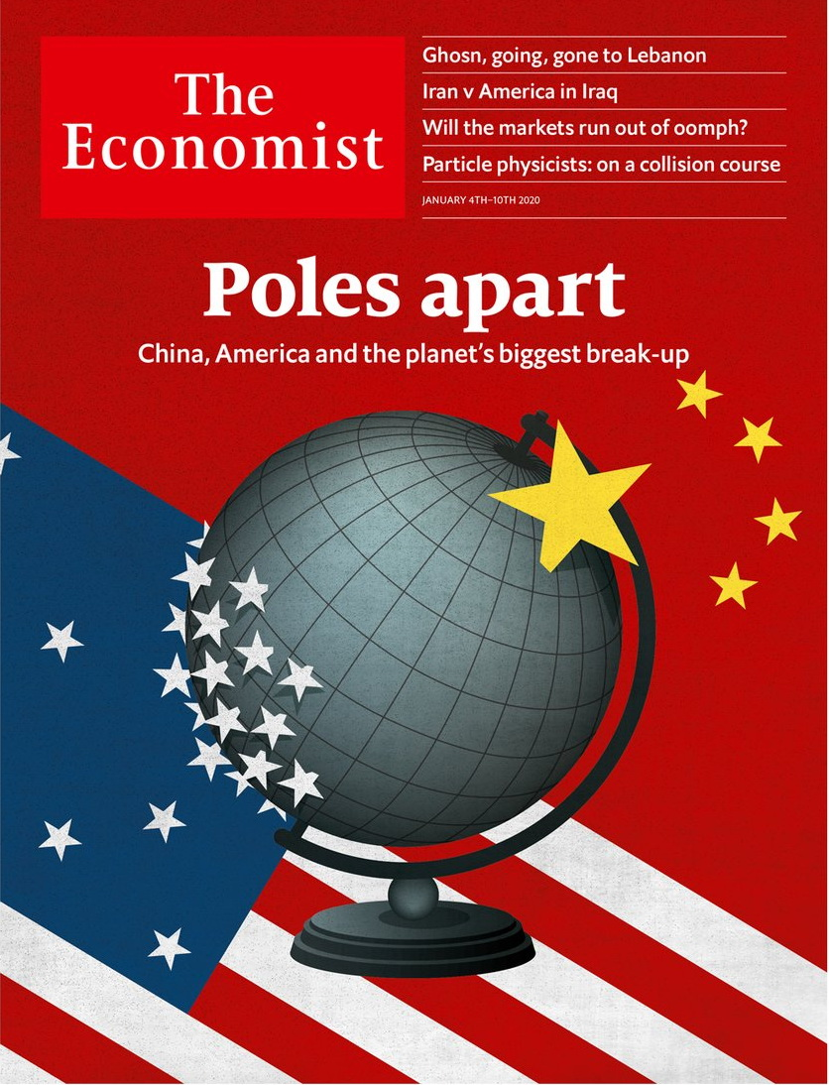

# Table of Contents

The world this week

The world this week

KAL’s cartoon

Leaders

China and America: Poles apart

America, Iran and Iraq: Undeterred

Renault-Nissan: Fled to the Med

Brazil: A year of governing dangerously

Criminal justice: How to reduce rape

Letters

Letters to the editor: On carbon capture, health care, rats, conservation, Joe Biden

Briefing

Chinese students in America: The new red scare

United States

Suburbs: Laboratories of democracy

Sex education in Texas schools: TexEd

Romance novelists: The wrong kind of racy

The decline of Vegas weddings: Crying in the chapel

Lexington: Pete Buttigieg heads South

The Americas

A year of Jair Bolsonaro: Please don’t let me be misunderstood

Colombia: Not so fast

Asia

Justice in Japan: Ghosn, going, gone

Fires in Australia: The summer inferno

Election tension in Taiwan: The China factor

Who’s an Indian citizen?: Papers, please

Banyan: Restoring order

China

China’s view of America: 400-pound rivals

Journalist wanted

Middle East and Africa

America, Iran and Iraq: Combustible

Countering Iran: Neighbourhood watch

Algeria: Hoping for a cheerier Algeria

The end of the CFA: Francly speaking

The Rand Club: Rhodes to redemption

Education in Liberia: Schools of hard knocks

Europe

Germany: From protest to power

Campione d’Italia: Unhappy recruit

Joblessness in the EU: Steady state

Charlemagne: Huntington’s disease

Britain

Reshaping the state: The Cummings plan

Darts: Bull market

Bagehot: One nation under Boris

International

Sexual assault: Her word against his

Technology Quarterly

Chinese technology: From the people who brought you fireworks...

Success stories: Reactors and railways

Cars: Electric leapfrog

Intellectual property: Laser brain

Data: A new trinity

Microprocessors: From bottom to top

The future: Of coupling and decoupling

Business

American firms in China: Still worth it

LG: Life’s not good enough

Entertainment: Thank you for the music

Bartleby: A manager’s manifesto

Schumpeter: Cloning Tesla

Finance and economics

The stockmarket: Christmas bonus

The World Trade Organisation: What’s the catch?

Digital banking in South-East Asia: Up for Grab

Minimum wages: Who pays?

Buttonwood: Feeling TIPSy

Free exchange: Planned obsolescence

Science and technology

Physics: Assembling the future

The Richard Casement internship

Books and arts

Ostracism: And stay out

Vanished worlds: Writing wrongs

Johnson: Climate-speak

Economic and financial indicators

Economic data, commodities and markets

Graphic detail

Predicting 2020: What are the odds?

Obituary

Yuri Luzhkov: Tearing down the past



### Friday, January 3, 2020

|  |  |
| --- | --- |
| The world this week | 2 |
| Leaders | 5 |
| Letters | 1 |
| Briefing | 1 |
| United States | 5 |
| The Americas | 2 |
| Asia | 5 |
| China | 2 |
| Middle East and Africa | 6 |
| Europe | 4 |
| Britain | 3 |
| International | 1 |
| Technology Quarterly | 7 |
| Business | 5 |
| Finance and economics | 6 |
| Science and technology | 2 |
| Books and arts | 3 |
| Economic and financial indicators | 1 |
| Graphic detail | 1 |
| Obituary | 1 |

|  |  |  |
| --- | --- | --- |
|  | Sections | Leaders |

The world this week

The world this week

The world this week.

KAL’s cartoon

KAL’s cartoon.

|  |  |  |
| --- | --- | --- |
|  | Sections | Leaders |

|  |  |  |  |
| --- | --- | --- | --- |
|  | Articles | Sections | Next |

# The world this week

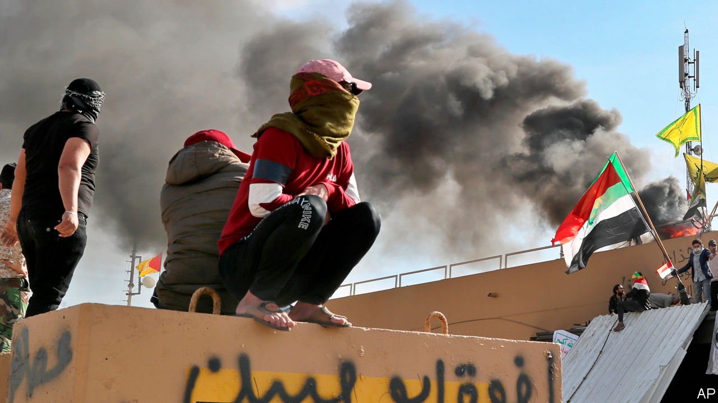

Jan 4th 2020

After an Iranian-backed militia allegedly attacked an Iraqi army base and killed an American contractor, America bombed the militia’s bases in Iraq and Syria. The militia’s supporters then staged violent protests outside the American embassy in Baghdad. The Iraqi authorities, who had dispersed recent anti-government protests with lethal force, stood by and let the anti-American rioters enter the compound. Donald Trump blamed Iran for organising the mêlée. The Pentagon deployed an extra 750 troops to the region. See article.

In Somalia America carried out air strikes against al-Shabaab jihadists suspected of planting a car bomb on the outskirts of Mogadishu that killed at least 80 people.

A court in Saudi Arabia sentenced five men to death for murdering Jamal Khashoggi at the Saudi consulate in Istanbul in 2018. The closed trial concluded that the killing of the Saudi dissident was an impulsive decision taken by the assassins. The CIA believes that Crown Prince Muhammad bin Salman ordered the murder. He denies it.

Binyamin Netanyahu, the prime minister of Israel, said he would ask parliament to grant him immunity from prosecution in three corruption cases. Court proceedings against Mr Netanyahu would be put on hold until the request could be heard, probably after a general election in March. Earlier in December he easily defeated a challenge to his leadership of the Likud party.

Joe Biden, a former vice-president, said he “would obey any subpoena” to testify at the impeachment trial of Donald Trump in the Senate, having earlier suggested that he would not do so. Mr Trump’s request to Ukraine to investigate Mr Biden’s son formed the basis of the vote in the House to impeach the president.

Boris Johnson, the Conservative prime minister, moved Britain closer to Brexit. His withdrawal agreement with the EU won a majority of 124 in the House of Commons. Britain will formally leave on January 31st. But that is only the end of the beginning of the Brexit ordeal; Mr Johnson must now try to secure a good trade deal by the end of 2020.

Andrew Bailey was named as the new governor of the Bank of England, to take over from Mark Carney in mid-March. Mr Bailey has been head of the Financial Conduct Authority since 2016. Before that he was a deputy governor at the bank. See [article](https://www.economist.com/britain/2019/12/20/in-andrew-bailey-the-bank-of-england-gets-a-technocratic-new-boss).

Firefighters fought Australia’s worst wildfires for decades. The government refused to review its climate policy. See [article](https://www.economist.com/node/21777601).

Carlos Ghosn, a former boss of Nissan and Renault, jumped bail and was somehow spirited out of Japan, where he had been awaiting trial for alleged financial misdeeds. He turned up in Lebanon, which has no extradition agreement with Japan. Mr Ghosn, a Lebanese citizen, said he fled to escape a “rigged” justice system and “political persecution”. See [article](https://www.economist.com/node/21777575).

North Korea’s dictator, Kim Jong Un, said he would end a moratorium on testing nuclear weapons and long-range missiles. He tested two dozen short-range missiles in 2019.

He Jiankui, a Chinese biologist who achieved notoriety in 2018 by altering the DNA of twin girls when they were still embryos, was sentenced by a court in Shenzhen to three years in prison for an “illegal medical practice”.

Tens of thousands of pro-democracy Hong Kongers demonstrated on New Year’s Day. Police fired tear-gas and arrested 400 people. In India protests continued against a new law that makes it easier for refugees from Afghanistan, Bangladesh or Pakistan to gain Indian citizenship, as long as they are not Muslim.

Bolivia’s interim president, Jeanine Añez, expelled the Mexican ambassador and two Spanish diplomats, accusing them of trying to give succour to an aide of Evo Morales, who stepped down as president in November amid protests against his 13 years in power. Ms Añez is overseeing a caretaker government.

Germany and Russia responded angrily to America’s imposition of sanctions on companies that work on the Nord Stream 2 pipeline, which will transport gas directly to Germany from Russia via the Baltic Sea. America argues that Russia is seeking to dominate German energy. But the German finance minister described the penalties as a “serious interference” in Germany’s internal affairs. The sanctions are unlikely to stop the pipeline’s completion by the end of 2020.

Boeing sacked Dennis Muilenburg as chief executive, deciding “that a change in leadership was necessary to restore confidence” in the company amid the debacle of its 737 MAX jetliner, which has been grounded for nine months after two fatal crashes. The new CEO will be David Calhoun, who is currently Boeing’s chairman.

Stockmarkets had a sparkling 2019, ending the year much higher than when it started. The FTSE All-World, a global index, rose by a quarter over the year, its best performance since 2009. The S&P 500 was up by 29%, the NASDAQ by 35% and the Euro Stoxx 50 by 25%. Other European and Japanese markets recorded similar gains. After a rotten 2018, China’s CSI 300 index rebounded, rising by a third in 2019. See article.

Read this article on <https://www.economist.com/the-world-this-week/2020/01/04/the-world-this-week>

|  |  |  |  |
| --- | --- | --- | --- |
|  | Articles | Sections | Next |

|  |  |  |  |
| --- | --- | --- | --- |
| Previous | Articles | Sections | Next |

# KAL’s cartoon

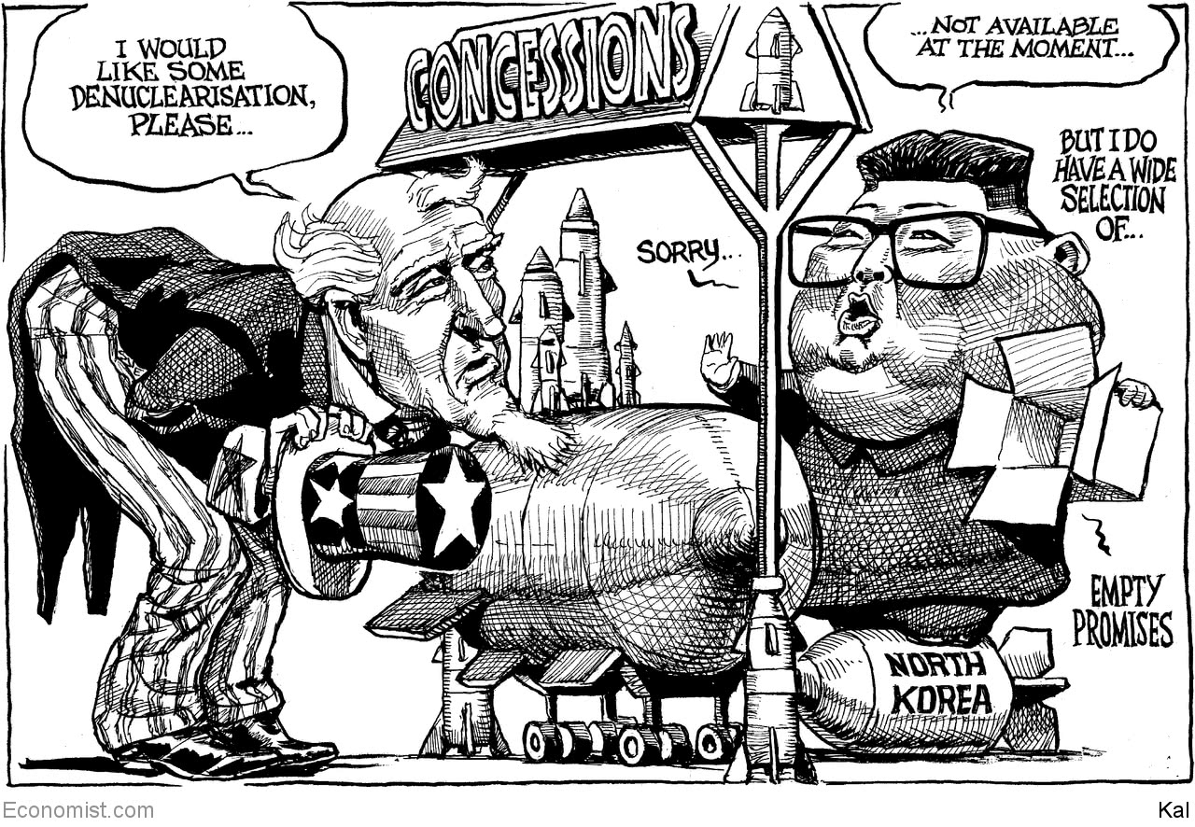

Jan 2nd 2020

Read this article on <https://www.economist.com/the-world-this-week/2020/01/02/kals-cartoon>

|  |  |  |  |
| --- | --- | --- | --- |
| Previous | Articles | Sections | Next |

|  |  |  |
| --- | --- | --- |
| The world this week | Sections | Letters |

Leaders

China and America: Poles apart

Don’t be fooled by the trade deal between America and China.

America, Iran and Iraq: Undeterred

America shows how not to tame Iran.

Renault-Nissan: Fled to the Med

No one comes out of the Carlos Ghosn affair smelling of roses.

Brazil: A year of governing dangerously

A year of Jair Bolsonaro.

Criminal justice: How to reduce rape

How to reduce rape.

|  |  |  |
| --- | --- | --- |
| The world this week | Sections | Letters |

|  |  |  |  |
| --- | --- | --- | --- |
|  | Articles | Sections | Next |

The superpower split

# Don’t be fooled by the trade deal between America and China

The planet’s biggest break-up is under way

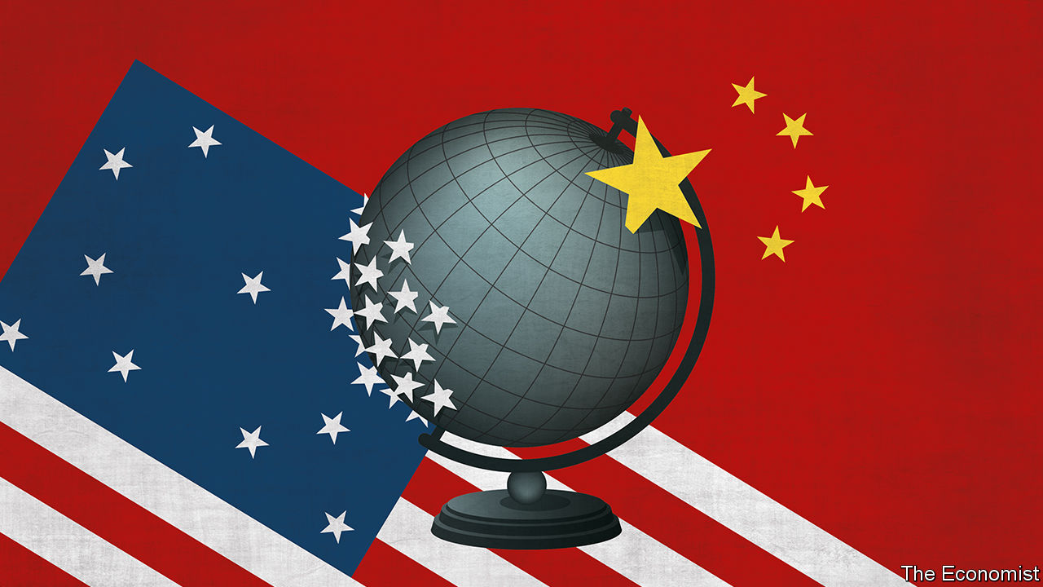

Jan 2nd 2020

ON JANUARY 15TH, after three years of a bitter trade war, America and China are due to sign a “phase one” deal that trims tariffs and obliges China to buy more from American farmers. Don’t be fooled. This modest accord cannot disguise how the world’s most important relationship is at its most perilous juncture since before Richard Nixon and Mao Zedong re-established links five decades ago. The threat to the West from China’s high-tech authoritarianism has become all too clear. Everything from its pioneering artificial-intelligence firms to its gulags in Xinjiang spread alarm across the world.

Just as visible is America’s incoherent response, which veers between demanding that the Chinese government buy Iowan soyabeans and insisting it must abandon its state-led economic model. The two sides used to think they could both thrive; today each has vision of success in which the other lot falls behind. A partial dismantling of their bonds is under way. In the 2020s the world will discover just how far this decoupling will go, how much it will cost and whether, as it confronts China, America will be tempted to compromise its own values.

The roots of the superpower split go back 20 years. When China joined the World Trade Organisation in 2001 reformers at home and friends abroad dreamed that it would liberalise its economy and, perhaps, its politics too, smoothing its integration into an American-led world order.

That vision has died. The West has faced a financial crisis and turned inward. China’s behaviour has improved in some ways: its giant trade surplus has fallen back to 3% of GDP. But it has an even bleaker form of dictatorship under President Xi Jinping and has taken to viewing America with distrust and scorn (see article). As with every emerging great power, China’s hankering to exert its influence is growing along with its stature. It wants to be a rule-setter in global commerce, with sway over information flows, commercial standards and finance. It has built bases in the South China Sea, is meddling with the 45m-strong Chinese diaspora and bullying its critics abroad.

President Donald Trump has responded with a policy of confrontation that has won bipartisan support in America. Yet the China hawks thronging Washington agencies and corporate boardrooms share no consensus over whether America’s goal should be the mercantilist pursuit of a lower bilateral trade deficit, the shareholder-driven search for profits in American-owned subsidiaries in China or a geopolitical campaign to thwart China’s expansion. Meanwhile, Mr Xi oscillates between grim calls for national self-reliance one day and paeans to globalisation the next, while the European Union is unsure if it is an estranged American ally, a Chinese partner or an awakening liberal superpower in its own right.

Muddled thinking brings muddled results. Huawei, a Chinese tech giant, faces such a disjointed campaign of American pressure that its sales rose by 18% in 2019 to a record $122bn. The EU has restricted Chinese investment even as Italy has joined China’s belt-and-road trade scheme. China spent 2019 promising to open its big, primitive capital markets to Wall Street even as it undermined the rule of law in Hong Kong, its global financial hub. The phase-one trade deal fits this pattern. It mixes mercantilist and capitalist goals, leaves most tariffs intact and puts aside deeper disagreements for later. Mr Trump’s tactical aim is to help the economy in an election year; China is happy to buy time.

Geopolitical incoherence is neither safe nor stable. True, it has not yet inflicted a big economic cost—since 2017 bilateral trade and direct investment flows between the superpowers have dropped by 9% and 60% respectively, but the world economy still grew by about 3% in 2019. Some businesses, such as Starbucks’s 4,125 cafés in China, need never be affected. But confrontation is constantly spreading into new arenas. America’s campuses are convulsed by a red scare about Chinese spying and intimidation (see Briefing). Rows blaze over athletes kowtowing to China, naval docking rights and alleged censorship on TikTok, a Chinese app used by teenagers worldwide. In the background is the risk of a confrontation between the superpowers over Taiwan, which holds elections in January (see article).

Each side is planning for a disengagement that limits the other superpower’s day-to-day influence, reduces its long-term threat and mitigates the risk of economic sabotage. This involves an exceptionally complex set of calculations, because the two superpowers are so intertwined. In technology, most electronic devices in America are assembled in China, and, reciprocally, Chinese tech firms rely on foreign suppliers for over 55% of their high-end inputs into robotics, 65% of those into cloud computing and 90% of those into semiconductors. It would take 10-15 years for China to become self-sufficient in computer chips and for America to shift suppliers (see [Technology Quarterly](https://www.economist.com/technology-quarterly/2020/01/04/technological-progress-in-china-could-still-lead-to-fireworks)). Likewise in high finance, which could serve as a vehicle for sanctions. The yuan accounts for just 2% of international payments and Chinese banks hold over $1trn in dollar assets. Again, shifting trade partners to the yuan and winding down the banks’ dollar exposure will take at least a decade, probably longer. And when it comes to research, China still trains its best talent and finds its best ideas in America’s world-beating universities—at the moment there are 370,000 mainland students on campuses in the United States.

Were the superpower rivalry to spiral out of control, the costs would be vast. To build a duplicate tech hardware supply-chain would take $2trn or so, 6% of the superpowers’ combined GDP. Climate change, a great challenge which could provide a common purpose, would be even harder to cope with. Also at stake is the system of alliances that is a pillar of America’s strength. Some 65 countries and territories rely on China as their largest supplier of imports and, asked to choose between the superpowers, not all of them would opt for Uncle Sam—especially if it continues to pursue today’s policy of America First. Most precious of all are the principles that really made America great: global rules, open markets, free speech, respect for allies and due process. In the 2000s people used to ask how much China might become like America. In the 2020s the bigger question is whether a full superpower split might make America more like China. ■

Read this article on <https://www.economist.com/leaders/2020/01/02/dont-be-fooled-by-the-trade-deal-between-america-and-china>

|  |  |  |  |
| --- | --- | --- | --- |
|  | Articles | Sections | Next |

|  |  |  |  |
| --- | --- | --- | --- |
| Previous | Articles | Sections | Next |

Undeterred

# America shows how not to tame Iran

By bombing Iraqi territory, America has helped Iran

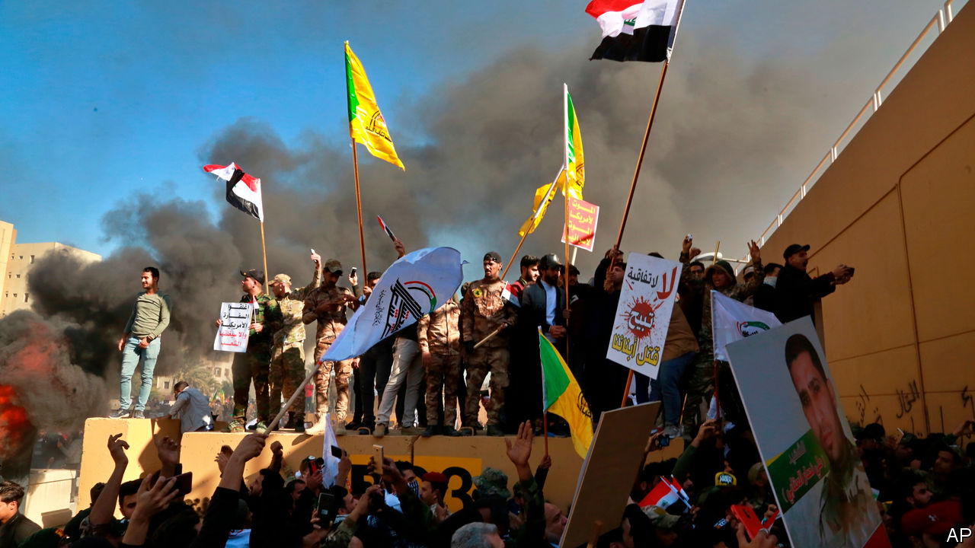

Jan 4th 2020

AFTER NEARLY coming to blows in 2019, America and Iran celebrated the new year in fitting style: with prophecies of war. The escalation began on December 27th, when dozens of missiles, allegedly fired by an Iranian-backed militia in Iraq called Kataib Hizbullah, struck an Iraqi military base in Kirkuk, killing an American contractor and wounding American and Iraqi soldiers. Two days later America responded, over objections from the Iraqi government, with air strikes on Iraqi soil that killed at least 25 militia members and wounded over 50. After thousands of militiamen and protesters then attacked the American embassy in Baghdad, President Donald Trump said Iran would be held responsible. “They will pay a very BIG PRICE!” tweeted Mr Trump. “This is not a Warning, it is a Threat. Happy New Year!”

Iran is responsible for stoking the conflict. Its interference in Iraq has spurred tens of thousands of Iraqis to march against it in the streets since October. The protesters are fed up with their own politicians, many of whom seem to want only to please Iran’s leaders, their fellow-Shia patrons. Tehran has even helped its Iraqi clients quell the unrest. Hundreds of protesters have been killed by pro-Iran militias. At the same time, says America, Iranian-backed groups have carried out nearly a dozen attacks on Iraqi bases and facilities housing American contractors and soldiers, who are there at the invitation of the Iraqi government to train local forces. With the Iraqis neglecting their security, America understandably hit back to deter future attacks.

But officials in Washington appeared taken by surprise when the killing of Iraqi citizens on Iraqi soil against the wishes of the Iraqi government ended up causing a savage backlash (see article). Iraqi officials accused America, accurately, of violating Iraqi sovereignty. The crowds that stormed the embassy, in the heavily guarded Green Zone of Baghdad, seemed to have been waved through by local security forces. Iran, no doubt, also had a hand in stirring up the unrest. As Mr Trump dispatched hundreds of extra troops to the region, a coalition of pro-Iran parties in Iraq called for the withdrawal of all American soldiers. Parliament may be receptive.

The episode has underlined the contradictions in the president’s approach. His chief aim in the Middle East is to curb Iran. In 2018 he pulled out of a deal that froze Iran’s nuclear programme. Since then he has heaped sanctions on Iran as part of a campaign of “maximum pressure”. At the same time, however, he has done little to hit back when Iran and its proxies attacked commercial shipping, Saudi oil facilities and American targets. Now Mr Trump has at last returned fire—but he has chiefly harmed himself. The air strikes have stoked anti-Americanism. On the streets of Baghdad, chants of “out, out Iran” gave way to “death to America”. A strike designed to punish Iran has ended up rewarding it.

Sixteen years after overthrowing Saddam Hussein, that smacks of poor intelligence and of a depressingly weak influence over the government in Baghdad. It is an ominous sign for the durability of America’s continuing presence in Iraq.

But America’s contradictions are dwarfed by those of the Iraqi state, which shoots one lot of protesters while encouraging another to run riot. Prominent politicians, such as Hadi al-Amiri, who heads a large bloc in parliament and controls a powerful militia, even joined the group outside the American embassy. He and other militia leaders, to say nothing of Iran, would like to see America go. And yet the Iraqi army depends on the Americans for guns, training and money (some $5.8bn since 2014) even as their bitter enemies, the jihadists of Islamic State, are regrouping. That points to a bigger problem: Iraq’s militias are nominally under the government’s control, but act at best independently and at worst for Iran. If Kataib Hizbullah did indeed fire missiles at an Iraqi military base, one arm of the state attacked another.

Iran’s baleful influence is making Iraq even more dysfunctional. The government is dominated by people like Mr Amiri, who are in thrall to Tehran. They have used its backing to accumulate power, while entrenching ethnic and sectarian divisions and milking the state. Rather than curb Iranian meddling, as the people want, they invite it, ignoring the dreadful example Iran has set lording over crisis-ridden Lebanon and war-torn Syria.

The Iraqi people know their country can do better. Its politicians should heed them, not the mullahs next door. Until that happens, however, Iraq will be caught in a miserable tug-of-war between America and Iran, a global superpower and a regional one. It is a struggle that, going by the evidence of this week, America will lose—and that Iraq will thus lose, too. ■

Read this article on <https://www.economist.com/leaders/2020/01/04/america-shows-how-not-to-tame-iran>

|  |  |  |  |
| --- | --- | --- | --- |
| Previous | Articles | Sections | Next |

|  |  |  |  |
| --- | --- | --- | --- |
| Previous | Articles | Sections | Next |

Fled to the Med

# No one comes out of the Carlos Ghosn affair smelling of roses

Le Cost Killer is on the run

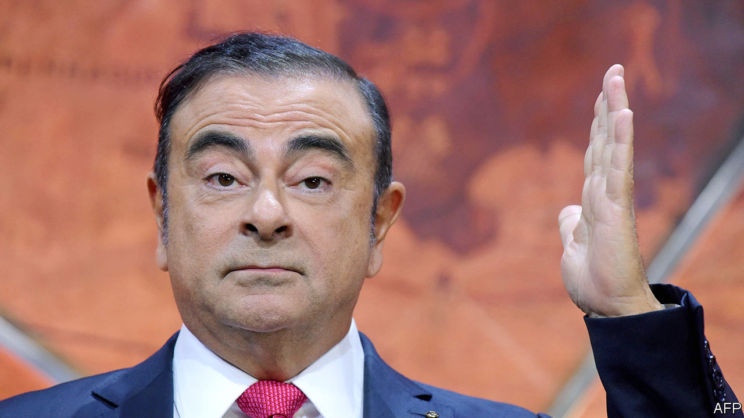

Jan 2nd 2020

THE LAST time there was an international fugitive from justice called Carlos lying low in Lebanon was in 1975, when Carlos the Jackal hid in Beirut. Today the man on the run is not a terrorist but a celebrity executive known for fanatical cost-cutting. On December 31st Carlos Ghosn, the former boss of Renault-Nissan, who was arrested in Japan in November 2018 on charges of financial misconduct, jumped bail and fled to Lebanon. He grew up there and it has no extradition arrangements with Japan. Mr Ghosn says he is a victim of “injustice and political persecution” by Japan’s legal system. Japan’s prosecutors, meanwhile, view him as a crook evading justice. In fact, this is far from being a simple morality tale. Each of the three main parties in the saga—Renault-Nissan, Japan’s authorities and Mr Ghosn himself—has hard questions to answer.

Mr Ghosn took charge of Nissan in 2001 and then, in 2005, of Renault, too. The French car firm has a 43% stake in the Japanese one, and together with Mitsubishi they form an alliance that is the world’s biggest carmaker by volume. It sounds impressive, but even the laser-focused Mr Ghosn struggled to make the fiddly pact run smoothly. He claims that he was planning closer integration of Renault and Nissan, and that nationalistic Japanese executives and officials, who wanted to keep Nissan independent, foiled the plan by engineering his arrest.

Mr Ghosn sees himself as a martyr and denies any wrongdoing, but his conduct merits investigation. In September America’s Securities and Exchange Commission said that he and a colleague concealed $140m of compensation payments from Nissan, involving secret contracts, backdated letters and misleading disclosures. Nissan, Mr Ghosn and his colleague settled the charges and paid fines while neither admitting nor denying guilt. Mr Ghosn is banned from being a company officer in America for ten years. There have been reports of other complex transactions between Nissan and its former boss which, if true, suggest that an imperious leader may have lost his sense of the boundary between his own finances and those of the firm he ran.

You might hope that Japan’s justice system would swiftly and fairly get to the bottom of all this. But its use of confessions to secure a conviction rate of over 99% reflects a harsh treatment of suspects that has been on full display here (see article). Mr Ghosn was arrested, released, rearrested and then released on bail again. He was subject to interrogation without a lawyer. His lawyers say they have been unable to see key documents and that, while on bail, Mr Ghosn’s access to his wife and the internet were restricted. After 13 months of investigations, the trial has still not begun. What is more, rotten disclosure about pay is common across Japan Inc.

As the stink around Mr Ghosn’s case worsens, Renault and Nissan, which together employ over 300,000 people, are tottering. Unable to reap the efficiencies of being a single company, they have long produced mediocre performance—their combined return on equity probably slipped below 5% in 2019. Paralysed by the scandal, both firms face shrinking sales and margins. In May Renault sought redemption through a merger with Fiat Chrysler to create a European champion, but managerial dithering and meddling by the French government caused the deal to collapse. (Fiat’s chairman sits on the board of The Economist’s parent company.) Fiat is now merging with another French car firm, PSA, instead.

What next? Renault and Nissan should either merge or unwind their cross-shareholdings. Both need to cut costs in order to get fit again. Japan’s authorities must explain how Mr Ghosn absconded, and deal with his claims of persecution. As for the boss-turned-bolter, he has pledged to clear his name. But his position is extraordinary. He is an outlaw, holed up in a country half the size of New Jersey. From being king of the car industry he now risks a lifetime on the back seat, hiding under a blanket. ■

Read this article on <https://www.economist.com/leaders/2020/01/02/no-one-comes-out-of-the-carlos-ghosn-affair-smelling-of-roses>

|  |  |  |  |
| --- | --- | --- | --- |
| Previous | Articles | Sections | Next |

|  |  |  |  |
| --- | --- | --- | --- |
| Previous | Articles | Sections | Next |

Governing dangerously

# A year of Jair Bolsonaro

Brazil’s president can boast some achievements. They come at a high price

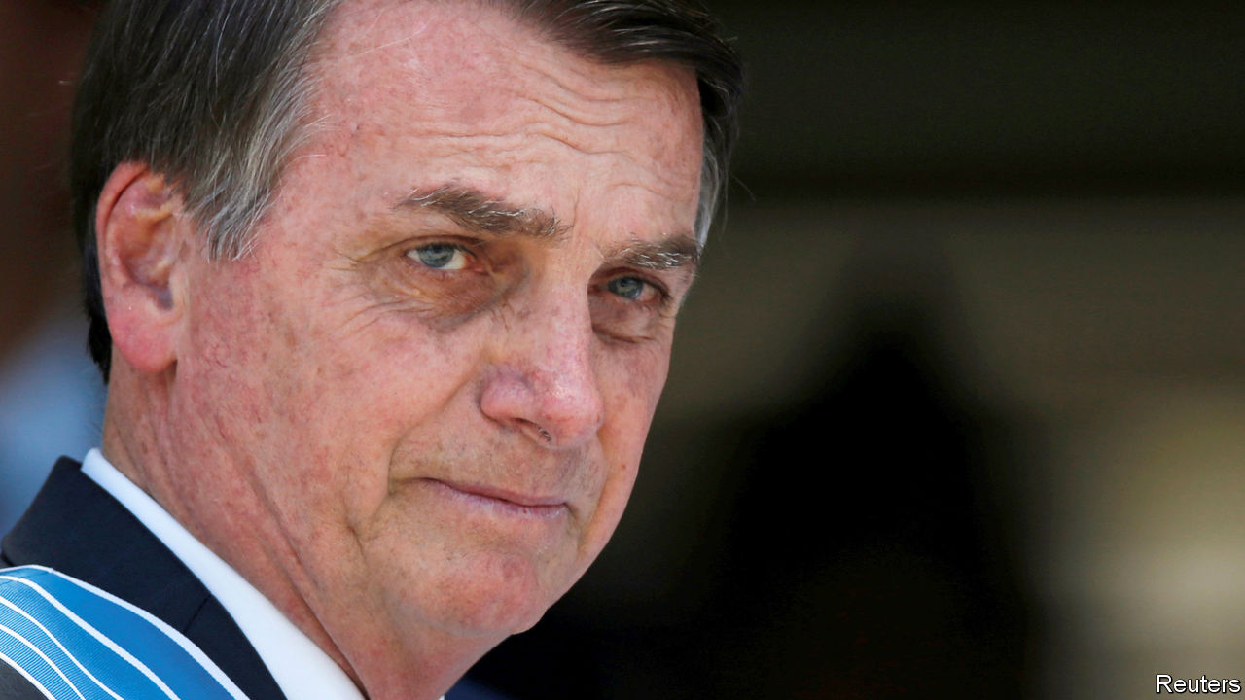

Jan 4th 2020

WHEN JAIR BOLSONARO took office as Brazil’s president on January 1st 2019, many observers feared the worst. The former army captain had made his name by extolling the military dictators who ruled from 1964 to 1985 and by disparaging women and gays. He won the election because voters were traumatised by the country’s worst-ever recession, from 2014 to 2016, by crime and by revelations of corruption at the highest levels of politics and business. They hoped that Mr Bolsonaro would restore prosperity, peace and probity to Brazil.

After his first year in office they have some of what they wanted. The economy has improved, and violent crime has fallen. Yet Mr Bolsonaro has not put to rest the doubts raised by his unlikely rise to power. The provocateur has not become a statesman. Instead of strengthening Brazil’s democratic institutions, he is testing them. When it comes to corruption and the environment, Brazil is either stuck or going backwards.

Mr Bolsonaro’s main achievement is pension reform, a prize that has eluded Brazilian governments for decades and which congress agreed on in November. This will help remove a trap that Brazil set itself by paying lavish benefits to people who, on average, retire in their mid-50s. Without reform, pension spending as a share of GDP would have nearly doubled by 2050, with alarming consequences for public debt and the government’s capacity to spend money on anything else. Brazil will now gradually introduce minimum retirement ages of 65 for men and 62 for women, and will reduce benefits as a share of people’s earnings.

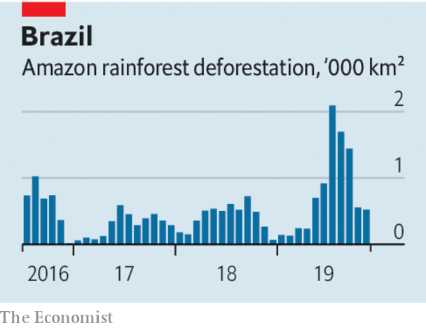

This has helped restore confidence in the economy. Interest rates have dropped to their lowest level in 33 years. Growth in 2020 should be at least 2%, well above the Latin American average. If Paulo Guedes, the Chicago-trained, pro-market economy minister, had his way, pension reform would mark the start of a transformation in Brazil’s fortunes (see [articles](https://www.economist.com/node/21777642)). He rightly believes that the state has kept Brazil poorer and more unequal than it should be, by spending too much money on the wrong things and subjecting businesses to needless rules and the world’s most baffling tax system. He wants to privatise public enterprises, shrink a bloated administration, simplify taxes and transfer power and money to states and municipalities. In 2019 Mercosur (a four-country bloc including Brazil and Argentina) reached a trade agreement with the EU. If it is ratified, it could help Brazil shed its status as one of the world’s more closed economies.

Mr Guedes urges the president’s critics to focus on that. The top man has “bad manners, but great principles”. It would be truer to say that Mr Bolsonaro, a fierce social conservative, has merely adopted Mr Guedes’s economic creed, for the time being. In other spheres, his ideas cannot just be brushed aside, even if congress and the president’s more level-headed advisers have so far contained his worst instincts. As long as he continues to endorse police violence, there is little chance of stopping its long upward trend. While left-wing protests were raging in other Latin American countries one of his sons, a congressman, said that if such protests turned violent in Brazil the government could revive a decree that shut congress during the dictatorship. In December, irritated by press accusations, the president turned on a journalist, saying, “Your face looks an awful lot like a homosexual’s, but that’s no reason to accuse you of being a homosexual.”

Although murders have fallen, largely because inter-gang warfare has eased, Mr Bolsonaro has all but given up the fight against white-collar crime. Sergio Moro, the justice minister, has been compromised by revelations of his improperly close dealings with prosecutors when he was the judge in charge of the vast anti-corruption probe that helped propel Mr Bolsonaro to power. Congress stripped Mr Moro’s crime bill of most of its anti-corruption measures. Prosecutors are investigating allegations that another of Mr Bolsonaro’s sons, a senator from Rio de Janeiro, pocketed money meant for employees when he was a state legislator and has links to murderous “militias” of ex-policemen.

Then there is the environment. Early data suggest deforestation in the Amazon in the first 11 months of 2019 rose by 80% compared with 2018. Mr Bolsonaro sacked the chief of the space agency after it reported unwelcome deforestation data, and has hollowed out environmental-enforcement agencies and egged on ranchers and loggers who set fires to clear land. At recent global climate-change talks, Brazil played the wrecker.

If Mr Bolsonaro transforms the economy, Brazilians will have reason to be grateful. But they, and the world, will have paid a high and unnecessary price. ■

Read this article on <https://www.economist.com/leaders/2020/01/04/a-year-of-jair-bolsonaro>

|  |  |  |  |
| --- | --- | --- | --- |
| Previous | Articles | Sections | Next |

|  |  |  |  |
| --- | --- | --- | --- |
| Previous | Articles | Sections | Next |

Elusive justice

# How to reduce rape

It is the hardest violent crime to prosecute. But most countries can do better



Jan 4th 2020

SEXUAL VIOLENCE is less common today than it was in earlier generations. But even in rich, peaceful democracies it is both widespread and distressingly easy to get away with. A fifth of American women will be raped at some point, by one estimate. Yet only a quarter of victims report it. Most stay silent despite the lifelong damage that rape can inflict and the desire to lock up a predator and deter others. They do so partly because the odds are stacked against them. In England and Wales in the 12 months to March 2019 only 1.5% of reported rapes ended in a criminal charge. With so little prospect of justice, many women are reluctant to undergo the ordeal of reporting an attack to the police.

Many people think women often lie about rape. They do not. The precise figure is unknowable, but the most credible estimates are that between 2% and 8% of rape allegations are false. In surveys, many police officers presume that the figure is far higher, which surely affects how they handle complaints. When a British teenager reported that she had been gang-raped in Cyprus, local police grilled her for hours, while she was traumatised, without a lawyer present. She says they pressed her into retracting her allegations, which she now insists are true. On December 30th she was convicted of lying, and faces up to a year in prison. Other women thinking of reporting rape in Cyprus may now decide not to.

Rape is an unusually difficult crime to prove, particularly when neither party denies that sex occurred (see article). A jury must be persuaded beyond reasonable doubt that the victim is telling the truth and the perpetrator is lying. Without other witnesses or physical evidence, this is hard. So long as the accused is presumed innocent until proven guilty—a cornerstone of any decent justice system—conviction rates for rape will never be as high as they are for murder.

Nonetheless, most countries could and should handle rape cases better. It starts with the law. Rape should be plainly defined as sex without consent. Several European countries and American states still require proof that force, or the threat of force, was used. This gives scant protection to victims who were unconscious, or who froze. In most of the non-Western world marital rape remains legal; it should not be. Statutes of limitations should be extended or scrapped, as they have been in Britain. Judges should let supporting witnesses attest to a pattern of predatory behaviour by the accused, as will happen at the trial of Harvey Weinstein, a film producer, which opens on January 6th.

To encourage more women to come forward, their cases should be dealt with more sensitively. In Britain nearly half of women who report rape now pull out during investigations, in part because they find the process so unpleasant. Specialised investigators should be trained in the best ways to interview traumatised complainants. In Germany, unlike Britain, all reports of rape are investigated. In Sweden such investigations are overseen by prosecutors. Evidence gathered from phones can provide valuable corroboration, but if the evidence-gathering feels like a digital strip-search, exposing the complainant’s whole life to scrutiny, it will deter many from pressing charges. More money can help, sometimes in obvious ways. Until recently some American cities had backlogs of thousands of untested “rape kits” (the DNA and other evidence collected from a victim’s body just after an alleged assault). New York City paid around $12m to clear its backlog of 17,000 untested kits amassed before 1999, helping find 2,000 matches and secure 200 arrests. Other cities have wisely followed its example.

Lastly, attitudes need to change. Sex education in Canadian, Dutch and Swedish schools includes teaching children about consent. This has been shown to reduce rape; it should be copied (see article). In colleges and workplaces, victims of sexual misconduct should have plenty of ways to report it, including in confidence and in escrow (so that, for example, a report is released only if more than one person makes a similar complaint about the same attacker). Rape and other forms of sexual abuse can never be eliminated. But they can be deterred more effectively than they are today. ■

Read this article on <https://www.economist.com/leaders/2020/01/04/how-to-reduce-rape>

|  |  |  |  |
| --- | --- | --- | --- |
| Previous | Articles | Sections | Next |

|  |  |  |
| --- | --- | --- |
| Leaders | Sections | Briefing |

Letters

Letters to the editor: On carbon capture, health care, rats, conservation, Joe Biden

Letters to the editor.

|  |  |  |
| --- | --- | --- |
| Leaders | Sections | Briefing |

|  |  |  |  |
| --- | --- | --- | --- |
|  | Articles | Sections | Next |

On carbon capture, health care, rats, conservation, Joe Biden

# Letters to the editor

A selection of correspondence

Jan 4th 2020

Letters are welcome and should be addressed to the Editor at letters@economist.com

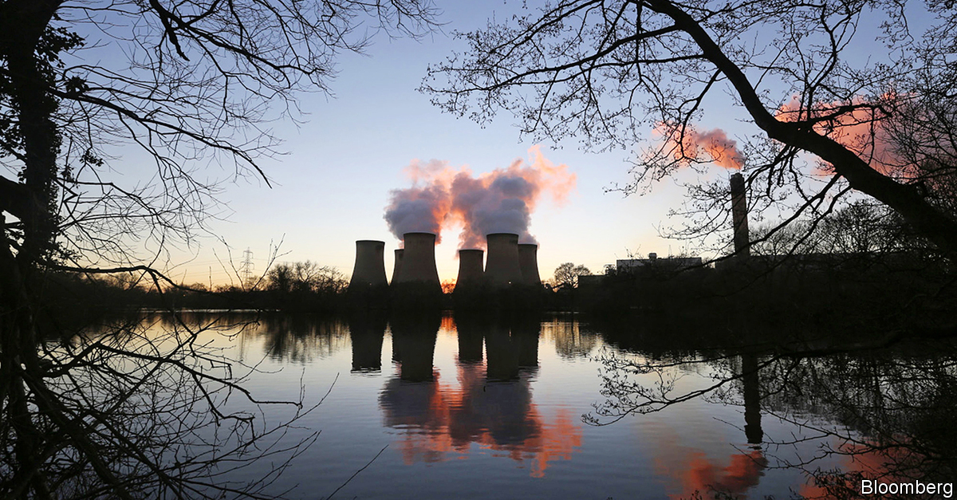

## Negative carbon emissions

Regarding the idea of pulling carbon dioxide out of the atmosphere, you favour artificial systems over natural ones (“The chronic complexity of carbon capture”, [December 7th](https://www.economist.com/briefing/2019/12/05/climate-policy-needs-negative-carbon-dioxide-emissions)). Yet profitable carbon removal through natural-systems farming, grazing and forest and marine management is already proven, scalable and rich in side benefits. It can robustly achieve a 1.5oC climate trajectory with no overshoot, strongly support the UN’s Sustainable Development Goals and avoid between $1trn and $3trn of supply-side investments a year by 2050, if coupled with lucrative and conservatively assessed energy efficiency and modern renewables. However, inertia and policy perversity block this in both energy and carbon removal, the former making the latter problematic.

Systems that grow and sustain themselves will outperform machinery that must be built, maintained, protected and powered. This incurs opportunity cost: needlessly costly methods worsen climate change by saving less carbon per dollar. Emphasising carbon removal through unnatural systems can incur moral hazard, waste money and time, and distract from the profitable solutions that are available.

A recent paper, “Recalibrating climate prospects”, shows how “integrative assessment models” that translate climate science into choices and consequences generally understate mitigation opportunities. Offsetting these biases, what Jeremy Grantham calls “the race of our lives” is very much on. Neither despair nor complacency is warranted.

AMORY LOVINS  
Co-founder  
Rocky Mountain Institute  
Basalt, Colorado

Although trees and other plants need significant land area for carbon capture and storage, nature’s process is far more efficient than industry’s. Carbon has a molecular weight of 12 and oxygen 16, so carbon dioxide has a molecular weight of 44. Carbon capture stores the whole amount, whereas plants elegantly store only 27% of that weight as carbon biomass, releasing the oxygen to the atmosphere for our benefit. Let’s give carbon credit where it’s due.

MICHAEL RAMAGE  
Reader in architecture and engineering  
University of Cambridge

Your analysis of carbon capture and storage was welcome, if somewhat pessimistic. We recently analysed ten recognised carbon-utilisation pathways and found that, at the top end, around 10bn tonnes of carbon dioxide a year could be used by 2050, a sizeable chunk of current emissions. Some of these pathways, notably the production of urea and polymers, could already be profitable. Others would require a carbon price of less than $100 per tonne.

As you implied, a carbon tax could speed their deployment. A simpler alternative is mandatory sequestration: requiring fossil-fuel companies to capture and safely dispose of a fraction of the carbon dioxide that they extract or import. Indeed, Britain had such a bill on the table in 2015. Perhaps it is time to bring it back.

CAMERON HEPBURN  
Smith School of Enterprise and Environment  
University of Oxford



## Pricing health care

Price transparency in health care can be helpful to patients (“Diagnosis: opaque”, [November 23rd](https://www.economist.com/business/2019/11/21/donald-trump-wants-hospitals-to-be-more-upfront-about-prices)), though it has limitations in the American market. The price mechanism works best when the buyer has the luxury of choice and time, which patients often do not because of market consolidation and clinical urgency. Around 40% of the insured population are already in public programmes with fixed prices that are largely transparent and often set below the cost of providing care.

Crucially, without transparency of quality and therefore value of care, it is hard for patients to know what they are getting for the price. A surgeon who performs a procedure few others can, and none better, typically receives the same payment as someone with worse outcomes. Isolated price transparency is as helpful as washing only one side of a window.

LYELL JONES  
Professor of neurology  
Mayo Clinic College of Medicine and Science  
Rochester, Minnesota

## The rat trap

I was disappointed to see your take on rat control in California, siding with the pest-control industry and their toxic products (“Something rodent in the state”, [November 23rd](https://www.economist.com/united-states/2019/11/23/a-bill-would-make-it-harder-to-control-californias-thriving-rats)). Those of us who support this bill are not pro-rat, we just want to stop the indiscriminate killing of non-rat species. There are many other means of controlling pests such as snap traps and electrical traps that do not take nearly the same toll on wildlife. Poisons allow the pest-control companies to kill off their competition, literally.

SIOBHAN RUCKSan Francisco

The Royal Horticultural Society says you should grow mint around your composters as rats do not like the smell. It has certainly worked around my composter. On that evidence, a friend from Lagos says she plans to set up a farm there to produce the herb, and reckons she will make a mint out of it.

DUNCAN STEPHENSON  
Leeds



## Animal conservation

Your article about the benefits of newly created fake rhino horn did not address the challenges and risks (“Fooled you”, [November 16th](https://www.economist.com/science-and-technology/2019/11/14/how-to-forge-rhinoceros-horn)). Might this new material end up legitimising trade in rhino horn, for example? Furthermore, rhino horn is not just being used for traditional Chinese medicine, but also for conspicuous consumption. Fake horn will not work for that market, just as fake diamonds have not supplanted the real thing on wedding rings. That is not to say this new horn will definitely do harm, but that the risks need to be considered.

The fake-horn approach fundamentally misses the underlying weakness in the economics of conservation: poaching is cheap and quick and can generate good financial return; conservation is long-term and expensive and struggles to generate revenue. We need more businesses selling products that help protect wildlife by creating local jobs, generating revenue for conservation organisations, and paying taxes in countries with wildlife to create an economic justification for conservation and the resources to support it.

If the 12m people who watched “Planet Earth II” in Britain bought just one cup of £2 wildlife-friendly coffee on average each week for a year, it would generate more than £1bn for conservation. Legitimate purpose-driven businesses, not forgers, are the key to saving wildlife.

RICHARD MILBURN  
Marjan Centre for the Study of Conflict and Conservation  
King’s College London

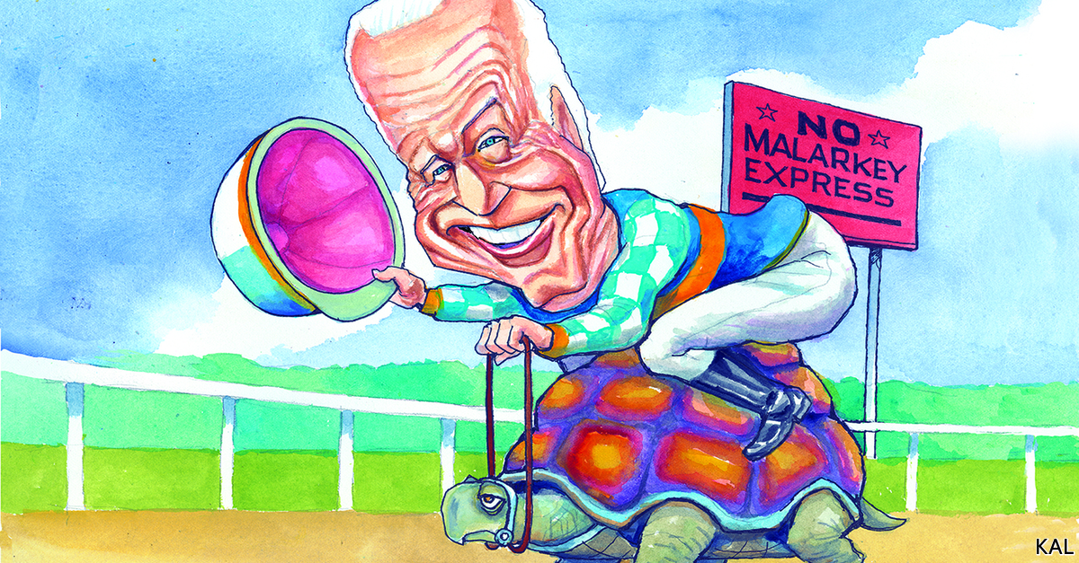

## More than a peck on the cheek

Lexington’s column on Joe Biden provided a noteworthy example of Winston Churchill’s observation that America and Britain are divided by a common language ([December 7th](https://www.economist.com/united-states/2019/12/07/the-stickiness-of-joe-biden)). With all of Mr Biden’s problems with the #MeToo movement, he would surely be unhappy to be reported as “planting peckers” on one elderly cheek. One hesitates to visualise it.

RICHARD WAUGAMAN  
Clinical professor of psychiatry  
Georgetown University  
Washington, DC

Read this article on <https://www.economist.com/letters/2020/01/04/letters-to-the-editor>

|  |  |  |  |
| --- | --- | --- | --- |
|  | Articles | Sections | Next |

|  |  |  |
| --- | --- | --- |
| Letters | Sections | United States |

Briefing

Chinese students in America: The new red scare

The new red scare on American campuses.

|  |  |  |
| --- | --- | --- |
| Letters | Sections | United States |

|  |  |  |  |
| --- | --- | --- | --- |
|  | Articles | Sections | Next |

Chinese students

# The new red scare on American campuses

Both their host government and their home government increasingly view Chinese students with suspicion

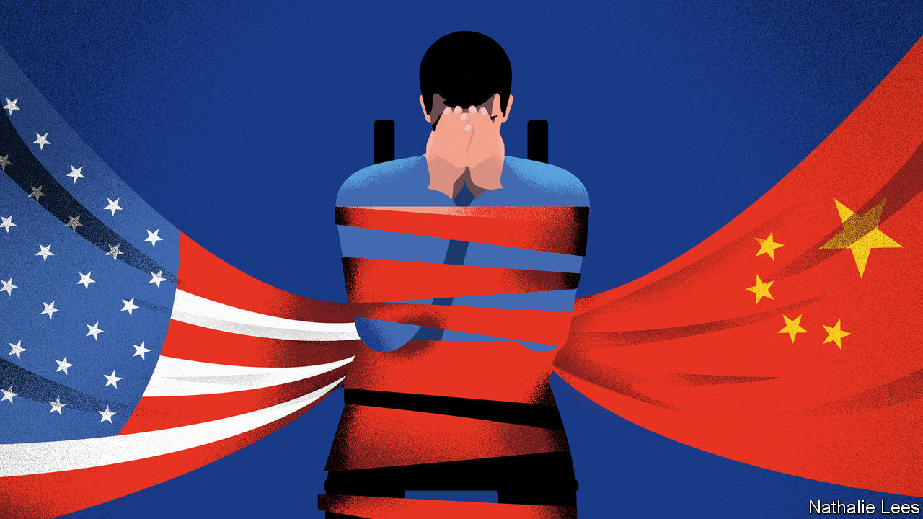

Jan 2nd 2020 | NEW YORK

EARLY LAST autumn Alex and Victor, two students from mainland China, sat in the back row of a packed auditorium at Columbia Law School, in New York. They were there for a talk by Joshua Wong, thrice-jailed young hero of the Hong Kong democracy movement, which the two students support. They applauded enthusiastically; they also wore blue face masks.

The masks were in part symbols of solidarity with Mr Wong’s fellow protesters half a world away. But they were also a way of hiding their identities from face-recognition systems in China that might be scanning pictures of the audience, and from Chinese students in the hall less in tune with Mr Wong’s message—such as the ones who sang the national anthem of the People’s Republic in response to the talk. Their names are not, in fact, Alex and Victor; they asked The Economist to give them pseudonyms and not to say where in China they came from. As they talked, other Chinese students quietly observed them, national flags in hand.

There are 19.8m university students in America, of whom just over a million come from other countries. A bit less than a fifth of these foreigners come from India, and 6% from the European Union. Fully a third are Chinese—a much larger fraction than from anywhere else, and more students than China sends to all the other countries in the world put together. At Columbia, half of the nearly 12,000 international students are from China. This is all very good for the students’ future prospects and the universities’ coffers. But it worries the American government, the Chinese Communist Party (CCP) and some champions of academic freedom.

The American government thinks some Chinese students and researchers are responsible for a great deal of intellectual-property theft. The CCP fears that people like Alex and Victor are contracting dangerous levels of democratic idealism. And China’s efforts to curtail the room such dissidence has to flourish in worries people who care about free expression on American campuses and beyond.

## A special relationship

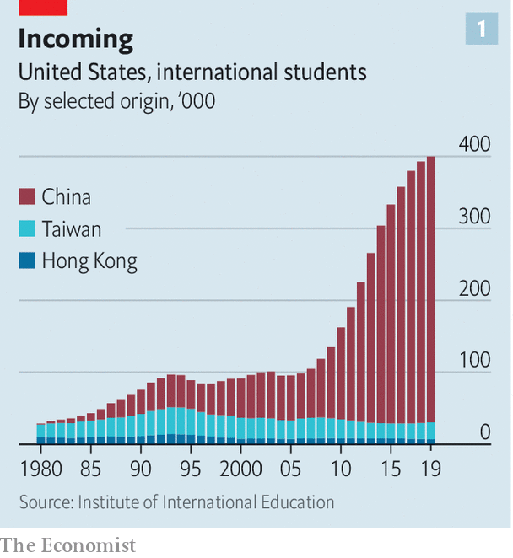

The number of mainland Chinese students in America grew by 276% over the past decade (see chart 1) as China’s elite sought to buy excellent educations for their children and American researchers sought talent. In 2018, the most recent year for which figures are available, Chinese graduate students received 13% of all science and engineering doctorates awarded by American universities.

The rate at which researchers at the Massachusetts Institute of Technology (MIT) co-author papers with colleagues at leading Chinese universities has risen tenfold over the past decade—part of a trend which has seen collaborations between American and Chinese researchers become more numerous than collaborations with any other country (see chart 2). Many Chinese researchers have significant resources as well as sharp minds; some sorts of lab work are easier and cheaper in China than in America. It is hardly surprising that American researchers—especially the growing number who have former pupils back in China—want to work with them.

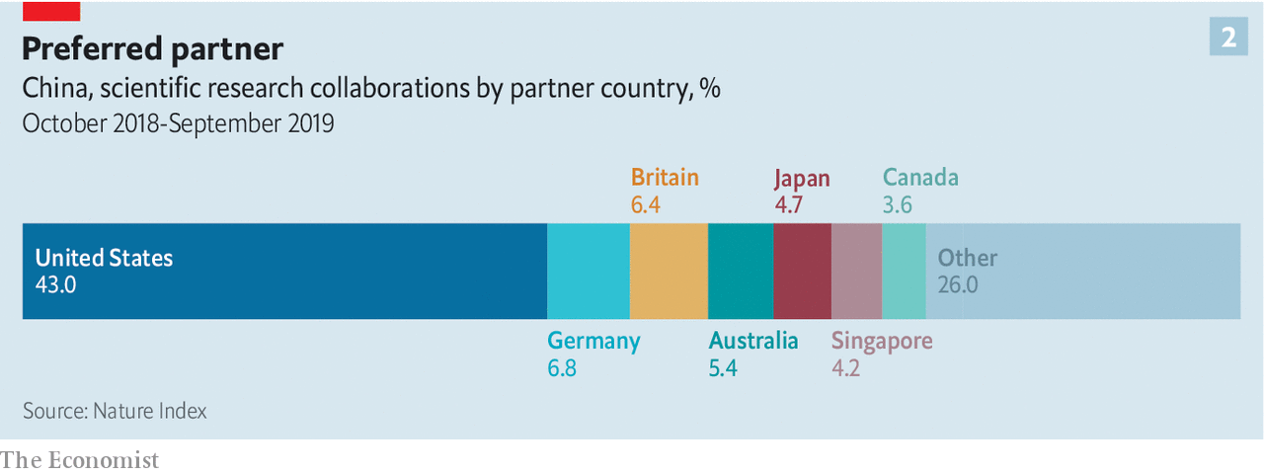

Not all of this collaboration is peer-to-peer. Chinese companies fund an increasing amount of research at American universities, including into areas prioritised in the “Made in China 2025” industrial-policy initiative—a policy America’s Department of Justice has referred to as a “roadmap to [intellectual-property] theft”. MIT, for example, has research partnerships with SenseTime, a Hong Kong company that provides facial-recognition technology to Chinese police, and iFlytek, a Chinese firm that works on voice recognition and which has paid for research at Princeton and Rutgers.

The administration of President Donald Trump worries about all this. In the past two years, scrutiny of mainland Chinese on American campuses has intensified, and with it scrutiny of other students and researchers who are ethnically Chinese, including Chinese-Americans. Some see this new scrutiny as testing American academia’s reputation for openness, international co-operation and the free exchange of ideas. Christopher Wray, the director of the FBI, believes it provides a valuable counterweight to academic “naivety”.

In 2018 Mr Wray testified to the Senate intelligence committee that China poses a “whole-of-society threat” to America, one which demands a “whole-of-society response”. In Mr Wray’s analysis the fact that American researchers collaborate so much with Chinese researchers is a cause for concern; such scientists and students are among the “non-traditional collectors” of an intelligence operation he has described as “deep and diverse and wide and vexing”.

In 2018 and 2019 agents from the FBI’s 56 national field offices contacted hundreds, perhaps thousands, of students, researchers and professors with ties to China—many of them from China or ethnically Chinese, including Chinese-Americans—to determine whether they might be working on behalf of the Communist Party. The National Institutes of Health (NIH), Department of Energy and other providers of federal grants have urged universities to monitor researchers for connections to Chinese institutions or “talent” programmes which seek to attract scientists, often Americans of Chinese ethnicity, who have gained expertise deemed of value in China. China’s “Thousand Talents” programme, which in part offers scientists incentives to set up labs in China, was used to recruit at least 6,000 experts from overseas between 2008 to 2017.

The NIH says that it has identified 180 researchers to whom it has provided grants who may not have disclosed payments from, or other affiliations with, Chinese institutions—including some who appear to have established “shadow labs” in China mirroring their NIH-funded ones in America. In 2019 two research institutions—MD Anderson, a cancer-research centre in Houston, and Emory University in Atlanta—cut ties with five researchers, all of them ethnically Chinese, who had taken money from China. In December federal authorities arrested a Chinese cancer researcher at Logan Airport in Boston after he allegedly tried to smuggle to China vials of biological material taken from a Harvard teaching hospital. (His Harvard-sponsored visa has also been revoked.)

But officials at some universities say that private briefings from the FBI have left them both unconvinced of the scope of the problem and unclear what actions need to be pursued. “What exactly Mr Wray has in mind, where precisely he sees the threat—this is all left frustratingly vague,” says an international-research administrator at an elite university that has been briefed by the FBI (and where the FBI has also interviewed visiting Chinese scholars). “Some of the guidance has been, ‘Be careful about anything to do with biotech.’ Well biotech is huge…I don’t even know which faculty to talk to if you don’t tell me more.”

## Risk management

Faced with such scepticism, last summer the National Security Council, the State Department, the Department of Justice (though not the FBI) and experts on Chinese influence operations briefed some 15 university presidents, provosts and other senior administrators in a two-day session at St Michaels, Maryland. One of those giving the briefings noted that the idea of technology developed on their campuses aiding China’s repression of Uighurs in the western province of Xinjiang seemed particularly salient to the administrators: such links could damage their institutions’ reputations. This is not a purely theoretical issue. In October SenseTime and iFlytek, the artificial-intelligence firms with research partnerships at MIT, were blacklisted by the American government for allegedly abetting the abuses in Xinjiang.

As well as investigating Chinese students and researchers already in America, the administration has also looked at ways to make it harder for them to arrive and easier for them to be expelled. In 2018 some of Mr Trump’s aides argued for severe restrictions on student visas for Chinese nationals. Instead the administration curtailed five-year visas for foreign graduate students in certain fields of science and technology such as aviation and robotics; these students now get renewable one-year visas. The Department of Homeland Security has also made it easier to declare that foreign students are overstaying their visas. Educators report anecdotally that invited Chinese scholars are finding it much harder to get visas, including short-term visas for academic conferences that in the past were routinely issued.

Concerns about what Chinese students get up to are not unique to the executive branch. Marco Rubio, a Republican senator from Florida, and Mark Warner, a Democratic senator from Virginia, have been among the most prominent figures on Capitol Hill warning not just of Chinese intelligence operations at American universities, but also of those universities’ worrying dependence on Chinese money via tuition fees and research partnerships. Pressure from senators and congressmen is one of the reasons why, since 2018, at least 15 universities have closed the Confucius Institutes, paid for by China, that offer Chinese language instruction and arrange cultural events. A new federal restriction that bars universities with Confucius Institutes from Defence Department funding for Chinese-language study has also been a factor.

Some university administrators, scientists and civil libertarians worry that the administration’s conception of the “China threat” is so broad and vague that anyone with the slightest connection to China can become a target for questioning by the FBI—a new Red Scare. Lee Bollinger, president of Columbia, published an op-ed in the Washington Post titled “No, I won’t start spying on my foreign-born students”. Rafael Reif, the president of MIT, wrote in an open letter that students and staff of Chinese ethnicity “tell me that, in their dealings with government agencies, they now feel unfairly scrutinised, stigmatised and on edge.” Several groups of Chinese and Chinese-American scientists published a letter in Science, America’s leading scientific journal, expressing fears of “scapegoating, stereotyping and racial profiling”.

Communist Party figures have been happy to see the Trump administration’s spy-hunt portrayed as a xenophobic exercise. In December Hua Chunying, a foreign ministry spokeswoman, praised the “courage” of Fareed Zakaria, an American commentator who belittled the administration’s concerns in an article headlined “The New China Scare”.

## Bubbling up

The Trump administration, for its part, has tried to have things both ways. While happy to be seen as tough by those to whom toughness appeals, in public officials say that Chinese students and scholars are as welcome as ever. White House officials claim only to be concerned about a tiny fraction of people on student visas who may be operating as spies. Though Mr Trump is reported to have said, at a dinner with American corporate bosses, that “almost every student that comes over to this country [from China] is a spy”, he said at the G-20 summit last June that “we want to have Chinese students come” and that they are “tremendous assets” who should be treated “just like anybody else”.

Fears of China’s espionage are not new. Since 2011 more than 90% of all American prosecutions for economic espionage have been linked to China. But that does not mean their increased prominence can be simply chalked down to a hawkish change under Mr Trump. China has changed, too. Both its ambitions and its authoritarianism have become more marked, especially since President Xi Jinping abolished the term limit on his presidency in 2018. The internment of more than 1m Uighurs in detention centres, a severe crackdown on lawyers and activists and a hardline response to protests in Hong Kong have fatally undermined the old argument that Western engagement with China would see it liberalise. In the past it was possible to argue that Chinese students in the West would return home with new ideas about freedom of expression and individual dignity and political agendas to match. Now it is clear that, in some cases at least, their presence is an overseas redoubt for the CCP’s ideas about conformity and loyalty.

Some China-watchers point to Australia as a worrying exemplar. Australian officials have warned for years of China’s influence operations in the country, including at universities. In July students from mainland China threw punches at other students demonstrating in solidarity with the Hong Kong protesters at the University of Queensland. The consul-general in Brisbane, Xu Jie—who is, unusually for a senior Chinese diplomat, an adjunct lecturer at the university—praised them for their “patriotic behaviour”.

Talks by Chinese dissidents are a particularly touchy subject. In 2015 Teng Biao, who is now an adjunct lecturer at Hunter College in New York, was a visiting scholar at Harvard Law School. In a report on Chinese influence at American universities produced by the Wilson Centre, a think-tank, in 2018, Mr Teng described how he planned to invite Chen Guangcheng, a blind lawyer who in 2012 made a daring solo escape from house arrest to the American Embassy in Beijing, to give a talk there. An “influential person” at the university persuaded him that hosting Mr Chen would “reflect poorly on Harvard”: the university’s then-president, Drew Faust, was in Beijing meeting Mr Xi.

Mr Teng is still unwilling to identify the “powerful professor” who warned him off. He thinks it could further damage his prospects in the job market, where his position as a dissident is already a black mark: “The pressure from the Chinese government is real and is strong.” The Wilson Centre report also documented instances of what appeared to be blatant efforts by China to influence free expression, including freezing Chinese participation in lucrative programmes for such offences as inviting the Dalai Lama to speak on campus.

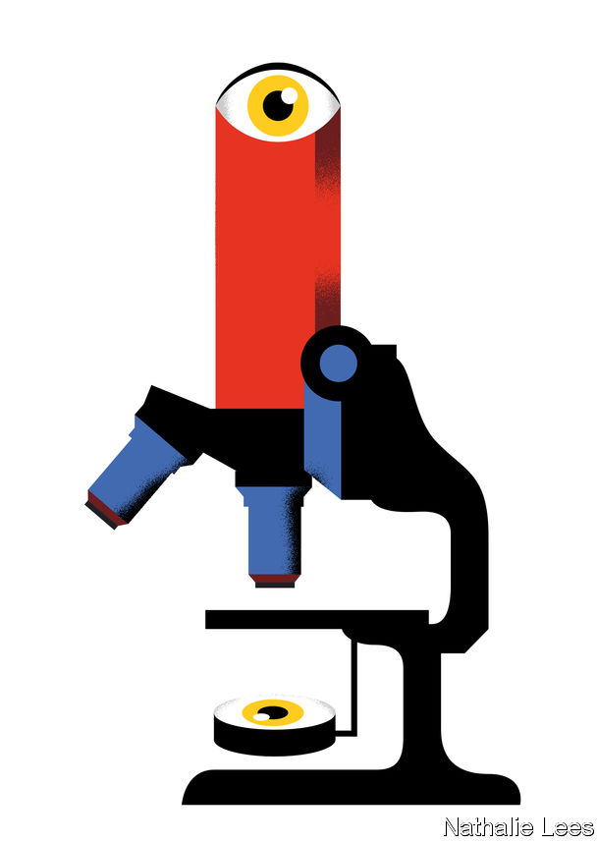

Beijing’s wishes in such matters are often communicated through the Chinese Students and Scholars Associations (CSSAS), that are to be found on more than 150 American campuses. In 2019 the CSSA at Purdue University in Indiana asked administrators to cancel a talk by Mr Chen. When the talk went ahead (with police protection) the organisation circulated an announcement that such speaking events provoke “fierce controversy and dissatisfaction among Chinese students.”

Other manifestations of Chinese influence are more subtle. Columbia shows off a bust of Vaclav Havel, the dissident playwright who, after the fall of communism, became president of the Czech Republic; he was a guest of the university for some weeks in 2006. But they will not find a bust of Liu Xiaobo, a Chinese writer who won the Nobel peace prize for his human rights activism, despite the fact that he too had been a guest at the university, back in 1989. (A request to place such a bust, made on behalf of his widow, was rejected.)

In the curricula and cultural activities of Confucius Institutes language students will find no more mention of human-rights activists like Liu than they will of the Tiananmen Square protests in 1989 or the repression in Xinjiang.

Students from China often refrain from discussing sensitive subjects in front of other Chinese students. A professor at one Ivy League university says that after some students asked to submit written work touching on human rights under a pseudonym he now offers that option to all. Alex and Victor avoid sensitive topics when with their peers and keep their distance from Columbia’s CSSA. “In China too I heard so many stories about students reporting on their professors because their professors mentioned Tiananmen in class,” Victor says. “These fellow students would do this in mainland China and they would do the same abroad.”

## Worlds within worlds

The number of Chinese students in America is not yet dropping in response to any of this. The fact that it has ceased growing may have something to do with the tensions, or with worries about visas. But some of those worries are not specific to China; numbers of students from elsewhere are down, too. And other factors are at play. Foreign-exchange controls have tightened; China’s economy has slowed. More Chinese families now sending children abroad may opt for cheaper destinations. Though America is still preferred, enthusiasm for it is waning while enthusiasm for Britain waxes.

But the boom is over—and so are the hopes that it might in and of itself bring new amity. Both the greater number of Chinese students and the greater power of information technology mean that it is ever easier for them to remain isolated on campus, mixing little with their American peers. They use WeChat, a social-media app, both to stay in touch with friends and family back home and as their sole source of news, much of which reflects their government’s view of their host country. In 2018 a Purdue University survey of a large midwestern university found that 42% of Chinese students had a less favourable perception of America than they had when they arrived; just 16% said their impression had improved. Their study abroad has not exactly built a bridge between the two countries. The intense scrutiny they face from both Beijing and Washington threatens to widen the divide. ■

[From 1843 magazine: What Chinese students found when they moved to America’s Midwest](https://www.economist.com/1843/features/alienation-101)

Read this article on <https://www.economist.com/briefing/2020/01/02/the-new-red-scare-on-american-campuses>

|  |  |  |  |
| --- | --- | --- | --- |
|  | Articles | Sections | Next |

|  |  |  |
| --- | --- | --- |
| Briefing | Sections | The Americas |

United States

Suburbs: Laboratories of democracy

The 2020 presidential election will be decided in the suburbs.

Sex education in Texas schools: TexEd

Austin has changed sex education in its schools.

Romance novelists: The wrong kind of racy

A dispute over racism roils the world of romance novelists.

The decline of Vegas weddings: Crying in the chapel

The decline of Las Vegas weddings.

Lexington: Pete Buttigieg heads South

Pete Buttigieg’s illuminating struggle down South.

|  |  |  |
| --- | --- | --- |
| Briefing | Sections | The Americas |

|  |  |  |  |
| --- | --- | --- | --- |
|  | Articles | Sections | Next |

Laboratories of democracy

# The 2020 presidential election will be decided in the suburbs

Contrary to a widespread belief, Democrats do not have a decisive edge in suburbia



Jan 4th 2020 | SAVANNAH, GEORGIA

UNDER THE SPANISH MOSS and live oaks of Skidaway Island, a suburb of Savannah, the Oyster Roast, a barbecue-cum-fund-raiser for the University of Georgia, is winding down and politics is raising its ugly head. “When we first came here,” says Allen Blount, a businessman from Jacksonville, “we were the only Democrats for miles around, and had to keep quiet about it. Now we’ve discovered a network of secret Democrats, but we still keep quiet so as not to upset our Republican friends.” Skidaway is majority Republican. Ten miles north, in a precinct of downtown Savannah, Hillary Clinton won 98% of the vote. Almost next door, in the suburb of Bloomingdale, Donald Trump won over 80%. “It’s still red versus blue,” says Mr Blount, “but everything is more complicated.”

And not only in suburban Savannah. More than half of votes in 2020 will probably be suburban ones. It is hard to be precise because America has no standard definition of suburbs, and definitions matter. Some people classify them as areas dominated by single-family homes and commuting by car, but that is not how the Census Bureau does things. Data on jobs, ethnicity and education are gathered by county; America has just over 3,000 of these. Even though Kalawao County in Hawaii has fewer than 100 residents, whereas Los Angeles County has over 10m and includes dense urban areas and empty countryside, counties are therefore the only proxy for suburbs. Based on the counties around the 100 largest cities, Bill Frey of the Brookings Institution, a think-tank, distinguishes between three sorts of suburb: inner “mature” ones in which 75-95% of the land is built upon; outer “emerging” ones with 25-75% urbanisation; and “exurbs” with less than 25% of land developed.

Once upon a time, all these places voted Republican. Orange County, a swathe of southern California, did not choose a single Democratic presidential candidate between 1936 and 2016. National elections pitted Republican suburbs versus Democratic cities plus the rural South.

That has changed as suburbs have grown and altered. Between 1980 and 2016, according to Mr Frey, the proportion of whites living in mature suburbs fell from 70% to 58%. Shares of African-American, Asian and Hispanic residents rose correspondingly. All tend to be more reliable Democratic voters than whites. In Loudoun County, part of those Virginia suburbs that have moved towards the Democrats, the share of Asians has almost quadrupled since 2000, to 20%. This used to be a place of white picket fences, white painted churches and white people. Now its malls are full of Vietnamese, Korean and Indian businesses. In 2018, according to Mr Frey, 56% of voters in this kind of mature suburb plumped for Democrats.

Mature suburbs have also become magnets for America’s most highly educated graduates. Their jobs may be in or near big cities but they commute from nearby tech suburbs, such as Aurora outside Denver or Cedar Park near Austin (a phenomenon sometimes called “bright flight”). According to Wendell Cox of Demographia, a public-policy firm, nearly three-quarters of college graduates live in what he calls “earlier” and “later” suburbs (analogous to Mr Frey’s mature and emerging ones). Like minorities, graduates lean Democratic. Democrats control every district where more than half of voters have college degrees, including Georgia’s sixth, in the northern Atlanta suburbs, which was once Newt Gingrich’s stronghold and is now represented by a fierce gun-control advocate.

It is possible, too, that people of different personality types are increasingly concentrated in different suburbs, or so says Will Wilkinson of the Niskanen Institute, a think-tank in Washington, DC (and before that of The Economist). Psychologists identify the so-called “big five” personality traits, features which underpin other aspects of personality and are stable throughout adulthood. They are openness to new experiences; conscientiousness; extroversion; agreeableness and neuroticism. Mr Wilkinson argues that at least two of these traits are not distributed randomly.

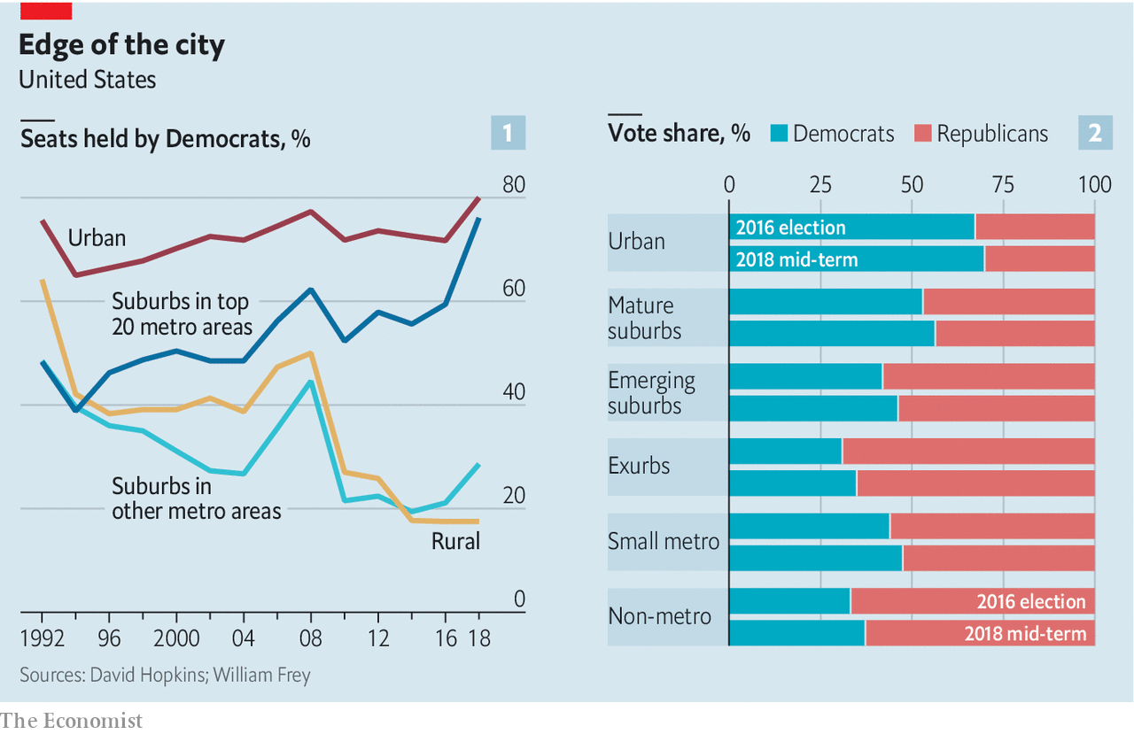

As economic change and migration shift people and jobs around, folk with a greater degree of openness are more willing to move, whereas conscientious people—those with more respect for rules, duty and self-discipline—prefer to stay put. This is may sound far-fetched. But Markus Jokela of the University of Helsinki has shown that personality traits predict people’s willingness to move long distances, and Jason Rentfrow of Cambridge University finds that openness is more common in the states of New England, the mid-Atlantic and the Pacific coast.

Their suburbs are, not by chance, more vital economically. The counties that voted for Mrs Clinton in 2016 accounted for three-quarters of America’s GDP growth in 2010-17 and two-thirds of its new jobs. Put all this together, and a pattern emerges: inner suburbs are better educated, ethnically more mixed, produce more jobs and income, may have more people with the trait of “openness”—and vote Democratic.

But that leaves a big chunk of the suburban landscape where Republicans still dominate. Using Mr Frey’s classification, Mr Trump won 61m votes to Mrs Clinton’s 57m in the three kinds of suburb. Using a slightly different classification, which separates suburbs around the 20 largest cities from the rest, David Hopkins of Boston College found that, outside the top 20, Mr Trump won a higher share of the vote than any Republican presidential candidate since Ronald Reagan’s landslide re-election of 1984. And while Democrats increased their total suburban vote in 2018, most of their gains came in mature (inner) ones. The Republican vote in emerging (outer) suburbs, exurbs and small towns either held steady or dropped by only a small amount. Republicans seem to be consolidating their position in outer suburbia.

All this suggests that suburbs contain two swathes of voters, each loyal to a different party. The gap between them is widening. In 1992, according to Mr Hopkins, the different suburbs voted similarly, with both suburban seats around the largest 20 cities and all the rest split roughly 50:50 between the parties. By 2018, however, these two places had diverged. Big-city suburbs (which, like mature ones, are racially mixed and better educated) had become almost as Democratic as the urban centres they surround. But suburbs outside the top 20 were almost as Republican as the rural areas into which they imperceptibly fade.

So what does that imply for 2020? On the face of it, it looks like good news for Democrats. Using Mr Frey’s classification, mature suburbs contain 82m people, compared with just 27m in Republican-leaning emerging suburbs and 9m in safe Republican exurbs. The Democrats’ potential pool of voters is larger and, in 2018, they increased their actual vote from 57m to 61m, carrying the overall suburban vote. Many of Mr Trump’s policies, such as caging immigrant children at the border and disdain for American allies, are unpopular with suburban voters.

But Republicans are resilient. Even 2018’s blue wave did not sweep them away nationally. In suburbs around the 100 largest cities, the Democrats were ahead by only 4m votes, out of 118m. If you include small towns in the total, the parties’ votes were almost identical, 91m Democrats to 90m Republicans.

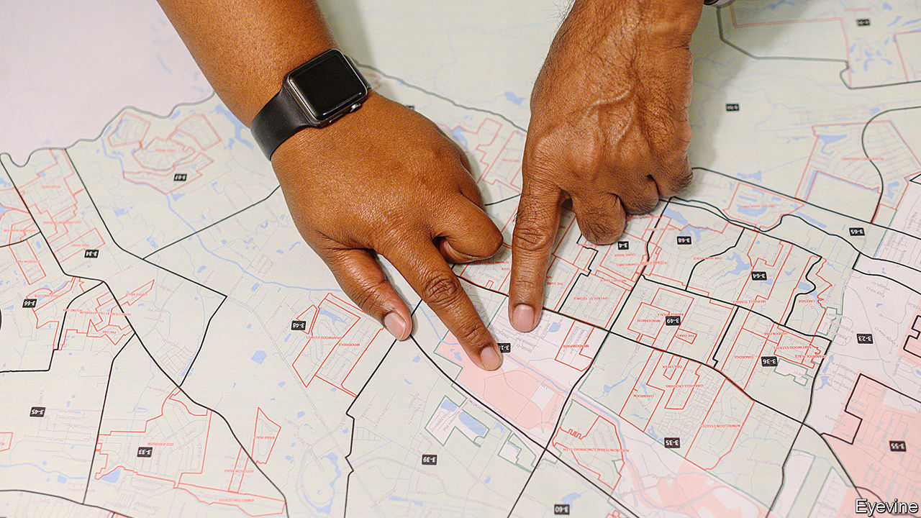

Pinpointing Republicans

Moreover, recent demographic shifts favour Republicans. The surge in urban and inner-suburban growth that took place in the early 2010s (and helped Democrats) is ebbing. Between 2010 and 2015, according to the Census Bureau, cities of over 1m grew faster than the surrounding suburbs. Since then, suburbs have grown more. Growth in emerging suburbs and exurbs has rebounded. Many of the biggest gains have come in mid-sized cities in states Mr Trump won, such as Akron, Ohio and Youngstown, Pennsylvania.

This could mean, argues David Wasserman of the Cook Political Report, that Mr Trump could lose the popular vote again as Democrats rack up suburban victories, but win the presidency thanks to an increasing electoral-college advantage in rust-belt states with few graduates or minorities. In sum, Democrats have increased their suburban support, but not everywhere and not yet by enough to be decisive.

Back on Skidaway Island, the Oyster Roast is over and politics is set briefly aside. The fundraiser has produced $35,000 for marine research in Georgia, and launched the state’s first oyster hatchery. At the next event, in November, there will presumably be even more oysters to eat—but no truce in the political battle at that other, bigger event that month. ■

Read this article on <https://www.economist.com/united-states/2020/01/04/the-2020-presidential-election-will-be-decided-in-the-suburbs>

|  |  |  |  |
| --- | --- | --- | --- |
|  | Articles | Sections | Next |

|  |  |  |  |
| --- | --- | --- | --- |
| Previous | Articles | Sections | Next |

TexEd

# Austin has changed sex education in its schools

The rest of Texas is primed to react

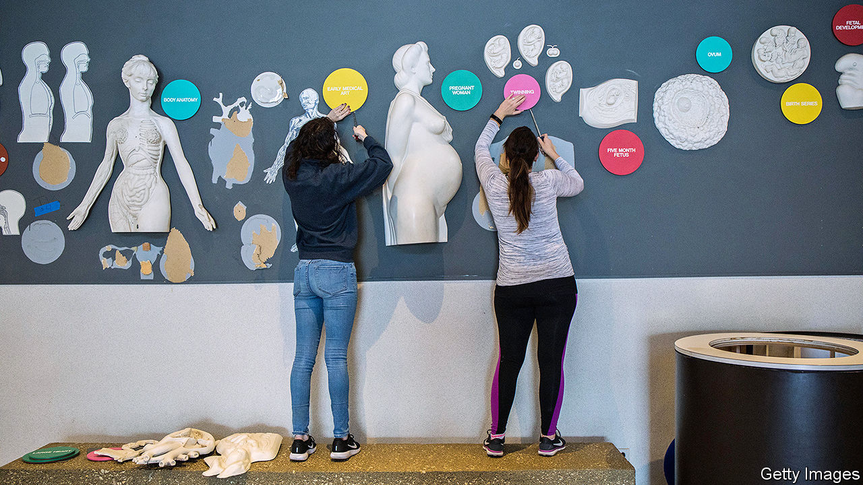

Jan 4th 2020 | AUSTIN

FOR A CONSERVATIVE place, Texans are talking a lot about anal sex. The cause is a change to sex-education lessons in the progressive city of Austin which, some fear, could spread to the rest of the state.

Texas is a poster-child for abstinence education. Over 80% of schools teach either abstinence-only or nothing on sex at all. State law requires teaching to emphasise abstinence “as the preferred choice of behaviour in relationship to all sexual activity for unmarried persons of school age.” It does not require mention of condoms, contraceptives or sexual orientation. The last time the state Board of Education touched this hot-button issue, in 2004, abstinence advocates won and kept calls for more comprehensive sex education at bay.

This does not appear to have worked. Texas has one of the highest teen-pregnancy rates in America. For all the abstinence lessons, over 60% of high-school seniors say they have had sex. According to the Centres for Disease Control and Prevention, Texan teens are the least likely in America to have used contraception last time they did. “We’re creating generation after generation after generation of sexually illiterate adults,” David Wiley, founder of the Texas Campaign to Prevent Teen Pregnancy, told the Houston Chronicle.

Change is under way. The share of school districts teaching abstinence-plus (don’t have sex, but if you do, be safe) increased from 4% in 2008 to 17% in 2016, according to Texas Freedom Network (TFN), an advocacy group. In October the board of Austin’s independent school district unanimously voted for an updated sex-education curriculum for 8- to 14-year-olds. For the youngest children the syllabus involves naming body parts and the idea that some of them are private, which is thought to help guard against sexual abuse. Later on it includes lessons on contraceptives, disease prevention, LGBT relations, gender identity and consent. The battle in Austin was fierce and may foreshadow a larger one: in 2020 the state Board of Education will consider revising state standards for teaching health and sex education.

All this has infuriated conservatives. Some worry that Austin’s updated material promotes the sexualisation of young children, grooms teenagers for under-age sex and amounts to “LGBT indoctrination”. One mother worries that teaching 11-year-old boys how to put on condoms will “get them aroused” and “encourage risk-taking”. Another fears that teaching girls that motherhood is optional collides with conservative family values. On the day of the Austin vote, the Christian Broadcasting Network declared: “Texas School District Mandates Teaching Kids How to Have Anal Sex.”

The Austin vote may have been unanimous, but the run-up was far from consensual. First, a change in the law meant the district could not buy teaching material from Planned Parenthood and had to create its own. Then came haggling over content. Concessions included removal of several references to body parts (all related to disease prevention) and, allegedly, a video with mixed-race and gay parents. When it came to the vote dozens of speakers lined up into the night, mostly objecting. “It’s not appropriate for a government body to encourage students to engage in any kind of sexual activity,” said David Walls from Texas Values, a conservative advocacy group.

The lessons on gender identity are among the most controversial parts of the new curriculum. Ten-year-olds will be presented with a “gender-bread person” handout to illustrate the idea that biological sex refers to the reproductive system and that gender identity is the way people see themselves. Pupils will be taught that the two do not always match.

Although the new curriculum will be taught from May in Austin, and parents can opt out, opponents say this is just the beginning. Concerned Parents of Texas, a group claiming to represent “parents, educators and concerned citizens”, says the material encourages risky behaviour and gender confusion and may be against Texas law. “They are pushing anal sex,” says Caryl Ayala, a former primary schoolteacher and one of the group’s founders. She worries about children’s physical health and life prospects, but also about the trauma of engaging in sex before marriage. “A condom doesn’t protect the heart of a child,” she adds, holding a binder of school material which, she believes, is pornographic.

In her eighth-floor office overlooking the city, Lisa Goodnow, from the Austin schools district, sighs as she recalls the tug-of-war over an update which, she believes, is well overdue. “Kids are two clicks away from seeing anything online. That’s not where we want our students to get information,” she says. For many public-health, gay and trans campaigners, the Austin change is a victory. But the real fight has not started yet, says Dan Quinn, from TFN. More conservative districts may well look at Austin’s battle and think it easier not to have sex education at all, or stick to abstinence. Book publishers may agree. The other side also believes that the real fight has not yet started. “It won’t stay in Austin, it’s already spreading, they want to change the state,” says Jennifer Fleck, a Republican candidate for the state legislature. “It’s time to draw a line in the sand and say: ‘You need to stop and move back’.”■

Read this article on <https://www.economist.com/united-states/2020/01/04/austin-has-changed-sex-education-in-its-schools>

|  |  |  |  |
| --- | --- | --- | --- |
| Previous | Articles | Sections | Next |

|  |  |  |  |
| --- | --- | --- | --- |
| Previous | Articles | Sections | Next |

The wrong kind of racy

# A dispute over racism roils the world of romance novelists

Truth is stranger, and less sexually charged, than bodice rippers



Jan 4th 2020

IT BEGAN, like so many contemporary racial kerfuffles, on social media. Courtney Milan, a bestselling romance novelist and former chair of the Romance Writers of America (RWA)’s ethics committee (which sounds like fun) called “Somewhere Lies the Moon”, a historical novel by Kathryn Lynn Davis, “a fucking racist mess”. Ms Milan, who is Chinese-American, objected to physical descriptions (“slightly yellow” faces and “slanted almond eyes”) and to a character who said that Chinese women were “demure and quiet, as our mothers have trained us to be” and “modest and submissive, so they will make good wives.”

Ms Davis and Suzan Tisdale, a writer who also runs a romance-publishing imprint that employs Ms Davis, accused Ms Milan of violating several sections of the RWA’s ethics code. The RWA’s ethics committee dismissed all of Ms Davis’s complaints save one: that Ms Milan’s comments violated “the organisation’s expressed purpose of creating a ‘safe and respectful environment’” for its members. The committee recommended a year’s suspension of Ms Milan’s RWA membership, and a lifetime ban on holding any RWA leadership position.

Soon after that ruling was made public, a clutch of authors took to Twitter to support Ms Milan, and condemn the RWA. Several members of the RWA’s board resigned. The RWA swiftly rescinded Ms Milan’s punishment, but the controversy raged on. A petition urging the association’s sublimely named new president, Damon Suede, to resign began circulating online. Mr Suede says he does not plan to step down, but the petition’s backers say they have garnered enough signatories to force a recall election.

The romance-writing world was already roiled by issues of race and representation. In 2017 just over 6% of books released by major romance publishers were written by non-white writers, according to a study by The Ripped Bodice, a romance-only bookstore. HelenKay Dimon, a former RWA president, believes that one of the reasons this dispute raised such strong feelings was that “coming out of last year...there was a little bit of hope” that things were getting better, and that using the RWA’s ethics code to punish a non-white writer for calling out what she saw as racist stereotypes “felt like a violation”. LaQuette, a mononymous African-American romance writer, says that before the row blew up, “we were one step closer to finding that...support” for non-white romance writers. But that “this event in a matter of days destroyed all that.”

At this point, romance readers might wonder several things. Is it really unimaginable for a fictional woman in the 19th century—even a Chinese woman, with all the attendant stereotype warnings—to praise demureness and modesty? Why did Ms Davis not simply apologise for having given offence? Is there any fight more bitter than one among well-intentioned, decent people who are trying to convince each other that they are best intentioned and most decent?

Ms Milan was initially punished, as Ms LaQuette notes, for “something that amounted to an argument on Twitter.” As Ms Dimon noted, the RWA’s board, which made the mess, was “incredibly diverse.” RWA board members seem broadly committed to the goal of improving things for writers from overlooked groups. Tone-deaf racial representations in bodice rippers may rank fairly low on the hierarchy of America’s social ills. Yet if a trade group that has done well by numerous writers sunders over it, romance authors of all backgrounds may find themselves bereft.

Read this article on <https://www.economist.com/united-states/2020/01/04/a-dispute-over-racism-roils-the-world-of-romance-novelists>

|  |  |  |  |
| --- | --- | --- | --- |
| Previous | Articles | Sections | Next |

|  |  |  |  |
| --- | --- | --- | --- |
| Previous | Articles | Sections | Next |

Crying in the chapel

# The decline of Las Vegas weddings

A much-mythologised institution hits the skids



Jan 4th 2020

“GET ‘MARRIED’ to your best friend for life, your longtime partner, your cellphone, anything really!” reads the brochure for The Little Vegas Chapel. Its pretend wedding package ($199) promises all the thrill of a wedding without the lifetime obligation. Many Las Vegas chapels now offer a range of non-binding ceremonies to pad out thinning wedding schedules. Vow-renewals account for much of their business, alongside friendship affirmations and business-partner commitments.

The self-proclaimed “wedding capital of the world” is suffering from millennials postponing marriage, perhaps indefinitely. About 40% fewer licences were issued to couples in their 20s and 30s in Clark County in 2018 than a decade earlier. Overall, marriage licences issued were down 42% on their peak in 2004, which meant that the local economy missed out on $1bn of annual revenue. A Vegas wedding was supposed to be a counter-cultural choice, but turns out to have been tied to those traditional habits it was supposed to subvert.

Las Vegas’s Hollywood image as the backdrop for impulsive romantic unions is divorced from reality. Its marriage-licence bureau’s 24-hour service, which started in 1979, stopped in 2006. Henceforth, it closed at midnight—not to deter any regrettable 4am decisions, but for lack of trade. By the time the office changed the rules, only 4% of its customers were pitching up after midnight.

Ron DeCar, an Elvis impersonator and owner of the Viva Las Vegas chapel, has seen customer numbers, and hence his takings, fall every year for over a decade. He has been inventive in attempts to arrest the decline, offering 14 variations on his standard Elvis package. For Blue Hawaii ($795), the chapel is filled with palm trees and an atmospheric “ocean mist”. A dancer dressed as a hula girl, or Priscilla Presley, as preferred, is there to assist Mr DeCar as officiating Elvis. For the Pink Caddy Luxury Option ($1,616), the bride is driven down the nave in a 1964 convertible Cadillac through candlelit dry ice. Live-streaming means that guests can watch the whole thing remotely.

For all the creativity, this chapel, like the others, faces a shaky future. One of the most venerable, A Little White Wedding Chapel, the venue for about 800,000 ten-minute weddings, failed to find a buyer after six months. Even fame as the chapel of choice for Britney Spears, Frank Sinatra and Michael Jordan did not help. In October its owners gave up, stuck for now with a little white elephant.

To drum up trade, the clerk’s office will run a pop-up licence booth at the local airport in 2020. It should make marrying more expedient—and perhaps tempt newly arrived couples. Christine Crews of the airport’s public affairs department enthuses that between the booth, flower-vending machines, jewellers and liquor stores, the airport offers all you need for an impromptu proposal. However slick the set-up, the integral ingredient—the willing couple themselves—may yet remain elusive.

Read this article on <https://www.economist.com/united-states/2020/01/04/the-decline-of-las-vegas-weddings>

|  |  |  |  |
| --- | --- | --- | --- |
| Previous | Articles | Sections | Next |

|  |  |  |  |
| --- | --- | --- | --- |
| Previous | Articles | Sections | Next |

Lexington

# Pete Buttigieg’s illuminating struggle down South

The front-runner in Iowa and New Hampshire may have no path to the Democratic nomination

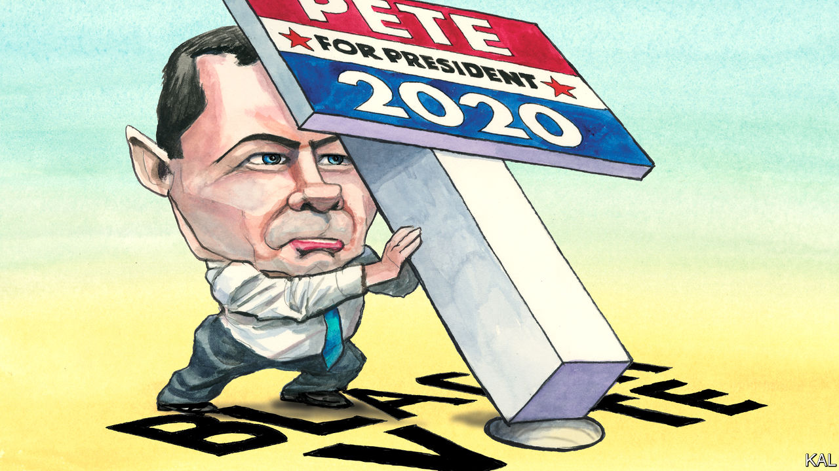

Jan 4th 2020

THE TRAVEL writer Paul Theroux called Allendale a “ghost town”—“poor, neglected, hopeless-looking, a vivid failure”—and the capital of South Carolina’s poorest county seems not to have improved in the years since his visit. Derelict shops and pump stations line its approach roads. It looks as though it has been hit by a hurricane—though Allendale would probably be less forsaken if it had been. Its more prosaic calamity, half a century ago, was the construction of the I-95 highway, which diverted away the traffic between Columbia and the coast that had been its lifeline. Poor and isolated, its heavily African-American population has fallen by a quarter this century. “There are no jobs here,” says Willa Jennings, the local Democratic Party chairwoman. “But”, she adds, for the tantalising benefit of the three Pete Buttigieg campaign managers crowding eagerly around her, “we vote.”

That is why the staffers’ sudden interest in Allendale is familiar to Ms Jennings. Every presidential cycle or so, Democratic contenders flock to South Carolina, which has the earliest primary of any diverse southern state. Given that 60% of its Democratic voters are black, the candidates often claim to have an answer to racial injustice, which they advertise on well-publicised trips to poor black communities. Mr Buttigieg’s “Douglass Plan”, true to type, includes promises to hire more black teachers, splurge $50bn on historically black colleges and reverse the exodus from poor rural communities. The mayor of South Bend, Indiana, was recently in Allendale to promote it. But Ms Jennings sounded unconvinced. “Candidates often come and promise the world to us and after we come out to vote in full force, we never hear from them again,” she tells his three staffers, all of whom are black. As for trying to reverse the exodus: “I don’t think that would be a good idea,” she says. People in Allendale want help to move to places where there are good jobs, not inducements to stay where there are none.

After the campaign team left, Ms Jennings was more direct. Mr Buttigieg (whose name she found unpronounceable) was a “young man” whom most voters in Allendale did not know. And even if he could change that between now and the primary vote next month (which she doubted), she seemed to consider his record too thin to be persuasive. His homosexuality might prove additionally off-putting to older black voters; Ms Jennings had heard of local pastors denouncing it. Most in Allendale were already for Joe Biden—as around half of all black voters are. National polls suggest 2% back Mr Buttigieg. And Ms Jennings suspected they would not change their minds even if the talented parvenu mayor swept Iowa and New Hampshire, as the polls suggest he could. “To be honest,” she said, “African-Americans love Barack Obama, and they say that if Joe was good enough for him, he’s good enough for us.”

Mr Buttigieg’s contrasting prospects in the earliest voting states and more diverse subsequent ones is one of the oddities of the cycle. Many Democrats—including Mr Obama—boosted their chances in the diverse South with wins in Iowa or New Hampshire. Almost none in recent times has secured the nomination without winning at least one of those states. Yet notwithstanding Mr Buttigieg’s strong numbers in Iowa and New Hampshire and alluring reasonableness, his failure hitherto to impress black voters, who make up a quarter of the Democratic electorate overall, has put him on track to dazzle briefly and then flop. And there may be nothing he can do to prevent this. After a slow start, his South Carolina operation is as well staffed and resourced as most of his rivals’. Yet it has won hardly any endorsements from local politicians or otherwise improved Mr Buttigieg’s standing in the state.

The anomaly reflects other oddities, including the combination of a crowded Democratic field and a weak front-runner in Mr Biden. This has made it easier for the former vice-president’s challengers to break through locally—as Mr Buttigieg, a midwesterner, first managed in Iowa—than nationwide. Yet it more profoundly reflects a widening fissure in the Democratic coalition. Whereas white progressives have moved to the left, non-whites remain moderate, sceptical and often conservative—especially on the sexual-liberty issues that energise the left. According to a poll by Third Way, a centrist think-tank, of the 79% of African-Americans who identify as Democratic, a third “lean conservative”.

It may seem odd that Mr Buttigieg has come to symbolise this clash, given that he is pretty moderate himself. Yet this makes his struggles even more revealing of how the main Democratic groupings are diverging. Though centrist by the standards of Elizabeth Warren, whose fantastical health-care plan he eviscerated, his proposals are to the left of Mr Obama’s: he vows to make college debt-free, for example. And sceptical black voters are not only liable to dismiss such radicalism as too left-wing. Well-used to false promises, many find it incredible—which may explain why the Douglass Plan appears to be falling flat. It includes so many proposals outside the purview of the federal government that it would look unachievable even if proposed by a weightier figure than the mayor of Indiana’s fourth-biggest city. By contrast, says Robbie Dublin, an Allendale businessman, “Joe Biden doesn’t promise much, he just says he’ll do the best he can. I like that.”

## Inspiration or perspiration?

To fully unite the Democratic Party appears to require the sort of generally inspiring yet credibly moderate figure Mr Obama was. Yet such figures are rare. In the absence of one this time round, the party is already setting its hopes on the next best thing, a common enemy, in Donald Trump. This may be enough; defeating the president is the priority for all Democrats. Yet the growing dissonance between white and non-white voters points to an inherent strain in this hope. Many voters in Iowa think an inspiring but untested figure like Mr Buttigieg would be likelier to beat Mr Trump than a stick-in-the-mud like Mr Biden. Black voters seem to think the opposite. They cannot both be right.■

Read this article on <https://www.economist.com/united-states/2020/01/04/pete-buttigiegs-illuminating-struggle-down-south>

|  |  |  |  |
| --- | --- | --- | --- |
| Previous | Articles | Sections | Next |

|  |  |  |
| --- | --- | --- |
| United States | Sections | Asia |

The Americas

A year of Jair Bolsonaro: Please don’t let me be misunderstood

Jair Bolsonaro’s contentious first year in office.

Colombia: Not so fast

The troubles of Bogotá’s TransMilenio.

|  |  |  |
| --- | --- | --- |
| United States | Sections | Asia |

|  |  |  |  |
| --- | --- | --- | --- |
|  | Articles | Sections | Next |

Please don’t let me be misunderstood

# Jair Bolsonaro’s contentious first year in office

Brazil’s global image is worse; its economy is doing better



Jan 4th 2020 | BRASÍLIA

SINCE JAIR BOLSONARO became Brazil’s president on January 1st 2019, he has quarrelled with an impressive array of foreign leaders and celebrities. After France’s president, Emmanuel Macron, accused him of encouraging deforestation of the Amazon, Mr Bolsonaro called his wife ugly. When Greta Thunberg, a young Swedish climate activist, highlighted the murder of indigenous people in the Amazon, the Brazilian president called her a “brat”. Michelle Bachelet, the UN human-rights commissioner (and a former president of Chile), criticised a rise in killings by police in Brazil. Mr Bolsonaro responded by praising Chile’s dictatorship of the 1970s and 1980s, which tortured her father.

These spats are a sign of the gulf between Brazil’s far-right president, who has made a career out of attacking liberal ideas about tolerance, human rights and conservation, and the elites who espouse them. Mr Bolsonaro’s put-downs suggest he does not mind causing offence. But senior officials in his government do worry, especially when NGOs threaten to promote boycotts of Brazilian products and governments reconsider whether to ratify trade deals.

The world is “misreading” Mr Bolsonaro, said the economy minister, Paulo Guedes, during an interview in Brasília, the country’s capital, last month. He has “bad manners, but great principles”. Mr Guedes hopes to change the conversation by shifting the focus from deforestation and police brutality to what he takes to be the president’s main project, a radical transformation of the economy that will enrich all Brazilians, including the poorest. “Instead of throwing stones at Brazil” people should be applauding, he says.

There is much to admire in the plans that Mr Guedes described. But they do not answer some of the biggest doubts about Mr Bolsonaro’s presidency. And it is unclear how much of the programme he will carry out. The applause may have to wait.

The vision is unapologetically liberal, or “neoliberal”, as its left-wing critics call it. Mr Guedes blames most of Brazil’s problems, including its high level of income inequality, on the overgrown state, which “spends a lot of money on the wrong things”. Since the 1980s public expenditure as a share of GDP has trebled to 42%, a level similar to that of European welfare states. The quality of services is that of much poorer countries.

Red tape and a complex tax system thwart private enterprise, but the state also coddles some industries at the expense of everyone else. “Forty years of closed markets” have protected rent-seeking industries, he says. “Imagine, 200m suckers being exploited by six banks, six shipping companies. Everything in Brazil is six.” Social security and free universities benefit the relatively well-off more than the poor.

Mr Guedes wants to roll all this back. He proposes to simplify the tax system radically, while reducing rates and expanding the base; to privatise nearly all state companies; and, after cutting red tape to enable businesses to withstand competition, to open the economy to the world. Ordinary Brazilians, he contends, will benefit in two ways: from the jobs that a freer economy will create, and from spending that focuses more on what they need, such as infrastructure and education. Ideally, states would take over more responsibility from the federal government. Mr Guedes calls for “more Brazil, less Brasília”.

Mr Bolsonaro’s government made a start on this agenda, with a constitutional reform of the pension system. This will save the government 855bn reais ($210bn) over ten years and lessen the danger that public debt will reach crippling levels. As the reform took shape in 2019 confidence grew, leading to a recovery in investment (see chart). The economy grew by 0.6% between the second quarter and the third, more than expected. Annual growth for 2020 is forecast to be at least 2%. That may make Brazil one of Latin America’s fastest growing economies.

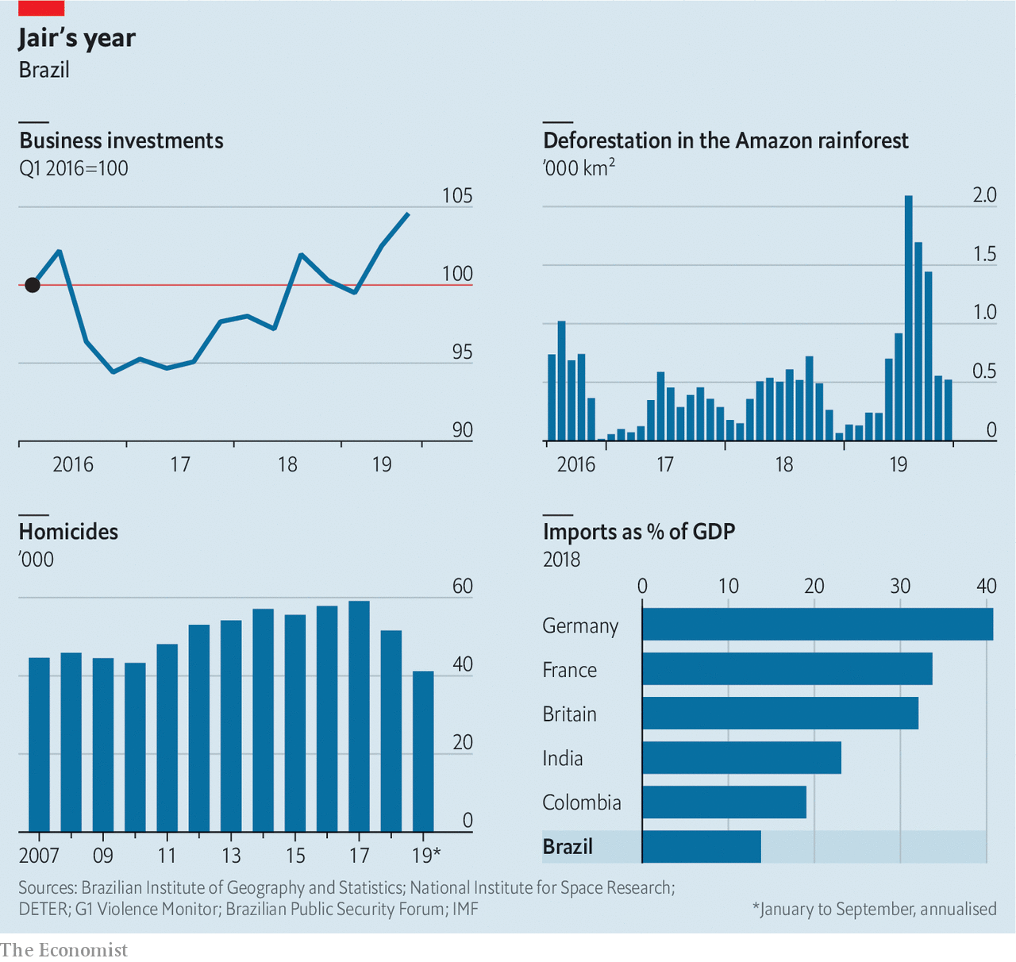

But there are reasons to withhold applause. One is that the democratic governments that took over after the end of military rule in 1985 accomplished more than Mr Guedes gives them credit for. It was the Real Plan of Itamar Franco, president from 1992 to 1994, that finally licked inflation. Pension reform began under the left-wing Workers’ Party, which governed from 2003 to 2016, and Mr Bolsonaro’s predecessor, Michel Temer, put a constitutional cap on public spending.

It is not clear what will follow pension reform. Mr Guedes’s plans are a “wish list, rather than a reform strategy”, says Ricardo Sennes of Prospectiva, a consultancy. In November Mr Guedes delivered to congress proposals for three constitutional amendments that would curb spending in order to honour the constitutional limit. Congress may water them down.

Mr Bolsonaro recently told Mr Guedes to hold off on a public-sector reform that would have weakened civil servants’ job security. The economy minister has not endorsed a tax-reform proposal that has support in the lower house of congress, but has yet to present an alternative. The president of the senate recently said that a proposal to privatise Eletrobras, the state electric utility, would not get through congress.

While Mr Guedes may be right to say that jobs are “the most important element of social inclusion”, that does not excuse the poor performance of most ministries besides his. The education ministry, led by a conservative ideologue, accomplished almost nothing in 2019. The health ministry has been slow to replace thousands of Cuban doctors expelled by Mr Bolsonaro at the beginning of his term. They served mainly poor Brazilians in remote areas. Although the number of people living on less than $1.90 a day is at its highest since 2012, the government has not raised spending on Bolsa Família, an income-transfer programme, enough to meet demand. Some 700,000 families are waiting for benefits. “The poor are not a priority for this government,” says Randolfe Rodrigues, the leader of the opposition in the senate.

Mr Guedes’s defence of Mr Bolsonaro’s democratic record is less convincing than that of his economic programme. “We’re a democratic regime,” he says. But many Brazilians fear that the president’s commitment to that idea is weak. He continues to express admiration for the generals who ruled Brazil from 1964 to 1985. One of his sons, Eduardo, a congressman, recently said that if left-wing protests spread to Brazil and got out of hand, the government could issue a decree like one that shut down congress during the dictatorship. Mr Bolsonaro responded to negative coverage in Folha de S.Paulo, a newspaper, by threatening to cancel government subscriptions to it. “If Brazil takes an authoritarian turn, we will look back and say that the signs were all here,” says Pedro Abramovay of Open Society Foundations, an NGO.

Congress has so far contained Mr Bolsonaro’s authoritarian instincts. It has rejected or not scheduled for debate a dozen or so radical proposals, such as a bill that would allow millions of Brazilians to carry guns and a misconceived project to purge schools of leftist ideology.

Foreign critics focus less on the fate of democracy than on that of the forest. From January to November 2019 the Amazon lost 8,974 square km (3,465 square miles) of forest, an 80% rise over the same period in 2018, according to preliminary satellite data. Green groups accuse the government of weakening enforcement of environmental laws and encouraging loggers and ranchers to destroy the forest. That may spook foreign investors. “They’re afraid of being photographed with Bolsonaro,” says Matias Spektor of Fundação Getulio Vargas, a university in São Paulo.

Such concerns could also wreck Mr Guedes’s hopes of opening up the economy through trade deals. Mercosur, a bloc dominated by Brazil and Argentina, signed a long-awaited accord with the European Union in June. But European anger about Brazil’s environmental policies could jeopardise its ratification (as could the recent election of Alberto Fernández, a left-wing protectionist, as Argentina’s president).

Progress on economic issues may be helping Mr Bolsonaro’s reputation at home. So too is a reduction in the number of murders in 2019, although that has little to do with the president’s policies. Brazil has so far been spared the wave of protests that struck such neighbouring countries as Chile and Ecuador late in 2019. That may be in part because Brazil had such convulsions in 2015 and 2016, when the economy was in recession and some of the country’s most powerful politicians were being arrested for corruption. Public anger helped bring about the impeachment of one president, Dilma Rousseff, and eventually led to Mr Bolsonaro’s election.

Now his family is dogged by scandal, and his vows to fight corruption are looking empty. A son, Flávio, a senator from Rio de Janeiro, is being investigated for money laundering. The president threatened to replace the director of the federal police after the investigation revealed links between Flávio and right-wing militia groups. Sergio Moro, the justice minister, failed to get through congress most of his proposals for curbing corruption. His credibility was undermined by revelations that when he was a corruption-fighting judge he had improperly close dealings with prosecutors.

Six months ago it appeared that the scandals would delay economic reforms, and possibly end Mr Bolsonaro’s presidency early. There is little talk of that now. The streets are quiet. Mr Bolsonaro’s approval rating slumped in the first half of the year but has stabilised at about 30%. The public seem willing accept reforms even if they are disenchanted with the politicians who are leading them. “Brazilians are living through a distinct social moment in which society is favourable to change,” says Paulo Hartung, the former governor of Espírito Santo, a state that underwent a tough fiscal adjustment in 2015. Brazil may advance, despite its brawling president. ■

Read this article on <https://www.economist.com/the-americas/2020/01/04/jair-bolsonaros-contentious-first-year-in-office>

|  |  |  |  |
| --- | --- | --- | --- |
|  | Articles | Sections | Next |

|  |  |  |  |
| --- | --- | --- | --- |
| Previous | Articles | Sections | Next |

Not so fast

# The troubles of Bogotá’s TransMilenio

A model public-transport system runs into trouble



Jan 4th 2020 | BOGOTÁ

DURING ONE recent morning rush hour Yuraima Salas, a cleaner running late for work, found herself squeezed in a crowd of commuters waiting for a bus. When it arrived the crowd surged, she tripped and someone trod on her foot. She ended up in hospital, with severe bruises and a sprained ankle.

Ms Salas was a casualty of Bogotá’s TransMilenio bus system, which uses stations on dedicated lanes to mimic an underground metro. Cities smaller than Colombia’s capital, such as Curitiba in Brazil, pioneered such bus rapid-transit (BRT) systems. Bogotá, with 8m people (four times the population of Curitiba), was the first to build one on a large scale. Enrique Peñalosa, the mayor who built it in the late 1990s, became a star among urban planners. Now the TransMilenio is overcrowded and unpopular. Bogotá’s mayor, Claudia López, who took office on January 1st, campaigned against expanding it and in favour of adding to a planned overground train system. Bogotá is the largest Latin American city without an urban rail network. She may have to reconsider those ideas.

At first, the TransMilenio was a triumph. Bogotá built the first 40km (25 miles) of lanes in a third of the time and at a sixth of what it would have cost to create an overground metro of the same length. In 2000, its first year of operation, TransMilenio reduced average commuting times from 90 minutes to 70. The system’s buses are as fast as New York’s subway and carry 2.4m passengers a day, more than most European metros. Had TransMilenio not been built, Bogotá’s GDP would be 1% lower than it is, according to a study by Nick Tsivanidis, an economist at the University of California, Berkeley. The poor benefited as much as the rich.

But the system is under strain. One line that runs through the city centre carries 45,000 people an hour, 15,000 more than it was built for. Riders can queue for 40 minutes to enter stations. Once inside, they wait some more to board packed buses. The TransMilenio is the least popular mode of transport in Bogotá, according to surveys.

Recent mayors invested too little in it. Samuel Moreno, a leftist, won the mayorship in 2007 with the backing of bus companies who resented competition from TransMilenio. He favoured construction of a metro, a more popular project that posed a less immediate threat to the bus lobby. Once in office Mr Moreno decided to expand TransMilenio after all, by building a new line on Calle 26, one of the city’s most important arteries. He went to jail for taking millions of dollars in bribes from builders. The scandal delayed by two years (until 2012) the opening of the new line and further tarnished TransMilenio’s image.

Mr Moreno’s successor, Gustavo Petro, today Colombia’s most prominent left-wing politician, did further damage. To please commuters he cut TransMilenio’s fare by 20%, which cost the system 600bn pesos ($180m) of revenue over three years. Starved of money, the system left broken turnstiles and jammed bus doors unrepaired. Mr Petro did not renew the bus fleet. Just 114km of a planned 380km of bus lanes were built by 2015. Meanwhile, Bogotá’s population exploded. The city’s drivers have the world’s third-longest commuting times.

Mr Peñalosa, who returned as mayor in 2016, had hoped to repeat his public-transport triumphs. He awarded a contract to begin construction of a 24km overground metro line, which is due to open in 2026, and planned three more BRT lanes, which will connect to it. The plan to expand the TransMilenio enraged many bogotanos, who elected Ms López, a member of the Green Party, as mayor in part because she said she opposed it.

She may change her mind. It could cost $1.5bn to build a second overground metro line. Bogotá does not have that money. Nor do commuters, who would have to pay a fare of 15,000 pesos, nearly 2% of a monthly minimum wage, to cover the cost of construction. Ms López cannot count on the central government paying most of the bill.

She may look for cheaper ways to relieve commuters’ misery. She is said to be reconsidering her opposition to one of Mr Peñalosa’s proposals, a new BRT lane on Calle 68, which links western working-class suburbs to the city centre. That could ease congestion on existing lines. She has talked of fixing doors and turnstiles and upgrading TransMilenio stations. Such improvements would make Ms Salas’s journeys more bearable. To make them pleasant and fast will require much more investment—including more expansion.■

Read this article on <https://www.economist.com/the-americas/2020/01/04/the-troubles-of-bogotas-transmilenio>

|  |  |  |  |
| --- | --- | --- | --- |
| Previous | Articles | Sections | Next |

|  |  |  |
| --- | --- | --- |
| The Americas | Sections | China |

Asia

Justice in Japan: Ghosn, going, gone

The flight of a car-industry megastar shocks Japan.

Fires in Australia: The summer inferno

Australia’s bushfires intensify its debate about climate change.

Election tension in Taiwan: The China factor

Taiwan’s China-sceptic president, Tsai Ing-wen, may win again.

Who’s an Indian citizen?: Papers, please

Protests against India’s anti-Muslim citizenship law have turned bloody.

Banyan: Restoring order

Why Japanese names have flipped.

|  |  |  |
| --- | --- | --- |
| The Americas | Sections | China |

|  |  |  |  |
| --- | --- | --- | --- |
|  | Articles | Sections | Next |

Ghosn, going, gone

# The flight of a car-industry megastar shocks Japan

In Lebanon, Carlos Ghosn is unlikely to plan a quiet life



Jan 4th 2020 | TOKYO

CARLOS GHOSN, a former chairman of Nissan and Renault, would ring in the new year at his luxurious home in Tokyo. Or so Japanese prosecutors thought until two days before the start of the 2020s. News that Mr Ghosn, 65, had other plans came from an unexpected source: a report by the Associated Press quoting Ricardo Karam, a Lebanese television host and friend of Mr Ghosn. He said the megastar executive had skipped bail and fled to Lebanon. In a statement released a day later through a spokeswoman, Mr Ghosn insisted: “I have not fled justice—I have escaped injustice and political persecution.”

## Who ya gonna call? Ghosnbusters!

His dramatic escape has raised big questions for Japan. How did he do it, despite constant surveillance of his movements? And is there any truth to his claims that the charges against him were politically motivated? Before his arrest in Tokyo in November 2018, Mr Ghosn had been rumoured to be working on a merger between Renault, a French carmaker, and its partner Nissan, a Japanese company. This would have offended many in the Japanese establishment, as it would have looked like a foreign takeover of a Japanese industrial icon.

How Mr Ghosn managed to flee was still a mystery as we went to press. Local media in Lebanon said he arrived in Beirut from Turkey on a private jet. Yet NHK, Japan’s state broadcaster, reported that Japanese immigration officials had no record of him leaving the country. Mr Ghosn’s lawyer, Hironaka Junichiro, said he was “surprised and baffled” by his client’s departure. He said he held Mr Ghosn’s passports from Lebanon, Brazil and France and it would have been difficult to pull off such a feat “without the assistance of some large organisation”. Mr Ghosn’s wife, contacted by Reuters news agency, described as “fiction” reports that her husband had left his house hidden in a musical-instrument case used by performers who had just played for him.

Many in Japan do not agree that Mr Ghosn escaped injustice. Officials worry that his story could embolden other would-be fugitives. He got away despite his face being widely recognisable. Before his arrest he was a hero in Japan for having helped to revive Nissan, and had even featured in a manga comic series. An official from the prosecutor’s office told Japanese media that Mr Ghosn had made a mockery of the criminal-justice system.

Mr Ghosn stands accused of misappropriating company funds—allegations he denies, saying he was framed by “back-stabbing” Nissan bosses. After more than 120 days in jail, he was released in April 2019 on bail of ¥1.5bn ($13.8m). His trial had been due to begin in April 2020. He is unlikely to attend it. Lebanon has no extradition treaty with Japan. Officials there say Mr Ghosn is in Lebanon legally (he reportedly arrived using a French passport).

He has chosen a friendly refuge. Though now vilified in Japan, Mr Ghosn is a celebrity in Lebanon, where he lived as a child and has strong family ties (though he was born in Brazil). His face has appeared on Lebanese postage stamps. After his arrest, billboards proclaiming “We are all Carlos Ghosn” popped up across Beirut. Gibran Bassil, the foreign minister, has publicly expressed support for him.

In the statement released after his arrival in Lebanon, Mr Ghosn referred to “a rigged Japanese justice system where guilt is presumed, discrimination is rampant, and basic human rights are denied”. He is not entirely wrong. Well over 99% of those who are indicted are convicted. Police may hold suspects for 23 days without charge and interrogate them without lawyers present. Courts regard the resulting confessions as the “king of evidence”, though some are clearly coerced. (Mr Ghosn did not provide one.) In the unlikely event that a defendant is found innocent, the state can appeal and subject him to double jeopardy—a process that can take years. Greg Kelly, a former aide to Mr Ghosn who has also been charged with financial misconduct, remains in Japan on bail, awaiting trial. He, too, maintains his innocence.

Mr Ghosn will find it tough rebuilding his career. In September he, Mr Kelly and Nissan settled with America’s Securities and Exchange Commission over charges of filing fraudulent records of Mr Ghosn’s pay and retirement benefits. Mr Ghosn paid a $1m penalty and accepted a ten-year ban on serving as an officer or director of a public firm. He, Mr Kelly and Nissan neither admitted nor denied wrongdoing.

However, few expect Mr Ghosn, a lover of the limelight who celebrated his second marriage and his new wife’s 50th birthday with a Marie Antoinette-themed party at Versailles, to fade into obscurity. “I can now finally communicate freely with the media, and look forward to starting next week,” he said in his statement. He will have many questions to answer. ■

Read this article on <https://www.economist.com/asia/2020/01/04/the-flight-of-a-car-industry-megastar-shocks-japan>

|  |  |  |  |
| --- | --- | --- | --- |
|  | Articles | Sections | Next |

|  |  |  |  |
| --- | --- | --- | --- |
| Previous | Articles | Sections | Next |

Summer inferno

# Australia’s bushfires intensify its debate about climate change

The government that scrapped a carbon tax has no plans to bring it back



Jan 2nd 2020 | SYDNEY

THE FIRES eased over Christmas. But as 2020 neared, Australia’s inferno blazed anew. In the state of Victoria, thousands of people fled to the seashore on New Year’s Eve as bushfires ringed the coastal town of Mallacoota. Samuel McPaul, a volunteer firefighter, died earlier in neighbouring New South Wales when a “fire tornado”, as colleagues described it, overturned his vehicle. The federal government has called in military planes and ships to help evacuate people sheltering on beaches in both states. Experts say the fires are the most extensive in Australia’s history and are far from over. They have sparked heated debate about the impact of climate change and the government’s equivocal commitment to tackling it.

New South Wales is the country’s most populous state and has suffered some of the biggest losses: 15 lives and about 1,300 homes. (Pictured is a house under threat in Lake Conjola.) The state’s bushfires have covered almost 40,000 square kilometres, nearly the area of Denmark. That is greater than the total area during the past three years’ fire seasons. These usually start in October, Australia’s mid-spring. In 2019 the fires began in July. A drought that started in eastern Australia three years ago had left plenty of dry fuel. On December 18th Australia as a whole had its hottest day on record, at 41.9°C. The fires have spread across the country, at one point closing the highway to the Nullarbor Plain that links Western Australia to the east coast.

In early December former fire chiefs called on the government to help organise an emergency meeting to discuss the growing threat of wildfires amid global warming. Scott Morrison, the prime minister, had different plans. He took his family on a holiday to Hawaii, without telling the public. After an outcry, and the deaths of two firefighters during his absence, he returned just before Christmas. But he rejected requests to change the approach his conservative Liberal-National coalition takes to climate change.

The government’s climate policy takes its tone from John Howard, a former Liberal prime minister, who once dismissed calls for action as “the latest progressive cause” and a “substitute religion”. As the fires took hold in November, Michael McCormack, the deputy prime minister, blamed “inner-city raving lunatics” for linking them to climate policy and Australia’s coal industry. Coal, a big source of carbon emissions, is Australia’s second-biggest export, and is used to generate almost two-thirds of its electricity. The coalition abolished a carbon tax imposed by the former Labor government. In place of this market-driven mechanism it set up a public fund worth A$3.5bn ($2.5bn), partly to pay polluters to cut emissions.

Critics say such measures are inadequate. Greta Thunberg, a Swedish climate activist, cited the fires when tweeting criticism of Australia’s climate policy. Mr Morrison retorted that he was “not here to try and impress people overseas”. As the fires raged, some countries at a recent UN climate conference in Madrid grumbled about Australia’s apparent sleight of hand, involving the use of carbon credits linked to its emission-reduction targets for 2020 as a way of meeting its higher targets for 2030. Angus Taylor, the energy minister, argues that because Australia produces just 1.3% of global emissions, it “can’t single-handedly have a meaningful impact”.

The fires are raising the temperature of Australia’s climate-change debate. Mr Morrison says climate change is just one of “many factors” behind the inferno. Greg Mullins, a former fire chief, retorts that these factors all relate to climate change. He and fellow ex-chiefs still plan to convene a meeting to discuss the problem, even if the government stays aloof. “We’ll invite the prime minister,” he says, wryly. Some business leaders also want the government to adopt a tougher climate policy. Peter Harmer, the head of IAG, an insurance firm, speaks of an “urgent need for Australia to prepare for and adapt to climate change”. With no end to the bushfires in sight, such calls are bound to grow. ■

Read this article on <https://www.economist.com/asia/2020/01/02/australias-bushfires-intensify-its-debate-about-climate-change>

|  |  |  |  |
| --- | --- | --- | --- |
| Previous | Articles | Sections | Next |

|  |  |  |  |
| --- | --- | --- | --- |
| Previous | Articles | Sections | Next |

The Hong Kong effect

# Taiwan’s China-sceptic president, Tsai Ing-wen, may win again

But the threat from Beijing is not going away

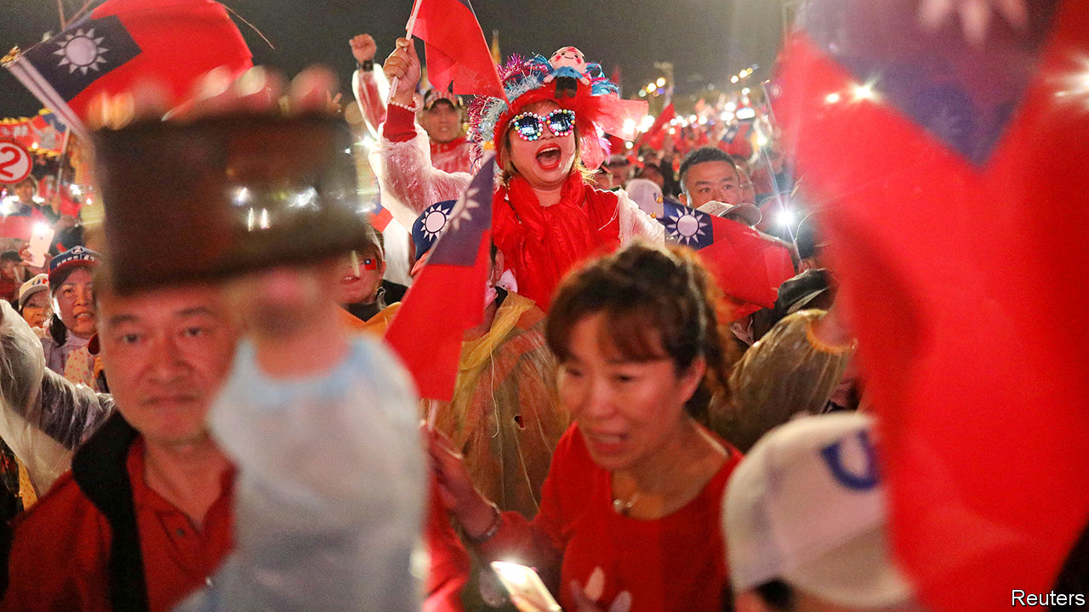

Jan 2nd 2020 | KAOHSIUNG AND TAIPEI

ELECTION RALLIES in Taiwan often feel like festivals with a dash of politics thrown in. At a recent one in Taiwan’s capital, Taipei, thousands of people watched a fireworks display, then heard a blind blues singer. Eventually the show’s political star took to the stage: Enoch Wu, a young would-be legislator for the ruling Democratic Progressive Party (DPP). China’s leader, Xi Jinping, “is watching to see if we are sure to defend our homeland,” he told the crowd. “We are,” his fans roared back.

One question always looms largest in Taiwan’s elections for president and parliament, held simultaneously every four years, this time on January 11th: how to handle the island’s twitchy relations with an ever more powerful China. Many of Taiwan’s nearly 24m people have been warily watching the unrest in Hong Kong. Twice in 2019 Mr Xi declared that Taiwan should reunify with the mainland under a “one country, two systems” formula, as Hong Kong did. China’s ability to force such a solution on Taiwan is increasingly plain. On December 26th China sent its newly commissioned aircraft-carrier, the Shandong, through the Taiwan Strait for the second time in as many months.

Since 2000 Taiwanese voters’ main choice for president has been either a candidate who leans toward independence from China, thereby incurring China’s wrath, or one who wants closer ties despite the risk of ensnarement by the mainland’s Communists. So far the China-sceptic, pro-independence DPP has won three times and the China-embracing Kuomintang (KMT) twice. The legislature, however, has usually been controlled by China-friendly types—until 2016, when the DPP secured both the presidency—with Tsai Ing-wen becoming Taiwan’s first female leader—and a majority in the Legislative Yuan, as the parliament is known.

Ms Tsai’s support for Hong Kong’s protesters seems to have boosted her chance of winning again. American talk of “decoupling” from China’s economy, particularly in technology, has helped her, too. Taiwan’s tech giants do not want to risk losing access to Western markets by siding with China. Some are moving out of China and are investing more in South-East Asia and in Taiwan itself. Less focused on the mainland, some Taiwanese businessmen are becoming keener on the DPP.

Ms Tsai’s main opponent is the KMT’s Han Kuo-yu, the mayor of the southern port city of Kaohsiung, which is usually a DPP stronghold. His chances dipped in November when another China-friendly politician, James Soong of the People First Party, entered the fray. Mr Soong may peel away some of Mr Han’s supporters.

The president hammers home her China point. In a televised presidential debate she read out a letter from a young Hong Konger. “I ask Taiwan’s people not believe the Chinese Communists,” the author said. “Don’t fall into China’s money trap.” Ms Tsai also boasts that the economy under the DPP has grown, following a recession under the previous KMT government.

Some voters are not persuaded. Salaries, they grumble, have been virtually flat for almost two decades. The average monthly full-time wage is NT$49,170 ($1,635), including bonuses, far lower than in other rich countries in the region, such as Singapore where it is about S$4,560 ($3,390). Poorer and older people tend to back Mr Han, who harks back to the boom years of the 1970s and 1980s under the KMT. (He avoids reminding them that Taiwan was then a one-party dictatorship).

Mr Han is unlikely to win the presidency, but there is more of a question-mark over the legislature. Mr Wu, the DPP candidate who tried to whip up support with fireworks and blues, may have excited his backers with talk of a Chinese threat. But that is because his KMT rival is Wayne Chiang—a great-grandson of Chiang Kai-shek and grandson of Chiang Ching-kuo, rulers of Taiwan during nearly four decades of martial law. Though the Chiangs hated the Communists for ousting them from China, DPP loyalists consider them China incarnate: mainland-born autocrats who tried to crush Taiwanese culture. All the same, Wayne Chiang, an incumbent MP with a local following, will be hard to beat.

If the DPP loses control of the 113-strong parliament, where it now has 68 seats, Ms Tsai will have a hard time ruling. The KMT and its allies could block bills disliked by China, such as a law passed on December 31st making it illegal to accept Chinese funds for political activities. The KMT says it supports measures to strengthen national security, but condemns the recent bill as too sweeping.

China has denounced it, too, but has largely refrained from sabre-rattling during the campaign to avoid playing into Ms Tsai’s hands. After she was elected, China bolstered its military posturing, for instance with bomber-jets flying around the island. It also persuaded seven of Taiwan’s diplomatic allies to switch to China, reducing the number to 15. But since the middle of 2019 the jets have stopped their exercises. The aircraft-carrier’s transits raised eyebrows in Taiwan, but Andrew Yang, a former deputy defence minister for the KMT, says they were routine tests.

Should the DPP win both the presidency and legislature, China will certainly be unhappy. But Ms Tsai is a pragmatist. She would probably use a new mandate to keep Taiwan on the same course, rebuffing China’s political demands while trying not to pick quarrels that could risk a military conflict. American diplomats would welcome this. They were rattled by the more confrontational approach of the DPP’s Chen Shui-bian, Taiwan’s president from 2000 to 2008, who enraged China with his efforts to assert Taiwan’s separate identity.

But four more years of Ms Tsai would not guarantee peace. President Donald Trump appears to have little interest in sparring with China over Taiwan, but some of his appointees, egged on by many members of Congress, are keen to strengthen America’s unofficial ties with the island. In August the State Department approved the sale of 66 F-16 fighter jets to Taiwan. China’s patience may one day wear thin. ■

Read this article on <https://www.economist.com/asia/2020/01/02/taiwans-china-sceptic-president-tsai-ing-wen-may-win-again>

|  |  |  |  |
| --- | --- | --- | --- |
| Previous | Articles | Sections | Next |

|  |  |  |  |
| --- | --- | --- | --- |
| Previous | Articles | Sections | Next |

Papers, please

# Protests against India’s anti-Muslim citizenship law have turned bloody

Narendra Modi, the Hindu-nationalist prime minister, faces angry crowds and a constitutional challenge

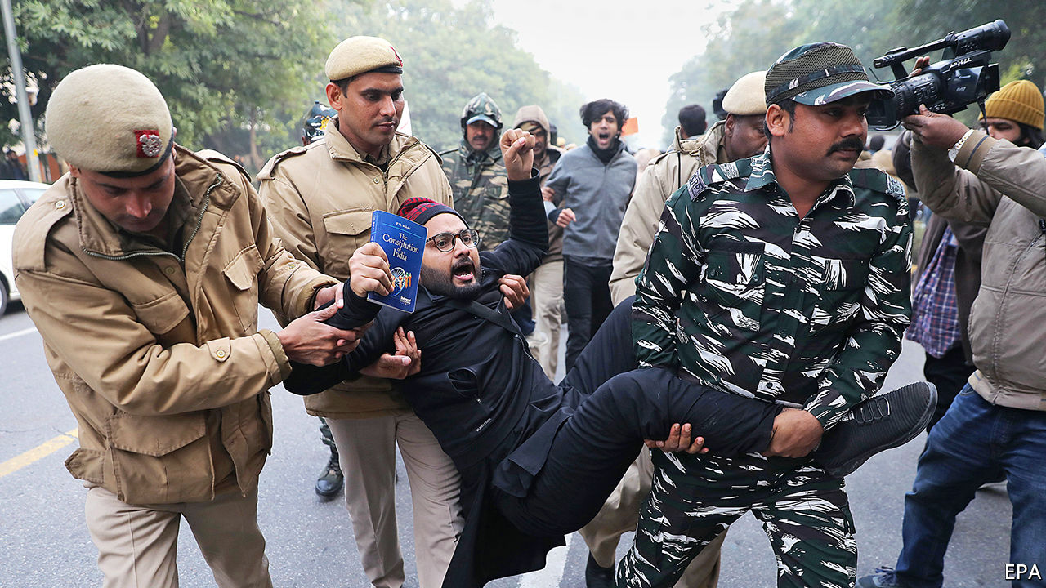

Jan 4th 2020

SINCE INDIA’S enacting of new citizenship rules on December 12th, widespread protests against them have left 27 dead, scores injured and tempers high. The prime minister, Narendra Modi, says he wants to make it easier for refugees to naturalise as Indians—unless they are Muslims. His government also plans to conduct a nationwide tally of citizens to hound out foreign “infiltrators”. Hindus and devotees of other named faiths who cannot prove they are citizens will probably be able to naturalise quickly. Muslims without the right papers—a common problem in rural areas—may not be so lucky. Mr Modi used his crushing parliamentary majority to pass the law, but the fury against it from across the political spectrum marks the strongest challenge to his Hindu-nationalist party since it won power in 2014. All eyes turn now to the Supreme Court, expected to rule later this month on whether the law is constitutional.

Read this article on <https://www.economist.com/asia/2020/01/04/protests-against-indias-anti-muslim-citizenship-law-have-turned-bloody>

|  |  |  |  |
| --- | --- | --- | --- |
| Previous | Articles | Sections | Next |

|  |  |  |  |
| --- | --- | --- | --- |
| Previous | Articles | Sections | Next |

Banyan

# Why Japanese names have flipped

They will now be written in English in the same order as in Japanese

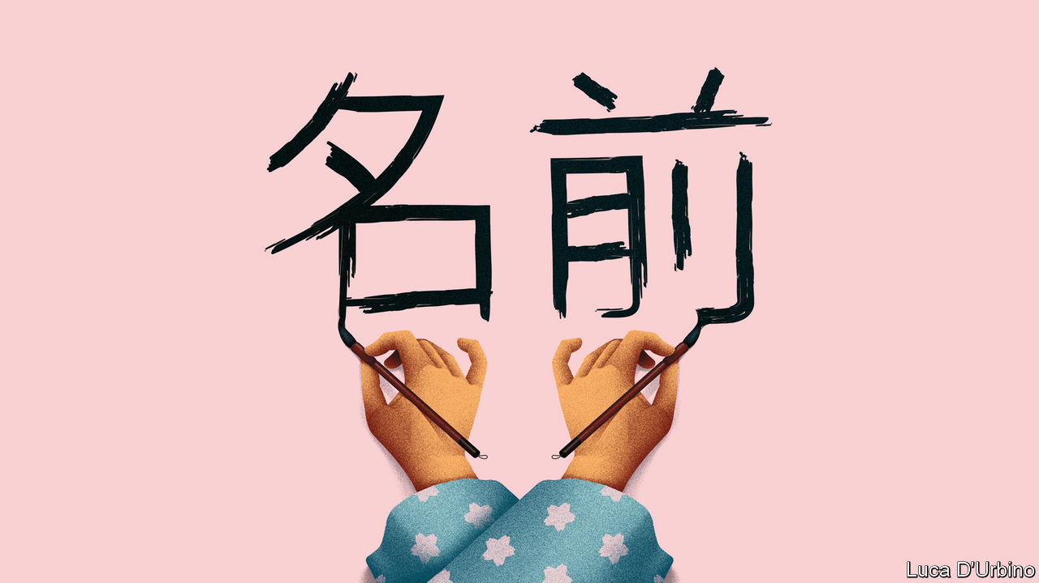

Jan 4th 2020

ON JANUARY 1ST a minor lexical revolution rolled through Japan. A new decree ordained that official documents should reverse the order of Japanese people’s names when they are rendered in the Latin alphabet. Hitherto in, say, English documents, Japanese names have been written with the given name first, using the Western practice. Henceforth the family name will come first and, to banish any ambiguity, may be entirely capitalised. One backer of the change is the prime minister. From now on The Economist will refer to him as Abe Shinzo rather than Shinzo Abe.

Like other newspapers, we have long followed the convention of writing Japanese names in the Western order (while scholarly publications have tended to use the Japanese order). If Japan wants to change, why should anyone object? As is common in East Asian cultures, in Japanese the family name always comes first.

National pride motivates many advocates of the change. From a Japanese perspective, writes Peter Tasker, a Tokyo-based commentator, in the Nikkei Asian Review, it represents “authenticity and normalisation”. The fact that Asian powers are on the rise, both geopolitically and culturally, is part of the point, Mr Tasker argues.

Japanese conservatives do not see why they should say their names backwards just for the convenience of Western minds too lazy to grasp a basic facet of Japanese culture. Some 59% of Japanese in a recent opinion poll favoured reverting to surname-first. Yet there is an irony. Japan first decided to put given names first when talking to foreigners way back in the 1870s, during the Meiji era. It was actually a gesture by nationalist reformers who wanted to keep Western imperialists at bay.

Japan, they argued, could keep its independence only by abandoning the paternalism of Confucius, imported from China, which had long governed society and family life. Instead it should rapidly learn modern Western ways in everything from military affairs to education, both to ward off Western powers and to impress them. English name-order was a tiny part of the package. Reformists had drunk deeply of the social Darwinism then prevailing in the West, which taught that only the strongest societies would survive. One, Mori Arinori, even proposed adopting English as Japan’s language.

In 1885 a friend of Mori’s, Fukuzawa Yukichi, penned a polemic, “Goodbye Asia”, arguing that Western civilisation was like measles: if it didn’t kill you, it would make you stronger and should be embraced. He said the static cultures of China and Korea would make those countries more vulnerable to Western conquest. He urged Japan to cut its spiritual and civilisational ties with them. It was, with hindsight, a small step from there to a sense of Japanese exceptionalism, and then to militarism. (And among many other humiliations, Japanese occupiers forced their Korean subjects to scrap their names for Japanese ones.)

Chinese reformers and revolutionaries were later inspired by Fukuzawa and his like to reform or abandon the Chinese language. The great novelist Lu Xun argued in the 1920s that the Confucian ideologies holding China back were being subconsciously reinforced by the archaic Chinese used in writing. He called for a new vernacular. Chen Duxiu, a co-founder of the Communist Party, urged the use of Roman letters to replace the thousands of Chinese characters.

As for Japan, defeat after the second world war aggravated what a Japanese writer, Mizumura Minae, in “The Fall of Language in the Age of English”, deems an inferiority complex among Japanese intellectuals regarding their own tongue. One novelist, Shiga Naoya, even blamed the Japanese language for the start of the war (he advocated a switch to French).

Mr Abe and his allies, by contrast, have no truck with self-loathing. With China on the rise and America proving a wobbly ally, he believes it is time for Japan to stand tall again and celebrate tradition. As in China, shades of Confucianism are back. Mr Abe wants to change the constitution to emphasise family over the individual.

Still, asks Jeffrey Kingston of Temple University in Tokyo, is name order “the big naming question facing Japan in the 21st century?” Surely, he says, that is the official ban on married couples retaining separate family names, a rule that in practice means wives nearly always take their husbands’ names. Mr Abe may be a traditionalist, but didn’t he promise to empower women?

Read this article on <https://www.economist.com/asia/2020/01/04/why-japanese-names-have-flipped>

|  |  |  |  |
| --- | --- | --- | --- |
| Previous | Articles | Sections | Next |

|  |  |  |
| --- | --- | --- |
| Asia | Sections | Middle East and ... |

China

China’s view of America: 400-pound rivals

China views Donald Trump’s America with growing distrust and scorn.

Journalist wanted

Journalist wanted.

|  |  |  |
| --- | --- | --- |
| Asia | Sections | Middle East and ... |

|  |  |  |  |
| --- | --- | --- | --- |
|  | Articles | Sections | Next |

400-pound rivals

# China views Donald Trump’s America with growing distrust and scorn

And cynics in Beijing hope for his re-election

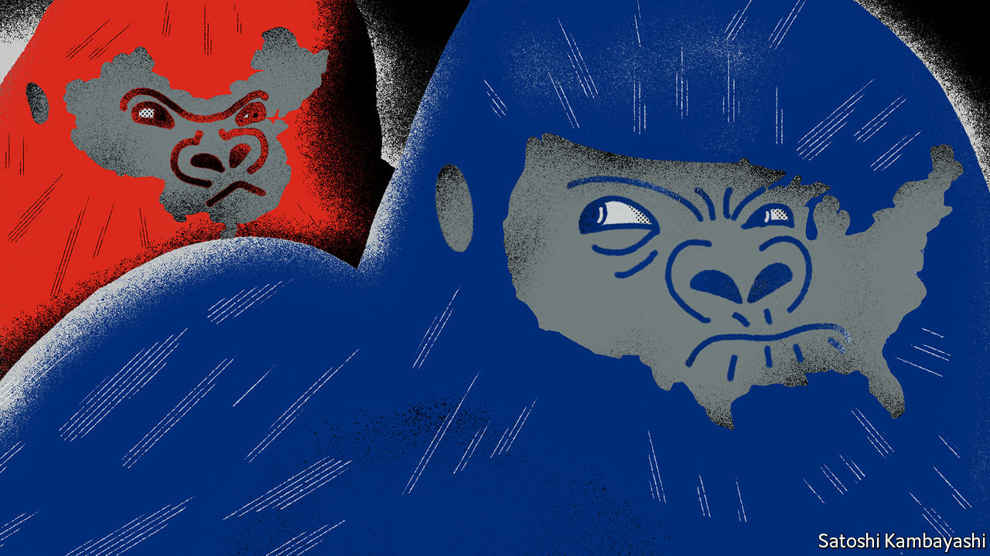

Jan 2nd 2020 | BEIJING

ZOOLOGISTS USE a mild-sounding term—“displacements”—for moments when a strong, young mountain gorilla confronts the dominant male in his group. Behind the jargon lies a brutal reality: a drawn-out, bloody conflict looms. China’s leaders similarly use prim, technical-sounding terms to describe their confrontation with America. In closed-door briefings and chats with Western bigwigs, they chide the country led by President Donald Trump for responding to China’s rise with “strategic anxiety” (ie, fear). They insist that China’s only crime is to have grown so rapidly.

However, behind that chilly, self-serving analysis lurks a series of angrier, more primal calculations about relative heft. These began before Mr Trump came to office, and will continue even if an initial trade truce is made formal (Mr Trump says he will sign one on January 15th). They will endure long after November, when American voters next choose a president. China has spent decades growing stronger and richer. It already senses that only one country—America—can defy Chinese ambitions with any confidence. Its leaders have a bleak worldview in which might makes right, and it is a fairy tale to pretend that universal rules bind all powers equally. Increasingly, they can imagine a day when even America ducks a direct challenge, and the global balance of power shifts for ever.

## Getting hairy

China does not seek a fight now. Like a powerful juvenile warily sizing up a silverback gorilla—his age and status marked by the silvery fur on his back, and his mighty muscles and teeth—China knows that America can inflict terrible damage, as it wields still-unrivalled economic, financial and military might. But officials and scholars in Beijing no longer bother to conceal their impatience and scorn for an America they view—with a perilous mix of hubris and paranoia—as old, tired and clumsy.

When addressing foreigners, China’s leaders talk piously of their commitment to free trade, market opening and globalisation. Their domestic actions betray a different agenda: namely, to make Chinese companies dominant in high-value manufacturing sectors, and to hasten the day when they no longer depend on America for vital technologies. Long before Mr Trump was elected, China pursued such policies as “indigenous innovation” and “civil-military fusion”. Since Mr Trump’s tariff war with China began in 2018, President Xi Jinping and his underlings have accelerated efforts to make China self-sufficient in high-value sectors, creating supply chains that are “autonomous, controllable, safe and effective”, in Mr Xi’s words.

For decades Chinese officials have seen bilateral relations swinging, pendulum-like, between periods of hostility (notably during American elections, when candidates promise to shield workers from unfair Chinese competition) and a profit-driven willingness to engage. Now Chinese and American insiders talk of a downward spiral. Both countries have become quick to assume the other has malign motives. Where relations were once balanced between co-operation and competition, and China’s rise seemed on balance to benefit both countries, Chinese officials accuse Mr Trump and his team of seeking co-operation only when it serves a coercive, short-sighted “America First” agenda. They do not see this changing soon—far from it. They view relations with sour fatalism, and America as a sore loser.

Chinese experts talk wistfully of the scores of dialogues and mechanisms that used to underpin co-operation with America’s government before Mr Trump scrapped most of them. But, when pressed, they struggle to explain what a useful agenda for future talks might be. Instead, they prefer to count the ways in which America is to blame for today’s tensions. In China’s telling, American companies became accustomed to making fat profits in China, but see Chinese rivals catching them up and potentially setting global standards for future technologies. Now American businesses are crying cheat, and demanding that trade rules designed for the rich world be used to keep China down.

Populist election victories in the West are ascribed to domestic failures in the countries concerned. Chinese officials say that America failed to educate workers, allowed inequalities to yawn and never built social safety-nets to help victims of globalisation—and is now scapegoating China for those ills.

In public, Chinese officials call Mr Trump’s tariffs self-defeating and stress their country’s economic resilience. In private, they are both less confident and less focused on tariffs than they pretend. They are less bullish because economic sentiment in China was fragile before the trade war. Worse, the tariff feud has planted seeds of uncertainty about the country in the heads of every chief executive pondering where to place a new factory.

Chinese officials are less focused on tariffs than they maintain in public because they believe Mr Trump will lose his leverage over time, as he frets about the impact on American farm states and other places where he needs votes. Chinese officials fear other forms of competition more than any tariff fight. In Beijing leaders do worry about the consequences of a technology war with America or of an all-out struggle for global influence.

It is not just a figure of speech when officials in Beijing divide foreign grandees into “friends of China”, and “anti-China forces”. China’s rulers take an intensely personalised view of foreign relations. Communist Party bosses have learned over decades that individual foreign envoys, CEOs and political leaders can be turned into reliable advocates for China with the right blend of high-level access and reasoned appeals, financial incentives and flattery.

But Chinese officials feel sadly short of influential friends in the corridors of American power. Within the Trump administration, only the treasury secretary, Steven Mnuchin, is seen as representing the old, familiar American approach of putting profit first when engaging with China. There are firms that rely heavily on China as a supply base and market, from Apple to General Motors, which sells more cars in China than in America. But the profit motive itself is under suspicion in the new, populist Washington, where even Republican members of Congress urge businessmen to weigh America’s national interests in dealings with China, and not just their shareholders’ dividends.

## China can live with “Trump first”

After much study, leaders in Beijing have decided that Mr Trump is neither a friend of China nor a traditional anti-China hawk, in the sense of someone who disapproves of the party’s policies on grounds of principle. In essence, Mr Trump is seen as a friend of Mr Trump—a man whose self-interest is his only reliable guiding instinct. Famous scholars at elite universities in China who have studied America for years tut-tut about how that makes Mr Trump unpredictable and liable to break any promise he makes to Mr Xi. More cynical figures, including some close to the national security bureaucracy, unblushingly root for Mr Trump to win re-election in 2020, so that he can continue to upset allies and cast into doubt decades-long American security guarantees in Asia. Their great fear is that Mr Trump may be captured by sincerely hawkish aides. That includes economic nationalists with trade portfolios, like Robert Lighthizer and Peter Navarro. But unique animus is aimed at the “two Mikes”: the vice-president, Mike Pence, and the secretary of state, Mike Pompeo. In Beijing both are called anti-communist, evangelical Christian zealots, with ambitions to succeed Mr Trump in 2024.

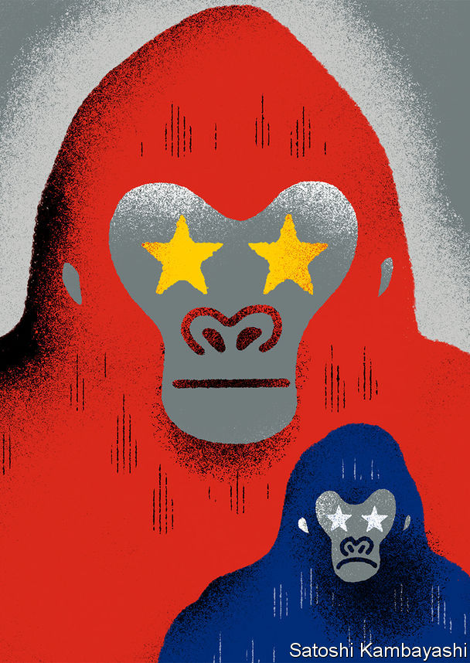

China is sure it is in a worldwide influence war, in which its propaganda about Xinjiang, Hong Kong or Huawei is pitted against an “anti-China” story. Mr Pence and Mr Pompeo are semi-openly reviled as crazy, ignorant warriors in that conflict. They are accused of slandering China over its iron-fisted rule in the western region of Xinjiang, and of egging on pro-democracy protesters in Hong Kong, whom China calls terrorists and separatists. Mr Pence and Mr Pompeo are also condemned for leading a diplomatic charge to warn smaller countries to beware of Chinese loans and technology (the results have been mixed). Chinese officials have not missed the factor that links all successful efforts at American arm-twisting. Countries have proved most tractable when America has real co-operation to offer or to withhold, whether that involves Poland and its yearning for a permanent garrison of American troops to act as a tripwire against Russian aggression, or Brexit Britain dreaming of a free-trade deal with Mr Trump. Where American envoys merely nag countries to shun China’s investments without offering concrete alternatives, they have fared less well. As one Chinese insider crows, America under Mr Trump looks “self-isolating”.

Chinese officials who favour Mr Trump’s re-election hope that he will feel free in his second term to disavow hawks around him and pursue transactional policies. They fret that a Democratic president may place more weight on human, labour and environmental rights.

All this fulminating does not mean that China seeks to match the hawks in Washington and drag their two countries into a new cold war, in which the world is divided into rival camps. China believes that most other nations do not want to choose between it and America, at least for now. China is playing for time, as it builds its strength and tries to construct alternatives to such potent tools of American power as the dollar-denominated financial system. China’s interest in developing its own blockchain technology and international payment systems is in part a sign of its fear of American sanctions that would expel Chinese banks from American markets.

Some Chinese voices say their country has not lost interest in an offer China made to Mr Trump’s predecessors, involving a “new model of great-power relations”: code for carving the world into spheres of geopolitical influence, and an end to American carping about China’s ways. Others stress China’s right to help write the rules of globalisation. That would be reasonable, were it not that China’s aim is to make the world safe for techno-authoritarian state capitalism. Chinese officials want to avoid confronting America for now. But few silverbacks gracefully retire. Increasingly, America is seen as an obstacle to China’s rise. That means trouble looms. ■

Read this article on <https://www.economist.com/china/2020/01/02/china-views-donald-trumps-america-with-growing-distrust-and-scorn>

|  |  |  |  |
| --- | --- | --- | --- |
|  | Articles | Sections | Next |

|  |  |  |  |
| --- | --- | --- | --- |
| Previous | Articles | Sections | Next |

# Journalist wanted

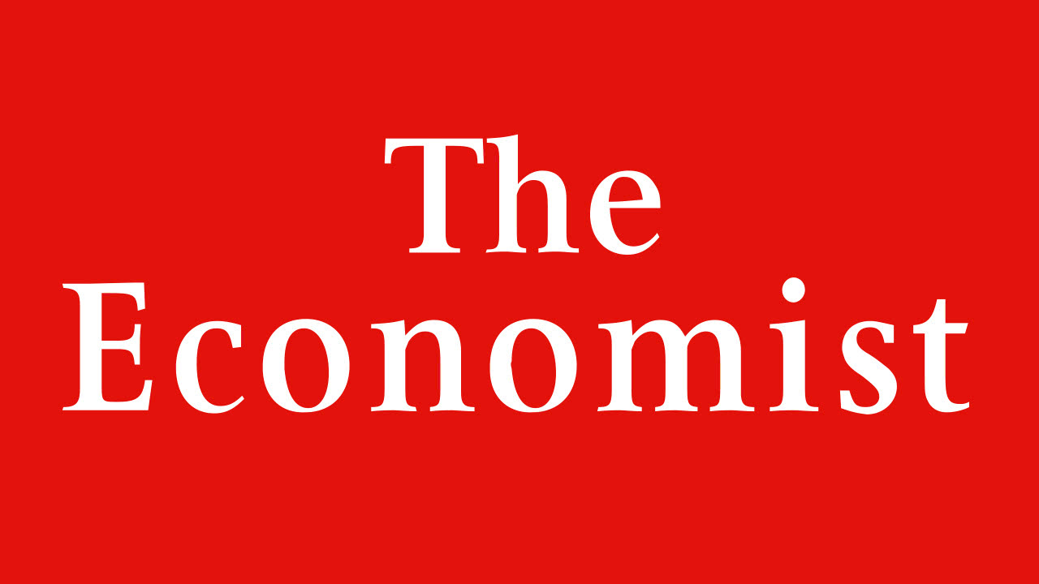

Jan 4th 2020

Journalist wanted: The Economist is hiring a new China correspondent to join our Beijing bureau. We’re looking for someone with a deep knowledge of China, excellent writing skills in English and a sharp analytical brain. Please send a CV and an unpublished 600-word article on any China-related topic to chinajob@economist.com by January 31st.

Read this article on <https://www.economist.com/china/2020/01/04/journalist-wanted>

|  |  |  |  |
| --- | --- | --- | --- |
| Previous | Articles | Sections | Next |

|  |  |  |
| --- | --- | --- |
| China | Sections | Europe |

Middle East and Africa

America, Iran and Iraq: Combustible

The conflict between America and Iran intensifies in Iraq.

Countering Iran: Neighbourhood watch

How America and its allies are keeping tabs on Iran at sea.

Algeria: Hoping for a cheerier Algeria

An Algerian general takes over from another general.

The end of the CFA: Francly speaking

Making sense of west Africa’s new currency.

The Rand Club: Rhodes to redemption

The new generation trying to overhaul a once racist and sexist club.

Education in Liberia: Schools of hard knocks

Lessons from a radical education experiment in Liberia.

|  |  |  |
| --- | --- | --- |
| China | Sections | Europe |

|  |  |  |  |
| --- | --- | --- | --- |
|  | Articles | Sections | Next |

Combustible

# The conflict between America and Iran intensifies in Iraq

Missiles, air strikes and an embassy under attack

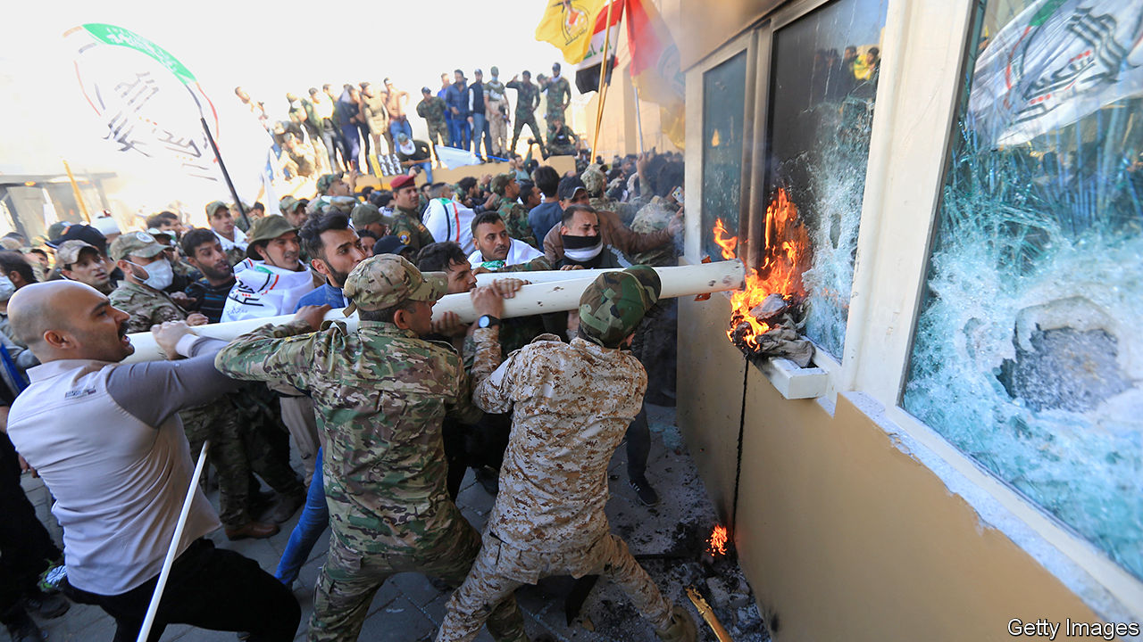

Jan 2nd 2020

FOR MONTHS young Iraqi protesters trying to reach the Green Zone, the government enclave in Baghdad, were met with bullets and tear-gas canisters, the latter often fired at their heads. But on December 31st hundreds of militiamen were allowed to enter unmolested. The men, affiliated to Kataib Hizbullah, an Iranian-backed Shia paramilitary group, tried to storm the American embassy. They threw petrol bombs over the walls and broke into a reception area where security personnel would normally screen visitors. Iraqi police largely stood by for hours; it was not until nightfall that the Counter Terrorism Service (CTS), an elite unit, sent men to secure the embassy. They did not have orders to evict the rioters, who made plans to camp outside. As night fell, American Apache helicopters could be seen flying overhead, dropping flares.

The riot was another escalation in a crisis between America, Iran and Iraq. On December 27th more than 30 rockets hit an Iraqi military base near Kirkuk. That attack, the 11th of its kind in two months, killed an American contractor and wounded four American soldiers. The American response, two days later, was a series of air strikes on five bases run by Kataib Hizbullah. At least 25 of its members were killed.

This was an “unacceptable vicious assault”, fumed Adel Abdul-Mahdi, Iraq’s outgoing prime minister. He was referring not to the initial rocket attack but to the retaliatory air strikes that followed. Those strikes had violated Iraqi sovereignty and “would force Iraq to review its relations and its security, political and legal framework” with America, said the government.

Mr Abdul-Mahdi had a point. America killed Iraqi nationals on Iraqi soil, in an attack carried out without the blessing of the Iraqi government. But America was not the only actor to make a mockery of Iraqi sovereignty. Though Kataib Hizbullah is backed by Iran, it is nominally under the control of Iraq’s government, like other paramilitary groups created to fight the jihadists of Islamic State (IS). If it fired rockets at an Iraqi military base, one branch of the Iraqi state bombed another. At the American embassy days later, at least one photograph showed a uniformed member of the Iraqi security forces helping rioters smash windows.

American officials are quietly seething at the Iraqi government’s willingness to rebuke them while giving a free hand to Iranian-backed groups. Iraq failed in its “responsibility to protect us as their invited guests”, complained a State Department official. In December American officials accused Iran of stashing short-range missiles in the country, and there are suspicions that Iraq may have been the launching point for a drone and missile attack on Saudi oil facilities in September. The raid on Kataib Hizbullah is a major blow in that contest. “We haven’t killed this many tier-one Iranian proxies in one go, ever,” says Michael Knights of the Washington Institute for Near East Policy, a think-tank.

But this is at best a tactical achievement. America is 19 months into Donald Trump’s “maximum pressure” campaign against Iran, which began with his decision to withdraw from a deal that curbed Iran’s nuclear programme in return for economic relief. His sanctions have cut Iran off from the world economy. Oil exports crashed from around 2.5m barrels a day in 2017 to less than half a million now. The Iranian rial has collapsed and many citizens struggle to afford necessities like medicine.

But economic pain has not compelled Iran to negotiate a new agreement, let alone moderate its regional policies. Quite the opposite. America blames it for the sabotage of oil tankers in the Persian Gulf last summer and the attack on two oil facilities in Saudi Arabia in September. In a conference call on December 30th, hours before the embassy riot, American officials tried to portray such belligerence as a sign of progress. “Iran is currently in a state of panicked aggression,” said Brian Hook, the special envoy for Iran. “They are lashing out. They’re not used to being told no.”

Far from panicked, though, Iran’s aggression looks calculated. Since October it has faced a wave of popular anger across the region. Protesters in Iraq want an end to Iran’s meddling. Those in Lebanon have turned some of their ire on Hizbullah, a Shia militia and political party that is separate from Kataib Hizbullah but similarly backed by Iran. Meanwhile, Iran itself was convulsed by unrest in late November after the government raised fuel prices.

So the American strike was a welcome distraction. On December 30th a coalition of pro-Iran parties in Iraq demanded the expulsion of all 6,000 American troops. They proposed similar legislation earlier in the year but lacked support in parliament. MPs may be more receptive this time. American officials argue they had no choice but to hit Kataib Hizbullah. The Pentagon, understandably, is worried about protecting troops and contractors in Iraq. But the Trump administration seems to have thought little about the political consequences—in part, because there is almost no one in Baghdad to consider them. The embassy there, which once housed 2,000 diplomats, now has just ten political officers and six working on military affairs. The secretary of state, Mike Pompeo, wants to cut those numbers further.

Iran would be happy to see America go, but Iraq has plenty to lose. Its army remains weak, demoralised and corrupt. Shia militias and Kurdish peshmerga are motivated and capable but have their own agenda. What is left—army commando units and the CTS, which played a pivotal role in rolling back IS—relies on close co-operation with American special forces and spies. Since 2014 America has spent $5.8bn on military aid for Iraq. That would matter less had the crisis not come at an especially delicate time. IS is regrouping in Iraq. In December a Kurdish intelligence chief told the BBC that the group had become “like al-Qaeda on steroids”, nestled in Iraq’s Hamrin mountains and flush with cash.

For the time being America is sending more troops. Mr Trump dispatched 100 marines to reinforce the embassy. As The Economist went to press, hundreds more soldiers were preparing for deployment to Kuwait, and perhaps onward to Iraq. Meanwhile, militia leaders eventually told their men to withdraw from the embassy, out of “respect for the Iraqi government”. But they had made their point. Sixteen years after America invaded Iraq with the hope of installing a friendly government, it can barely keep its own embassy safe. ■

Read this article on <https://www.economist.com/middle-east-and-africa/2020/01/02/the-conflict-between-america-and-iran-intensifies-in-iraq>

|  |  |  |  |
| --- | --- | --- | --- |
|  | Articles | Sections | Next |

|  |  |  |  |
| --- | --- | --- | --- |
| Previous | Articles | Sections | Next |

Neighbourhood watch

# How America and its allies are keeping tabs on Iran at sea

Many eyes aim to deter Iran from making mischief



Jan 4th 2020 | MANAMA

FOR ALMOST two decades America’s navy and its allies in the Middle East spent most of their time chasing pirates, drug smugglers and terrorists in the region’s busy waters. But a string of attacks on oil tankers in 2019—blamed on Iran—has shifted their focus.

In July America launched Operation Sentinel to improve its ability to spot and respond to threats to shipping in and around the Persian Gulf. In November it formally placed the operation under a coalition with the ungainly name of the International Maritime Security Construct (IMSC). This now consists of seven countries: America, Australia, Bahrain, Britain, Saudi Arabia, the UAE—and plucky Albania (which can squeeze most of its sailors onto one aeroplane).

The concept is straightforward. Iran wants to force America to ease sanctions that are crippling its economy. Interfering with international shipping is one way of exerting pressure. The IMSC is intended to deter Iran from making mischief by increasing the likelihood that it would be caught in the act.

To do so the IMSC stations two warships, which it calls sentinels, in the Strait of Hormuz, the choke-point that carries one-fifth of the world’s oil. Smaller, mostly Arab vessels, called sentries, patrol inside the Persian Gulf. Drones and planes keep watch from above. “We are monitoring much more of the Arabian Gulf and the Arabian Sea than we were a year ago, and we’re monitoring it much more frequently,” says Vice-Admiral James Malloy, the commander of America’s Fifth Fleet.

Intelligence is gathered at a headquarters in Manama, the capital of Bahrain, where 65% of the personnel are non-American. The IMSC’S Arab members may lack firepower, but they are “essential” to the mission because of their knowledge of local shipping patterns, says Admiral Malloy. Command will rotate between members such that a Saudi admiral may control British ships.

Iran has not struck at sea since the mission began. Yet it has not all been plain sailing for the IMSC. When America began gathering allies, France, Germany and other European countries refused to join an effort that risked association with President Donald Trump’s policy of “maximum pressure” against Iran. Even Britain initially balked, proposing a European-led force instead.

France went ahead with a competing initiative that has since welcomed the Netherlands and Denmark. America takes a dim view of it. The French mission “does not exist” at sea, says Admiral Malloy. “We are not co-ordinating or sharing information, and there are no immediate plans to do so.” Both outfits want new members, but others are keeping their distance. Japan will soon send a destroyer and surveillance plane to the region. It will share intelligence with the IMSC but remain apart from it.

Iran will be less than pleased with all the new visitors. Its threats to shipping, far from strengthening its hand against America, have led to it being hemmed in even more tightly.

Read this article on <https://www.economist.com/middle-east-and-africa/2020/01/04/how-america-and-its-allies-are-keeping-tabs-on-iran-at-sea>

|  |  |  |  |
| --- | --- | --- | --- |
| Previous | Articles | Sections | Next |

|  |  |  |  |
| --- | --- | --- | --- |
| Previous | Articles | Sections | Next |

Hoping for a cheerier Algeria

# An Algerian general takes over from another general

As a new government struggles with empty coffers and angry streets



Jan 4th 2020 | ALGIERS

IT WAS AS if the old general running the country behind the scenes for the past eight months had not died after all. A bare week after a heart attack felled General Gaid Salah on December 23rd, another septuagenarian in a green uniform under a brocaded peaked hat harangued a hall full of generals (all similarly attired). The army, said General Said Chanegriha, the country’s new top military man, must confront a “serious conspiracy against stability”. No one doubted he was referring to the protest movement known as Hirak that has convulsed Algeria since last February. In April it brought down the country’s despot, Abdelaziz Bouteflika, after 20 years in office. Though a new civilian president, Abdelmajid Tebboune, had been elected in early December, the new general in charge said the risk of chaos was too great for the army to return to the barracks.

Algeria had a few months of civilian rule after independence in 1962. But the generals have dominated ever since. Keeping their grip is getting harder. What began as a protest against corrupt politicians has turned on the generals. The hundreds of thousands who cheered when the army removed an ailing Mr Bouteflika in April now march every Friday against those who ousted him. They hiss at the phalanx of anti-riot forces facing them and call for the isaba, or gang of top brass, to go. “You can’t recycle this rubbish,” they cry. “Civilian not military rule.”

The generals have tried to mollify the protesters by imprisoning two former prime ministers, several security chiefs and a slew of top businessmen. But leading lights in Hirak have denounced those hasty proceedings as show-trials. They also accuse the generals of replacing one set of cronies with another.

On December 12th the army oversaw a presidential election to fill Mr Bouteflika’s shoes. But the five candidates were all handpicked ageing former apparatchiks. Turnout was the lowest ever. On December 28th President Tebboune, 74, named a university professor and former diplomat, Abdelaziz Djerad, as prime minister. The opposition so far has been unusually united, with Berbers, Islamists and secular types all marching together.

Economic woe fuels their anger. Mr Bouteflika’s men, led by his brother, Said, squandered the country’s huge oil wealth. In the past five years foreign-exchange reserves of some $200bn have fallen to $30bn. Oil and gas exports generate 95% of foreign-currency receipts, but are falling. Gas exports are 20% lower than last year. The government has curbed imports and slashed spending on public works, including housing, a subsidised sector that has been crucial to keeping people quiet.

The army’s recent anti-corruption drive has upset many business people. Posh restaurants in Algiers such as Le Tantra, where ministers munched with magnates, are empty. To slow capital flight, the authorities have stepped up checks on people leaving by the main airport. Negotiations on a possible loan from the IMF are said to be under way. But the big cuts in subsidies and welfare sure to be demanded may prompt another wave of unrest. “I foresee very violent demonstrations if they move on subsidies,” says a diplomat in Algiers. European governments fear another surge of illegal immigrants crossing the Mediterranean.

If he is to survive without the army propping him up, Mr Tebboune needs popular support. He could free the jailed leaders of Hirak and ask them to help him pave the way towards a genuine democracy. He could turn a presidential system into a parliamentary one, hold early parliamentary elections and devolve power to the regions, particularly the Kabyle, where Berbers predominate. Mr Tebboune might find many protesters amenable. After marching for so many weeks, they are tired and fearful of endless acrimonious division.

Would the army let him? Ever since independence it has thwarted moves towards democracy. In 1991 it cancelled free elections after Islamists won the first round, unleashing a civil war in which perhaps 200,000 people died. The army, Africa’s biggest buyer of arms, is still very strong. But it needs enemies. It accuses Hirak of threatening national unity. And it rails against the build-up of foreign forces, especially Egyptian, in Libya to the east. In the provinces it deploys hired thugs known as beltajiya, armed with sticks and stones, to clear protesters from the squares.

The top brass are the late General Salah’s protégés. But younger officers may be less keen to play politics. So far the generals have resisted the temptation to have the protesters shot. General Chanegriha is Algeria’s first commander not to have been a mujahid (a fighter) in the anti-colonial war of liberation. Returning the army to the barracks would be a victory of a new kind—one that Algerians sorely need. ■

Read this article on <https://www.economist.com/middle-east-and-africa/2020/01/04/an-algerian-general-takes-over-from-another-general>

|  |  |  |  |
| --- | --- | --- | --- |
| Previous | Articles | Sections | Next |

|  |  |  |  |
| --- | --- | --- | --- |
| Previous | Articles | Sections | Next |

Francly speaking

# Making sense of west Africa’s new currency

The French-backed CFA franc is going. Will the new eco be as stable?

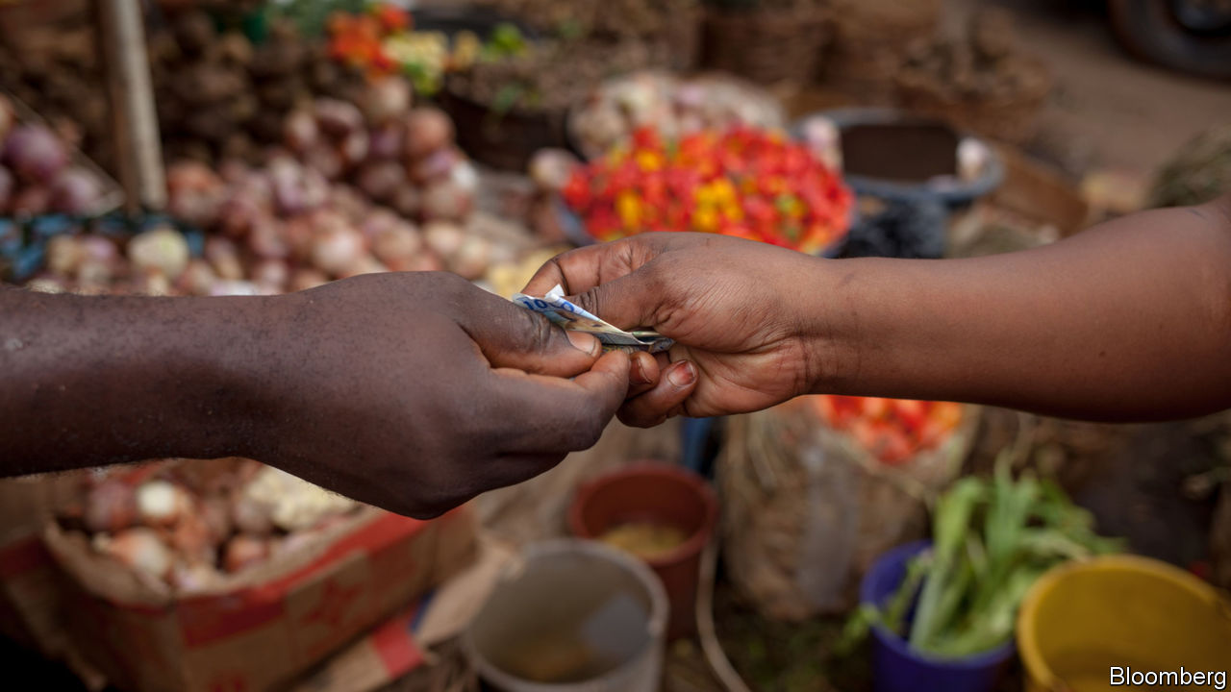

Jan 4th 2020 | DAKAR AND KAMPALA

MONETARY POLICY, done well, is meant to put everyone but economists to sleep. Yet in west Africa it has pulled thousands of protesters onto the streets. Many locals have long objected to the west African and central African CFA francs, two monetary unions pegged to the euro and backed by France. This arrangement has delivered low inflation and currency stability to the 14 African countries that use one or other of the CFA francs. But critics call the CFA a relic of past subjugation and absurdly portray it as a “colonial tax” imposed by France, the former power.

On December 21st those calling for an end to the CFA franc mostly got their way. Emmanuel Macron and Alassane Ouattara, the presidents of France and Ivory Coast, announced the most far-reaching changes to the currency area since its formation in 1945. The west African CFA franc, which is used by eight countries, will be ditched in 2020 and replaced by the eco, which will have far looser ties to France. The central African CFA franc is unchanged, but many expect the six countries using it to implement similar reforms.

The symbolism is powerful. The currency’s acronym originally stood for “French Colonies of Africa” and the CFA has become a lightning rod for anti-French sentiment across west Africa—in early December Mr Macron threatened to withdraw the 4,500 French troops battling jihadists in the Sahel unless governments in the region ended their “ambiguity” towards “anti-French movements”. Mr Macron seems to hope that he will quell some of the anger against France by backing away from the currency it once championed.

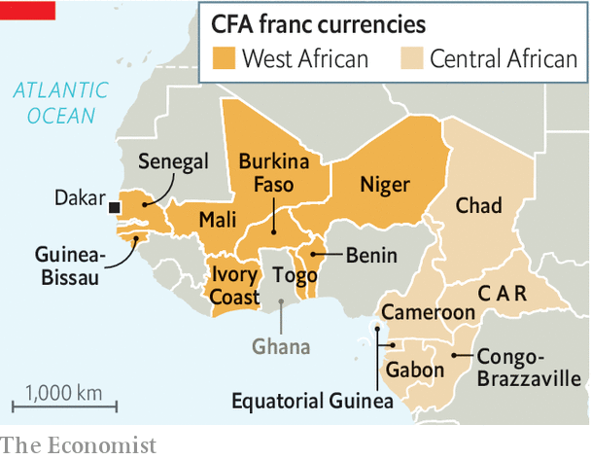

Yet the economic implications will be large. France says it will continue to support the currency’s peg to the euro. But this guarantee—in effect a promise to make unlimited transfers from the French treasury if the eco comes under speculative attack—is one that markets may doubt, especially in a crisis. “How can we short this thing?” asked one hedge fund trader, on hearing news of the new currency.

Confidence in the eco is waning even before it has been formed because the old safeguards are being dismantled. Today, countries using the CFA deposit half their foreign-exchange reserves into an account at the French treasury. When the eco is formed this obligation will end, presumably allowing them to go to the Central Bank of West African States in Dakar (BCEAO). The French representative on the currency union’s board will also be shown the door. With less oversight of the union and no control over its reserves, France may hesitate to write a blank cheque.

Maintaining the eco’s peg to the euro may also impose uncomfortable limits on the monetary sovereignty of its members. Any country that maintains a fixed exchange rate while letting capital flow freely across borders—as west African ones will continue to do—forfeits a measure of monetary autonomy. For instance if the BCEAO were to slash interest rates from their benchmark of 2.5%, capital would probably flee to the relative safety of Europe. The central bank could burn through reserves, but eventually it would either have to raise interest rates or let the exchange rate slide.

By choosing to retain the peg, west African governments are deliberately binding their own hands. A problem for central banks everywhere is convincing people that they will not give in to political pressure to stoke booms or print money. The peg is, in effect, a commitment to track the anti-inflationary stance of the European Central Bank. This has produced benefits: inflation has been much lower in Ivory Coast, which uses the CFA franc, than in neighbouring Ghana, which does not.

Yet critics worry that monetary policies aimed at keeping inflation low in Europe are not necessarily right for Africa. The rigidity of the currency’s peg, which has only been devalued once in its history, is also a worry. If wage growth in the eco zone exceeds that of the euro-zone (adjusting for productivity) then the eco’s fixed exchange rate would become overvalued. That would retard exports and encourage imports.

For all the uncertainty, the change has already produced one positive outcome. A passionate argument about neocolonialism is being transformed into a drier one about inflation. That should calm tempers in the streets, even as it sets economists’ pulses racing. ■

Read this article on <https://www.economist.com/middle-east-and-africa/2020/01/04/making-sense-of-west-africas-new-currency>

|  |  |  |  |
| --- | --- | --- | --- |
| Previous | Articles | Sections | Next |

|  |  |  |  |
| --- | --- | --- | --- |
| Previous | Articles | Sections | Next |

Reviving Johannesburg’s Rand Club

# The new generation trying to overhaul a once racist and sexist club

A bastion of a reactionary era reinvents itself

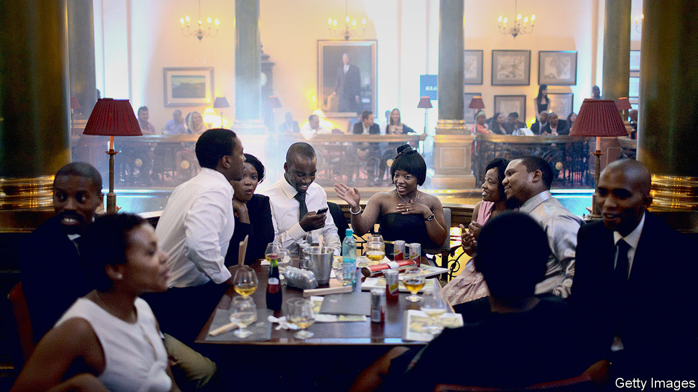

Jan 4th 2020 | JOHANNESBURG

WHEN ALICIA THOMPSON was a student in Johannesburg before the end of apartheid, she would often walk past the beautiful cars parked outside a club she was not allowed to join. It was not by chance that the Rand Club, the oldest private-members’ club in the city, was filled with old white men. It was by design. Women and blacks were not admitted as members until the early 1990s. “It was not my space,” says Ms Thompson. “That was the power of apartheid: you never questioned where you couldn’t go.”

The Rand Club was once a centre of power in Johannesburg, the haunt of financiers and mining magnates, including Cecil Rhodes and Lionel Phillips, who in 1913 was inconveniently shot by a trade unionist on the way to lunch (he survived, but missed his meal). Its official history calls it “a civilised refuge for good fellows”. Rules imposed decorum; no ice in drinks in the billiards room, for example, lest clinking distract players. At the same time the longest bar in Africa (31.2 metres) encouraged inebriation.

But for most South Africans the club was seen as the reactionary lair of a racist business elite. Legend has it that decor depicting the signs of the zodiac does not include Virgo, a female sign. Any member who dared to sponsor a black friend would most likely have been ostracised, or “blackballed”.

The Rand Club’s traditions are squarely at odds with today’s multiracial South Africa. Only a few years ago protests led to the removal of statues of Rhodes at institutions such as the University of Cape Town. (Rhodes was a co-founder of the club, where there is still a room named after him.) But a group of younger members, including Ms Thompson, who is black and female, believes that it is better to transform the club than close it.

In 2016 a crisis presented the new group with their opportunity. The club was nearly bankrupt. Many businesses had migrated from the inner city and membership had fallen to a few hundred from thousands in the club’s heyday.

Rick Currie, a fourth-generation member, and two other members lent it 6.5m rand ($450,000). Part of the deal was to revamp the club, which now hosts weddings, parties, opera recitals and jazz nights. Rooms are rented out on Booking.com, a travel site. Artists from across Africa have been invited to display their works. It houses a bookshop and tailor. All of these activities have helped the bottom line—the club is profitable for the first time in decades—and loosened up the straitened atmosphere.

For some the Rand will always be a relic of a backward era. But for Ms Thompson it is transcending its history. Ascending the main staircase, she points to where a portrait of Queen Elizabeth used to be. In Her Majesty’s stead is a painting of Nelson Mandela. His steady gaze is a reminder that change can happen, even in the most unexpected places.

Read this article on <https://www.economist.com/middle-east-and-africa/2020/01/04/the-new-generation-trying-to-overhaul-a-once-racist-and-sexist-club>

|  |  |  |  |
| --- | --- | --- | --- |
| Previous | Articles | Sections | Next |

|  |  |  |  |
| --- | --- | --- | --- |
| Previous | Articles | Sections | Next |

On trial

# Lessons from a radical education experiment in Liberia

The messy reality of trying to improve schools in a poor country

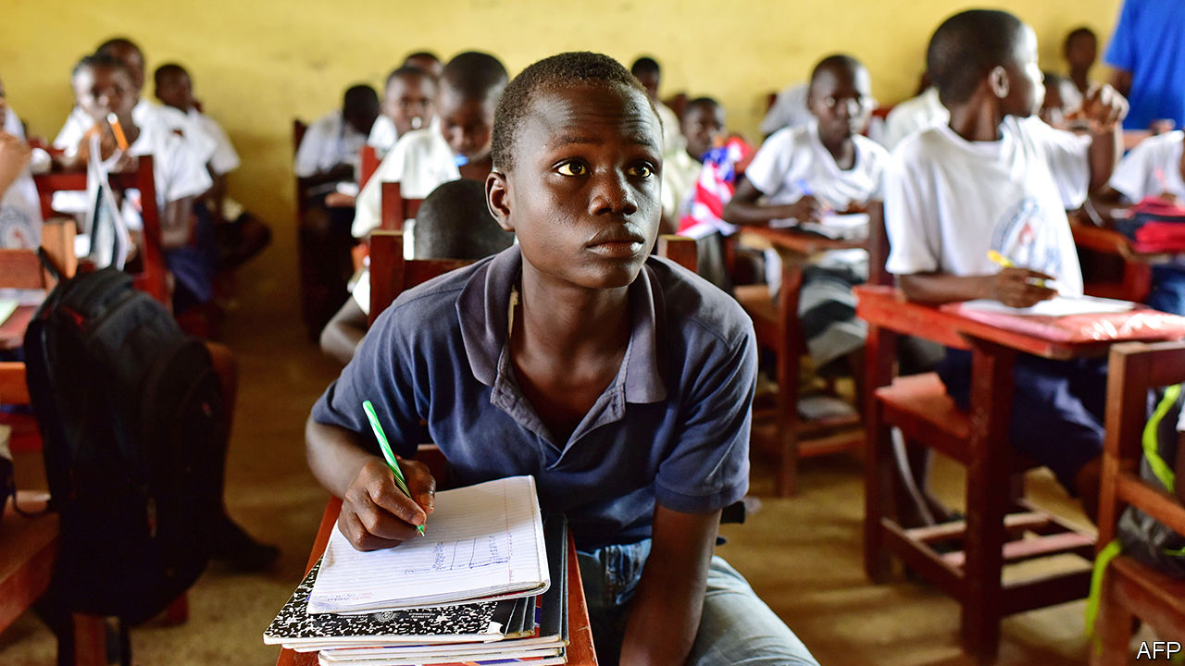

Jan 4th 2020

IN 2016 GEORGE WERNER faced an unenviable task. Liberia’s education minister was in charge of one of the most difficult school systems in the world. More than a decade of civil war and an outbreak of Ebola in 2014 had stopped many children from going to class. Those who did learned little. Just 25% of Liberian women who completed primary school could read, one of the lowest shares anywhere. Mr Werner’s budget was a mere $50 per pupil per year. Many teachers on his payroll were “ghosts” who did not exist but somehow kept on drawing salaries.

So Mr Werner signed off on one of the boldest public-policy experiments in recent African history. He outsourced 93 primary schools containing 8.6% of state-school pupils to eight private operators. Five charities and three companies were monitored in a randomised controlled trial (RCT). Researchers tracked test scores in the operators’ schools and nearby government ones. More than three years later, the results are in. They reveal the messy reality of education reform in one of the world’s poorest countries.

On average children who began the study in outsourced schools learned more than those in government ones. But those gains were “modest”, says Justin Sandefur of the Centre for Global Development. Pupils beginning in privately run schools could on average read 15 words per minute three years later, versus 11 in state-run classrooms. Any boost is welcome, but the average reading level in the pilot schools is still behind the 45-60 words per minute deemed necessary to understand a simple passage (and far behind the more than 100 words per minute that peers in rich countries can read). Improvements in maths skills were of a similar magnitude.

Unspectacular results are perhaps unsurprising. Running a school in Liberia is hard. Operators talk of building classrooms from scratch and being unable to reach schools during rainy seasons. Unlike in, say, charter schools in America, staff members were mostly recruited from the existing pool of teachers. Many were badly educated. Operators could not fire poor performers or reward good ones.

They had an advantage nevertheless. With the help of philanthropic donations they could supplement the government’s budget of $50 per pupil—almost all of which goes on teachers’ salaries. In the first year they spent on average about $300 per pupil beyond the government’s contribution. Two years later that amount was $119. The figures suggest that after spending on startup costs, operators learned to do things more cheaply. Though this was more true of some than others.

The biggest spender was Bridge International Academies, a company that opened its first schools in Kenya in 2009. It improved scores, but at a cost of $161 per pupil after three years. Children were also more likely to drop out of its schools.

The case of Bridge does, however, point to one of the advantages of the study. Researchers were able to look at the performance of eight different operators, with eight different models. In theory that diversity allows them—and, more importantly, Liberian policymakers—to decide which approach worked best, and why.

Three of the operators had no effect on pupils’ results whatsoever. The other five did improve scores. Some had downsides but two operators come out of the evaluation with their reputations enhanced.

One is Rising Academies, which was founded in Sierra Leone in 2014 to teach children during the Ebola crisis. In June a research paper found that Rising pupils in that country learned as much in one year of schooling as peers in government schools learned in more than two. One reason for its success in both Sierra Leone and Liberia is that “we are willing to work with the grain of the system,” says Paul Skidmore, Rising’s chief executive. In Liberia it gave teachers coaching and feedback. Rising also spent more time than other operators talking with parents about, for example, why their children skipped school.

Another success was Street Child. This was the cheapest operator ($37 per pupil per year on top of the government’s spending) that improved results. “Ensuring that our programme was sustainable and that Liberia could afford it was always the priority,” says Tom Dannatt, the charity’s founder. Whereas some operators splashed out on technology, Street Child kept things simple. Teachers would at times trace out words in the dirt with a stick.

Some development types are unimpressed with Liberia’s experiment, pointing to how far behind many pupils remain. Yet one can be too cynical. Running such a programme in Liberia was always going to be messy, argues Mr Skidmore. Donors often say they want projects to be quick, cheap, rigorously evaluated and under the control of local politicians. Liberia’s scheme was all of that. It cost far less than a typical project (using just $23m of donor cash); it was set up in less than a year; and it was subjected to a RCT. It also survived a change of government.

That hints at another success: the project was seen as useful by Liberian policymakers. Through the scheme Mr Werner and his successor were able to glean insights from school operators who would not otherwise have come to the country. The government is now encouraging those who improved scores to take on the running of more schools. Rising began with just five; today it has 87. Several African governments are mulling similar “public-private partnerships”. If designed well, they could help hundreds of thousands of children. But it is not only children who must learn lessons through these experiments. Policymakers must do so, too. ■

Read this article on <https://www.economist.com/middle-east-and-africa/2020/01/04/lessons-from-a-radical-education-experiment-in-liberia>

|  |  |  |  |
| --- | --- | --- | --- |
| Previous | Articles | Sections | Next |

|  |  |  |
| --- | --- | --- |
| Middle East and ... | Sections | Britain |

Europe

Germany: From protest to power

The stars have aligned for Germany’s Greens.

Campione d’Italia: Unhappy recruit

A tiny Italian exclave unwillingly joins the EU’s customs union.

Joblessness in the EU: Steady state

Europe’s employment recovery seems to be nearing an end.

Charlemagne: Huntington’s disease

Huntington’s disease and the clash of civilisation-states.

|  |  |  |
| --- | --- | --- |
| Middle East and ... | Sections | Britain |

|  |  |  |  |
| --- | --- | --- | --- |
|  | Articles | Sections | Next |

From protest to power

# The stars have aligned for Germany’s Greens

The next election may put them in government



Jan 4th 2020 | BERLIN

THE STORY of Germany’s Greens is a series of once-per-decade eruptions. Forty years ago an eccentric band of environmentalists, peaceniks and anti-nuclear activists gathered in Karlsruhe to set up a political party. In the early 1990s, after the party stumbled by failing to back German reunification, it merged with civil-society groups in the former east, yielding a clunky name that survives today: Alliance 90/The Greens. In 1998 the party joined Germany’s federal government serving for seven years as junior partner to Gerhard Schröder’s Social Democrats (SPD). In 2011, surging in polls after the Fukushima nuclear disaster, they took control of their first German state: Baden-Württemberg, in the rich south-west, where Winfried Kretschmann, a communist-turned-centrist, remains the Green premier today. Now a fifth eruption is looming.

As the Greens prepare to mark their 40th birthday on January 13th, they are squarely ensconced as Germany’s second most popular party (behind Angela Merkel’s conservative Christian Democratic Union, the CDU), and have a hunger for power that would have scandalised their hippie forebears. Germany’s next election is due in autumn 2021, if the ailing “grand coalition” of the CDU (and its Bavarian sister party, the CSU) and the SPD survives that long. Whenever it comes, it will almost certainly restore the Greens to government, probably alongside the CDU/CSU. It is even conceivable that Germany will provide the world with its first Green leader (bar a short-lived Latvian premiership in 2004).

A confluence of factors explains the Greens’ success. Germany’s federal structure offers smaller parties a chance to earn experience, and respect, in the Länder (states). Political fragmentation, and Green flexibility—a coalition with conservatives here, ex-communists there—sees them in office in 11 of the 16 states, as many as the SPD. This has trained a cadre of Green professionals in the art of government, rooted the party across Germany and stoked an appetite for power. It has also given the party an effective veto in the Bundesrat (Germany’s upper house, which comprises representatives of state governments), where it has tightened energy and climate laws.

The party itself has shaped up, too. For the past two years the Greens have been led by Robert Habeck and Annalena Baerbock, a telegenic, cheerful pairing who personify the triumph of the party’s “Realo” (pragmatic) wing over its hard-core “Fundis”. Mr Habeck, 50, a perma-stubbled former minister in the northern state of Schleswig-Holstein with a relaxed manner, has quickly become one of Germany’s most popular politicians; Ms Baerbock, 39, is a sharp-witted MP who knows her party inside-out. Where previous co-leaders (one from each wing) ran separate party fiefs to keep the peace, the current pair share personnel, philosophy and even an office. The Greens are mostly united, and the leaders’ hunger for power widely shared: a recent party congress re-elected them with North Korea-sized majorities. This leaves them well placed to gain from German voters’ new obsession with tackling climate change.

## Adding meat to the Greens

Above all, the Greens’ policies have broadened. “We are working hard not to be perceived as a single-issue party,” says Mr Habeck. Take public investment, where the Green plan is a refreshing contrast to the pro-austerity dogma of the CDU and others. The party wants to make up for years of underinvestment by borrowing €35bn ($39bn) per year to upgrade transport, digital, energy and other infrastructure, loosening the constitutional “debt brake”, which limits deficits, to exploit more generous EU rules. (That would be hard but possible, insists Mr Habeck.) A second strand is a social policy targeted at disaffected SPD voters. The Greens want a higher minimum wage, rent caps and to make Germany’s welfare system more generous again by softening earlier reforms.

Foreign policy is trickier. Most Greens shed their instinctive pacifism long ago. They take a tough line on China (the party opposes inviting Huawei to build Germany’s 5G networks) and Russia (it is against the Kremlin-backed Nord Stream 2 gas pipeline). Yet such impulses do not make up a broader strategy. And since 1999, when the party split over whether to back intervention in Kosovo, it has grown only more sceptical of military adventures abroad. The party resists what Mr Habeck calls the “symbolic” NATO target of devoting 2% of GDP to defence, instead vaguely urging a focus on capabilities and co-operation with European allies. Yet France, Germany’s most important partner, wants it to step up its military help in places such as the Sahel. “European soldiers, including Germans, must be prepared to deploy under certain circumstances,” says Mr Habeck, while acknowledging that the issue is “extremely challenging” for his party.

Difficult compromises are being forged on climate, the party’s signature issue, too. Despite having battled to shake off their image as humourless eco-moralists tossing off prohibitions against motorists and carnivores, the Greens are again talking about bans, which Mr Habeck has called “the condition for freedom”. The Greens want to phase out coal power and the combustion engine (in new cars) by 2030. They also want cheaper trains, dearer flights, EU tariffs on climate-unfriendly imports and a higher price on carbon emissions—plus compensation for those affected by it. Yet overall the party seeks to harness the power of markets and innovation, not to scare voters with radical proposals implying privation. The party assiduously courts business; Mr Kretschmann, its most successful politician, hugs closely the car firms that employ hundreds of thousands in his state. Still, there are limits. The Greens will not shake off their founding opposition to zero-carbon nuclear energy.

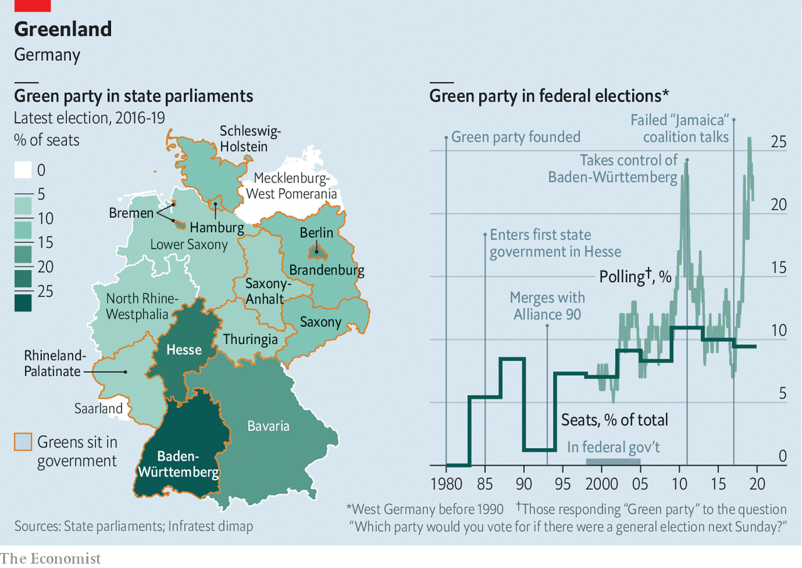

The common thread is a little bit of everything: climate-friendly growth that hurts neither companies nor the poor; investment plus fiscal responsibility; a foreign policy combining ethics with realism, all wrapped in an EU flag. Underpinning this is the closest the party gets to a political philosophy, as outlined by Mr Habeck. “Society has changed, and the idea of one-size-fits-all parties isn’t working,” he says. “If you think Greens have the answer, you can vote for us whether you’re an old lady or a punk in Berlin.”

To an extent, data back the party’s claim to transcend left-right divisions. At the European election in May, where the Greens came second with 20.5%, they took almost as many votes from the CDU as from the SPD. (They won among all voters aged under 60.) And as Germans adopt greener lifestyles the party returns the compliment, embracing local customs and traditions. “I like beer-tents, I like my Dirndl,” chuckles Katharina Schulze, who led the Greens to their best-ever result in Bavaria in 2018 after campaigning accordingly.

A recent poll found voters favouring a CDU/CSU-Green coalition after the next election. Once unthinkable, such “black” (conservative)-green tie-ups are spreading: Mr Kretschmann has led one since 2016, and Hesse, another rich state, has a conservative-led one. (In Austria the Greens agreed this week to join Sebastian Kurz’s People’s Party in coalition.) There was a dry run after Germany’s 2017 election, when the CDU/CSU, Greens and the liberal Free Democrats tried (and failed) to assemble a “Jamaica” coalition. But next time finding agreement on euro-zone, social, asylum and climate policy could prove tricky, and the CDU/CSU would seek Green concessions on security policy that the party base might struggle to swallow.

Still, the Greens are likely to ensure that Germany’s next election is the first in post-war history in which the CDU and SPD fail to occupy the top two spots. Could they lead a green-black government? It is not impossible: they briefly topped polls last spring. A Green-led coalition with the SPD and hard-left Die Linke is another option, though the numbers are not yet there. But the chance of a Green chancellor means Ms Baerbock and Mr Habeck must confront the awkward question of which of them it would be. Many insiders quietly admit to preferring Ms Baerbock, but Mr Habeck’s charisma and profile make him the favourite.

Such thoughts belie a concern among some Greens that the party’s current polling high may prove to be as fleeting as previous ones, especially if an economic slowdown displaces the climate among voters’ concerns and the party wilts under the scrutiny of an approaching election. That could happen, but neither governing party looks set to stage a recovery, and the Greens’ newly diversified policy portfolio is a hedge against voter caprice. For now, the party appears to be on a steady course towards government. ■

Read this article on <https://www.economist.com/europe/2020/01/04/the-stars-have-aligned-for-germanys-greens>

|  |  |  |  |
| --- | --- | --- | --- |
|  | Articles | Sections | Next |

|  |  |  |  |
| --- | --- | --- | --- |
| Previous | Articles | Sections | Next |

Goodbye casino, hello smugglers

# A tiny Italian exclave unwillingly joins the EU’s customs union

Campione d’Italia, a little piece of Italy inside Switzerland

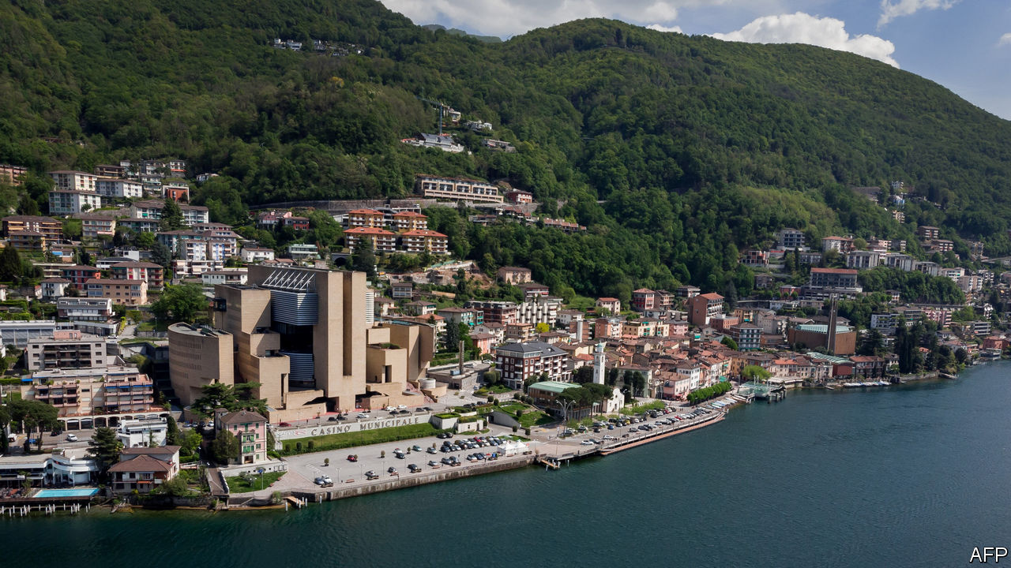

Jan 4th 2020 | CAMPIONE

“WE FEEL COMPLETELY abandoned,” says Giancarlo Bortoli, as a cormorant skims behind him to land on Lake Lugano. A retired croupier, Mr Bortoli is a citizen of one of Europe’s least-known micro-territories: Campione d’Italia, an exclave of Italy within Switzerland. With fewer than 2,000 residents, the exclave results from a territorial adjustment in the 16th century. Like similar geopolitical oddities, Campione has a colourful past. Its casino, owned by the local government, was founded in 1917, reputedly to help tease intelligence out of off-duty diplomats in the first world war. Among those who later found it convenient to establish themselves in Campione was Howard Marks, one of the world’s biggest cannabis-smugglers.

Visitors coming from Switzerland encounter a grandiose arch marking the frontier. Yet “until now, it was as if Campione were part of Switzerland,” says Alessandro Alfieri, a senator for Lombardy, the Italian region to which the exclave belongs. Campione’s inhabitants have their rubbish collected, their water purified and their telephones supplied by Swiss utilities. They drive on Swiss number-plates. And until this week they were, in effect, part of the Swiss customs area, an arrangement with which they were perfectly happy.

At the start of 2020 Campione was brought into the EU customs area, meaning all sorts of new checks and duties will now be required. The exclave was already reeling from the closure of its (heavily indebted) casino in July 2018, Europe’s largest, and the main source of revenue for the local authority. With many of Campione’s residents living on unemployment benefit of less than €900 a month, having lost their jobs either at the casino or the council, the once buoyantly prosperous exclave is a glum place these days. Still, by placing it under a customs regime different from that of the country surrounding it, the EU may have opened a potential new source of income for some—smuggling.

Read this article on <https://www.economist.com/europe/2020/01/04/a-tiny-italian-exclave-unwillingly-joins-the-eus-customs-union>

|  |  |  |  |
| --- | --- | --- | --- |
| Previous | Articles | Sections | Next |

|  |  |  |  |
| --- | --- | --- | --- |
| Previous | Articles | Sections | Next |

Steady state

# Europe’s employment recovery seems to be nearing an end

The EU’s unemployment rate has not changed since the spring

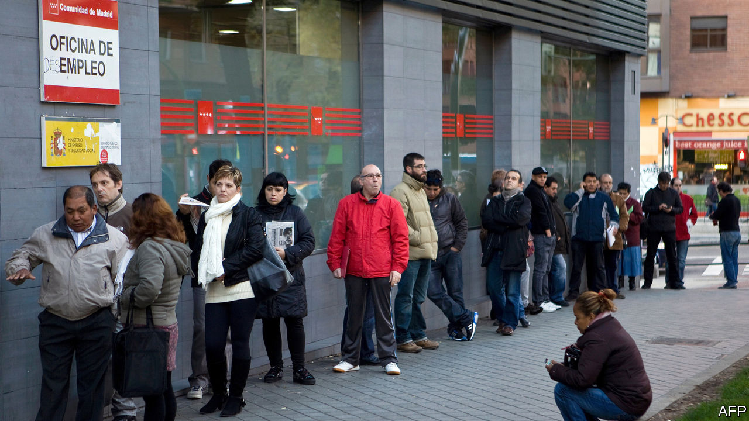

Jan 4th 2020

A DECADE AGO, as the sovereign-debt crisis engulfed the euro zone, long queues of the unemployed snaked outside job centres in Athens and Madrid. Unemployment, which had already been rising after the global financial crisis of 2007-08, took another jump up. By the summer of 2013 over a quarter of the workforce—and half of young people—were out of work in Greece and Spain. Then the crisis waned and the picture drastically improved. Unemployment has fallen by 40%, from more than 26m in the EU to just shy of 16m. Remarkably, the recovery has taken place even as more women and older people entered the workforce. Around 14m new jobs have been added, or around 6% of total employment.

In 2019, though, that recovery seemed to draw to a close. The EU unemployment rate has been stuck at 6.3% since May; the euro-area average has hovered around 7.5%. Job creation, too, has lost momentum. In the first nine months of the year employment grew at an average quarterly pace of only 0.2%, half the rate seen in 2017, when the economy was motoring along. What has driven the deceleration?

One explanation is that the labour market has returned to normal as the economy has recovered from the depths of the crisis. Companies may have soaked up the spare capacity that was generated by the recession, meaning that unemployment cannot fall much further without stoking wage inflation. But as this spare capacity cannot be measured directly, economists must search for clues about its extent.

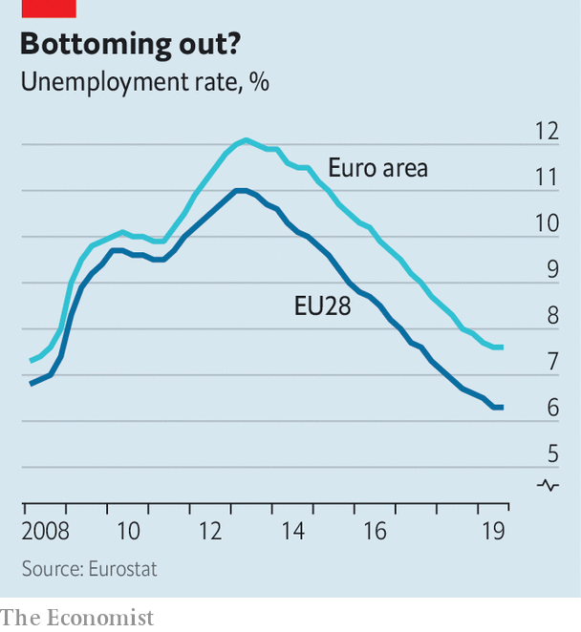

Across the EU as a whole, the unemployment rate is now slightly below where it was in 2008, and the employment rate is actually at a record peak. Wage growth, meanwhile, is at its highest for a decade. All this is consistent with diminishing spare capacity. But in America and in Britain, where the recovery started earlier than in the rest of the EU, economists have been surprised by how low unemployment has fallen. That suggests that unemployment in the EU could fall even further.

The explanation fits some countries better than others. It seems apt for central and eastern Europe, where economies are growing rapidly as they catch up with those in the west, but the workforce is shrinking. In the Czech Republic the unemployment rate is an eye-poppingly low 2.2%—on par with that of Japan—and wages are rising at an annual rate of 7%. In Germany and the Netherlands, jobless rates are just over 3%, the lowest for decades.

By contrast, unemployment rates in France, Italy and Spain are still high compared with before the crisis, suggesting there is still some slack left. Yet these rates too have stabilised as employment growth has moderated. (One exception is Greece, which has the highest unemployment rate in the EU, of 17%, where joblessness is continuing to fall sharply.) This suggests another culprit for flatlining unemployment might be a shortfall in demand. Overall, the EU’s economy has been slowing since 2018, and bosses may want to take on fewer staff as a result.

The labour-market effects of the slowdown are, unsurprisingly, most evident in Germany’s manufacturing sector, which has been in recession for over a year. There, employment actually fell in the third quarter of 2019 for the first time in four years. Bosses have also been squeezing workers’ hours: a survey by the IFO Institute for Economic Research found that 8.4% of German manufacturing firms were operating short-time working schemes in December 2019, the highest share since 2010. More than 15% are expected to bring in shorter hours over the next three months.

What happens next will depend on how the economy fares, and whether the slowdown spreads beyond manufacturing, which employs only around 15% of the EU workforce. Forecasters expect the unemployment rate barely to budge: the European Commission, for instance, expects the EU rate to drop no further than to 6.2% by 2021. That assumes the European economy does not slow further; but the bad news keeps coming. A survey of purchasing managers, released on January 2nd, suggested that manufacturing activity in Germany was still shrinking in December, and that it decelerated in France. The longer these troubles continue, the more likely it is that bosses will become reluctant to hire more workers, and may lay some off. ■

Read this article on <https://www.economist.com/europe/2020/01/04/europes-employment-recovery-seems-to-be-nearing-an-end>

|  |  |  |  |
| --- | --- | --- | --- |
| Previous | Articles | Sections | Next |

|  |  |  |  |
| --- | --- | --- | --- |
| Previous | Articles | Sections | Next |

Charlemagne

# Huntington’s disease and the clash of civilisation-states

Our new Charlemagne columnist ponders Europe’s future

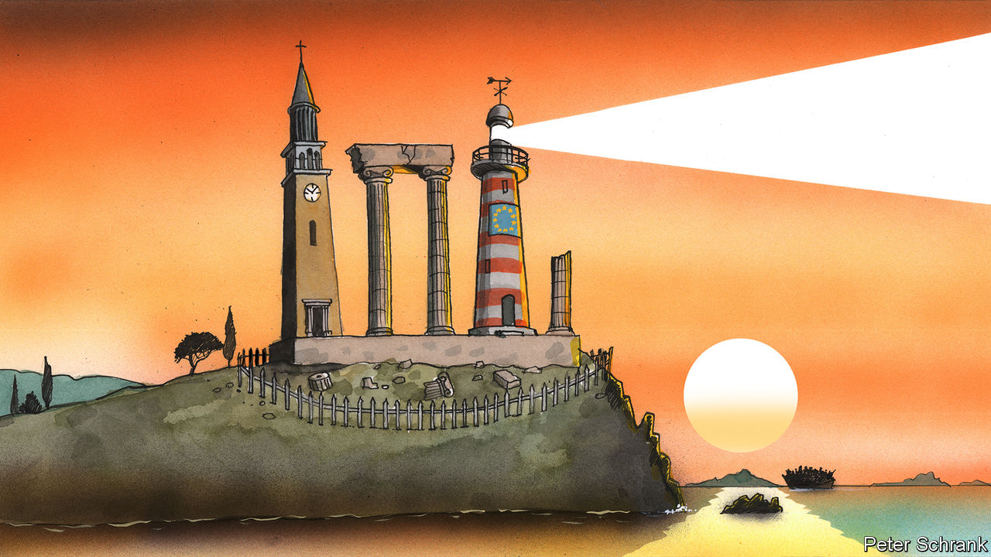

Jan 4th 2020

SAMUEL HUNTINGTON was almost right. The late American professor pricked a bubble of Western triumphalism with a gloomy prediction of strife in “The Clash of Civilisations?” in 1993. Where he erred was the medium through which this friction would take place. Rather than civilisations rubbing against one another as groups of nation-states, as Mr Huntington forecast, the 21st century is witnessing the rise of the “civilisation-state”.

The term is in vogue. Chinese academics herald China as the world’s sole civilisation-state, rather than an old-hat, 19th-century nation-state. Vladimir Putin, however, has hopped on the bandwagon, declaring that Russia’s status as a civilisation-state prevented the country “from dissolving in this diverse world”. Indian commentators have long wrestled with whether their country is one, too. Other potential candidates for civilisation-state status include the United States and even Turkey. Another name is rarely mentioned, but should be added to this growing list: the EU.

A world of civilisation-states, where the state protects (and projects) an entire civilisation rather than a mere nation, fits the EU rather well. No longer would the bloc be a geopolitical duck-billed platypus, occupying its own weird category. Though it is clearly much more than a trading union, it is still far from being a nation-state. It has its own currency, budget rules and regulates everything from strawberry size to car emissions. It controls essential parts of state sovereignty, such as customs, as well as migration between its member states. And in the coming decades it will probably build something resembling a small army and even police its borders. But the EU member-states still wield far greater powers across much domestic, and even more foreign, policy.

EU leaders of every flavour, meanwhile, have started banging on about civilisation. Viktor Orban, Hungary’s prime minister, has long couched his attacks on refugees as a defence of European civilisation. The European Commission has just offered its own rather bloodless and bureaucratic version of civilisation by introducing a commissioner for “Protecting The European Way of Life”, responsible for dealing with security, migration and integration. (After an outcry, the title was flipped with a spot of linguistic gymnastics to “Promoting Our European Way of Life”.) Emmanuel Macron, meanwhile, speaks of European civilisation in existential terms, demanding that the bloc gets its act together or be superseded by China and America.

These visions of the European civilisation-state are different, which is potentially something of a problem. Mr Orban equates European civilisation with white Christendom, whereas the commission at least attempts to build on civic values. Mr Macron focuses on the geopolitical strength of America and China, which could undermine the enlightenment values represented by Europe. Still, they share common themes.

All, for example, are defensive. European leaders talk about protecting Europe. Rather than engage in political evangelism, the EU is giving up on universalism, even though civilisation-states naturally tend to be expansive. Where European leaders once spoke of “Western” values, increasingly they speak of European ones. America has taken a nativist turn, and Brexit Britain is following suit. In such circumstances, a renewed focus on a specific European civilisation—and how to defend it—is only natural.

Sadly, chatter about civilisations can swiftly become paranoid. The far right peddles conspiracy theories about European civilisation being “replaced”, whether by immigrants or rising powers such as China. Such talk is now echoed by moderate politicians. “We know that civilisations are disappearing,” declared Mr Macron last summer, warning that Europe would be wiped out too unless it changes fundamentally. A shared apocalyptic vision may bind the populist right into the European project, but it would do so only at a heavy cost to Europe’s self-proclaimed values.

Likewise, the renewed emphasis on European civilisation is exclusive. In his book “The Rise of the Civilisational State”, Christopher Coker argues that questions of culture rather than political ideology are now the currency of politics. Such a shift changes the fundamental question asked of citizens, as Mr Huntington laid out two decades ago. If politics and economics dominate, then the question is “What do you think?” This has a mutable answer. If culture dominates, the question becomes “Who are you?”—an answer that can less easily be changed.

## There’s a good side and a bad side. Choose wisely

A more benign analysis holds that European leaders have built on shared civilisational foundations since 1945, carving out a niche for Europe in the face of increasingly powerful allies and rivals, whether America, Russia or China. “The concept of the EU as civilisational state is so deeply embedded in European politics now that it shapes the rhetoric of all political actors involved in it,” argues Alexander Clarkson, a historian at King’s College London. In short, the urge has always been there, but now it has a natty name.

If the vision of Mr Macron and his fellows triumphs, then this civilisational turn need not have a dark side. Limiting “universal” values to the European sphere shows a dearth of ambition but a practical admission of the EU’s place in an increasingly illiberal world order dominated by America and China. Yet the risks of this shift are also obvious. A paranoid continent, fearing for its continued existence, is not one that makes healthy decisions. An emphasis on specifically European values could lead to chauvinism. A political class that echoes far-right tropes about being replaced risks feeding the very populists they want to squeeze out. One of the EU’s crowning achievements has been tempering the nationalism that triggered two world wars in the space of three decades. Replacing “nationalism” with a crude form of “civilisationalism” would do little good. As Huntington might have said, a clash of civilisation-states would be ugly indeed. ■

Read this article on <https://www.economist.com/europe/2020/01/04/huntingtons-disease-and-the-clash-of-civilisation-states>

|  |  |  |  |
| --- | --- | --- | --- |
| Previous | Articles | Sections | Next |

|  |  |  |
| --- | --- | --- |
| Europe | Sections | International |

Britain

Reshaping the state: The Cummings plan

Dominic Cummings’s plan to reshape the state.

Darts: Bull market

How darts flew from pastime to prime time.

Bagehot: One nation under Boris

Boris Johnson is reinventing one-nation Conservatism.

|  |  |  |
| --- | --- | --- |
| Europe | Sections | International |

|  |  |  |  |
| --- | --- | --- | --- |
|  | Articles | Sections | Next |

Britain after Brexit

# Dominic Cummings’s plan to reshape the state

Why Downing Street thinks that to get anything done it must first fix the machinery of government

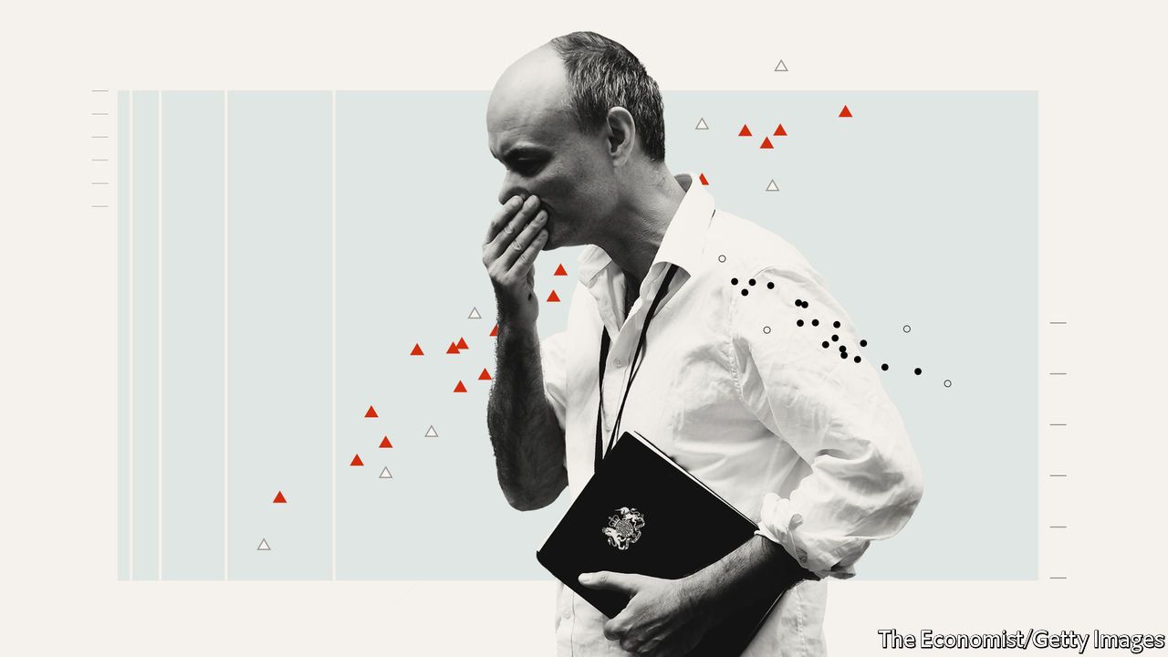

Jan 2nd 2020

THE SUSPICION with which many Brexiteers have long regarded Brussels has come to be matched by an equal mistrust of Whitehall. After repeated delays to Britain’s exit from the European Union, many Leavers became convinced that bien-pensant officials were out to subvert the will of the people. Yet for Dominic Cummings, the prime minister’s chief adviser and brains behind the Leave campaign, the frustration with the civil service goes back much further. The subtitle of an entry on his personal blog, written in 2014, sums up his outlook: “The failures of Westminster & Whitehall: Wrong people, bad education and training, dysfunctional institutions with no architecture for fixing errors.” Some Eurosceptics want to put a bomb under Whitehall in order to get Brexit done. Mr Cummings wants to get Brexit done so that he can put a bomb under Whitehall.

Following Boris Johnson’s triumph in the December election, the government has an opportunity to reshape the country. Labour is in chaos, the Remainers are defeated and the British system gives huge power to governments with a large parliamentary majority. Mr Cummings’s thinking—set out over hundreds of thousands of words in a blog that ranges from Sun Tzu and Bismarck to education policy and space exploration—helps explain why many in Downing Street think that to get anything done in government they will first have to fix the civil service.

Mr Cummings has lambasted cabinet government as an outdated, oversized decision-making mechanism. Once Britain has left the EU, the number of departments is reportedly due to be cut, with Business absorbing Trade, the Foreign Office taking International Development, and the Department for Exiting the EU scrapped. A “super-department”, including education, research and innovation, is rumoured, and the Home Office may even be broken up. If Mr Cummings gets his way these changes will be just the start.

Civil service reform is not usually a priority for a new administration. Most turn their attention to it only after finding their initial vim frustrated. At the start of her second term, Margaret Thatcher tried to make officials more accountable and to focus them on outcomes. At the start of his, Tony Blair brought in Michael Barber, who had worked on school reform, to split the government’s aims into measurable targets and pursue them relentlessly. Or, in the words of Mr Cummings, establish “what should be minimal competence for people who do not know how to prioritise and are managerially incompetent”.

In his view, this incompetence reflects a system that incentivises the wrong things. Mr Cummings has called for greater use of redundancy to get rid of people not up to it. He wants training to emphasise quantitative skills and for those who are effective to stay in place for longer (some departments lose more than a fifth of their workers each year, through rotations or exits). Job specifications may also change. According to Mr Cummings, permanent secretaries, who run departments, face an impossible job (as “chief policy adviser, department CEO and a fixer”) and are promoted on their ability to play the game. Almost none of them, and indeed almost no minister or adviser, is “+3 standard deviations…on even one relevant dimension (IQ, willpower/toughness, management ability, metacognition, etc)”. As an ally notes, Mr Cummings “doesn’t care if he hires socialists, he just wants people to be competent.”

Another part of the answer, Mr Cummings believes, lies in hiring brilliant people to work on specific problems outside of bureaucratic constraints. He points to the success of America’s work on intercontinental ballistic missiles and some aspects of the Apollo programme in the 1950s and 1960s, which brought the world’s best scientists and engineers into government projects. More broadly, he argues that such examples illustrate the importance of clearly defined goals, the use of long-term budgets to save money and the need for “an extreme focus on errors”. He has called for “red teams”, as used by the CIA and defence firms, to argue the opposite view in meetings, to counter groupthink.

All of this is likely to involve tackling what Nick Pearce, head of the Downing Street policy unit under Gordon Brown, calls the “key tension” at the heart of Britain’s bureaucracy: that ministers are held responsible for what their department does but do not have much control over it. Britain is unusual in that ministers have little sway over who runs their department and limited ability to make appointments, compared with similar political systems like Australia and Canada. Mr Cummings recounts a litany of errors by officials during his previous stint at the Department for Education: “With all of them, regardless of how incompetently they had been handled—nobody was ever fired.”

He writes that part of the reason he and his then-boss, Michael Gove, “got much more done than ANY insider thought was possible—including [David] Cameron and the Perm Sec—was because we bent or broke the rules.” A devil-may-care approach could spread in a government eager to get things done. Mr Cummings thinks politicians are cowed by government legal advice, often by lawyers citing European directives. A recent report by Policy Exchange, a sympathetic think-tank, suggests making it easier for ministers to take advice from external lawyers.

Rearranging government departments “is a very sizeable task in and of itself,” with a mixed record of success, notes Catherine Haddon of the Institute for Government, a think-tank. Writing about how to transform the state is one thing; doing so is quite another. So old hands suspect gradual evolution is more likely than a big bang. To Mr Cummings, that may sound like the usual complacency: “There is a widespread befuddled defeatism that nothing much in Westminster can really change,” he blogged. Now he has another chance to prove the establishment wrong. ■

Read this article on <https://www.economist.com/britain/2020/01/02/dominic-cummingss-plan-to-reshape-the-state>

|  |  |  |  |
| --- | --- | --- | --- |
|  | Articles | Sections | Next |

|  |  |  |  |
| --- | --- | --- | --- |
| Previous | Articles | Sections | Next |

Bull market

# How darts flew from pastime to prime time

The sport has staggered out of the pub and onto television. Next stop, America



Jan 2nd 2020 | ALEXANDRA PALACE

BRITISH SPORT has a new star. On December 17th Fallon Sherrock, a 25-year-old from Milton Keynes, became the first woman to win a match at the PDC World Darts Championship, the sport’s most prestigious event. She then went one better by knocking out the tournament’s 11th seed with a magical shot at the bullseye, eventually taking home £25,000 ($33,000) in prize money. Ms Sherrock, a far cry from the beer-bellied blokes who used to typify the game, symbolises how in recent years darts has gone from a peculiar British pastime to an entertainment juggernaut with transatlantic ambitions.

Darts staggered out of the pub and onto television in the 1970s, but low viewing-figures and a loutish reputation eventually led broadcasters and sponsors to pull the plug. In the early 1990s a group of disgruntled players broke from the stuffy British Darts Organisation and struck a deal with Sky, Rupert Murdoch’s fledgling broadcaster. Their new outfit, which became the Professional Darts Corporation (PDC), attracted the attention of Barry Hearn, a promoter with a knack for turning pub games into money-spinners (snooker gave him his big break). In 2001 Mr Hearn took over the PDC and set about revitalising the sport.

The corporation has turned darts into Britain’s biggest pantomime, with heroes and villains, outrageous costumes and jeering from the crowd. Fans “want to see 180s [the maximum a player can score with three darts], big finishes and players giving it large on stage,” according to Matthew Porter, the PDC’s chief executive. At the World Championship, one pint-swilling fan wearing an ill-fitting nun’s habit confirms as much: “It’s such a good night out, we come to have a laugh basically.” The results of the matches hardly seem to matter.

The PDC’s efforts have paid off. Some 85,000 fans flocked to Alexandra Palace, in north London, to watch Ms Sherrock and 95 other players compete for £2.5m in prize money. According to Dave Clark, who presents Sky’s coverage, in recent years darts has been the second-most-watched sport on the network over Christmas, beaten only by football.

This British pursuit has found devotees farther afield. German and Dutch fans bought a third of the tickets to the World Championship, and broadcasters from both countries covered the event live. Players such as Michael van Gerwen boost its continental appeal. The “doyen of Dutch darts” was beaten in the tournament’s final on New Year’s Day by Peter “Snakebite” Wright, a flamboyant Scot sporting a purple mohawk.

In 2020 Madison Square Garden in New York will host a PDC event for the first time, as part of an effort to introduce the sport to even bigger markets. Although it is played in bars, darts has never been enjoyed as a spectator sport in the United States, according to Patrick Chaplin, a historian of the game. If Americans want to see big characters playing up to raucous crowds they can watch WWE wrestling. There is a knottier problem, too: much of the sponsorship for PDC events comes from bookmakers, but in most states gambling on sport is illegal. In New York punters can bet on sports only in a handful of casinos, not online or at events. Without bookies’ money, the PDC’s glitzy tournaments and bulging prize pots become less feasible.

There may seem something indelibly British about darts; the heavy-drinking fans suggest that the game has never really escaped the pub. But the PDC is convinced that its boisterous, made-for-TV repackaging of the sport can find an even bigger audience abroad, and that players such as Ms Sherrock can shake off its blokey image. If the bet comes off, expect to see the arrows flying around the world.

Read this article on <https://www.economist.com/britain/2020/01/02/how-darts-flew-from-pastime-to-prime-time>

|  |  |  |  |
| --- | --- | --- | --- |
| Previous | Articles | Sections | Next |

|  |  |  |  |
| --- | --- | --- | --- |
| Previous | Articles | Sections | Next |

Bagehot

# Boris Johnson is reinventing one-nation Conservatism

The phrase doesn’t mean what most Tories think it means

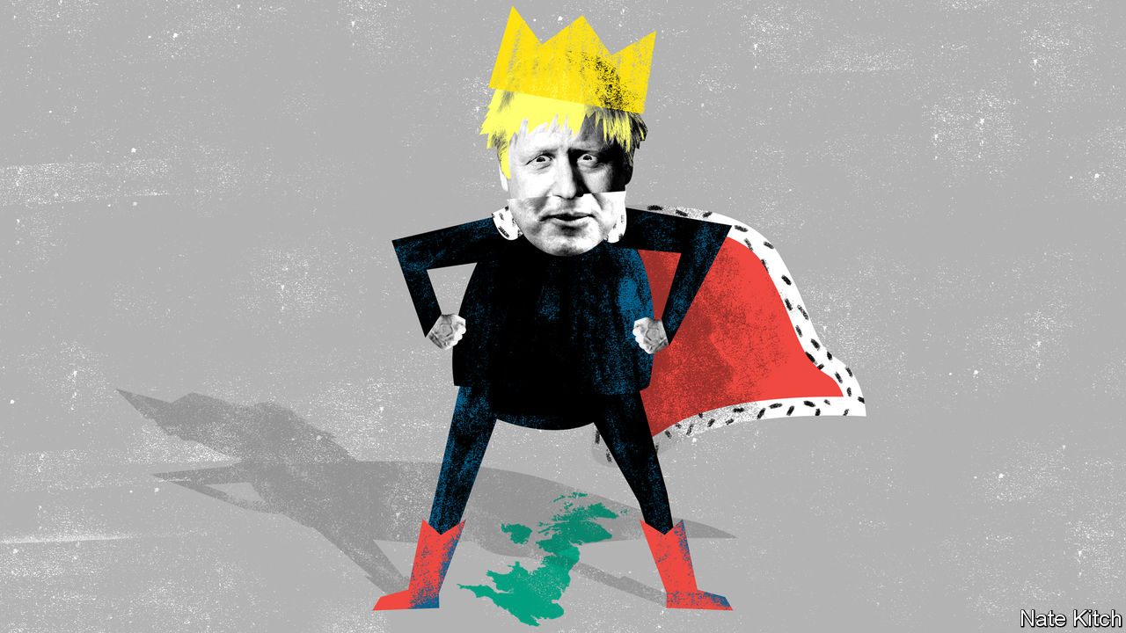

Jan 4th 2020

BORIS JOHNSON is well placed to become one of the most powerful prime ministers in modern times. Margaret Thatcher had to contend with a powerful internal opposition of moderate “wets”. Tony Blair had Gordon Brown to deal with. But Mr Johnson has purged the internal opposition and reduced his cabinet colleagues to a pack of poodles. If politics in 2019 was about calculating the strength of parliamentary factions, politics in 2020 and beyond will be about cataloguing the intrigues in the court of King Boris.

But what does Mr Johnson want to do with all this power, other than “get Brexit done”? The best clue lies in the phrase “one-nation Conservatism”. During the election campaign Mr Johnson repeatedly promised to lead a one-nation Conservative administration. Though it may sound like one of those feel-good phrases that politicians use to fill the void, the phrase is pregnant with meaning: you cannot understand the Johnson project without decoding it. Yet it does not mean what most Tories think it means.

Liberal Conservatives have seized on the phrase as a sign that the prime minister plans to dump the nasty Boris of the referendum and resurrect the cuddly Boris of the London-mayor years. They have even used it to put a positive gloss on his 87-seat working majority: freed from the parliamentary logic which gave such power to hardline Tory backbenchers, he will be able to bring about a soft Brexit and lots of progressive social policies.

It is easy to see why hopeful liberals might think like this. Since Thatcher’s early years, Tory wets have rallied behind the one-nation banner. Michael Heseltine used the phrase to mean support for economic intervention and European integration. David Cameron used it as code for causes such as environmentalism and gay marriage. In March 2019 dozens of moderate MPs such as Amber Rudd and Sir Nicholas Soames launched a One Nation Group aimed at counter-balancing the party’s Europhobes. But they are as wrong as it is possible to be. Mr Johnson didn’t expel 21 members of the One Nation Group from the party in order to start sucking up to them. And he didn’t capture a large swathe of working-class England in order to start courting the Notting Hill set.

One-nation Conservatism has in fact had many meanings over the decades. Benjamin Disraeli, who coined the phrase, used it to mean uniting the wealthy “classes” with the “masses” in a common national home. Lord Salisbury understood it to mean uniting the kingdom by defeating or co-opting the forces of Irish and Scottish nationalism (the party even changed its name to the Conservative and Unionist Party). Stanley Baldwin invoked it to champion the “real” (Conservative) England of civic patriotism against the “alien” (Labour) England of class divisions and mighty trade unions. Harold Macmillan used the term to mean mixing the welfare state with property-owning democracy. Mr Johnson is currently engaged in yet another reinvention of the phrase.

At its simplest, his version of one-nation Conservatism means an amalgam of left-wing policies on economics and right-wing policies on culture—the exact reverse of Mr Cameron’s approach. During the election campaign Mr Johnson praised the National Health Service as a “simple and beautiful idea that represents the best of our country”. In a recent cabinet meeting he described himself as “basically a Brexity Hezza”, referring to Lord Heseltine, who combined an enthusiasm for Europe with an equally powerful enthusiasm for government spending. Mr Johnson will combine big-government with a proud embrace of traditional values. He has already fired the first shots in the new culture wars by discouraging his ministers from appearing on the BBC’s agenda-setting “Today” programme or on Channel 4 News, and by promising a review of the supposedly Remoanerish law courts.

This policy mix is driven by the political realignment which allowed the Conservative Party to capture working-class northern seats while causing it to struggle in the most cosmopolitan enclaves of the south. Rachel Wolf, one of the authors of the party’s manifesto, says it was directed in particular at people who subscribe to conservative values (“they want criminals to be punished”) but who also rely heavily on public services.

At a deeper level, Mr Johnson’s version of one-nation Conservatism is about preventing the country from being broken apart by the rival forces of globalisation and nationalist-populism. During the Blair-Cameron years, England was in danger of splitting into Disraeli’s two nations, “between whom there is no intercourse and no sympathy”: a prosperous metropolitan nation that embraced globalisation and immigration, and a depressed provincial nation that regarded these phenomena as threats to both prosperity and social cohesion. Mr Johnson is hoping to close the regional gap that sees the state perversely subsidising the already prosperous south (spending on transport is twice as high per person in London as in the rest of the country). He has already announced that he will change a Treasury formula that makes it difficult to target government spending at poorer regions, and introduce an as-yet undefined “points system” for immigration. He is also hoping to use the power of the Downing Street bully pulpit to close the cultural gap which sees working-class northerners ignored by Londoners.

## Our island Tory

Mr Johnson’s version of one-nation Conservatism is risky. Brexit is likely to do worse economic damage to the north (with its manufacturing industries) than to the south (with its service-oriented economy). It will also strain the biggest one-nation problem of all, the union with Scotland and Northern Ireland. Persuading the London elite to get to know their country a bit better could degenerate into a culture war that splits the nation in the name of uniting it. That said, Mr Johnson’s reworking of an ancient Conservative creed has already provided him with two things his party had not had, in combination, since the 1980s: a large parliamentary majority and a direction of travel. ■

Read this article on <https://www.economist.com/britain/2020/01/04/boris-johnson-is-reinventing-one-nation-conservatism>

|  |  |  |  |
| --- | --- | --- | --- |
| Previous | Articles | Sections | Next |

|  |  |  |
| --- | --- | --- |
| Britain | Sections | Technology ... |

International

Sexual assault: Her word against his

Why so few rapists are convicted.

|  |  |  |
| --- | --- | --- |
| Britain | Sections | Technology ... |

|  |  |  |  |
| --- | --- | --- | --- |
|  | Articles | Sections | Next |

Her word against his

# Why so few rapists are convicted

The justice system is still stacked against women



Jan 4th 2020

ON JANUARY 6TH a rape trial will begin and the world will hear all about it. Harvey Weinstein, a Hollywood mogul, will face five charges of sex crimes. Dozens of women have accused him of using his position to prey on them. In 2017 their testimony helped set off the #MeToo movement. If found guilty, Mr Weinstein, who denies all allegations of non-consensual sex, could spend decades in prison.

The accusations against Mr Weinstein set off such a storm because so many women had experienced something similar. But in other ways, the case is wildly unrepresentative. Most rape trials do not involve a famous defendant or multiple movie stars. More importantly, most rapes are not reported and most that are reported never come to trial. In England and Wales only 1.5% of rapes reported in the year ending March 2019 led to charges being filed, compared with 7.8% for all crimes and 8.3% for all violent crimes.

Rape is one of the hardest crimes to prosecute. After a murder, there is a corpse. After a rape, by contrast, there may be no physical evidence at all. Often, the only evidence that a crime has even occurred is the word of the victim, flatly contradicted by the defendant. When it is essentially her word against his, it can be extremely difficult to prove beyond reasonable doubt that the accuser is telling the truth and the defendant is lying. It is doubly so when the general public—and therefore jurors—have deep misconceptions about what a typical rape looks like, and what a credible allegation sounds like.

As well as drawing on the latest research, this article will use a fictional case study to illustrate the difficulty of weighing “he-said-she-said” evidence. Although our reporters interviewed numerous real-life victims of sexual assault, we found it hard to present their cases fully and even-handedly without harming the individuals involved. The story of “Jane” and “Joe” is not true, but we have tried to make it typical of the vast majority of cases that never get near a courtroom.

Jane is 24 and an office assistant. She says that two years ago Joe, a colleague, raped her. They went for drinks after work and she missed her train home. They went back to his flat. Once they were there, she says, he held her down and raped her despite her saying “no” repeatedly. She did not fight or scream. They had kissed a year prior to the incident, at the office Christmas party.

Joe is a 40-year-old banker. He says that on the night in question, they kissed and then had consensual sex. The next morning she left before he woke. But he says they have stayed on friendly terms. He says it was a classic one-night stand: “she was totally into it.” She is now “clearly lying”.

Many people faced with these two accounts will find Joe’s more credible. People often think of rape as involving things conspicuously missing from Jane’s account: a predatory stranger, a weapon used to threaten or hurt, a secluded location and a victim anxious to report the crime straight away. They are mistaken. “Most common knowledge about sexual assault is wrong,” said Barbara Ziv, a forensic psychiatrist who testified as an expert witness in the trial of Bill Cosby, an American comedian convicted of three counts of aggravated indecent assault in 2018.

In America over 127,000 rapes were reported to police in 2018; in England and Wales 58,947 were reported in the year ending June 2019. A huge majority of the victims were women. Many reports are made long after the event; more than a quarter of attacks reported in England and Wales in 2017 took place over a year before. Some 80% of rapes reported are committed by a person known to the victim.

Sexual assault typically involves neither weapons nor visible injuries. The 2017 Crime Survey for England and Wales found the most common location to be the victim’s home (39%) and the second most common the offender’s home (24%). Just 10% happen in a public place such as a park or the street. Nearly a third of people claiming to be the victims of rape said they told no one; over half told an acquaintance; fewer than one in five told the police. When Christine Blasey Ford claimed, in testimony before the United States Senate, to have been assaulted decades ago by Brett Kavanaugh, then a nominee to the Supreme Court, President Donald Trump insisted that anyone who had experienced such an assault would go straight to the police. In fact sexual assault and rape are the most underreported violent crimes.

Victims may not report their ordeal for a number of reasons, such as embarrassment or thinking it will not help. They may remain in contact with their assailant for work reasons. They may flirt with him or have sex with him again as a way to regain, or establish, a sense of control over their relationship.

Jurors can find this hard to fathom. Defence lawyers exploit their confusion. Soon after allegations against Mr Weinstein surfaced two New York Times reporters revealed how Mr Weinstein’s then lawyer, Lisa Bloom, had tried to reassure board members of his company by saying photographs would soon be published of “several of the accusers in very friendly poses with Harvey after his alleged misconduct”. When such evidence reveals a continued relationship that the accuser has sought to hide, it can be relevant. The mere fact of a continued relationship, though, says little.

The absence of a weapon; missing, imprecise or mistaken memories; delayed reporting; prior acquaintance; claims of consent—they all make a rape complaint more likely to be dismissed by investigators, even though they are extremely common.

In the past in the West, and to this day in such places as Saudi Arabia, a woman’s word was explicitly given less weight than a man’s. The law required a victim’s “prompt outcry” and corroboration of her account “because ladies lie”, as Morris Ploscowe, a mid-20th-century American legal scholar, put it. Deborah Tuerkheimer, a law professor at Northwestern University in Illinois, argues that the American judicial process still systematically discounts the credibility of accusers. The prior conduct and character of the accuser routinely come under scrutiny.

People who know Jane, or think they know her, are likely to find her story more credible. “The Weinstein case is greatly helped by those accusing him being well-known actresses [whom] the public trusts,” says Elaine Herskowitz, an investigator and consultant. And by the fact that Mr Weinstein doesn’t look like George Clooney, adds Bennett Capers, a professor at Brooklyn Law School. If Joe is good-looking both men and women are more likely to believe him than if he is not.

The greater the power differential between rapist and victim, the likelier he is to get away with it, reckon criminal-justice scholars. Jurors are especially likely to disbelieve victims if they are sex workers, drug addicts or teenagers. When a boss harasses a cleaner who cannot afford to lose her job, she is unlikely to report him. And if she does, his high social status may, in jurors’ minds, lend credibility to his denial of wrongdoing. Jeffrey Epstein, a wealthy sex offender who died in custody in New York, selected teenage girls from broken homes to prey on. When Epstein was first accused this probably made it easier for his lawyers to persuade investigators that his accusers could not be trusted.

Jane goes to the police. Asked why she didn’t report the next day, she says she was embarrassed and thought there was no point. She told her friend Sally, but nobody else. The only reason why she is reporting the rape now, she says, is that she has felt emboldened by the #MeToo movement.

## Justice is hard to get

If victims think reporting assaults is pointless, it is not without reason. In a study recently released by America’s National Criminal Justice Reference Service, researchers followed the flow of reports of rape and attempted rape in six American jurisdictions between 2008 and 2012. Of 2,887 reports by women just a fifth led to an arrest. Only 1.6% of incidents reported led to a trial. “Police and prosecutors selected cases based on what they thought a jury would believe,” says Linda Williams, one of the study’s authors.#



Drop-off rates seem to be increasing. In 2018-19 Britain had its lowest number of rape prosecutions in a decade, despite the number of police reports nearly tripling since 2014. According to FBI data, in America police successfully closed just 33% of rape investigations in 2018 (including dismissals), the lowest “clearance rate” since the 1960s. Rape was second only to robbery as the least-solved violent crime. Lower clearance rates might be a sign that police are keeping complex cases open for longer. But it could equally indicate that more rapes are going unsolved.

The police decide to question Joe. He accuses Jane of lying. He says she is jealous because he has started a new relationship. She is now “crying rape” for attention, he suggests.

Again, Joe’s story fits with a public preconception: the idea that a large proportion of women who accuse men of abuse are lying. According to Ipsos Mori, a pollster, 57% of American men and 48% of women believe that “false accusations of sexual harassment against men are very common.” In a survey of nearly 900 police officers in America, over half stated that 10-50% of sexual-assault complainants lie about being attacked. One in ten said it was more like 50-100%. A poll by The Economist shows that in the aftermath of #MeToo people are more worried than before about false allegations of harassment and rape.

It is impossible to know the true rate of false reports. However, in a review of credible research, David Lisak, at the time at the University of Massachusetts, narrowed the estimate to between 2% and 8%. For those who are falsely accused, the process can be a nightmare with irreparable consequences. But if police presume accusers are lying, rape victims will not come forward, and rapists will rape with impunity. “What you want is a system that treats both testimonies seriously, which is not the same as automatically believing all of it,” says John Spencer of Cambridge University.

False accusations are much more likely than real ones to look like the stereotype of rape (violence, strangers and dark alleys). A study in 2014 of cases in Los Angeles found that of the 4.5% of rape allegations deemed to be false by the researchers, over three-quarters were for aggravated rape, which involves the use of a weapon, multiple suspects or collateral injury.

The investigators start to dig into Jane’s accusation. There are several gaps in her story. She cannot remember for sure how they got to Joe’s flat nor how and when exactly she got home afterwards. But she describes Joe’s sofa in great detail, including the squeaky sound it made. Joe’s sofa does squeak.

Neighbours say they heard no sounds of a struggle; but Jane does not say she struggled. She says she froze.

There is no physical evidence. Jane does not claim to have been physically injured. She did not go to hospital. In any case, Joe does not deny that they had sex.

Phone records show that Jane texted her friend Sally the morning after:

“need to talk asap :( call? x”.

Sally’s diary confirms that Jane told her she had been raped.

Jane also sent two messages to Joe in the weeks after the encounter:

“I’m bored. wassup with you? x”.

“you goin to the summer party? Hope so”

Joe did not reply to either. On the day that Jane texted Sally, he texted a friend about “banging the babe senseless”.

Beyond testimonial evidence, he-said-she-said inquiries typically focus on three things: the victim’s memory, her body and her digital footprints.

The ways in which the mind remembers, and forgets, assault can work to the accuser’s disadvantage. Memory of trauma can record some particulars in excruciating detail while leaving other details hazy or forgotten. “From a survival point of view this makes perfect sense,” says Jim Hopper of Harvard Medical School. “Our brain has evolved to remember what to avoid in the future, but not what was happening on the other side of the room.” Alcohol adds to the difficulties. In England and Wales over a third of self-reported rape victims said they had drunk alcohol when they were attacked. Heavy drinking can cause blackouts as well as removing the capacity for consent. Even moderate drinking can blur the memory of peripheral details.

The body, too, does not necessarily record the evidence people might expect. Non-consensual sex does not always lead to injury or physical trauma. One reason is “tonic immobility”, a dissociative response in which the body goes limp. Two thirds of rape of victims questioned in a Swedish study reported symptoms of tonic immobility. “Victims are still suspected of lying if their vulvas aren’t visibly shredded after a rape,” writes Kate Harding, a feminist author, in “Asking for It”.

Digital records are a new source of potential evidence. When witness statements and other evidence are inconclusive, jurors will struggle to choose between the accuser’s story and that of the accused. To increase their doubts, defence lawyers often try to demolish the accuser’s credibility. Trawling for any dodgy-looking detail of prior conduct is no longer acceptable in most jurisdictions. But material relevant to the relationship in which an assault is alleged to have happened is still allowed.

In Britain failures by police and prosecutors to investigate properly accusers’ phone records and disclose them to the defence have led to a number of rape cases collapsing. Victim advocates worry that in response the level of intrusion into phone, email and chat records will come to amount to a “digital strip search”. If an accuser signs an instrument called a Stafford statement a wide array of digital records related to her can be perused, including those from doctors and therapists. Such intrusion is another reason victims stop cooperating with investigations.

After investigation, the prosecutor decides there is not enough evidence to proceed to trial. But Jane’s story appears on social media. Having seen it, another woman comes forward claiming Joe did the same thing to her. An anonymous blog post alleges that when he and the author were interns 20 years ago he was “super creepy” and would “constantly talk about his penis”.

The human resources department at the bank where Jane and Joe work faces a meltdown; many women, and some men, say they feel uncomfortable around Joe. Joe’s local football club asks him to step down as coach of its girls’ team. His girlfriend leaves him.

Three months later, Jane resigns from her job; Joe’s friends at work make her feel uncomfortable. Jane continues to suffer from anxiety. Joe has a new girlfriend and is working in a different part of the same bank.

## Numbers matter

“I don’t care if 30 more women come forward and allege this kind of stuff, Les is our leader and it wouldn’t change my opinion of him,” Arnold Kopelson allegedly told fellow members of the board of CBS , a broadcaster, in July 2018. A single accusation of sexual misconduct against the company’s CEO, Les Moonves, had become a spate. But their sheer volume meant that unlike Mr Kopelson the public did care, and in time the shareholders came to care, too. Mr Moonves was forced out of his job; he might have been prosecuted had the statute of limitations relevant to the allegations not expired. Mr Moonves denies all of the allegations.

The retrial of Mr Cosby also demonstrated the power of numbers. The first case against him, which went to court in June 2017, ended in mistrial. But at retrial the judge allowed five additional victims to testify. Even though there was only one formal complainant, the volume of supportive testimony helped the jury to convict him. Some rapists do indeed, over time, rape more than one woman—a rare example of a commonplace about rape that has some truth. Multiple accusers make each other more credible, especially if they come out independently. But the number of allegations does not necessarily make any one easier to prove in legal terms.



When legal systems fail, people look elsewhere. Anonymous early-warning networks have existed for as long as women have scrawled the names of dangerous men on toilet doors or described colleagues as “not safe in taxis”. Shared spreadsheets such as the Shitty Media Men list which circulated in New York and the Westminster Sex list used in British political circles are digital equivalents.

Online tools built for the job now exist. Callisto, a system now used in many universities, gives those reluctant to report assaults two options: create but don’t file a report (in case they want to file it in the future) or enter their perpetrator into “Matching” (college authorities are only notified if several people enter the same name). The non-profit that runs it claims users are six times more likely to report abuse and that they do so much sooner than people without access to the tool.

After decades of institutional failure to take allegations seriously, #MeToo showed the power of social media to disseminate accounts of predation and to give accusers a new sense of solidarity. The sheer volume of allegations has caused some criminal cases to be opened or reopened. But it has also shown how hard it is to achieve justice for rape victims, or deter their attackers. ■

Read this article on <https://www.economist.com/international/2020/01/04/why-so-few-rapists-are-convicted>

|  |  |  |  |
| --- | --- | --- | --- |
|  | Articles | Sections | Next |

|  |  |  |
| --- | --- | --- |
| International | Sections | Business |

Technology Quarterly

Chinese technology: From the people who brought you fireworks...

With the state’s help, Chinese technology is booming.

Success stories: Reactors and railways

China’s nuclear industry and high-speed trains are world class.

Cars: Electric leapfrog

China has never mastered internal-combustion engines.

Intellectual property: Laser brain

Chinese inventiveness shows the weakness of the law.

Data: A new trinity

China’s success at AI has relied on good data.

Microprocessors: From bottom to top

China is slowly moving up the microprocessing value chain.

The future: Of coupling and decoupling

Technological progress in China could still lead to fireworks.

|  |  |  |
| --- | --- | --- |
| International | Sections | Business |

|  |  |  |  |
| --- | --- | --- | --- |
|  | Articles | Sections | Next |

Chinese technology

# With the state’s help, Chinese technology is booming

But it will not be a smooth road to global dominance, says Hal Hodson

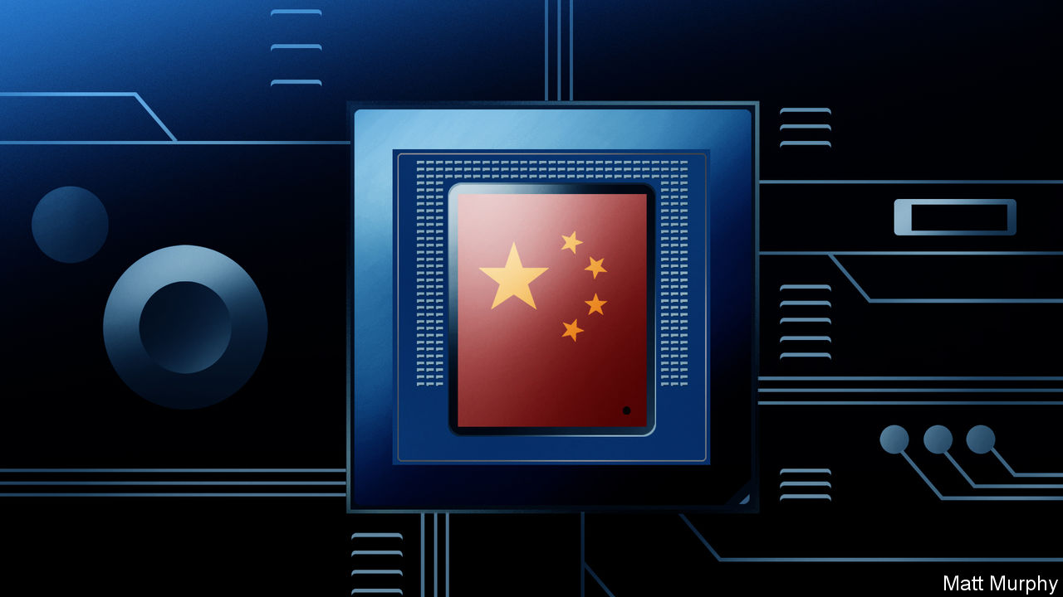

Jan 2nd 2020

FOR MOST of human history, China was the world’s most advanced technological power. The blast furnace originated there, and thus so, too, did cast iron. Other breakthroughs included porcelain and paper. Its gunpowder propelled the first military rockets farther than javelin or arrow could fly; its compasses magically revealed magnetic north when the stars were hidden.

Only in the Middle Ages did Europe began to match Chinese ingenuity and capacity in these fields, doing so largely through imitation. Only with the growth of European mechanical industries and overseas empires in the 18th century did the Westerners become its rivals. In the centuries that followed, hampered by its own stifling education system, China was defeated in the opium wars, then suffered terrible civil unrest and a disastrous revolution that reduced the country to a technological bystander and “Made in China” to a byword for gimcrackery.

Now China is back, trailing clouds of smartphones, high-speed trains, stealthy aircraft, bitcoin mines and other appurtenances of high-tech flair. The parts of the world that overtook it are worried. In 2015 its leaders announced a ten-year, $300bn plan, “Made in China 2025”, designed to make its semiconductor, electric-vehicle and artificial-intelligence industries (and many others) as good as any in the world, if not better. This declaration that China was no longer content with being a factory for American high-tech products created a new tension between the world’s two largest economies. As the plan approaches its halfway point, this conflict seem to be worsening.

America accuses China of stealing and spying its way up the technology supply chain and hobbling American technology by keeping it out of the Chinese market. Its defence department worries about running military operations through networks stuffed with Chinese components. Senators are troubled by how China is using technology to oppress its own people. The American policy establishment fears that the trend for connecting previously unconnected objects like trains and cars to computer networks will offer the Chinese government increased geopolitical leverage at the very least—and at worst, direct control of parts of other countries’ infrastructure. China’s perspective is more straightforward: America is unfairly using its existing power to curtail China’s rightful technological return.

Much thinking about these issues focuses on what technological capabilities China has and what it lacks, where it is ahead of America and where it is lagging behind. But that piecemeal account offers little help in understanding China’s ability to foster new technologies or to dominate the supply chains and standards that underpin them. The vital question is not what technologies China has access to now, but how it built that access and how its capacity for fostering new technologies is evolving.

That is the focus of this report. Obviously, how the correlation of forces between the two powers ends up is important. But to understand that you also need to come to grips with Chinese technology on its own terms. Details of the processes behind the country’s technological development are vital to assessing the long-term challenge posed by a technologically ascendant China. They can get lost in a higher-level geopolitical discussion that is hyperbolic and polarised.

The process of gaining that understanding starts with looking at older technologies, such as high-speed trains and nuclear-power plants. The work of indigenising these technologies is almost complete, and the Chinese firms and state-owned enterprises behind them are poised to export to the world. As such, they represent a model of successful state-led development that has used the state’s repressive power over its citizenry and the sway it holds over the economy to deploy technology on a massive scale.

## It’s my party

No government controls more of an economy worth controlling than China’s does. Some 51,000 state-owned firms employ about 20m people and are collectively worth $29trn, according to analysis in 2017 by the OECD, a club of mainly rich countries. Many private Chinese firms claim that they receive no state support, and in strictly monetary terms that is often true, but free land from provincial governments and a side hustle in property management is the norm. The Communist Party’s ability to ensure the successful deployment of a technology is not restricted to funding. The state hedges risk, squashes NIMBYism and pays for infrastructure.

But two other factors are taking over from raw state power as the motor of Chinese technological development. One is the place its companies occupy in many of the most important supply chains in the world, giving them easy access to all sorts of technological know-how. As workshop to the world, China—and particularly the Pearl River Delta region that includes the booming cities of Shenzhen and Guangzhou—makes components for almost everything, understands how to assemble them, and is set up to bring together the right ones as quickly as possible. This geoepistemological advantage explains why the only successful smartphone companies founded since 2010 have been those set up around Shenzhen. (They are all non-state firms.) Their success has spread to new markets based on similar components. The consumer-drone market is dominated by China because drones are basically phones with rotors.

Secondly, the size and particularities of the Chinese market have become spurs to innovation in their own right. WeChat and Alipay, which use QR codes to make payments with phones, emerged and took hold in China because payment cards were not yet established; as a result Chinese cities are becoming cashless. The Communist Party’s need for social control has stimulated an entire industry of machine-learning technologies catering to the security services. The West does not like the applications to which China’s AI companies—mostly, also, non-state firms—turn their algorithms, but there is no denying the scale of their ambition (though their success has some under-appreciated foundations).

Not every peculiarity of the Chinese system is a benefit. State support is frequently doled out to firms or industries based on non-commercial factors. Ignorance and corruption mess things up; so does a thirst for prestige. In the crucial battleground of semiconductors, Beijing’s investment policy is largely based on chasing after the highest-value sections of the supply chain by pumping money into Chinese versions of the foreign companies now commanding those heights. Truly innovative and effective semiconductor businesses sometimes suffer merely because they are less coveted by party officials.

Examining Chinese tech development reveals things not just about China, it illuminates global trends. Some are obvious. A government able to shape and ignore public opinion can do things that governments forced to listen to the people—including vocal minorities—cannot. If China’s technocrats want nuclear power and genetically modified organisms, they will get them.

Some trends are subtler. China’s failure to catch up in technologies like internal-combustion engines, civil aviation and, to date, semiconductors shows how hard it is to make humanity’s most complex mechanisms. The organisations which manage to do so depend on arcane insights and baroque procedures carefully nurtured by corporate hierarchies over decades. That even an economy as mighty as China’s can scarcely catch up should give pause for reflection about the possibilities for innovation elsewhere.

The potential for new technologies to enhance and project Chinese power, and the threat that poses to a global order led by America, hangs over China’s technological development. But these are not its sole inspiration. China is grappling with an ageing population, environmental degradation and a slowing economy. The strengths and weaknesses of its attempts to solve these problems technologically will have lessons for other countries in similar straits, and for those which see China not just as a competitor but as an ever more sophisticated market.

For countries which wish to co-exist with China, its weaknesses reveal good places to invest in developing one’s own capabilities. For those who wish to reduce or curtail Chinese technological power, knowing its strengths and vulnerabilities is vital. ■

Read this article on <https://www.economist.com/technology-quarterly/2020/01/02/with-the-states-help-chinese-technology-is-booming>

|  |  |  |  |
| --- | --- | --- | --- |
|  | Articles | Sections | Next |

|  |  |  |  |
| --- | --- | --- | --- |
| Previous | Articles | Sections | Next |

Success stories

# China’s nuclear industry and high-speed trains are world class

And the state has been crucial in making them so



Jan 2nd 2020

WITHIN THE cavernous factory of Dongfang Heavy Machinery Company (DFHM), a state-owned firm based in Guangdong province, lies what looks like a suit of armour built for a mis-shapen giant. In fact, they are parts built to contain something even more fearsome—nuclear reactors and the high-pressure, high-temperature steam that they produce. Some are still being worked on. Some are almost ready to head off, by barge, to sites along the southern coast where China is expanding its nuclear-power industry with greater ambition than any other country in the world.

In 1996, with the help of Framatome, a French firm with a lot of nuclear history, China built a reactor at Ling Ao, 60km (37 miles) from Hong Kong. Part of the deal was that Framatome would share its know-how. It helped a local firm that had previously made boilers learn how to make the hulking metre-thick metal vessels that can safely contain a nuclear reaction. That firm became DFHM. As well as the main reactor vessels, it also now makes the steam generators which turn the nuclear heat into something which can drive turbines and make electricity. Zou Jie, a DFHM executive, says his firm’s products are now competitive with Framatome’s.

One reason for this progress is that China’s nuclear industry has gained experience quickly. In the past 20 years China has built nuclear plants faster than any other country; its nuclear capacity is now 43GW, third only to that of France (63GW) and America (99GW). Unlike in those two countries, though, China’s capacity is growing. And whereas in 1996 just 1% of the value of its first nuclear plants came from domestic firms, that figure is now 85%.

A very similar story can be seen in the country’s high-speed-rail network, though with a telling interlude. China committed to high-speed rail, as to nuclear plants, under Deng Xiaoping in the early 1990s. But it started off down a home-grown technological dead end of trains which, instead of running on wheels, levitate above their track on magnetic fields. Engineers around the world had failed to make such systems work; Chinese engineers proved no exception. So in the 2000s China swallowed its pride and commissioned more traditional trains from overseas providers who promised to let subcontractors indigenise the technology.

## They’ve been workin’ on the railroad

As with nuclear, once committed, the country pushed hard. By the end of 2018 China had 29,000km of high-speed track, two-thirds of the global total. Chinese-designed trains do not yet match their Japanese and European counterparts. But one of the four high-speed-train models deployed on the network is now fully Chinese-made, and ready for export.

China’s development of nuclear power and high-speed trains shows that the power of technology does not, as is often assumed, lie primarily in innovation. What matters most about a technology is that it should be both useful and used. And the factors that make it so may be a matter of politics more than ever better widgets.

For any technology that seems to meet a national need but faces right-of-way issues during its deployment, as high-speed rail does, or concerns about public safety, as nuclear does, there is no greater ally than the Chinese Communist Party. When 1m people in Hong Kong signed a petition against the construction of a nuclear plant nearby, a Chinese minister shut down their complaints by stating that “unscientific objections” would not stop the project.

Knowing things can be built quickly makes the commitment to really big engineering projects more feasible in China than elsewhere. It is the same in Russia, the other authoritarian power where nuclear plants are still built for domestic use and export. Even with few political risks and lots of fairly skilled cheap labour the upfront capital costs of building nuclear plants are huge; but China’s governments, national and provincial, and state-owned companies had no worries about their balance-sheets.

Being a one-party state does not blind China to public concerns about safety. When 40 people died in a high-speed-train collision near the city of Wenzhou in 2011, the public was outraged. Passenger numbers fell; work on new lines was paused; safety procedures were scrutinised. There has not been a similar accident since. After the Fukushima nuclear meltdown in Japan that same year, the Chinese government’s position on new plants went from “active” to “conservative”, says Mr Zou of DFHM, and deployment slowed down. That means China will miss the target of 58GW of nuclear-generation capacity it set itself for 2020. But if, as Mr Zou expects, China continues to build up to eight reactors a year, it should meet the lower end of its target of 120GW by 2030.

Some of these reactors are still of foreign design. Versions of both the AP1000, an American design, and the EPR, a French one, have begun operating in China over the past two years. But that underlines China’s edge. It is the only country, including France and America, yet to have successfully built either design. Rather than importing more nuclear technology, Mr Zou and others are looking to export their own.

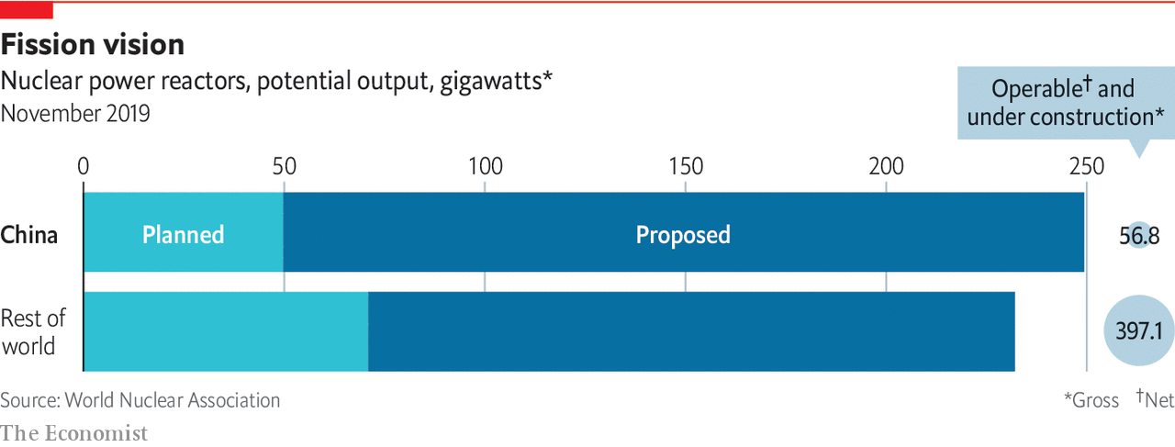

The reactor of choice—Mr Zou says that Li Keqiang, China’s prime minister, has ordered that it be given pride of place—is China’s brand new Hualong One. It is developed from reactors based on French designs, as those were in turn based on American designs, but can reasonably claim to be completely Chinese. Although none has yet been finished (the first is due to be connected to the grid in Fujian province in 2020), two are being built near Karachi in Pakistan. Another is planned for Argentina, and Britain is evaluating plans to build one at Bradwell in Essex. One advantage of such exports is that the Chinese will get the design scrutinised by independent regulators abroad. That China’s nuclear regulator is part of the same government that is urging the industry’s expansion brings with it some serious concerns about safety.

The reactor-export business development of China’s nuclear industry has gone well. Technology-transfer agreements with foreign companies like Framatome were carried out without controversy. Lower wages for manufacturing workers combined with cheap state-backed loans meant that Chinese nuclear plants are some of the most affordable in the world. There have been no accidents in 20 years of operation.

Though many Western experts believe that nuclear power has a real, if smallish, role in the energy systems of the future, exporting nuclear plants may never be a huge business. In most places, the zero-carbon electricity they offer will not be as cheap as wind or solar. The Chinese are aware of this, too. Their renewables industry has grown even faster than nuclear power and the two sources are providing the country with broadly similar amounts of power. Again, the story is one of taking a foreign technology, indigenising it and scaling it up massively. Whether it be turbines, reactors, trains or satellite launchers, China has mastered this procedure. ■

Read this article on <https://www.economist.com/technology-quarterly/2020/01/02/chinas-nuclear-industry-and-high-speed-trains-are-world-class>

|  |  |  |  |
| --- | --- | --- | --- |
| Previous | Articles | Sections | Next |

|  |  |  |  |
| --- | --- | --- | --- |
| Previous | Articles | Sections | Next |

Cars

# China has never mastered internal-combustion engines

Electric cars will be different



Jan 2nd 2020

AT A SHINY new factory in the suburbs of the port city of Wenzhou in south-eastern China, a sturdy robot arm picks up a curved sheet of glass. As a vehicle crawls past it on a conveyor belt, the arm gently nestles the windscreen into its housing, then swivels back to get its greedy suction cups on the next one. Bleepy electronic versions of “Greensleeves” and “Baa Baa Black Sheep” blare out over the factory floor every so often, signalling break time for one of the various groups of human workers.

This is the first factory of a newish Chinese firm called WM Motor. At the end of the production line, brand new electric SUVs roll out into the world at a rate of about 16 every hour, two-thirds of the factory’s maximum rate. Though it currently makes only the one model, the company’s global ambitions are clear. The car’s Chinese name is Weima, which means “powerful horse”. Its Western name is a German word, Weltmeister, which means “world champion”. The German name is the one to focus on. Executives in China’s electric-vehicle industry believe it has a chance to do something that its older internal-combustion-engine carmakers never managed—become a global force.

That is quite an ambition for a Chinese car company. Though China may now make nuclear-power plants able to dominate the world market, its domestic internal-combustion-engine cars cannot dominate even the Chinese market. The best-selling manufacturers are VW and Honda, whose vehicles are built by local joint ventures. This is because nuclear reactors, although they need extremely strong and carefully engineered components, are basically souped-up kettles. A car, and especially its engine, is something much finer, its pistons and valves continuously dancing, the string of explosions in each cylinder perfectly timed, the amount of torque transferred through the camshaft to the wheels just what the driver expects, all of it owned by someone who wants to devote as little time to maintaining this mechanical miracle as possible—ideally, none.

No amount of technology transfer, legitimate or otherwise, can boost a country to pole position in such an industry. As Japan and South Korea have shown, it takes decades of intense investment, hard graft and astute leadership to develop the engineering know-how and the intricate supply chains that make such things possible. China does not have the patience for that. “You would have to invest billions of dollars for another 20 years, and maybe then we would be getting close to the Germans,” says Freeman Shen, WM’s founder. “It’s hopeless.”

Tapping into existing supply chains might make things easier; but although China has the access this takes in electronics, in cars it does not. And the car industry’s supply chains are lines of co-operation as well as commerce. To make affordable, high-quality cars you do not just need the likes of Bosch to sell you off-the-shelf components. You need their active co-operation in creating just the right parts. If providing that co-operation means risking established business with bigger, better incumbents, it is unlikely to be completely forthcoming.

## No ICE, baby

Chinese EV firms like WM think that the fact that they depend on a completely different—and more electronic—set of components means they can do an end-run around the internal-combustion incumbents, taking the lead in a new industry rather than catching up in an old one. And they are the only ray of light in a very gloomy Chinese carmaking outlook. The rest of the car market has been shrinking for 16 straight months. Sales of EVs have been set back by cuts to the government subsidy programme in 2019, but nonetheless the government still wants a quarter of all cars sold by 2025 to be electric. Today they account for only 7% of the market. But China being China, that still works out as 1.5m vehicles a year, making it the largest EV market in the world.

The market is dominated by Chinese incumbents moving from internal-combustion vehicles to EVs. But there is also a pack of startups. Nio may be the most famous, but WM is perhaps the most ambitious. It owns and operates all of its factories, and although it said it had delivered only 12,600 cars in 2019 when your correspondent visited in October, it says it will soon have the capacity to produce 200,000 a year in Wenzhou, and that a slightly bigger plant in Huanggang, 630km inland in Hubei province, will make another 300,000 cars a year when it is completed.

These facilities come with the compliments of the provincial governments in Zhejiang and Hubei. Officials see the factories as bringing their provinces jobs, prestige and VAT receipts, which in China are collected when the car leaves the factory. And if WM succeeds, the officials associated with it will earn the sort of kudos that can elevate them a long way in the party hierarchy. Nio and Xpeng, WM’s venture-capital-backed competitors, have not yet benefited from quite this level of largesse. They are having their cars made by contract manufacturers, which is less capital-intensive but also yields less control over the process.

Getting high-tech factories built for nothing gives WM a chance to achieve something that China’s combustion-engine car companies never managed: develop core technology that is globally competitive. Mr Shen, a car-industry veteran, says he has had 1,000 engineers dedicated to working on electric vehicles for the past four years. “I guarantee that the largest car company in the world, Volkswagen, does not have 1,000 engineers dedicated to electric vehicles,” he says.

Mr Shen’s focus is on the EV’s battery packs and the power-management systems that distribute electricity around the vehicle. Because the battery pack is the most expensive part of the car, squeezing the same range out of less battery is a competitive advantage; that is what WM’s innovative battery-cell configurations are meant to do. Mr Shen says WM holds 1,200 patents, with the most important ones around the car’s battery, electric motor and control system. That is because such innovations could be reverse-engineered. The software that manages the battery’s thermal properties in a crash, on the other hand, is a complex trade secret.

Mr Shen says he expects the best electric-car companies to start building their own batteries eventually. Those have hitherto been sourced from giant companies like CATL, a Chinese firm which holds a large share of the global electric-vehicle-battery market. Big car companies would never source their engines from third parties; integrating them closely into the design and production process improves overall performance. Mr Shen expects electric cars to be no different.

Beside Nio and Xpeng, WM’s stiffest competition in China will come from two foreign firms, Tesla and VW. Tesla’s boss, Elon Musk, says the company’s Shanghai gigafactory will be making 1,000 cars a week by the end of 2019; they will mostly be its Model 3, which is both its cheapest car and, at 355,800 yuan ($50,000), still very expensive for the Chinese market. The factory, built in just eight months, is designed to make 500,000 cars a year.

Meanwhile, Volkswagen is refitting one existing Chinese factory and building a brand new factory to produce 600,000 EVs a year. It expects to produce 1m electric cars a year in the country by 2022 and to have manufactured 11.6m electric cars in China by 2028. If those ambitions are fulfilled the firm’s EVs will have captured about 5% of the total Chinese car market.

## Plug me in, beam me up

All this ambition suggests that there may be a bust on the way, and that the EV startups may suffer badly from it. WM is hoping to turn those particular lemons, grown through overzealous and incontinent state aid, into lemonade. It expects many of its smaller competitors to go bust over the next few years, especially now that the subsidy programme has been stopped. That will free up talented engineers.

A more rationally delivered advantage that the state is providing for WM and others hoping to sell EVs in China is charging infrastructure. This makes buyers more confident. The state also facilitates the roll-out of advanced technical features for the benefit of the public at large. Mr Shen says that WM is planning a pilot with State Grid, China’s largest utility, in 2020 whereby the batteries in its customers’ cars will be used as grid storage to help balance the flow of electricity in Beijing and Shanghai.

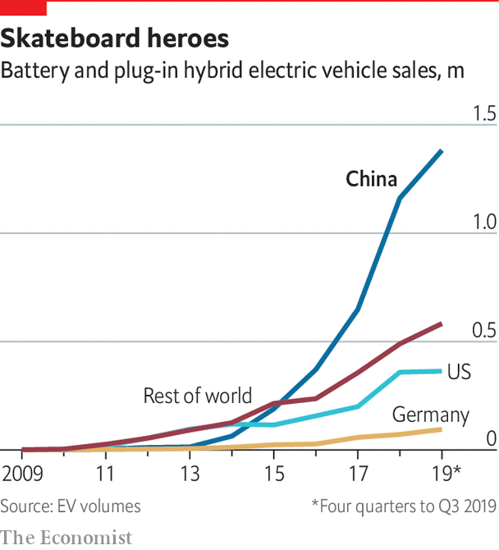

Even if WM fails, China is set to be a large market for EVs long before any other country, and that will benefit the industry as a whole. Because the government demands that all cars sold in China are made with Chinese components, the country will come to host the world’s most important supply chains for electric cars. This opens up the possibility that Chinese supply chains will eventually be used to provide components for the rest of world, as with smartphones.

It also suggests that such a strategy could see Chinese EV makers capture a lot of the value from vehicles made elsewhere. Their simplicity, compared with cars powered by internal combustion, makes EVs easier to manufacture in sections. Because there are no cooling fluids to pump around the vehicle, no drivetrain to run through the floor of the cabin, and no engine block poised to crush occupants in the event of a crash, the top and the bottom of the car can easily be separated out and produced independently. The bottom part, which contains the complexity of battery and power-management electronics, is called the “skateboard”, and embodies the lion’s share of the value of the car.

Mr Shen imagines a scenario in which his firm’s skateboards are shipped around the world to be integrated with bodies and interiors created by other manufacturers that have failed to create their own core EV technology. It would be a complete reversal of the situation today, where Chinese car companies need Western firms to supply the most valuable components. China’s huge market for EVs is creating a supply chain that startups like WM and self-reinventing incumbents like vw will rely on. That may end up being an advantage for the Chinese industry on a global scale.■

Read this article on <https://www.economist.com/technology-quarterly/2020/01/02/china-has-never-mastered-internal-combustion-engines>

|  |  |  |  |
| --- | --- | --- | --- |
| Previous | Articles | Sections | Next |

|  |  |  |  |
| --- | --- | --- | --- |
| Previous | Articles | Sections | Next |

Intellectual property

# Chinese inventiveness shows the weakness of the law

Entrepreneurs struggle to retain control of their inventions



Jan 2nd 2020

AS THE DOTCOM boom was approaching its peak in 1999, Yi Li was working for JDS Uniphase, a Silicon Valley company that made lasers and optical fibres. JDS was a high-flyer, with a market capitalisation fives times the value of Apple at that time. Investors loved the firm for its role in building out the infrastructure of the internet. But when boom turned to crash JDS’s share price plunged by 99.8%. Employees whose stock options had made them paper millionaires lost it all overnight. “I got killed by the bubble,” says Mr Li. “I was too young, too naive. But it was a very good lesson.”

The lesson was one that Mr Li would put to good use back in his native China. But even though he went on to make the fortune that he missed out on with JDS, he discovered first-hand the problems that Chinese entrepreneurs face in protecting their inventions in a nation where protections for intellectual property are nascent at best. His tussles to retain control of his inventions typify a big barrier to China’s technological advancement.

As he picked himself up, Mr Li asked himself where all the money that had poured into JDS had gone. Had it really just evaporated? He decided that, in fact, the apparent financial destruction of the company was what physicists call a phase change—the stuff was still there, but arranged in different forms. The money that had poured into the manufacture of communications equipment had made that equipment cheap, made the construction of a global internet feasible, and the future growth of internet companies a possibility. He developed a thesis for future success: in the wake of any over-investment there would always be a related opportunity to build upon its ashes in the form of newly cheap supply chains. The money that had been in JDS had flowed off towards the next generation of internet companies that its infrastructure had enabled: Google, Amazon and eBay.

Next time he saw a bubble, Mr Li was ready. It was 2004 and money had poured into the manufacture of light-emitting diode (LED) bulbs designed to illuminate rooms much more efficiently than incandescent bulbs. The price of the bulb’s fundamental component, the blue diode, had crashed. Mr Li saw that as an opportunity to develop a new kind of product: a laser projector that relied on the same supply chain that was pumping out cheap blue LEDs. At the time laser projectors were bulky and expensive because they needed three different types of laser, one to project each of the three additive primary colours of red, blue and green. But only the cost of blue laser components had crashed. Red and green lasers were still expensive.

Mr Li started thinking about how to make a laser projector using just blue light. Most cheap LED bulbs work by shining blue light generated by a semiconductor through a phosphorescent filter that absorbs it and re-emits red and green light in its place, thereby producing white light from the mixture. The same works with a laser but, because its light is so intense—1,000 times brighter than an LED—the phosphor filter burns out immediately. Mr Li came up with a ridiculously simple solution. Instead of keeping the filter static in front of the blue laser light, he set it spinning, a disc of phosphor which, if kept moving, could pump out red and green light, as well as blue, while relying on just a blue laser source. The spinning filter did not burn out, because no single spot was ever subjected to enough light intensity for long enough. Mr Li had found a way to tap the cheap blue-LED supply chain and build a laser projector that was ten times cheaper than the competition.

Once he had his design, Mr Li set up Appotronics in Shenzhen, as close to the LED supply chain as he could get. This cemented his first-mover advantage. His system for making a fully fledged laser projector out of a single blue diode was simple and easy to reverse-engineer, so he had to rely on patents for protection. If he had tried to keep it a secret and corner the market, competitors would have torn his devices apart and quickly copied them.

The design was a global hit. If you have recently used a cheap, portable projector that throws a surprisingly good image, it is likely to contain Mr Li’s design. He estimates that Appotronics is the only Chinese firm that holds a patent that has been cited as “prior art” more than 400 times, a sign that large numbers of companies are using the idea. Apple, the beacon of Silicon Valley innovation, has only a few dozen patents cited so often. A suitably bloodthirsty competitor can license the patent, then use it to develop a better product. But Appotronics’ proximity to the Chinese LED supply chains meant it could move much faster than its competitors in building improved new versions of the product.

While China’s supply chains have buoyed up his company, its intellectual-property (IP) system has held Mr Li and his firm back. The American government reels off a long list of problems with the Chinese system, such as trade-secret theft, failure to respect intellectual property and failure to license software (a $6.8bn hole, according to the American government). Mr Li’s problem is the cap on compensation for patent breaches. He says it is too low to disincentivise IP theft. This year the cap was raised from 1m to 5m yuan but that is still not very much. “The average payout in the American system is $2m. In China it’s 80,000 yuan ($11,300),” says Mr Li. “People [in China] are not going to waste money doing patent litigation. You discourage local companies from doing innovation.”

## So sue me

If Chinese companies do take patent disputes to court, the process often takes years—a lifetime for a young startup. But that is still progress. China did not have any patent law until 1985. Specialised courts for hearing IP cases were introduced in 2014. An analysis of those courts’ performance carried out by Renjun Bian of the law school at University of California, Berkeley, shows that, perhaps surprisingly, they have so far favoured non-Chinese patent holders over domestic ones. Ms Bian found that foreign patent holders were winning more cases, receiving injunctions at higher rates, and being awarded larger damages than domestic ones. Those results are probably a reflection of the legitimate nature of foreigners’ grievances—but they are also a sign of the courts’ good faith.

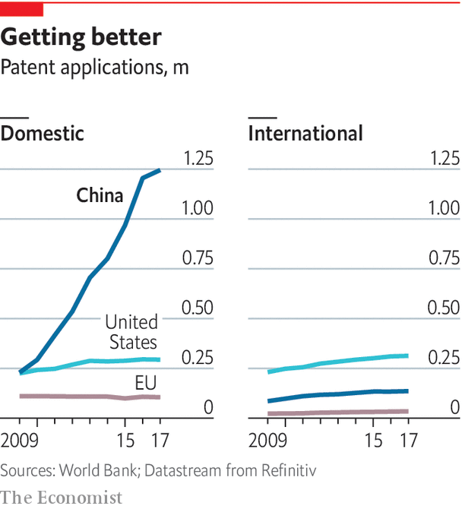

China’s progress on intellectual property (see chart) is not proving enough for America’s trade hawks. But internal pressure from innovators like Mr Li is more likely to create positive change in China’s IP system than a trade war is. This presents a conundrum for American policymakers. The best path to a Chinese system which respects and protects intellectual property is for China itself to become more innovative. And yet that very same Chinese innovation, and the more efficient use of resources as a nation that it makes possible, is unsettling to Americans.

The obsessive focus on the handling of IP in China also misses the bigger picture. Access to intellectual property is just one aspect of successful technology development. Mr Li’s valuable IP is sensitive because his design is simple and does not require a complex supply chain to produce (though being right next to the LED factories of Shenzhen has certainly been an advantage). His patent portfolio is the biggest edge he has.

In the case of more complex technologies like vehicles, nuclear plants or semiconductors, other factors matter more—relationships with suppliers, access to affordable labour, the know-how to use the IP at all. As the West grapples with China’s technological rise, it should remember that it holds great power in these less tangible areas beyond IP, areas from which it is hard to pilfer.■

Read this article on <https://www.economist.com/technology-quarterly/2020/01/02/chinese-inventiveness-shows-the-weakness-of-the-law>

|  |  |  |  |
| --- | --- | --- | --- |
| Previous | Articles | Sections | Next |

|  |  |  |  |
| --- | --- | --- | --- |
| Previous | Articles | Sections | Next |

Data

# China’s success at AI has relied on good data

But cheap labour has also played an important part



Jan 2nd 2020

CHINA IS THE land of face recognition. Cameras able to extract face prints from passers-by are common in the streets of large cities like Guangzhou and Shenzhen. Boxy vending machines at airports offer to let you pay for a cup of orange juice, robot-squeezed for perfect freshness, by scanning your face. From December 1st all people applying for an account with one of China’s telecoms companies such as China Mobile must have their face scanned. Previous regulations required proof of identity, but the possession of users’ face prints will let firms verify identities in real-time via smartphone cameras.

Considering the oppressive purposes to which this technology is being put—most notably in the Muslim-majority areas of north-west China—it would not be appropriate to call China’s rapid adoption of it anything more than a technical success. The underappreciated fact that companies leaping ahead in the field are more reliant on cleverly deployed cheap labour for their progress than on any technological edge, suggests another reason for caution before declaring a Chinese victory in the tech wars. But understanding how China has got face recognition to flourish is nonetheless instructive. Two of the world’s most valuable startups, Megvii and SenseTime, worth $4bn and $7.5bn respectively, are Chinese AI companies specialising in the field. Their application of it alone would make it one of the most widely deployed forms of artificial intelligence in the world.

Like most companies deploying intelligent software, Megvii and SenseTime rely on a technique called machine learning. They do not ask their human coders to program computers with rules that distinguish between one face and another. Instead the coders provide the computer with masses of data about faces, usually photographs, and write software which trawls through those photos looking for patterns which can be used reliably to tell one unique face from another. The patterns picked up by that learning software make better rules for recognising faces than anything a human coder could describe explicitly. Humans are good at recognising faces but, with the right software, computers can learn to be much better. Face-recognition software is much easier and cheaper to deploy than human recognisers. It just needs software, powerful computers and data—the new trinity of AI.

It is in the third of those categories, people will warn you, that China’s great advantage lies. It has loads of data. But its advantage is subtler than that. Data alone are not much use for building AI software. They must first be labelled. This means that the data set must be endowed with the contextual information that computers need in order to learn statistical associations between components of that data set and their meaning to human beings.

To learn to differentiate between cats and dogs, a computer is first shown pictures in which each animal is correctly labelled. To learn to distinguish between one person’s face and another, a computer must first be shown what a face is, using labelled data, and then how to tell the difference between cheekbones and brows, again via human labelling. Only with enough labelled instructions will it be able to start recognising faces without human help.

Underpinning companies like Megvii and SenseTime is a sprawling digital infrastructure through which data are collected, cleaned and labelled before being processed into the machine-learning software that makes face recognition tick. Just as Apple adds its brand to phones mostly assembled by cheap Chinese labour, so too the Chinese AI companies design and brand AI software and services which sit atop a data supply chain using cheap labour at Chinese data factories no one has ever heard of. Megvii has spent 218m yuan ($31m) on labelled data in the past three and a half years, according to its IPO prospectus. Many of the algorithms used contain little that is not available to any computer-science graduate student on Earth. Without China’s data-labelling infrastructure, which is without peer, they would be nowhere.

Charles Liu is the founder of one of China’s largest data factories, known in English by the initials MBH. He employs 300,000 data labellers across China’s poorest provinces. Each labeller works a six-hour shift each day, tagging a stream of faces, medical imagery and cityscapes. MBH pushes a stream of data to them as if on a digital conveyor belt, and they churn through it, creating the syllabus from which machines learn. They can turn it off to take a bathroom break, but that is the extent of their control. They do not choose which data to label but have them chosen for them.

Mr Liu claims that MBH’s trick is not just numbers, but the methods the firm uses to distribute labelling work efficiently to its workers. This is done using the same kind of machine-learning systems that Amazon, an American e-commerce giant, uses to recommend products to its customers. Instead of suggesting stuff to shoppers, MBH assigns labelling tasks to workers. First, it gathers data from its workers as they carry out labelling jobs. Mr Liu says the company records its workers’ gaze, mouse movements and keyboard strokes. It also takes note of what sort of data-labelling task the worker is performing, from medical-imagery labelling to text translation. By measuring performance according to the type of task, he says, he is able to find workers who are better at some tasks than others, and steer those tasks to those workers.

All of this happens automatically as MBH’s customers feed tasks into the company. At its most finely tuned, Mr Liu says these systems let his army of workers classify data almost in real time. In work for TikTok, a popular short-form video app owned by ByteDance, a company based in Beijing, he says MBH’s data labellers handle imagery which TikTok’s automated system cannot be sure is not pornographic. MBH shows the putative porn to hundreds or thousands of human workers who, like Justice Potter Stewart, know it when they see it. The company then returns their aggregated answer to TikTok in less than a second.

## AI arbitrage

For their efforts, MBH’s workers are paid an average salary of 3,000 yuan ($425) per month, three times more than the average worker in China’s poorest regions. Mr Liu can deploy wage arbitrage between the richest and poorest places, using the internet. In many ways MBH’s business works like Uber, a ride-hailing firm, as a crowdsourcing platform connecting supply of labour with demand. But the minimum wage that Uber can reasonably expect its drivers to take home is constrained by geography, as its drivers must live within a few hours of their markets. This restricts them to urban areas with high living costs, putting a lower bound on even the stingiest wage. Mr Liu suffers no such constraints. Workers from areas in which 3,000 yuan per month is a fine wage can happily label data for AI companies in Shenzhen, where it is not.

Many provincial governments are keen to get Mr Liu to open a data factory in their region and offer much-needed jobs. For every 5,000 workers MBH employs in a given month, local governments pay the firm 50,000 yuan. Across all 300,000 workers that adds up to 3m yuan ($425,000) in government money every month.

Mr Liu says that his firm sees fewer and fewer face-recognition labelling tasks these days compared with the boom of 2017. Increasingly common now are labelling requests for medical imagery from which software can learn to diagnose disease. There are also endless streetscapes which, once labelled, can teach autonomous cars about the cities they must navigate. Those are more difficult labelling tasks. Whereas every human knows what a face looks like, not everyone understands what a tumour looks like in an X-ray. Labelling such conditions requires specialist knowledge, and means that MBH must pay its labellers more money. Still, those labelling requests are indicative of the kinds of AI service that may reach widespread adoption in China in a few years’ time. Mr Liu says he will expand his workforce by 50% next year.

Without this data-labelling infrastructure, China’s AI services would not have taken off. Labelling services like MBH are what have allowed Alibaba to create a powerful machine-learning service like Taobao’s image-based product search. An Alibaba shopper can take a photo of an item in a shop window and immediately be steered to a page where they can purchase it. Alibaba processes a billion images like this a day. It also relies on labelled data for the machine-learning algorithms that are used in its retail stores, which operate under the brand Hema. Cameras installed throughout the glitzy new supermarkets track shoppers around the store and identify the products they take off the shelves.

Masses of labelled data don’t just make for powerful machine-learning software. By studying the inner workings of the software, microprocessor architects can concoct powerful new chips designed specifically to run machine-learning tasks. China’s digital infrastructure has produced some of the world’s most powerful such systems. Now those systems are producing, in turn, AI chips that are competitive with the best Silicon Valley has to offer. ■

Read this article on <https://www.economist.com/technology-quarterly/2020/01/02/chinas-success-at-ai-has-relied-on-good-data>

|  |  |  |  |
| --- | --- | --- | --- |
| Previous | Articles | Sections | Next |

|  |  |  |  |
| --- | --- | --- | --- |
| Previous | Articles | Sections | Next |

Microprocessors

# China is slowly moving up the microprocessing value chain

Getting good at designing is easier than at manufacturing, however

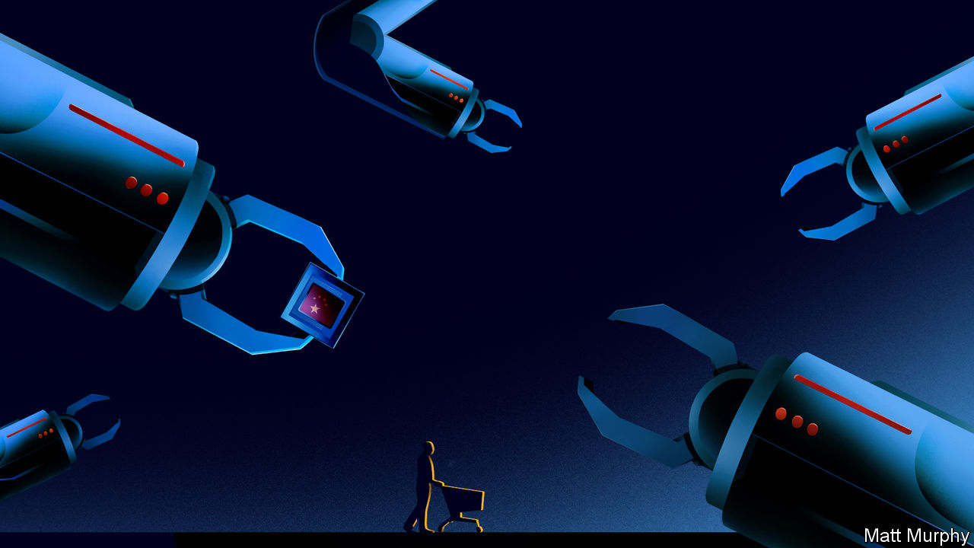

Jan 2nd 2020

THE FORTUNE PRECISION EQUIPMENT COMPANY makes chunks of metal. Hulking sheets of it are cut with millimetre accuracy using robot arms in room-sized enclosures bearing the brand of their German or Japanese manufacturers. The white spray of cooling lubricant makes the process look like an industrial-strength shower for some post-modern Cleopatra.

Based in Shenyang, five hours north-east of Beijing by train, Fortune is the bottom rung of the most important and complex supply chain on Earth: the one which produces the integrated circuits, or chips, found in smartphones and servers. Fortune’s robots make parts for equipment which will be installed in factories in Taiwan and Oregon, and used to etch circuitry on silicon and make chips. Selling equipment to industry giants like Applied Materials in America makes it a small success for the semiconductor supply chain. Much of the rest of the industry is not doing so well.

Failure to make cutting-edge chips is not exactly China’s fault. It is a difficult industry to kick-start. The factories that produce the chips are phenomenally expensive. The technology itself is even more complex than an internal-combustion engine. The intellectual property behind cutting-edge processes is fiercely guarded. In many ways the manufacturing of chips represents the supreme technological challenge for China, an amalgamation of all the other challenges presented in this report. It will have to call upon everything it has learned from successes and failures like nuclear plants and engines if it is to succeed.

The Chinese government is trying hard (the country’s biggest chip factory, SMIC, a private firm, has settled many suits over IP theft). In October the government raised 204bn yuan ($29bn) from the finance ministry, state-owned firms and local governments for its domestic chipmaking efforts. That followed 139bn yuan raised in 2014. The problem is that the government’s chip programme is optimising for the wrong thing. Instead of trying to stimulate a domestic chip industry to meet China’s huge market needs, the funds are being spent on trying to reach parity with chip companies like Intel.

Chips are a vital product to China because they are fundamental to any technology-led growth that the country desires for its future, as well as for making weapons. PwC, a consultancy, estimates that the global market for chips will grow by 4.6% a year, to be worth $575bn in 2022, driven by the requirements of cars, AI systems and communications networks.

Currently a huge share of that market value moves through China, but is not captured by it. The 418bn chips the country imported in 2018 cost $312bn, a quarter more than it spent importing crude oil. And beyond grabbing a larger part of the value chain for itself, controlling the production of chips would also give China indirect control over myriad other industries, from social networking to personal computing.

Most of the state-led efforts have failed so far. SMIC is on the verge of producing chips at levels of sophistication roughly equivalent to those reached by Intel a decade ago. Its revenues—$3.4bn in 2018—were about a tenth those of TSMC, its Taiwanese rival. SMIC is not yet globally known for its quality and reliability. But Fortune is making progress. It used to ship its metal components off to third parties in Japan and Taiwan to be cleaned up. Today it does not need to do that. The firm has its own clean rooms where it sands down its shiny aluminium components and gives them a smooth grey coating before vacuum packing them in thick plastic. The firm has also started shipping more complex components to its suppliers, simplifying what its customers have to do while capturing more of the value of the final product.

Although Chinese firms are still behind in the manufacture of chips, they have recently achieved some success with designing them for AI applications. In late September the nerdier corners of Silicon Valley were abuzz after Alibaba, a Chinese tech-giant, released Hanguang 800, a chip designed specifically for carrying out machine-learning tasks. Even though Alibaba relied on TSMC in Taiwan to fabricate the chips, AI engineers in the Valley remarked on the Hanguang’s performance, stating that it had beaten all other chips in its class. This was not supposed to happen, as China was thought to be well behind American chip companies.

## Faster, higher, stronger

On November 6th the latest results of MLPerf, an industry-standard benchmark for AI chips, were published. They showed that the Hanguang 800 chip was performing a standardised machine-learning task 13 times faster than the chip that Intel had just released (see chart). The comparison is not totally fair, as the Alibaba chip was made physically larger than the Intel chip, letting it draw more power and perform more calculations per second. But even compared with a bigger chip from Nvidia called the Titan RTX, the Hanguang 800 clocked in four times faster.

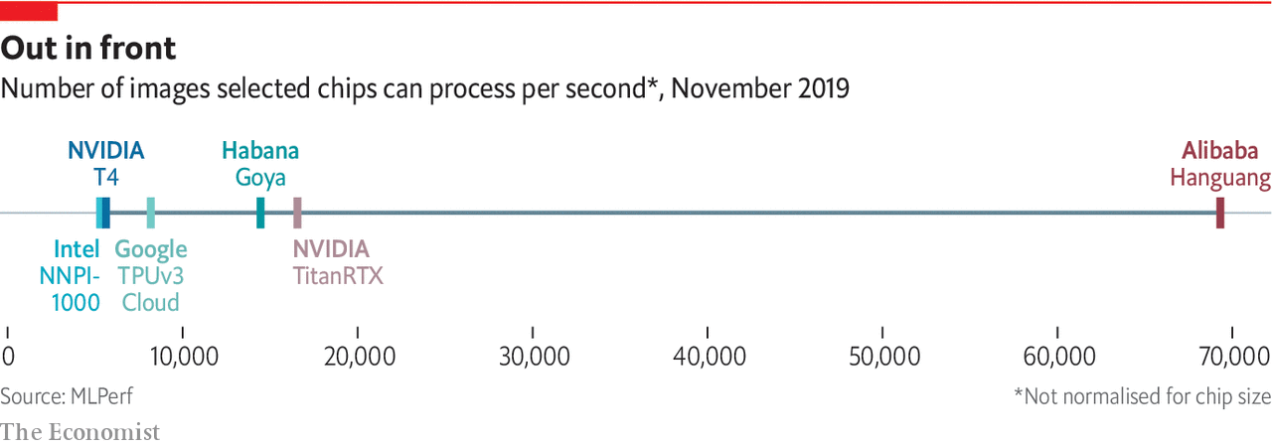

There are probably more caveats. Alibaba ran only one out of five tests. Poor performance in the others would betray a chip over-optimised for one task. But even in the most pessimistic scenario it is impressive. That a Chinese company has designed an AI chip which performs as well as, or better than, its Western competitors should alert American politicians and innovators to China’s progress in this area.

Whereas Fortune’s more industrial flavour of success in the manufacturing supply chain took a traditional route for Chinese firms—start at the bottom and work up—Alibaba’s success in designing a chip is more interesting. It is rooted in its wide deployment of machine-learning systems across its business, both in its Taobao online market and its Hema shops on the high street. The firm processes billions of images a day as part of its normal operations, and the machine-learning software it has trained to do that work is now very accurate and powerful.

The Hanguang 800’s designers spent a lot of time sitting next to the coders who built those algorithms. Their job was to work out how to render the algorithms in silicon, so the more time they could spend learning from engineers writing high-performance algorithms, the better. By being close to the market in which AI is used, like Taobao’s and Alibaba’s offline shops, the Hanguang designers were able to tweak the design of the chip to optimise its performance on those tasks. Indeed, in many ways, the data-labelling grunt work that makes Alibaba’s machine-learning algorithms as good as they are translates directly into the high performance of its new chip. China’s strength in data-labelling at the very bottom of the AI supply chain is translating into design strength at the top.

## Must do better

In other parts of the semiconductor supply chain, things are less rosy. Several executives, who asked for their names not to be attached to criticism of government policy, said that the stimulus had been going to the wrong place in trying to catch up with Western giants such as Intel, or TSMC in Taiwan. While Hanguang 800 is remarkable, Alibaba’s design work is a far less capital-intensive, less complex process than the physical manufacture of a chip (which, in Hanguang’s case, was still done in Taiwan).

If catching up on internal-combustion engines was hard, doing so on traditional semiconductor manufacturing will be close to impossible. The market for chips is changing fast. Instead the government would do well to focus on stimulating both design and manufacture of chips aimed at middle-end markets such as the internet of things, and emerging areas like AI.

In one way, China’s challenge with chips is even harder than the problem it faced with combustion-engine cars. There is no completely new technology arriving which will free China from the need to catch up with the rest of the world. But China’s chip companies should still listen to the market, not chase prestige.

Manufacturing and designing chips for the internet of things and AI applications offers an opportunity to leapfrog less agile chip companies, even if it is not the wholesale opportunity that electric vehicles present. If they can focus on these new areas and be patient, it is likely that the scale and depth of the country’s resources could end up winning its companies a permanent spot high on the global supply chain for semiconductors.■

Read this article on <https://www.economist.com/technology-quarterly/2020/01/02/china-is-slowly-moving-up-the-microprocessing-value-chain>

|  |  |  |  |
| --- | --- | --- | --- |
| Previous | Articles | Sections | Next |

|  |  |  |  |
| --- | --- | --- | --- |
| Previous | Articles | Sections | Next |

The future

# Technological progress in China could still lead to fireworks

Is a showdown likely with America?



Jan 2nd 2020

CHINA’S TECHNOLOGICAL rise, brought about by an authoritarian state actively guiding a market-oriented industrial base with access to global supply lines, is unlike anything in history. That does not necessarily make it unstoppable, or world-beating. But the possibility that it will provide a definitive edge in technologies vital to 21st-century success makes the West anxious.

America, in particular, is unsettled by the prospect of Chinese technological capabilities that might erode its geopolitical dominance. Behind their legitimate concerns that China has stolen IP and that some of its companies cheat, American politicians worry that China’s approach to technological development can produce results which America’s mostly market-led model cannot.

It is true that China has shown that a determined state can do much to accelerate the appropriation, diffusion, development and large-scale implementation of new technology and technology from elsewhere. It is also true that the processes by which it does so can be damaging—the state can misallocate resources, follow foolish fashions, refuse to accept that it is barking up the wrong tree. Patronage lends itself to corruption. China shows all these failings and more.

At the same time, alignment between the state and the companies that develop and build technologies is important not just because it allocates, or misallocates, funding. The state may call on technology to answer questions that the market, left to itself, would not. In China the alignment between government policy and corporate technology development can be seen in the shift towards electric vehicles, largely to cut air pollution. Government-led invention has a strong history in America, too. The network which became the internet was developed to test new approaches to military communication. But it has fallen from fashion.

Some suggest that the world could divide into techno-camps, with the current system in which most technology spreads globally unpicked—“decoupled”—into competing systems, one controlled by America, another by China. This would be very hard to bring about. Published research, patents, people, contracts, supply chains and technical standards all link Chinese technology to that which underpins all the other advanced economies—and vice versa. The location of the mind fomenting the next world-changing invention is impossible to predict. China can capture supply chains and rule its markets with an iron first. But it cannot capture all the world’s ideas.

Indeed, contributing at the highest level requires the country to change. A smallish cadre of researchers with some independence will often be more effective than an army of boffins required to optimise their output to hit political targets, as can be the case in China. This does not mean that freedom of political thought is necessary for high levels of technological achievement. Rather it suggests that when you use your time to hit mandated goals you will skip real invention in favour of political box-ticking.

One reason not to fear imminent decoupling is that, even at its most successful, China’s model of technological development can proceed only so fast. When a technology is complex and expensive, progress is slow, as is shown in the manufacture of semiconductors. Even assuming you know how to build and run a cutting-edge chip factory, it takes tens of billions of dollars to do so. It also requires close co-operation with an array of high-tech suppliers who are already tightly bound to the existing market leaders.

Since China will not be capturing a large slice of the semiconductor manufacturing pie any time soon, and because semiconductors are vital to future economic growth, the world’s existing locus of chip production gains heightened strategic importance. That the locus is Taiwan—over which China claims sovereignty, and where America has enough influence to urge restrictions on exports—further complicates the situation. Both American and Chinese firms rely on Taiwan for chip supplies, adding to its potential as a cause of conflict. If the tension between America and China keeps ratcheting up, the island nation could well come under pressure from both sides to curtail its supplies to the other. Any meddling risks upsetting the existing delicate balance and leading in a dangerous direction.

That would have been unthinkable a decade ago. At that time China’s technological progress was mostly unopposed by other powerful countries, which profited from it. But the age of perceived mutual benefit is over. It is hard for the world’s powerful countries, particularly America, to tolerate a China with a global outlook, access to advanced technology and real geopolitical heft. America has reportedly already started pressing the Taiwanese to restrict chip exports to Huawei, the Chinese tech giant, though the Taiwanese government denies it.

America should be careful about such interventions. A clumsy attempt to kneecap Huawei has shown that the Trump administration has little grasp of the dynamics of the technology ecosystem in which it is intervening. Its understanding of other aspects of Chinese technological development is probably even hazier. The threat posed by a technologically enabled Chinese Communist Party is real. In responding to it, America must be sure not to become its own worst enemy.■

Read this article on <https://www.economist.com/technology-quarterly/2020/01/02/technological-progress-in-china-could-still-lead-to-fireworks>

|  |  |  |  |
| --- | --- | --- | --- |
| Previous | Articles | Sections | Next |

|  |  |  |
| --- | --- | --- |
| Technology ... | Sections | Finance and ... |

Business

American firms in China: Still worth it

Despite political woes, America Inc is still thriving in China.

LG: Life’s not good enough

LG, South Korea’s cuddliest chaebol, wants a sharper edge.

Entertainment: Thank you for the music

Tencent buys a stake in Universal Music.

Bartleby: A manager’s manifesto

A manager’s manifesto for 2020.

Schumpeter: Cloning Tesla

Cloning Tesla: electric-vehicle wars in China.

|  |  |  |
| --- | --- | --- |
| Technology ... | Sections | Finance and ... |

|  |  |  |  |
| --- | --- | --- | --- |
|  | Articles | Sections | Next |

Still worth it

# Despite political woes, America Inc is still thriving in China

Trade wars aren’t the only complications multinationals face there

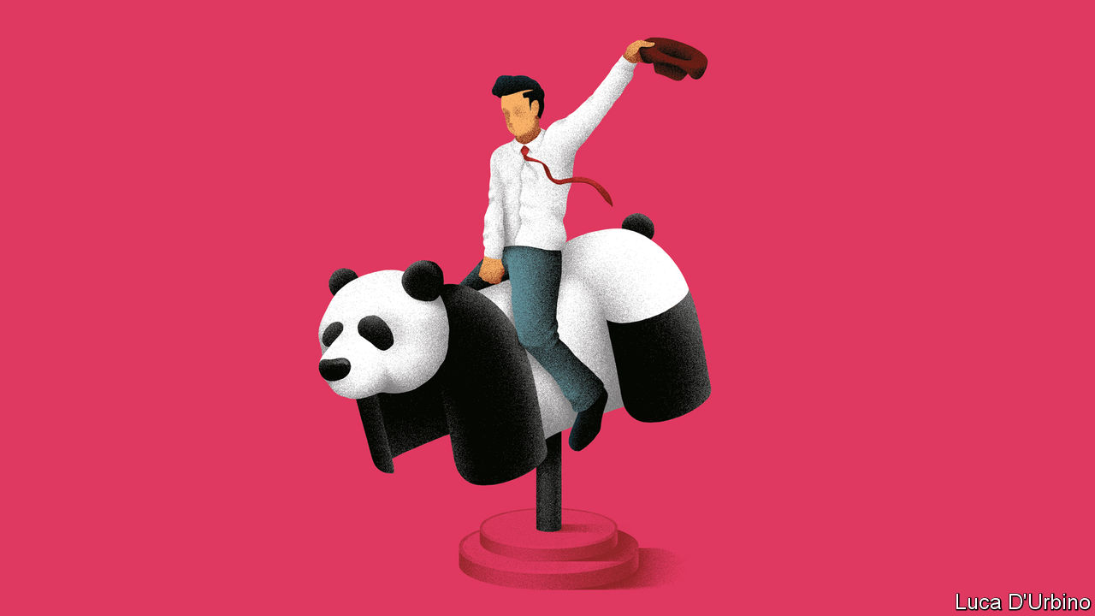

Jan 4th 2020 | NEW YORK AND SHANGHAI

FOUR DECADES ago communist China officially opened its doors to America and its capitalist firms. Politics, once seemingly set aside for the purpose of commerce, has recently made a comeback. President Xi Jinping has stirred up nationalism as part of his effort to consolidate power—worryingly for American firms seen as insufficiently deferential to China’s line on Hong Kong among other sensitive political topics. President Donald Trump’s trade war against China and his crackdown on Huawei, a domestic telecoms-equipment giant, have provoked further anti-American sentiments.

On December 31st Mr Trump tweeted that he will soon sign a “phase one” trade agreement with China. That will lead to some tariff cuts on Chinese imports, and to a presidential trip to Beijing for further haggling. When he visits, Mr Trump will surely hear grouses from his country’s firms about their troubles in China. What they are less likely to trumpet is how surprisingly well they are still doing there.

Some firms are suffering from a backlash arising from the trade war. But its effect on America Inc has been exaggerated. For one thing, American companies on average get only about 5% of their revenues from China (see chart), according to Morgan Stanley, a bank. Though the technology, automobile and consumer-products industries have greater exposure, for others China is an afterthought.

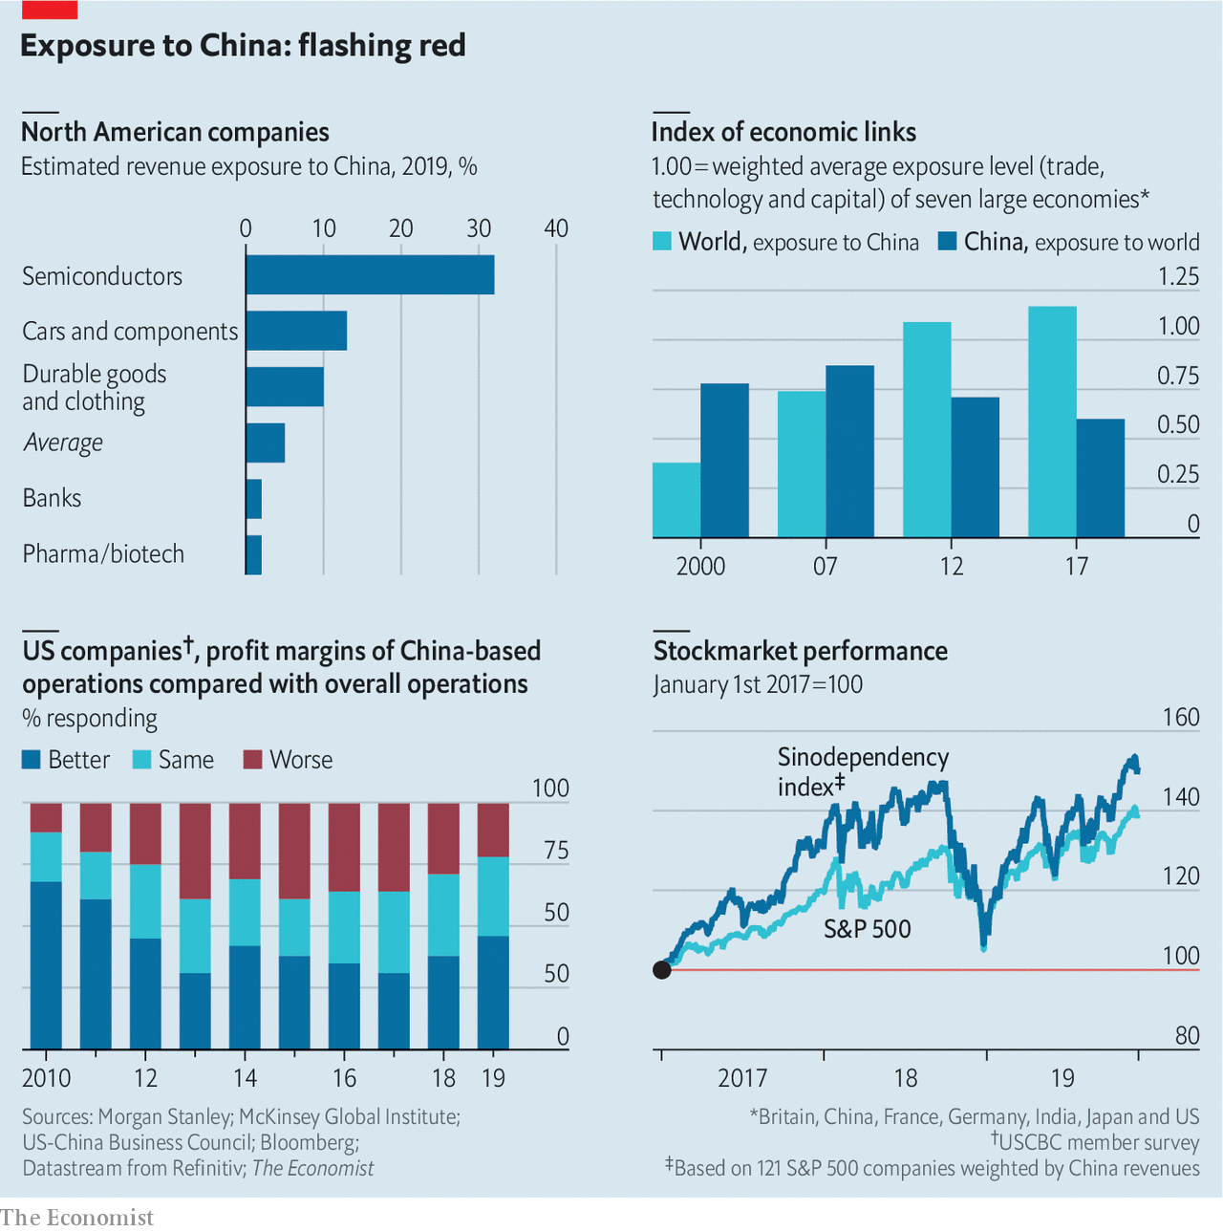

A third of respondents to a survey by the US China Business Council (USCBC), a trade group, claim they have been subjected to “increased scrutiny from Chinese regulators as a result of bilateral trade tensions.” However, local governments with their own growth targets have been rolling out the red carpet this year, foreign executives say. Thanks in part to such efforts, the share of American firms claiming their local operations had been hurt by “Made in China 2025”, an indigenous-innovation scheme America is wary of, plunged from 20% in 2017 to 12% in 2019.

Rising nationalism, stirred up by Mr Xi and embraced with zeal by mainland netizens, may prove a bigger problem than trade tensions. In November DC Comics was forced to pull a promotional poster for a Batman comic book from social media (Batwoman was shown throwing a molotov cocktail) as Chinese critics on social media drew parallels with the pro-democracy movement in Hong Kong. That came on the heels of a much-publicised row involving the National Basketball Association (NBA), after an executive at the Houston Rockets tweeted support for Hong Kong’s molotov-chuckers.

Previous nationalist backlashes stirred up by the Communist Party, for example against Lotte, a South Korean supermarket chain, and Toyota, a Japanese carmaker, led to no more than flash-in-the-pan boycotts. The basketball row, in contrast, is dragging on; the Rockets remain blacklisted in China, and by one reckoning have lost nearly $20m in sponsorship deals as a result.

Being seen to kowtow to China presents its own risks nowadays. The NBA, which claims 600m fans in China, promptly apologised—only for its apology to come under fire in America, including a reprimand from Mike Pence, the vice-president. In July Google scrapped a mooted return to the mainland’s censored online-search market after an employee revolt. Shutterstock, an online-photo agency, faced similar outrage from its workers in November over its decision to censor images in China.

American bosses are now in the unenviable position of having to weigh up the prospect of Chinese official ire with the sensibilities of politicians, employees and consumers at home. This risk will be heightened by increasing international concern over Xinjiang, a province in the west of China where officials stand accused of abusing Uighurs, the largest Muslim group in the country. American firms ranging from Kraft Heinz, a food giant, Coca-Cola, a fizzy-drinks colossus, and Nike, a sporting-goods brand, are reported to have supply chains that stretch into Xinjiang.

Despite these complications, most American firms remain committed to the mainland. The latest survey by the American Chamber of Commerce in Beijing finds that China remains in the top three as a global investment destination for 62% of its members, up from 56% in 2016; 87% of member firms tell the USCBC that they plan to keep doing business in China, roughly the same proportion as in recent years.

The reason is that the mainland remains a huge and growing market for most industries. American firms are still making money there. Andy Rothman of Matthews Asia, an investment firm, even argues that China is “the world’s best consumer story.” In dollar terms, retail sales in China are nearly as big as those in America, but they surged by 6% last year compared with a 2% rise in America. Chinese real incomes rose 120% over the last decade, whereas American ones grew by 17%. American multinationals are benefiting from this rising tide: the vast majority of their operations are not only profitable, but often increasingly so. Nearly half reported their Chinese operations were more profitable than elsewhere in 2019, up from 38% a year earlier.

More Budweiser beer is consumed in China than in America, notes Bruno Lannes of Bain, a consultancy. ABInBev, which brews the quintessentially American tipple, has seen its revenues in China grow more than six-fold even as its profit margins have fizzed. China’s market for fast-moving consumer goods rose by 5.2% in 2018, and foreign firms have benefited. Procter & Gamble, an American consumer-products goliath, says China represents more than 30% of its global sales growth. In December Tesla, an electric-vehicle pioneer, delivered the first EVs produced at its new factory in Shanghai (see Schumpeter).

If the threat from politics seems overblown, there is a genuine worry for American bosses on the mainland: market competition. Chinese smartphone makers have increased their share in the local market for phones costing over $400 from 12% in 2014 to 67% in 2018, says McKinsey, a consultancy. Domestic carmakers, who once made subsidised hunks of junk, have managed to reduce their defect rate by an order of magnitude since 2003; their market share has jumped from 26% in 2014 to 38% in 2018.

This is primarily the result of nimbleness, not subsidies. Unlike state-owned firms, which Mr Xi is propping up with renewed vigour, most Chinese private companies are frugal innovators. Only 9% of American firms complain that local private firms get unfair advantages like tax breaks, licensing approvals and subsidies. Political rows dominate the headlines today, but the longer-term challenge for American firms may prove to be the rise of China Inc.■

Read this article on <https://www.economist.com/business/2020/01/04/despite-political-woes-america-inc-is-still-thriving-in-china>

|  |  |  |  |
| --- | --- | --- | --- |
|  | Articles | Sections | Next |

|  |  |  |  |
| --- | --- | --- | --- |
| Previous | Articles | Sections | Next |

Life’s not good enough

# LG, South Korea’s cuddliest chaebol, wants a sharper edge

Can a newfound appetite for risk help it take on Samsung?



Jan 4th 2020 | SEOUL

BEFORE LG EXECUTIVES mull a new product, corporate types in South Korea like to joke, they first ask themselves: “Has Samsung already done this?” Only if the answer is “yes” does the country’s fourth-biggest conglomerate, which makes everything from consumer electronics and cosmetics to chemicals and health-care goods, move ahead with the plan.

The gibe says a lot about how LG is perceived on its home turf. Unlike Samsung, South Korea’s largest chaebol, which has been mired in scandal, LG oozes reliability and law abidance. When the government urged large groups to unwind their convoluted cross-shareholding structures, LG was one of the first to do so. But cuddliness may have blunted LG’s innovative edge. After years of profit growth the group’s performance has started to show cracks. LG Electronics, its flagship affiliate, has been struggling with plunging earnings in its mobile-phone division, where it faces fierce competition from Samsung, as well as Apple and China’s Huawei. Many are wondering if the “follower” strategy that has served LG well is still fit for purpose.

Koo Kwang-mo, the group’s chairman, may be among them. The 41-year-old took the reins in 2018 after the sudden death of his adoptive father, himself a descendant of the conglomerate’s founder. Although he keeps a similarly low profile to his predecessor, Mr Koo is testing out a more aggressive approach.

In November he appointed Brian Kwon, who had previously run LG Electronics’ mobile-phone and home-entertainment businesses, as boss of the whole affiliate. Mr Kwon’s battle with Samsung in flat-screen televisions involved taking out advertising explicitly mocking Samsung’s QLED technology as a has-been. Such brashness would have been unthinkable under the old guard, says Park Ju-Gun of CEOScore, a corporate watchdog in Seoul. LG Display, which makes the rival OLED technology used in LG’s televisions, is also being overhauled. In September its boss unexpectedly resigned and the company has since sacked dozens of executives and offered redundancy packages to many workers. In order to maintain its lead in large OLED panels it has ramped up capacity at its factories in South Korea and China. It has also sacrificed margins by pouring cash into research and development, hoping to catch up with Samsung in smaller, more profitable screens used in mobiles.

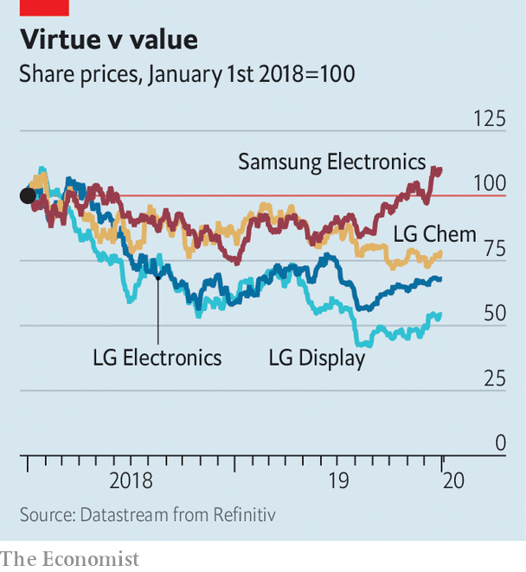

The newish head of LG Chem, Shin Hak-cheol, likewise has a reputation as a risk-taker. Last month the chemicals arm (which, like most parts of LG, is listed but ultimately controlled by the holding company Mr Koo heads) announced a joint venture with General Motors to produce batteries for its electric vehicles in a new factory in Ohio. Although demand for batteries is expected to grow, LG will be exposed to the fortunes of a single carmaker. These developments may be trial balloons for a plan to adopt a less risk-averse strategy for the group as a whole. So far, investors appear unimpressed. Shares of LG’s biggest companies have tumbled in the past two years; for all its scandals and deserved criticism of its governance, Samsung has done better (see chart). LG’s efforts to distinguish itself from Samsung’s vices are laudable. Mr Koo may need to do more to emulate its innovative virtues. ■

Read this article on <https://www.economist.com/business/2020/01/04/lg-south-koreas-cuddliest-chaebol-wants-a-sharper-edge>

|  |  |  |  |
| --- | --- | --- | --- |
| Previous | Articles | Sections | Next |

|  |  |  |  |
| --- | --- | --- | --- |
| Previous | Articles | Sections | Next |

Thank you for the music

# Tencent buys a stake in Universal Music

Streaming has turned the music business around in recent years



Jan 4th 2020

IT WAS A nice example of nominative determinism. On December 31st a consortium led by Tencent, a giant Chinese digital conglomerate, announced it was buying 10% of Universal Music Group, a subsidiary of Vivendi, a French company, for €3bn ($3.4bn). The deal, first mooted in August, gives Tencent a stake in a firm whose catalogue spans artists from ABBA and Bob Marley to Jay-Z and Taylor Swift.

Tencent’s purchase values Universal at around €30bn. That is remarkable, for two reasons. The first is that Vivendi’s total market capitalisation is just €31.5bn. But Universal is merely the largest component of a conglomerate that also includes Canal+, a French pay-TV channel, and Havas, a PR-and-advertising firm. Both bring in profits of hundreds of millions of euros, and Vivendi is only lightly indebted.

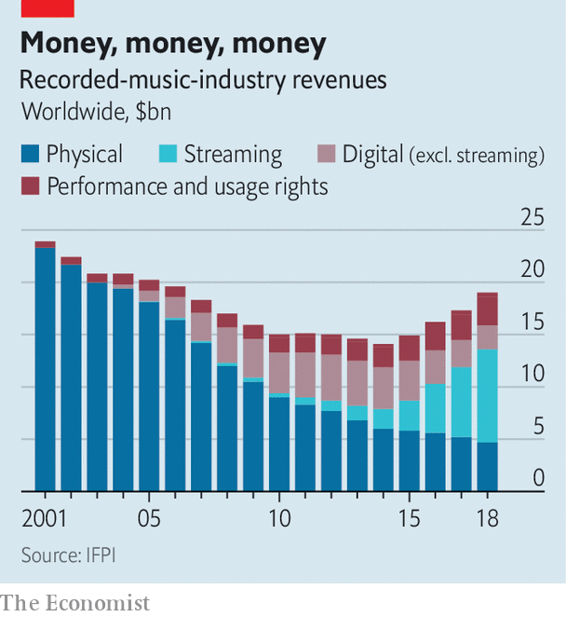

The second is that it illustrates the recorded-music industry’s remarkable recovery over the past few years. The International Federation of the Phonographic Industry, a trade body, reckons that sales of recorded music were $23.9bn in 2001. By 2014 that had dropped by 40%, to $14.3bn (see chart). The industry laid much of the blame on piracy fuelled by the internet.

Nowadays, though, the internet has become the music industry’s best friend. Music-streaming firms like Spotify, a Swedish company, and Deezer, a French one, have outcompeted the pirates with a mix of the go-anywhere convenience enabled by smartphones and subscription-based pricing. For $9.99 a month, Spotify users get access to more than 50m songs (true skinflints can pay nothing, if they are prepared to put up with adverts). High volumes make up for low prices. Spotify alone has over 100m paying users, which helped the firm achieve a valuation of $27bn in its April flotation. It has also helped reverse the decline in music-industry revenues, which are up 34% from their 2014 nadir.

The streaming market is highly concentrated. Spotify and Apple between them account for over half of it. But plenty of firms are nonetheless trying their luck, including Google, Amazon and Tencent itself, whose music-streaming subsidiary has around 35m paying users in China. The latest entrant is ByteDance, best-known for developing TikTok, a trendy social-media app; Resso, its streaming service, was released in India and Indonesia last month.

That rush of new entrants will bring new customers, helping the market grow. It will also boost the firms, like Universal, that control the music that streaming firms must license. Universal’s revenue grew by 24% last year. Tencent’s purchase therefore looks like an attempt to profit from both sides of the game.

It also fits with Tencent’s taste for investing in other firms, and with its growing presence in the Western entertainment industry. The firm is best known for WeChat, a multi-purpose chat, payment and social media app with over a billion users. But it has stakes in hundreds of smaller firms. It is the world’s biggest video-game company: revenues from gaming accounted for around two-fifths of its 2018 total of 313bn yuan ($47bn). It owns Riot Games, the makers of “League of Legends”, an e-sports title whose biggest matches attract tens of millions of viewers. It has a controlling stake in Supercell, the Finnish studio behind the hit mobile game “Clash of Clans”. And it has a 40% share in Epic Games, an American firm whose offerings include “Fortnite”, a popular online shooter. Epic Games was valued at nearly $15bn in 2018.

Tencent Music Entertainment Group, the firm’s streaming subsidiary, was listed on New York’s stock exchange in 2018. Its film-production company was involved with films such as “Wonder Woman” and “Terminator: Dark Fate”, the sixth instalment in the interminable “Terminator” franchise. The Universal deal may likewise not be the end of the story. Vivendi has given Tencent the option to double its stake at the same price, and has hinted that it might sell even more of Universal to the Chinese giant in future. Will Tencent be back? ■

Read this article on <https://www.economist.com/business/2020/01/04/tencent-buys-a-stake-in-universal-music>

|  |  |  |  |
| --- | --- | --- | --- |
| Previous | Articles | Sections | Next |

|  |  |  |  |
| --- | --- | --- | --- |
| Previous | Articles | Sections | Next |

Bartleby

# A manager’s manifesto for 2020

Eight resolutions to adopt in the new year



Jan 2nd 2020

THE START of the year is traditionally the time to make resolutions to change your behaviour. Hardly anyone keeps them, of course, but in the spirit of optimism, here are Bartleby’s eight suggestions for what managers ought to resolve to do in 2020.

1. Give out some praise. People don’t come to work just for the money. They like to feel they are making a valuable contribution. Praise doesn’t have to happen every day and it cannot be generic. Pick something specific that a worker has done which shows extra skill or effort and single them out; ideally so that others can hear the compliment. This is particularly important for the most junior employees, who will feel anxious about their status.

2. Remember that you set the tone. If a manager is angry and swears a lot, that will be seen as acceptable behaviour. If bosses barely communicate, they are unlikely to receive useful feedback. If they fail to keep their promises, workers will be less likely to co-operate. And if a manager frequently belittles a particular employee, that person is unlikely to get the respect of their colleagues. In contrast, a more relaxed, open boss is likely to lead to a relaxed, open workplace.

3. The buck also stops with you. If a team member makes a mistake, it needs to be fixed. And the manager is responsible for making that happen. It may well be that the mistake stems from inadequate instructions or giving the task to the wrong person. So the manager, as well as the staff member, needs to learn a lesson from the failure.

4. Make your priorities for the next year clear, and communicate them well. Is the company (or division) trying to launch a new product? Or to boost sales of existing products? Or to control costs? If you are not sure, then those who work for you will have no idea. That can lead to a lot of wasted effort.

5. To that end, cut out the jargon. The use of pretentious phrases and complex acronyms is generally designed to obfuscate rather than elucidate. In Bartleby’s experience, the reason people use unclear language is that they have nothing clear to say. If you are sending a general memo to all the staff, look carefully through it and ask whether you would have understood it on your first day of work. If not, make it simpler. Remember George Orwell’s maxim: “Never use a foreign phrase, a scientific word, or a jargon word if you can think of an everyday English equivalent.” It applies to other tongues, too.

6. Listen to your staff. They are the people who are dealing with customers and suppliers, and grappling with the bureaucracy of the organisation. Their feedback is essential, beyond annual engagement surveys. You hired them for their skill and expertise: learn to rely on it. If you don’t trust their judgment, you have hired the wrong people. If you don’t like listening to employees, go and set up as a sole trader.

7. Keep meetings short. Ideally, a meeting should be the length of a sitcom episode not a film by Martin Scorsese. Bartleby’s law is that 80% of the time of 80% of the people at meetings is wasted. If you doubt the numbers, have a think about the last big meeting you attended. Did everyone speak or was the discussion dominated by a small subset? How many people were gazing at their phones? A lot of people attend meetings out of a sense of duty or FOMO (fear of missing out). And what is the purpose of the meeting? If it is just to update people on progress, that can be done in an email or in a one-to-one conversation (which has the added benefit of allowing you to talk to your staff). Big meetings involving all the staff should be reserved for big news like acquisitions or lay-offs.

8. Drop the team-building exercises. Paintballing in the woods, tackling an army assault-course, constructing a model of the Empire State Building from matchsticks—no one wants to do this stuff. They don’t want to go to an awayday weekend, either; they would much rather be at home with their families. Why not build a team by introducing its members and explaining what you want each of them to do? It is a lot cheaper. It also wastes a lot less of everybody’s valuable time.

Will following these eight rules lead to instant business success? Of course not. None of this will work if the company lacks an attractive product or a decent business plan. But these rules might just make your firm a more efficient and pleasant place to work. And that is a reasonable goal for 2020.

Read this article on <https://www.economist.com/business/2020/01/02/a-managers-manifesto-for-2020>

|  |  |  |  |
| --- | --- | --- | --- |
| Previous | Articles | Sections | Next |

|  |  |  |  |
| --- | --- | --- | --- |
| Previous | Articles | Sections | Next |

Schumpeter

# Cloning Tesla: electric-vehicle wars in China

Why Elon Musk has learned to love China



Jan 4th 2020

WILLIAM BIN LI is as close as China may have come to cloning Elon Musk. The founder of NIO, a swanky electric-vehicle (EV) company, is in his 40s, a tech nerd, and though not as meme-able as the founder of Tesla, is treated like a rock star by his adoring customers. NIO, worth $4bn, is a fraction of the size of Mr Musk’s Tesla, valued at $75bn, but of all China’s 30-odd EV startups, it is the best known. It also raises and dashes investors’ hopes with Tesla-like frequency. On December 30th NIO’s shares soared 54% when Mr Li said output had probably reached 8,000 vehicles in the fourth quarter from almost 4,800 in the third. But over the whole of 2019 they lost almost 40% (see chart).

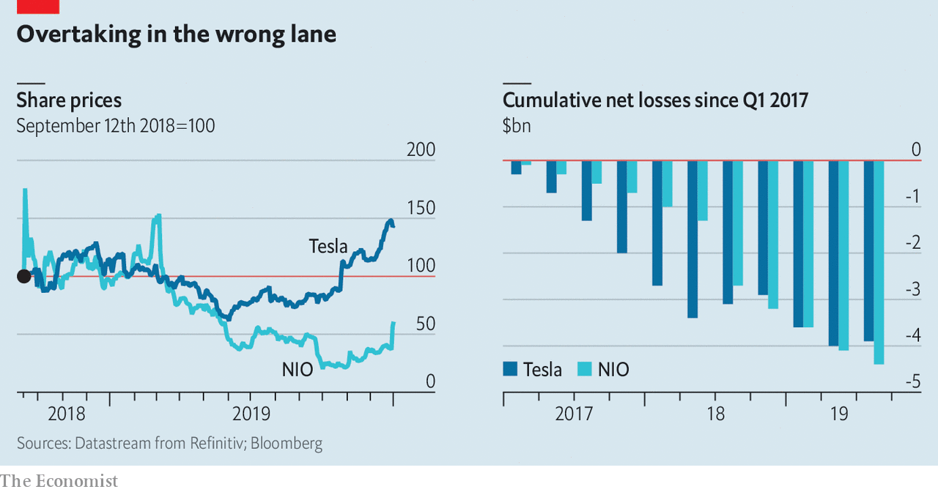

In truth, Mr Musk is in a league of his own. But Mr Li has long had the edge on him in one respect. As our Technology Quarterly in this issue reports, NIO is emblematic of China’s ambition to be a hub of global EV production, dominating electric vehicles in the 21st century as squarely as America did the internal-combustion engine in the 20th. As such, China would be a natural place to produce a “Tesla killer”, as NIO was dubbed during a CBS interview with Mr Li aired in 2019.

Yet if NIO is trying to topple Tesla, it is going about it in an odd way. It is copying some of the very aspects of Tesla’s business model that have made the American firm’s survival a matter of constant concern, such as lavish spending on sophisticated technology, resulting in correspondingly large holes in its cashflow statements. If anything can kill Tesla, it is more likely to be its perennial difficulty in generating cash than competition from a Chinese upstart with the same problem. Ironically, it could be China that ultimately secures Tesla a bright future. If only NIO could be so lucky.

Not long ago NIO was considered the more promising of the two. In the world’s largest car market, where sales of luxury vehicles are booming, it got its start in 2014 when state and local governments were throwing subsidies at both buyers and manufacturers of EVs. Venture-capital backing was abundant. NIO delivered its first commercial car, the ES8 SUV priced at above $70,000, in 2018. Shortly afterwards it issued shares on the New York Stock Exchange, both to raise money and to heighten its international profile so that it could sell cars around the world. Its shareholders include Baillie Gifford, an Edinburgh-based fund manager that is the largest institutional investor in Tesla.

Tu Le of Sino Auto Insights, an advisory firm, says NIO’s Tesla-killing aspirations got the better of it, though. It was rash to think it could quickly take on a firm 11 years older with huge global brand recognition and several models. NIO’s revenues, estimated at around $1.2bn for 2019, are dwarfed by the $24bn projected for Tesla. Yet since the start of 2017 its cumulative losses have overtaken those of Tesla (see chart). NIO has splashed out on spacious stores with libraries, coffee shops and crèches, sometimes directly across the street from Tesla showrooms. But unlike Tesla it has not invested much in factories, contracting manufacturing to JAC Motors, a state-owned carmaker, instead.

Furthermore, a cut in state subsidies for EV purchases since June has hurt investor sentiment, prompting fears of a funding crunch. NIO raised $100m from Tencent, the tech giant that is also one of its leading shareholders, in the third quarter, and Mr Li is expected to pitch in as much himself. But NIO burned through even more than that in the third quarter and has net debt of $1.3bn, according to Bernstein, an investment firm. Though NIO’s sales rose 22.5% in the third quarter compared with the previous three months, and it launched a third SUV on December 28th, it admits it needs funding if it is to survive for another year.

Given the precarious circumstances, the Chinese government might be expected to throw NIO a lifeline. Instead, it is Tesla that is getting the breaks. On December 30th, the day of NIO’s relief rally, the first Model 3s rolled out from Tesla’s Gigafactory in Shanghai, costing a mere $50,000 each. Though work started on the plant less than a year ago, production is already running at about 1,000 cars a week. Days before, the American firm received $1.3bn-worth of funding from Chinese lenders to complete the Shanghai-based factory. Production in China spares Tesla from import tariffs on finished vehicles, and its locally made cars also qualify for subsidies. Its shares have soared to record highs in recent days, though there are still nagging doubts about its ability to increase volumes, margins and cash generation. Perversely, Tesla may even have benefited from China’s trade war with America. The government hopes to portray Tesla’s investment, the first fully foreign-owned car plant in China, as a symbol of its openness.

NIO, despite being Chinese, does not offer the same geopolitical advantages, and without its own factories it has less leverage when asking state governments to support it. As Michael Dunne, the Tesla-driving boss of ZoZo Go, a car advisory firm, puts it, “NIO doesn’t have a clear-cut godfather in the Chinese government.” It is competing with a host of EV startups, such as Byton, WM and Xpeng, for funding. There is no guarantee all of them will survive.

In this fraught market, fortunes could quickly reverse again. NIO says it may soon announce new funding arrangements. A state-backed carmaker could take a big stake in it. Some analysts say it is unlikely the government will let NIO go bust, because it is such a symbol of China’s technological ambitions.

## So much giga and greater than America

For now, though, Tesla is in pole position. In fact, says Mr Dunne, China must already feel like home to Mr Musk. The government’s EV ambitions give Tesla a tailwind that it lacks in America; on January 1st its customers there stopped benefiting from a tax credit. Consumers love luxury-car brands; Tesla’s main competition will be with Germany’s premium carmakers, not Chinese ones. China’s manufacturing prowess will help Tesla overcome the “production hell” it suffered back home. And China may be quicker to encourage autonomous driving than America. For Mr Musk, the main drawback could be that Twitter, his favoured megaphone, is blocked behind the great firewall. But for Tesla that too must be a blessed relief. ■

Read this article on <https://www.economist.com/business/2020/01/04/cloning-tesla-electric-vehicle-wars-in-china>

|  |  |  |  |
| --- | --- | --- | --- |
| Previous | Articles | Sections | Next |

|  |  |  |
| --- | --- | --- |
| Business | Sections | Science and ... |

Finance and economics

The stockmarket: Christmas bonus

The causes of a booming stockmarket are unlikely to last through 2020.

The World Trade Organisation: What’s the catch?

Trade negotiators have missed a deadline to help protect fish stocks.

Digital banking in South-East Asia: Up for Grab

Grab and Singtel will bid for a digital-banking licence in Singapore.

Minimum wages: Who pays?

A study suggests that higher minimum wages hit poorer bosses’ pockets.

Buttonwood: Feeling TIPSy

Why the most important hedge is against unexpected inflation.

Free exchange: Planned obsolescence

China’s industrial policy has worked better than critics think.

|  |  |  |
| --- | --- | --- |
| Business | Sections | Science and ... |

|  |  |  |  |
| --- | --- | --- | --- |
|  | Articles | Sections | Next |

Christmas bonus

# The causes of a booming stockmarket are unlikely to last through 2020

Global growth, a trade deal and lower rates have added oomph to shares

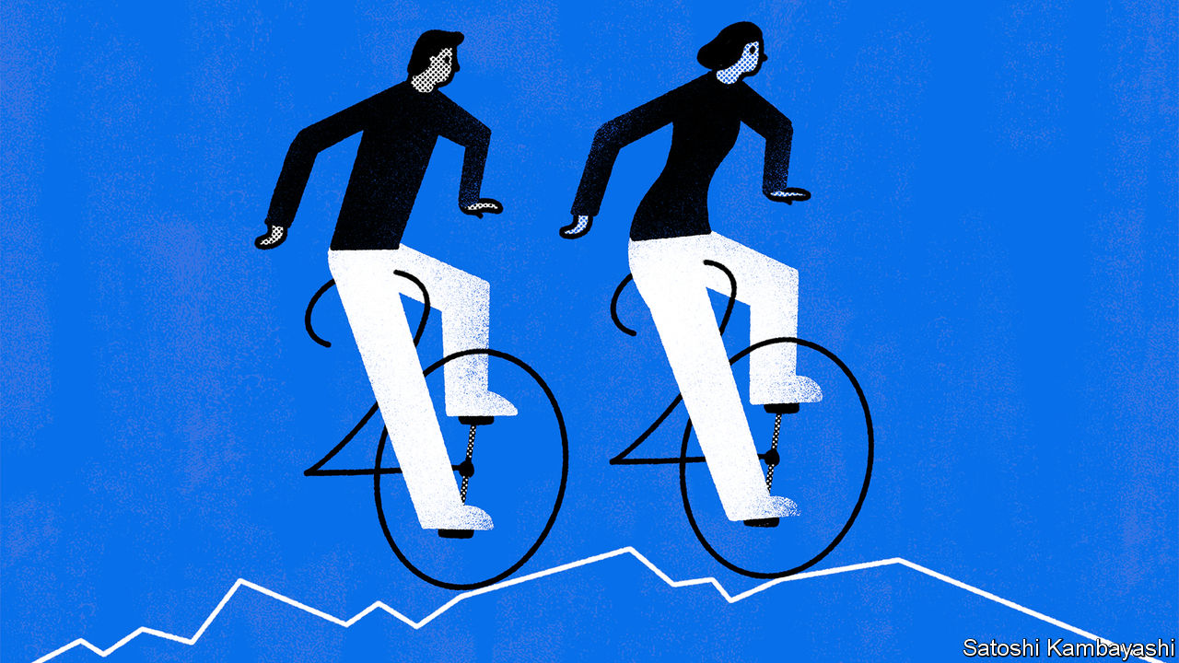

Jan 4th 2020 | NEW YORK

THE CHRISTMAS of 2018 was a dismal one for American stockmarket investors. Meagre gains eked out through a volatile year were reversed at its end, on fears of slowing global growth and all-out trade war between America and China. The S&P index of large companies tumbled by 15% between November 30th and December 24th that year. Many thought a recession was imminent.

The fears proved overblown. The S&P 500 rose by 28.9% during 2019, close to the 2013 record increase and well above the average annual gain for the past decade (see chart). December is often good for markets—a phenomenon traders call the “Santa rally”. This one was particularly strong, with the index rising by 2.9%. Markets beyond America also did well. The FTSE All-World, a global index, rose by 24% in dollar terms, its best showing since 2009.

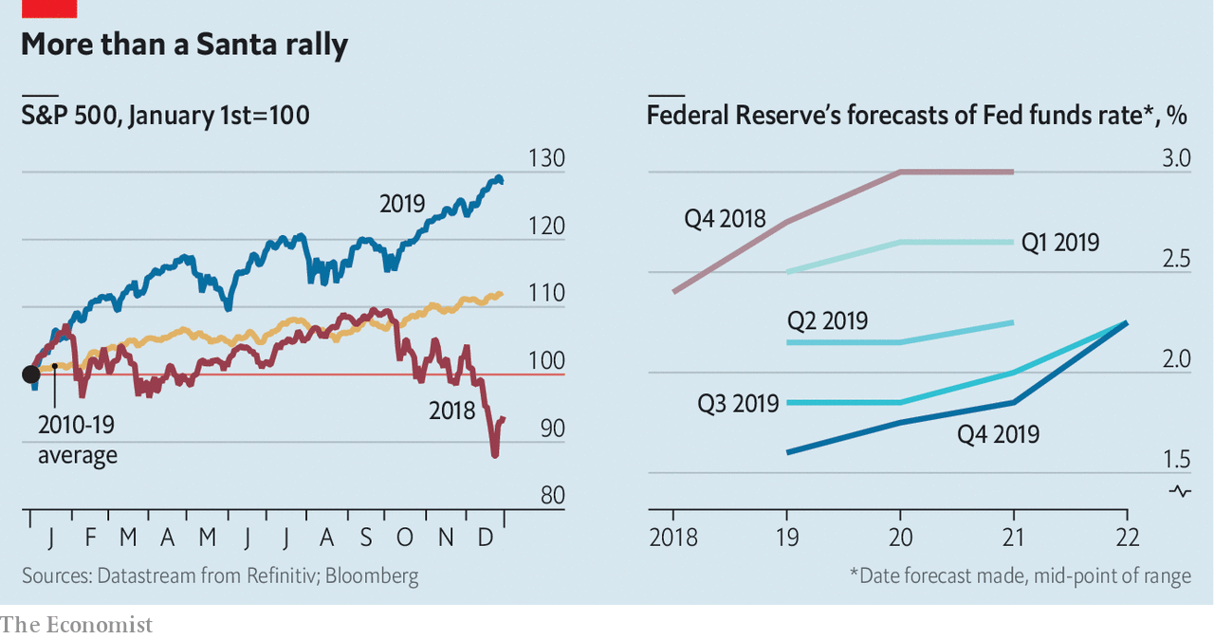

Share prices often rise when expectations of future profits do. But earnings have stagnated recently, so that does little to explain this year’s boom. Falling interest rates played a bigger part. These boost share prices by increasing the comparative value of claims to future income streams, such as profits. The Federal Reserve, which had finished 2018 signalling that it would tighten monetary policy, changed course early in 2019 and indicated that it would ease if necessary to offset any shocks caused by the trade war. Market predictions for policy rates tumbled. During the year the Fed cut three times, undoing nearly all the previous year’s tightening.

After turbulence in the repo market, the Fed also started to expand its balance-sheet by buying short-dated Treasuries. The move was billed as a technical solution to problems in an essential part of the financial system, not as an economic stimulus. But it may have acted as one, all the same. After the financial crisis a decade ago, the Fed’s swelling balance-sheet was credited with driving a stockmarket rally.

December’s market oomph seems to have come from a mini trade deal between America and China. America cancelled planned new tariffs on Chinese goods and cut some already in force. China agreed to buy more American goods.

It was a good year not just for stocks, but for most financial assets, including corporate debt, government bonds, commodities and gold. That is unusual. When risky assets such as stocks and high-yield corporate debt are rising, safer ones such as government bonds and gold generally fall. Investors flock from risk to safety in times of crisis, and back again when the outlook improves. But when policy interest rates fall, bond yields generally do too; and thus bond prices rise. Loose monetary policy also tends to boost commodity prices. Broad indices of American bond prices rose by 9% in 2019. The price of gold rose by 19%.

A bumper year, then. But what of 2020? The potent combination of monetary easing and evaporating risks to growth seems largely played out. Shifting from trade hostilities to a ceasefire had a big impact; any further rapprochement is unlikely to do so much. Meanwhile neither the Fed nor independent economists are forecasting interest-rate moves during 2020.

Economic growth is also less likely to provide a tailwind. In America and globally, growth slowed a little during 2019. According to the Conference Board, a think-tank, economists expect that slowdown to continue. Profit upgrades are therefore unlikely. And investors are already paying through the nose for stocks. The “earnings multiple”—share prices as a multiple of profits—is steep, at 21.6 for the S&P 500, far above the long-run average of around 16.

Election years tend to be turbulent for stockmarkets. Over the past century, America’s has been more buoyant in the first two years of a presidential term than in the final one. And investors are worried that the Democrats will pick a nominee from the party’s radical left. When Elizabeth Warren was rising in opinion polls in October, hedge-fund managers warned that markets would fare poorly under her.

In October Paul Tudor Jones of Tudor Investment, a hedge fund run from Palm Beach, claimed the stockmarket would fall by 25% if Ms Warren were to be elected president. The Wall Street Journal has reported that Bridgewater Associates, the world’s largest hedge fund, has spent $1.5bn on derivatives that will pay out if the S&P 500 falls by March. It is hard to tell much about a fund’s portfolio from a single trade (and Ray Dalio, its founder, denied that the trade is representative)—but that is around when it will become clear who the Democratic nominee is likely to be.

Fears in 2018 for the year ahead proved misplaced. Those for 2020 may be, too. But investors should not bank on it. Only 12 times since 1928 has the S&P 500 posted a better return than it did in 2019. Each time, the following year turned out weaker than the one that came before. More ominously, in four returns were negative. ■

Read this article on <https://www.economist.com/finance-and-economics/2020/01/04/the-causes-of-a-booming-stockmarket-are-unlikely-to-last-through-2020>

|  |  |  |  |
| --- | --- | --- | --- |
|  | Articles | Sections | Next |

|  |  |  |  |
| --- | --- | --- | --- |
| Previous | Articles | Sections | Next |

What’s the catch?

# Trade negotiators have missed a deadline to help protect fish stocks

Government subsidies support overfishing, but are hard to get rid of

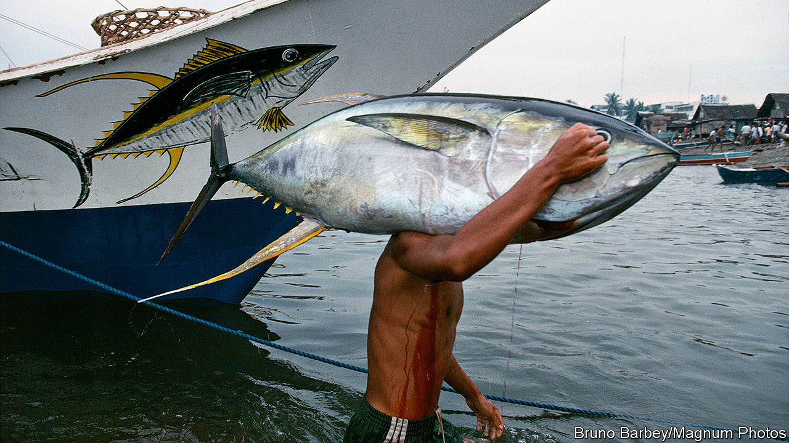

Jan 4th 2020 | WASHINGTON, DC

IN 2015 WORLD leaders signed up to a long list of sustainable development goals, among them an agreement to limit government subsidies that contribute to overfishing. Negotiators at the World Trade Organisation (WTO) were told to finish the job “by 2020”. They have missed their deadline.

Overfishing is a tragedy of the commons, with individuals and countries motivated by short-term self-interest to over-consume a limited resource. By one measure, the share of fish stocks being fished unsustainably has risen from 10% in 1974 to 33% in 2015. Governments make things worse with an estimated $22bn of annual subsidies that increase capacity, including for gear, ice, fuel and boat-building. One study estimated that half of fishing operations in the high seas (waters outside any national jurisdiction) would be unprofitable without government support.

Trade ministers were supposed to sort it all out at a WTO meeting in December in Kazakhstan. But the meeting was postponed till June, and big political deals are rarely struck remotely. Moreover, the murky nature of subsidies for unregulated and unreported fishing makes their work unusually difficult. Governments do not have lines in their budget that say “subsidies for illegal fishing”, points out Alice Tipping of the International Institute for Sustainable Development, a think-tank.

Negotiators are trying to devise a system that would alert governments to offending boats, which would become ineligible for future subsidies. That is tangling them up in arguments about what to do when a boat is found in disputed territory, how to deal with frivolous accusations and how to treat boats that are not associated with any country offering subsidies.

When it comes to legal fishing of overfished stocks, it is easier to spot the subsidies in government budget lines, but no easier to agree on what to do about them. America and the European Union, for example, have been arguing over whether to allow subsidies up to a cap, or whether to ban some subsidies and take a lenient approach to the rest. The EU favours the second option, arguing that where fisheries are well-managed, subsidies are not harmful. To others this looks like an attempt to ensure any eventual deal has loopholes.

Further complicating matters is a long-running row about how to treat developing countries. All WTO members agree that some need special consideration. But as an American representative pointed out at a recent WTO meeting, 17 of the world’s 26 most prolific fishing countries are developing ones. That means broad carve-outs for them would seriously weaken any deal.

China, both the world’s biggest fisher and biggest subsidiser of fishing, has proposed capping subsidies in proportion to the number of people in each country who work in the industry. But it is the world leader here, too, with 10m at the last count (in 2016). Other countries fear such a rule would constrain China too little.

Apart from the fish negotiations, almost nothing is happening at the WTO. Ms Tipping thinks this could be helpful, since the issue will not end up hostage to other, even more fraught, trade rows. But it also deprives negotiators of their most useful tool. Usually, trade talks make progress because the ambitious parties coax the foot-draggers forward by offering concessions on other matters. Now, though fish are on the table, the accompanying bargaining chips are off the menu. ■

Read this article on <https://www.economist.com/finance-and-economics/2020/01/04/trade-negotiators-have-missed-a-deadline-to-help-protect-fish-stocks>

|  |  |  |  |
| --- | --- | --- | --- |
| Previous | Articles | Sections | Next |

|  |  |  |  |
| --- | --- | --- | --- |
| Previous | Articles | Sections | Next |

Up for Grab

# Grab and Singtel will bid for a digital-banking licence in Singapore

A ride-hailing firm and a telecoms group take on South-East Asia’s banks

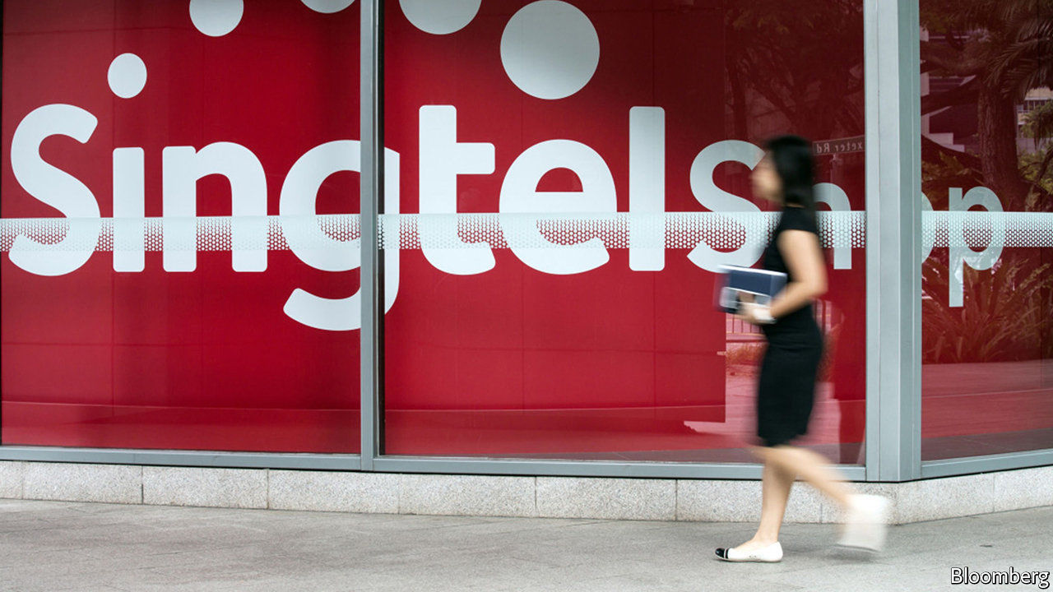

Jan 4th 2020

IN 2014 SINGTEL, a Singaporean telecoms group, teamed up with Standard Chartered, an Asia-focused bank, to create Dash, a mobile-money unit it claimed would “revolutionise mobile commerce and banking”. But red tape meant it went nowhere fast. It refocused on mobile payments, but still struggled. Insiders liked to quip, says one, that “the only place that accepted Dash was Singtel’s canteen”.

Singtel’s banking ambitions are no longer a joke. On December 30th it said it was tying up with Grab, a car-hailing firm, to bid for a digital-banking licence from the Monetary Authority of Singapore (MAS). Together, the two firms are well-placed to benefit from one of the city state’s biggest financial reforms in two decades—and perhaps, to shake up banking across South-East Asia, a market of 655m.

Singapore hopes the new licences will deepen banking penetration and boost competition. According to Arthur Lang of Singtel, though the city state is one of the world’s main financial centres, 40% of the population is either underbanked—lacking access to credit cards or long-term savings products—or unbanked—lacking even a basic account. The three biggest incumbents, DBS, OCBC and UOB, hold 61% of domestic deposits. A spokeswoman for MAS says the entry of non-banks will “add diversity and choice”. Tech firms should have access to better credit-assessment tools and data, allowing them to lend to underserved small firms and the young.

Singapore also wants to improve its reputation for financial innovation. Investors poured a record $735m into local fintechs in the first nine months of 2019. DBS, the most valuable local bank, is well-known for its digital savvy. But Singapore lacks thriving neobanks. Europe has many, including Monzo, Starling and N26. South Korea’s Kakao Bank already has over 10m customers. Singapore is set to announce winning bids by mid-2020—over a year after Hong Kong, a notorious digital laggard, completed a similar tender.

MAS has set a high bar for bidders. Hong Kong handed out eight licences; Singapore will award just five, only two of them for full-service banking. Each of the pair will require S$1.5bn ($1.1bn) in entry capital; Hong Kong set a threshold of just HK$300m ($38m) per licence. Virtual banks will be subject to the same capital-adequacy rules as high-street peers and must show they can turn a profit within five years. Singapore wants innovation, says Florian Hoppe of Bain, a consultancy, but fears its profitable incumbents will be destabilised if tech newcomers burn cash to grab market share.

Much of the interest initially came from early-stage startups, says Eric Dadoun, an angel investor. But MAS’s stiff demands seem to have put off all but household names. Razer, a maker of gaming gear, is leading a consortium that includes investment funds, an insurance firm and an internet company. Gojek (an Indonesian unicorn), Standard Chartered, local banks and OneConnect (a subsidiary of Ping An, a Chinese insurance titan) are thought to be interested. A mooted tie-up between Keppel, a conglomerate, Validus, a peer-to-peer lending platform, and OCBC collapsed hours before the December 31st deadline.

The Grab-Singtel tie-up has two major strengths. First, the firms have clout and a broad geographic spread. Singtel is South-East Asia’s largest telecoms firm. It owns or backs subsidiaries in Australia, Indonesia, the Philippines, Thailand and 14 African countries. Grab has been downloaded onto 166m phones in South-East Asia. A funding round in March valued it at $14bn.

Second, they fit together neatly. In much of the region, more people have smartphones than have bank accounts, and Singtel’s brand is strong. But it is not known for innovation—which is where Grab can help. Founded in 2011, it sees itself as a “super-app”. On top of ride-sharing and food delivery, it already offers payments, working-capital loans and microinsurance, notably to its drivers and suppliers.

The duo’s ambitions clearly stretch well beyond Singapore. Tellingly, Singtel’s efforts are being led by Mr Lang, who heads its international operations, rather than Yuen Kuan Moon, its digital guru. A recent report by Bain, Google and Temasek, one of Singapore’s two sovereign-wealth funds, found that over 70% of adults in South-East Asia are underbanked. It says revenues from digital finance could grow from $11bn today to $60bn in 2025. Moreover, where Singapore goes other regulators in the region usually follow, says Frank Troise of SoHo Capital, which advises firms looking to enter Asian markets. “Malaysia, Indonesia, Vietnam, Thailand and the Philippines are all watching this and they’re just going to copy-paste.” A local banker reckons that Asia’s incumbent lenders are in for “the fight of their life”.

Perhaps not just Asia’s. Uber, an American ride-hailing champion, owns 27.5% of Grab. Perhaps it will pick up some tips and data. In October it launched a money division, the latest attempt by a Silicon Valley stalwart to enter financial services. “If I was J.P. Morgan or Verizon right now,” says Mr Troise, “I’d be terrified.” ■

Read this article on <https://www.economist.com/finance-and-economics/2020/01/04/grab-and-singtel-will-bid-for-a-digital-banking-licence-in-singapore>

|  |  |  |  |
| --- | --- | --- | --- |
| Previous | Articles | Sections | Next |

|  |  |  |  |
| --- | --- | --- | --- |
| Previous | Articles | Sections | Next |

Who pays?

# A study suggests that higher minimum wages hit poorer bosses’ pockets

Wage floors are still progressive, but can have unintended consequences



Jan 4th 2020 | NEW YORK

A MINIMUM WAGE is supposed to redistribute money from rich to poor. But economists disagree about whether it actually does so. Some researchers, for example, have found that, in America, Canada and Europe, raising the minimum wage tends to decrease employment among the least-skilled workers, as firms downsize to trim costs. Others have found no effect on employment. And although no one doubts that the policy raises wages for the workers who stay employed, still unsettled is the question of where that extra money comes from.

A new paper by Lev Drucker and Katya Mazirov of Israel’s Ministry of Finance, and David Neumark of the University of California, Irvine, examines increases in Israel’s minimum wage in 2006-08 in search of an answer. The more low-wage workers a company employed, they found, the more its profits declined. Companies with 60-80% of staff earning the minimum wage saw their profits cut by almost half.

The researchers’ central insight is that firms with relatively low profits disproportionately employed minimum-wage workers, meaning those firms ultimately bore the greatest burden of mandated higher wages. Poorer business owners suffered bigger losses. Those on median incomes (for the population at large) took a profit hit 8% larger than those at the 75th percentile.

Since business owners with low earnings relative to their peers are still relatively well off compared with the general population, raising the minimum wage is still progressive. But it may seem unfair, as low-income businesspeople pay, but richer business owners and better-off employees do not. Those lower-income bosses who were hardest hit by minimum-wage increases earned only about as much as many mid- to high-earning workers. And a higher minimum wage is less progressive than raising taxes, which fall most heavily on the best-off, in order to fund tax credits for the poor. America’s earned-income tax credit works along these lines.

In some places, minimum-wage rules are designed to try to minimise the impact on low-earning firms. In America they apply only to businesses with sales exceeding a certain threshold. In South Korea, a minimum-wage increase in 2018 was accompanied by subsidies for small firms. The authors do not discuss how Israel’s lack of such provisions might affect their findings. But they do suggest using an employer tax credit to offset the disproportionate burden of minimum wages on low-income firms. Policymakers aiming to fight poverty and increase equity with minimum wages would do well to consider unintended effects.

Read this article on <https://www.economist.com/finance-and-economics/2020/01/04/a-study-suggests-that-higher-minimum-wages-hit-poorer-bosses-pockets>

|  |  |  |  |
| --- | --- | --- | --- |
| Previous | Articles | Sections | Next |

|  |  |  |  |
| --- | --- | --- | --- |
| Previous | Articles | Sections | Next |

Buttonwood

# Why the most important hedge is against unexpected inflation

High asset prices stem from low inflation and interest rates

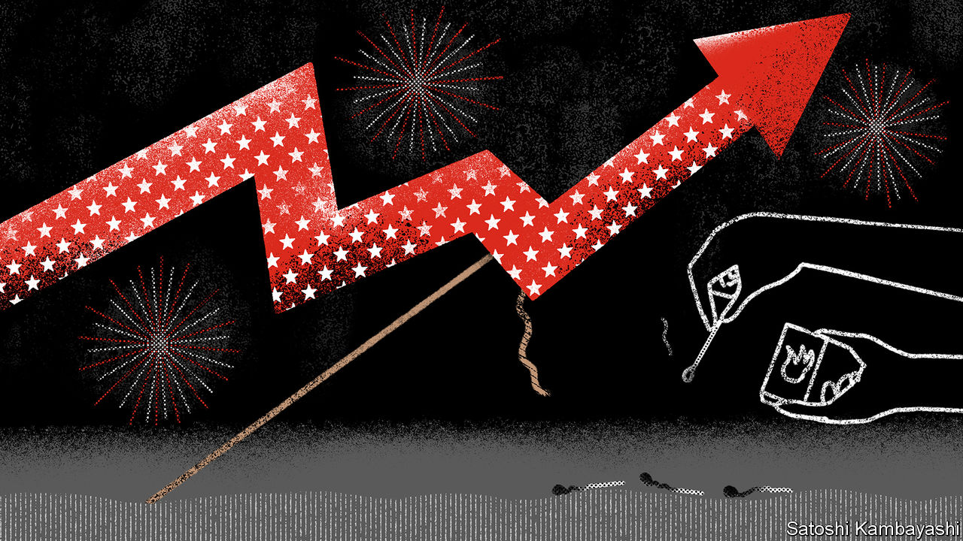

Jan 4th 2020

IT IS HARD to say precisely when a cherished theory of inflation lost its sway. But if you had to pick a moment, it might be during an exchange last July between Alexandria Ocasio-Cortez, a first-time congresswoman who had risen quickly to prominence, and Jerome Powell of the Federal Reserve.

The occasion was the twice-yearly testimony by the Fed’s chairman to Congress. The unemployment rate, noted Ms Ocasio-Cortez, had fallen by three percentage points since 2014, yet inflation was no higher. Might the Fed’s estimates of the lowest sustainable jobless rate have been too high in recent years? “Absolutely,” replied Mr Powell. The once-strong link between unemployment and inflation, known as the Phillips Curve, was a “faint heartbeat”, he said.

Inflation now seems no more pressing a worry than other diseases of the distant past—smallpox, say, or scurvy. Even central bankers, who are paid to be anxious, tend to fret that inflation in rich countries might stay too low, not that it might suddenly surge. Investors may see it differently. The whole edifice of asset prices is founded on the expectation that inflation—and thus interest rates—will stay low. An unexpected rise in inflation ought to be the thing investors are most determined to guard against.

Inflation clearly does not behave as it used to. It no longer goes up automatically when unemployment goes down. Perhaps this is because people have come to expect low inflation. Wages and prices are marked up less often and so are less responsive to slackness or tightness in the jobs market. Global supply chains mean local bottlenecks have less influence on prices.

For much of the decade that has just ended, central banks kept interest rates unusually low. This has had as little effect on inflation as low unemployment has. One explanation is the desire of ageing workers to set aside more of their income for retirement. This in turn has pushed down the equilibrium interest rate that balances the supply and demand for savings—with knock-on effects for asset prices. Rock-bottom bond yields reflect a belief that central banks will keep interest rates low indefinitely. And if bond yields stay low, expected returns on other assets (the earnings yield on equities, the rental yield on property and so on) will also stay low—and their prices will remain high.

A serious burst of inflation would change all that. It would be a sign that the low-interest-rate equilibrium had shifted. That would upset the constellation of high asset prices. For investors with portfolios stuffed with richly priced stocks, there is a strong reason to seek hedges against unexpected inflation. High-quality government bonds are the traditional diversifier for equity risk. But when inflation strikes, long-term nominal bonds are the worst assets to own. One way for the cautious to protect themselves is simply to hold more cash. Central banks would surely respond to a surge in inflation by raising short-term interest rates, thus boosting the returns on cash (with a delay).

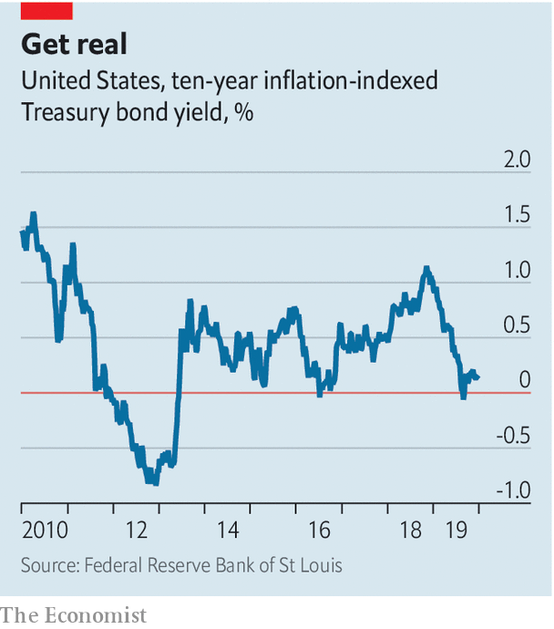

But in many places cash rates are below current inflation. A superior way to hedge is to hold Treasury Inflation-Protected Securities, or TIPS. The coupon—effectively a real rate of interest—is a fixed fraction of the principal. The principal is not fixed, however. It is adjusted over time to reflect increases in the consumer-price index, or CPI. Ten-year TIPS currently have a small but positive real yield of 0.1% or so (see chart). The yield on a nominal ten-year Treasury is around 1.9%. The difference between the two reflects expectations of inflation (that is, 1.8%).

By holding TIPS to maturity, an investor can receive inflation insurance and also be paid a real return of 0.1% a year. True, were there to be an inflation shock, the Fed would react and real interest rates would go up, which would have a downward effect on the price of TIPS. But that would be more than offset by the upward effect of a surge in demand for insurance against higher expected inflation, say John Roe and Chris Jeffery of Legal and General Investment Management.

Reasonable people might ask: “Why bother?” Inflation has been slain. The fear that it is just around the corner led to investment mistakes and policy errors during the 2010s. Fair enough. But the reasons for quiescent inflation in the face of low unemployment and the secular decline in interest rates are not fully understood. A decade from now, a successor to Mr Powell may be explaining to Congress how the Fed had undercooked its inflation forecasts.

Read this article on <https://www.economist.com/finance-and-economics/2020/01/04/why-the-most-important-hedge-is-against-unexpected-inflation>

|  |  |  |  |
| --- | --- | --- | --- |
| Previous | Articles | Sections | Next |

|  |  |  |  |
| --- | --- | --- | --- |
| Previous | Articles | Sections | Next |

Free exchange

# China’s industrial policy has worked better than critics think

But the state-led model is creaking

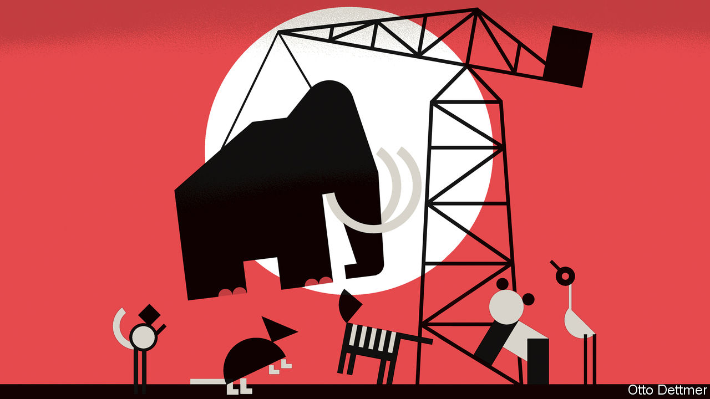

Jan 4th 2020

EARLY IN ITS trade dispute with China, America declared that Chinese industrial policy was a form of “economic aggression”. America’s negotiators hoped to rein it in. No such luck. The very week in December that America and China announced a mini-deal on trade, China’s president, Xi Jinping, vowed that the Chinese government would do more in 2020 to support strategic sectors, ranging from robotics to biomedicine. Having seen its vulnerability to American export controls, China is more determined to build up its domestic abilities than it was before the trade war began.

This raises an obvious question: does industrial policy work? Since at least Jean-Baptiste Colbert, France’s finance minister under Louis XIV in the 17th century, governments have used taxes, tariffs and subsidies to cultivate national champions. Colbert worried about the dominance of Venetian glassmakers; Mr Xi worries about the dominance of American chipmakers.

In principle industrial policy looks attractive. When markets are highly imperfect—a fact of life in developing countries—governments can use their muscle to stimulate activities that would otherwise be unthinkable for private entrepreneurs. When such policies succeed, the targeted sectors flourish, as South Korea’s chemicals industry did in the 1970s. That, in turn, can lead to technological advances and productivity gains for the wider economy.

But in practice industrial policy is hard to get right. Helping companies is as likely to promote laziness as competitiveness. Moreover, officials may be no better—and perhaps much worse—than businesspeople in choosing which industries to support.

Although China is far from alone in deploying industrial policy, it stands out for the sheer scale of its efforts. Since the 1980s it has produced dozens of plans and lavished public spending on sectors from solar power to film-making. One industry has been a big unintended beneficiary: the academic study of industrial policy. A large and growing economic literature considers China’s record.

A recent volume, edited by Loren Brandt of the University of Toronto and Thomas Rawski of the University of Pittsburgh, examines the electricity and telecommunications sectors. These are natural candidates for government intervention, given the high cost of building power grids and phone networks, plus the benefits to society. But China has done more than build basic systems; it has also tried to reach the frontier of global innovation.

It has had some success. State Grid Corporation of China is a world leader in ultra-high-voltage transmission. China has gone, the authors say, from “pygmy to emerging giant in civilian nuclear power”. But elsewhere it has come up short. Despite decades of support, its semiconductor firms are laggards. It has also failed to challenge Airbus and Boeing, or to produce any truly international car companies (see [Technology Quarterly](https://www.economist.com/node/21777441)).

One tentative conclusion is that China’s industrial policy works better when natural monopolies are involved. There is a clear role for a central authority with strong organising power to develop a power-transmission system or a high-speed rail network. Yet that same authority can stifle competition in sectors that need it. Alternatively, as often occurs in China, if lots of provincial governments try to foster their own champions, nominally in pursuit of national objectives, the outcome is extreme over-capacity, which undermines the targeted sector.

China’s shipbuilding industry provides a textbook example. Panle Jia Barwick and Nahim Bin Zahur, both of Cornell University, and Myrto Kalouptsidi of Harvard University estimate in a recent paper that between 2006 and 2013 the government directed policy support worth 550bn yuan (roughly $80bn at the time) to shipbuilders. Most went as subsidies for entrants to the sector, attracting subpar firms. China became the world’s biggest producer of ships. But the increase in net profits was just a fifth of the subsidies. Even the electricity sector, an ostensible success, is plagued by excess. A well-run power network should have back-up generating capacity equivalent to about 15% of peak load. The average among China’s provinces is more than 90%.

That, though, is not the end of the story. Ultimately, the value of industrial policy is in its wider economic impact. In a separate paper, Ernest Liu of Princeton University argues that state support is most effective when it targets those sectors that make the most essential inputs for others. Generally, these are upstream; turning raw materials into products used in a range of industries. Subsidies for them, even via state firms, can raise overall efficiency. As it happens, China has focused its support on the right sectors in Mr Liu’s calculations, such as steelmaking and machinery. China, put bluntly, might never have become the economic power that it is today without ambitious industrial policy.

## L’industrie, c’est moi

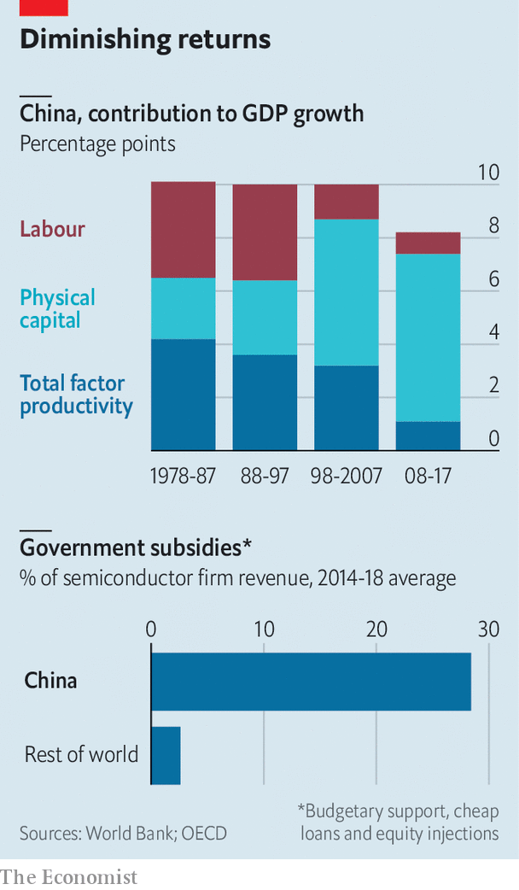

Mr Liu’s model does not indicate when subsidies are too high, nor does it set out how best to design policies. There is evidence that China’s heavy-handed intervention is becoming increasingly ineffective. Total factor productivity growth in China in recent years has been a third of what it was before the 2008 global financial crisis (see chart). Productivity has also slowed in other countries, but the World Bank, in a recent book about Chinese innovation, notes that China’s slowdown has been unusually sharp.

After conducting extensive case studies of the vehicle and renewable-energy sectors, among others, the bank ascribes some of the blame to Chinese industrial policies that undermine fair competition. It argues that rather than targeting support at specific firms, China should shift to more market-oriented policies. Even-handed regulations and incentives, which treat state firms no differently from private companies or foreign investors, would do more than lavish subsidies to promote entrepreneurship.

Such a shift would have the convenient side-effect of dealing with America’s concern that China’s mammoth subsidies undercut competitors globally. Industrial policy is always contentious. But it now looks like that rarest of things, an issue on which Chinese and American interests are aligned. Whether their leaders see it that way is another matter. ■

Read this article on <https://www.economist.com/finance-and-economics/2020/01/04/chinas-industrial-policy-has-worked-better-than-critics-think>

|  |  |  |  |
| --- | --- | --- | --- |
| Previous | Articles | Sections | Next |

|  |  |  |
| --- | --- | --- |
| Finance and ... | Sections | Books and arts |

Science and technology

Physics: Assembling the future

Finding new physics will require a new particle collider.

The Richard Casement internship

The Richard Casement internship.

|  |  |  |
| --- | --- | --- |
| Finance and ... | Sections | Books and arts |

|  |  |  |  |
| --- | --- | --- | --- |
|  | Articles | Sections | Next |

The future of physics

# Finding new physics will require a new particle collider

What it should look like and where it should be built are uncertain

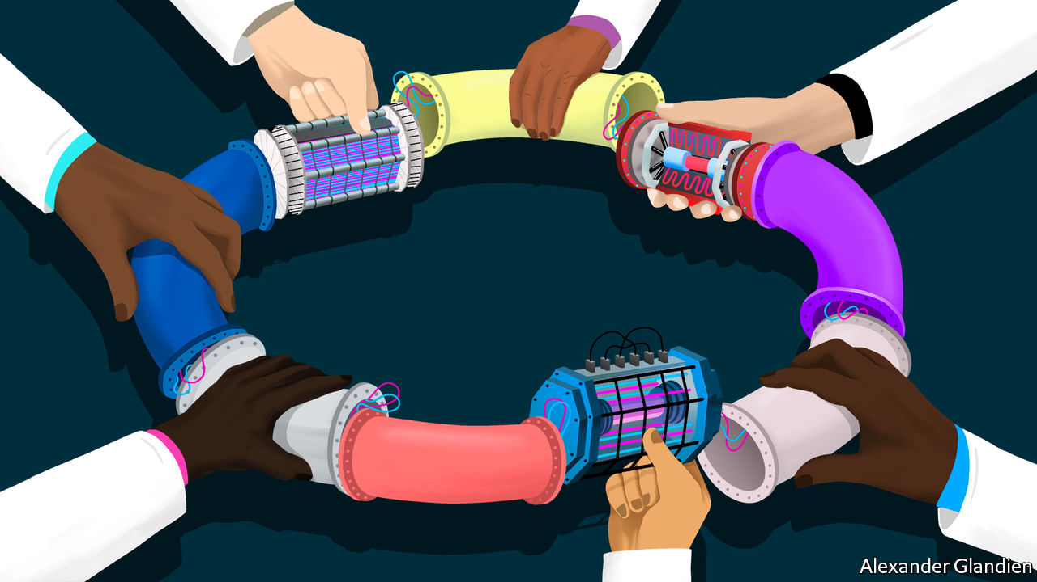

Jan 4th 2020 | GENEVA

DEEP UNDER the countryside north of Geneva, straddling the Franco-Swiss border, one of the most advanced scientific machines ever built has been banging subatomic particles together for more than a decade. This device, the Large Hadron Collider (LHC), accelerates beams of protons (members of a class of particle called hadrons) in opposite directions around a 27km ring until they reach almost the speed of light. Powerful magnets then force these protons into head-on collisions, causing the energy they carry to be converted—as described by Einstein’s best-known equation, E=mc2—into matter. And what matter! For sorting through the ejecta from the collisions gives physicists fleeting glimpses of the fundamental building blocks of the universe and the forces that bind or repel them.

The LHC belongs to the world’s leading particle-physics laboratory, CERN. It is the latest in a long line of increasingly sophisticated machines built over the past century by researchers intent on finding out how the universe truly works. The result of this effort has been one of the most successful, most tested scientific ideas of all time: the Standard Model of particle physics (see chart).

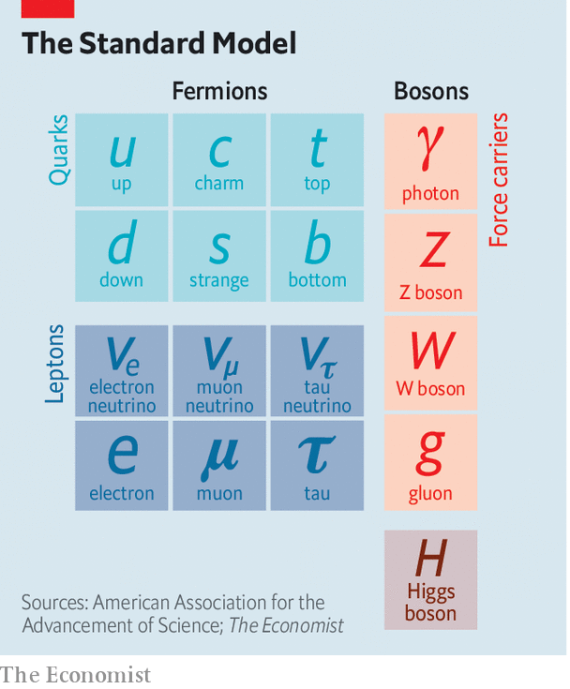

## High standards

The Standard Model is not, however, a theory of everything. It leaves many things unexplained. So, even though their multi-billion-franc toy at CERN has at least two more decades of collisions left to run, physicists are already considering what comes next. That means building a yet more powerful machine that can reach yet higher energies, and thus generate yet heavier and more interesting particles. And building that machine means, in turn, building the political will to pay for it and deciding where it will be constructed. This might be at CERN, or perhaps in Japan, or maybe in China—a prospect unwelcome to the current primus inter pares of the field, America.

The Standard Model is a quantum-mechanical description of all known elementary particles: from the quarks inside protons and neutrons, via the electrons that orbit atomic nuclei, to the photons that carry electromagnetic force and also light up the universe. Unlike Einstein’s General Relativity, its rival for the laurels of “most important theory in physics”, it is not the product of the musings of a lone genius. Though the name goes back only to 1975, the substance of the model was developed bit by bit by tens of thousands of scientists working for more than 80 years on hundreds of experiments around the world. The final piece of the jigsaw, the Higgs boson, which gives mass to certain other particles and thus ties the model together, was predicted by theoreticians in 1964 and found by the LHC in 2012.

The discovery of the Higgs, though, was supposed to be a beginning as well as an end, for the Standard Model now needs to be extended into something bigger. It does not, for example, include gravity. That is the province of General Relativity. Dark matter is also absent. This is a substance, invisible but detectable by its gravitational effects, that makes up 27% of the universe—over five times as much as the so-called normal matter of stars, planets, people and so on. And it does not include dark energy, a thing of unknown nature which constitutes the remaining 68% of reality and somehow acts to push everything else in the cosmos apart.

The Standard Model does include antimatter. But it predicts that equal amounts of matter and antimatter should have emerged at the beginning of time and, by now, these should have annihilated one another. Since this evidently has not happened—matter being common these days, and antimatter vanishingly rare—that prediction is in need of serious re-evaluation.

Each of these inadequacies points to physical laws, particles and forces yet to be discovered—mysteries which physicists had expected that the LHC would have started cracking open by now. But it has not. That suggests their hypotheses about what lies beyond the Standard Model, which were the basis of those expectations, must be wrong.

The weightiest expectation was placed on the shoulders of an elegant idea called supersymmetry. This theory, developed over the past 50 years, is a way of removing from the Standard Model a lot of things known in the trade as fudge factors. A fudge factor is an arbitrary value that makes a model work, but which itself defies deeper explanation. In the Standard Model, many such fudges can be erased by introducing, for each and every Standard Model particle, a heavier “supersymmetric” partner that has not yet been seen. The putative superpartners of the electron and quark, for example, are known as the selectron and squark.

Supersymmetry might also eradicate one more of the Standard Model’s inadequacies. The supersymmetric partners of another type of Standard Model particle, the neutrino, would be things called neutralinos. And neutralinos are plausible candidates to be the components of which dark matter is composed.

Unfortunately, after almost a decade of increasingly energetic collisions at the LHC, nothing new has emerged beyond the Higgs itself. No hidden dimensions. No unexplained phenomena. No supersymmetric particles. As a result supersymmetry has, for many physicists, lost its lustre. And of the myriad alternatives jostling to take its place, no one knows which, if any, might be closest to the truth.

This is all a headache for the practitioners of particle physics—a field in which experiments are notoriously expensive and take decades to build. It is also confusing, because physicists had come to expect that they could more or less predict what they would see next in their machines. Eugene Wigner, an American theoretical physicist of the 20th century, called this expectation “the unreasonable effectiveness of mathematics in the natural sciences”, and it began with the discovery of positrons, the antimatter equivalent of electrons.

Positrons were predicted in the 1920s by a formula that lies at the bedrock of the Standard Model. This formula, called the Dirac equation after its creator, Paul Dirac, suggested the existence of electrons with positive charges as well as the familiar negatively charged sort. Thus predicted, they were sought and found. Confidence in the prophetic power of maths was then confirmed over and over again, up to the triumphant discovery of the long-predicted Higgs. But the failure of supersymmetry has dented that confidence badly.

Regardless of the details, though, the consensus is that the route to finding physics beyond the Standard Model runs through the Higgs boson itself. This means examining and characterising that object in exquisite detail. Physicists do not know, for example, if it is truly an elementary particle with no internal structure (like an electron or a quark) or is a composite of smaller objects (in the way that protons and neutrons are made of three quarks each). It is even possible that what has been identified as the Higgs is not actually the particle predicted by the Standard Model—but, rather, a different particle from an as-yet-unknown theory that happens to have the Higgs’s predicted mass.

## Measure for measure

Annoyingly, while the LHC can now reliably produce what most people still do assume are Higgs bosons, its instruments cannot easily make the precision measurements needed to identify cracks in the Standard Model that would point to which of supersymmetry’s rivals looks most promising. One reason for this lies in the protons that the collider uses as its raw material. Because protons are made of quarks, which are held together by further particles called gluons, a proton-proton collision actually involves six quarks and multiple gluons, and is thus incredibly messy.

There is, though, a way to cut through that mess: use electrons instead. Since electrons are truly elementary, collisions involving them are cleaner than those between protons. But there is a price to pay. Electrons have about a two-thousandth of the mass of protons, and proportionately less kinetic energy at a given speed. To make them energetic enough to yield Higgs bosons will thus require a new machine.

Building an electron collider (or rather, in practice, a machine that collides electrons with positrons) to follow the LHC would have historical precedent. At CERN, in 1983, a hadron machine called the Super Proton Synchrotron, with a circumference of 7km, was used to find particles called the W and Z bosons, which are involved in a phenomenon known as the weak nuclear force. Subsequently, at the same laboratory, the Large Electron-Positron (LEP) collider began operating in 1989 to characterise and understand those newly discovered bosons in detail. The circular 27km tunnel built for the LEP now houses the LHC.

Continuing this pattern, one group of physicists at CERN proposes building a new machine there to accelerate electrons and positrons around a 100km tunnel that would extend beneath the Jura mountains. This Future Circular Collider (FCC) would produce collisions at energies of a whopping 365 giga electron volts (GeV), in the units used by physicists to measure both the energy and the mass of subatomic particles. It would produce millions of Higgs bosons over a period of several decades. Such a Higgs “factory” would let physicists pin down the precise details of the particle.

Higgs bosons are unstable. They decay into pairs of other particles almost as soon as they are created. The Standard Model predicts that around 60% of the time this will create a bottom quark and its antimatter equivalent. A further 21% of the time a pair of W bosons will emerge, and 9% of Higgs-boson decays should end up with a pair of gluons (the other 10% will result in yet further combinations). By making enormous numbers of Higgs bosons and then measuring the precise rates at which bottom quarks, W bosons, gluons and other elementary particles emerge, those running the FCC would be able to watch for discrepancies from the Standard Model’s predictions. The more Higgses created, the more statistical power the results will have, and the more confident researchers will be that any deviations from Standard Model predictions which they measure actually represent something real.

The FCC would build on CERN’s decades of experience with circular colliders, and might seem like the LHC’s natural successor. But a rival group of physicists disagree. Though circular colliders have ruled the roost for a long time, they have a problem. When charged particles (protons, electrons, positrons etc) move in a circle they emit energy, known as synchrotron radiation, in the form of X-rays. The faster the particles go, the more energy they lose. At full power, the FCC could emit (ie, waste) around 100 megawatts of synchrotron radiation. The only way to compensate for this, and thus ensure the particles inside collide at the maximum energy, would be to pump in more electricity, which would drive up the cost of operating the machine.

The rival group therefore propose to sidestep the hegemony of rings altogether, with a different successor to the LHC: a linear collider. This would accelerate electrons and positrons from opposite ends of a straight track and let them meet in the middle. Two such are on offer. CERN’s proposal is the Compact Linear Collider. A second is the diplomatically named International Linear Collider, which would probably be built in Japan.

Unlike a ring, a linear collider can be constructed in stages, which helps with budgeting. Both designs would, though, end up about 50km long if brought to completion. They would have collision energies of a tera electron volt (1TeV, or 1,000 GeV) or more, and would operate as Higgs factories—turning out many millions of these bosons.

If particle physics went down the linear-collider route, which of these machines would come out on top is moot. On the face of things, the International Linear Collider is ahead. Physicists from around the world have spent years working on the proposal and, in 2013, they secured Japan’s support to build it in Honshu. After that, however, progress slowed, and as yet there has been no decision on whether the project will go ahead. The Science Council of Japan, which advises the government on such matters, is still evaluating the scheme. It is expected to make its intentions clear in February. CERN, meanwhile, seems more interested in building a new ring. The Compact Linear Collider’s supporters in the organisation are a minority.

While the old Great Powers of physics argue about what to do next, though, they may find themselves outflanked. For China is moving into the field at breakneck speed. Under the leadership of Wang Yifang, head of the Institute of High Energy Physics in Beijing, the country has been training young scientists and building an impressive research infrastructure. Its flagship proposal is the Circular Electron-Positron Collider (CEPC), conceived by Dr Wang after the discovery of the Higgs boson and which has now been through several stages of technical design.



The latest iteration proposes a $5bn machine optimised to create and study Higgs bosons. It would sit in a tunnel with a circumference of 100km and achieve collisions at energies reaching around 240GeV. In its specification, it is not so far away from CERN’s FCC. Though the project is being developed by Chinese scientists, some of whom have worked at CERN, Dr Wang has also drawn on advice, support and critical feedback from other particle physicists around the world.

Whether or not Dr Wang’s project gets a green light will depend on how the government decides to weigh its value against other proposed scientific-research facilities it might build. One rival, for example, is a demonstration nuclear-fusion power plant. If the government does give the collider the go-ahead, part of its calculation will surely be the increased visibility and prestige that comes from being able to build and operate such a technologically advanced machine. China has ambitions to become a world leader in science, and there is no doubt a particle accelerator would help it achieve that goal.

## In with the new

China could certainly afford Dr Wang’s collider, though it would need to import a lot of accelerator scientists to beef up its capability to build and operate such a machine. If that did happen, CERN’s plans for a circular collider would look superfluous. But as CERN’s own history shows, big scientific projects tend to work best when access to the machine and its results is as open and internationally collaborative as possible. Dr Wang says he would welcome money, talent and in-kind contributions from other countries. If the CEPC became the world’s most powerful accelerator, those countries would no doubt jump at the chance to join in. Except one, that is: America.

America is home to a thriving community of particle physicists, and they have garnered many of the Nobel prizes handed out over the second half of the 20th century for the prediction and testing of various bits of the Standard Model. American government scientists are, however, currently banned from collaborating with their Chinese counterparts, and federal funding agencies will not pay for academics to work in China—a restriction that would apply to the CEPC, should it be built. Yet, if China went ahead with its accelerator, the centre of gravity of fundamental physics, and probably the next set of Nobel prizes for that topic, would surely move there.

The big holes in modern physics will not be solved by a single machine, however. All the groups proposing post-LHC electron-positron colliders are also working on plans for what comes after a couple of decades of using them to study the details of Higgs bosons. The FCC team proposes eventually ripping that machine from its 100km tunnel, just as the LEP was ripped from its, and replacing it, some time in the 2050s or later, with a hadron collider operating at 100TeV. In China Dr Wang’s team has begun work on a similar idea, in which a Super Proton-Proton Collider would sit in the tunnel alongside the previously built electron-positron collider.

Some physicists, though, are impatient. They argue that the cautious, step-by-step approach should be abandoned. Instead of making precise measurements of the Higgs boson using electron-positron machines, researchers should embrace a 100TeV hadron machine as soon as possible, and see what happens. Their argument is that the uncertainty which now abounds in the field makes it risky to focus only on an electron-positron collider, as this might end up unable to operate at high-enough energies to push deep into the territory of new physics. Moreover, as detectors improve and the algorithms used to seek the most useful data from collisions get more sophisticated, the problem of hadron colliders’ messy output could disappear. Hadron colliders will, however, always maintain their superiority in pushing forward the energy barrier to finding new physics.

As Jon Butterworth, a member of the team that discovered the Higgs boson in 2012, puts it, “My whole career there’s been a very clear road map of what we need to do next and now there isn’t one. We’ve outgrown our road map. Experiment is ahead of the theory. It’s an interesting and difficult time.” True. But then, making maps rather than following them is surely what exploration is about. ■

Read this article on <https://www.economist.com/science-and-technology/2020/01/04/finding-new-physics-will-require-a-new-particle-collider>

|  |  |  |  |
| --- | --- | --- | --- |
|  | Articles | Sections | Next |

|  |  |  |  |
| --- | --- | --- | --- |
| Previous | Articles | Sections | Next |

# The Richard Casement internship



Jan 4th 2020

We invite applications for the 2020 Richard Casement internship. We are looking for a would-be journalist to spend three months of the summer working on the newspaper in London, writing about science and technology. Applicants should write a letter introducing themselves and an article of about 600 words that they think would be suitable for publication in the Science & Technology section. They should be prepared to come for an interview in London or New York. A stipend of £2,000 a month will be paid to the successful candidate. Applications must reach us by January 26th. These should be sent to: casement2020@economist.com

Read this article on <https://www.economist.com/science-and-technology/2020/01/04/the-richard-casement-internship>

|  |  |  |  |
| --- | --- | --- | --- |
| Previous | Articles | Sections | Next |

|  |  |  |
| --- | --- | --- |
| Science and ... | Sections | Economic and ... |

Books and arts

Ostracism: And stay out

In ancient Athens, ostracism did the job of impeachment.

Vanished worlds: Writing wrongs

An intimate chronicle of Sephardic Jewish history.

Johnson: Climate-speak

Of train-boasts, plane-shame and electric automobiles.

|  |  |  |
| --- | --- | --- |
| Science and ... | Sections | Economic and ... |

|  |  |  |  |
| --- | --- | --- | --- |
|  | Articles | Sections | Next |

And stay out

# In ancient Athens, ostracism did the job of impeachment

When the system of temporary exile fell into disuse, Athenian democracy degenerated

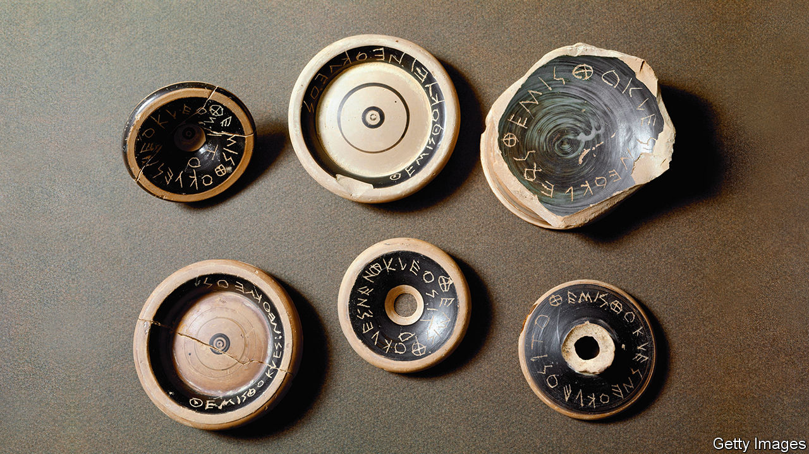

Jan 4th 2020 | ATHENS

AS EVERY AMERICAN knows, democracies need a means to deal with office-holders whose behaviour seems so terrible that they simply have to go. Modern states have impeachment; ancient Athens had ostracism, a gloriously simple device that gave voters the annual right to impose a decade of exile on a reviled individual.

The word ostracism comes from the ostrakon or potsherd (the equivalent of scrap paper) on which a candidate’s name was incised. With every new dig and discovery, fragments of pottery, bearing scratched names and sometimes a drawing or an insult, are deepening knowledge of the procedure among archaeologists and historians. It has become clear that the tool was at the heart of the Athenian political system.

It worked like this. At the beginning of each year, the electorate (adults who were neither female, enslaved or foreign) voted on whether the atmosphere would be improved by throwing out a dislikeable character. If the answer was yes, there would be an unpopularity contest two months later. Whoever received most votes had to leave.

What sort of person got the boot? The surviving works of ancient authors enumerate only a dozen figures who suffered ostracism or narrowly escaped it. The creator of the Athenian navy, Themistocles, endured the sanction; Pericles, the master statesman, used the weapon against enemies but avoided it himself. But now archaeologists are finding that those targeted for temporary expulsion were far more numerous than the textual record suggests.

In 471BC, for instance, the poll’s winner (or rather loser) was a blue-blood called Megakles, notorious—as ancient graffiti reveal—for his pushy mother and extravagant spending on horses. This was his second expulsion. Yet more than 100 other people may have been candidates for ostracism that year. This has been demonstrated by Stefan Brenne of Giessen University in Germany, who has just published the fruits of two decades’ meticulous reassembly and analysis of nearly 9,000 ostraka discovered in the Kerameikos cemetery in Athens in the late 1960s.

Often Mr Brenne found himself piecing together fragments that came from a single pot, perhaps deliberately broken by a group of friends who turned up to vote together. The sherds vary widely in size and quality: from 2cm (just under an inch) to ten times that length, from potters’ garbage to bits of high-class tableware. The round black base of a drinking-cup was a popular choice. “When I look at an ostrakon, I can hear the voters discussing what insults to write,” Mr Brenne says.

## Sling your hook

Meanwhile James Sickinger of Florida State University, the other world authority on ostraka, has been cataloguing the 80 or so found since 2010, mostly in the Agora, or market-place, where voting took place in Athens, with citizens queuing in a roped-off area to cast their sherds. These new fragments show how quickly ostracism caught on. As soon as the procedure came into use, in the mid-480s BC, Athenians adopted it with gusto, aiming at candidates high and low. The latest finds name bigwigs such as Xanthippus, father of Pericles, as well as a man called Habron about whom little besides his unpopularity is known.

Around 11,000 ostraka have been unearthed altogether. A few are beautiful. In one, the inscription is fired with the skilled techniques of black-figured pottery; another makes its point in verse. But most are amateurish, often featuring mistakes and obscenity. Victims are taunted for being adulterous, for being sodomised, and (in one case with an illustration) for being crypto-Persian. One ostrakon attacks the commander Kimon, who lived, amid rumours of incest, with his half-sister Elpinike: “Take Elpinike and Go!”

This Athenian system recalls the role played in other ancient societies by exorcism and witch-hunts, or the Israelites’ dispatch of a scapegoat, who bore the people’s sins, into the desert. Other than in a national emergency, the penalty for returning early was death. Look closely, though, and what seems a primitive punishment turns out to have been a mild and sophisticated way to release public discontent.

The victim was not deemed guilty of any crime—like modern impeachment, this was an essentially political business. He lost no assets, and could enjoy income from his property in exile. A nobleman could live out his banishment comfortably in another Greek city-state; once the decade was over, he could re-enter public life. (Some tried to get their own back instead: Themistocles defected to the Persians.) The fact that only a single person could be ostracised precluded wholesale purges. The careful counting of the sherds by the city’s archons, respected figures who rotated annually, meant verdicts were accepted.

## Closing the safety valve

It was a genuinely democratic process. From the start, powerful figures organised campaigns to expel adversaries, but the device’s legitimacy depended on ordinary voters being able to vent their whims and caprices. A well-known story, related by the historian Plutarch, describes a “boorish fellow” who came to the Agora and asked someone to incise the name Aristides. The someone was Aristides himself, who obliged but inquired as to the grievance. “None,” came the answer. “I am just tired of hearing that man called Aristides the Just.” Sarcastically or desperately, some sherds denounce an impersonal woe, such as “limos”, meaning hunger or poverty.

While it lasted, ostracism served many purposes. It was a warning to prominent types not to overreach—and to aspirants to tread carefully. And it was an effective safety-valve. The mood in the weeks between decisions to hold an ostracism and the votes was electric, as people spread salacious tales. According to Mr Brenne, the rumbustious comedies of Aristophanes, in which any bigwig could be lampooned, form a single genre with scribblings on the ostraka. But, in contrast to today’s political tussles, after the vote things calmed down.

In the final years of the fifth century BC, as democracy degenerated, ostracism lost its usefulness. The last occurred around 417BC, by which time war-weary Athenians had been seduced by demagogues. The dominant characters were the populist Alcibiades and the more moderate Nicias. It seemed likely that one or other would be expelled, but the powerful duo briefly buried their rivalry and had another politician, Hyperbolus, ejected instead. According to Plutarch, “the people felt disgruntled, because the procedure had been abused…and they abandoned it.” Votes on whether to conduct an ostracism were held for another century, but it never seemed to be worthwhile.

In the years that followed, Athens became a rougher place. The city mostly observed the outward form of democracy but often felt more like a militarised oligarchy. The interaction between social classes and individuals that enlivened the fifth century was over. And the idea that removing one person could solve the republic’s problems belonged to a more innocent age. ■

Read this article on <https://www.economist.com/books-and-arts/2020/01/04/in-ancient-athens-ostracism-did-the-job-of-impeachment>

|  |  |  |  |
| --- | --- | --- | --- |
|  | Articles | Sections | Next |

|  |  |  |  |
| --- | --- | --- | --- |
| Previous | Articles | Sections | Next |

Writing wrongs

# An intimate chronicle of Sephardic Jewish history

Sarah Abrevaya Stein brings the Levy clan of Salonika to life



Jan 4th 2020

Family Papers: A Sephardic Journey through the Twentieth Century. By Sarah Abrevaya Stein. Farrar, Straus and Giroux; 336 pages; $28.

WHEN THE sultan came to Salonika, David Levy was waiting. As befitted an Ottoman official and president of a local Jewish organisation, he greeted Mehmed V at the port when he landed in the summer of 1911. The next day, as the sultan was preparing to leave, he gave David a pair of diamond cufflinks. Yet all this pageantry was the wheeze of a dying world. Soon the Ottomans lost Salonika (now Thessaloniki) to the Greeks; their empire crumbled. And David, once dignified with the Turkish honorific effendi, would die in Auschwitz with much of his family in 1943.

David Levy’s path from Salonika to his murder is just one strand of a remarkable book in which, through years of research and thousands of documents, Sarah Abrevaya Stein tells the story of the whole Levy clan. She follows the prominent Sephardic family through interwar Greece and the Holocaust to the contemporary diaspora. For a while, one family member lived in Paris on pommes frites, getting into fistfights with anti-Dreyfusards. When another quit Salonika for a new life in Manchester, she left behind one of her 13 suitcases “so as not to jinx the voyage”.

By mining the Levy family archives, from photographs and birth certificates to medical records and passports, Ms Stein is able to summon her characters with the depth and feeling of a novelist. Thoughtfully, she notes that even the handwriting in letters can open windows into their authors’ lives. A dignified bureaucrat to the end, David Levy signed his name in elegant flourishes. Estherina, his daughter-in-law, composed “long, impassioned, if unintelligible letters in her loping hand”. This was not just sloppiness: she continued to write long after she went blind in middle age.

The languages the Levys used were as varied as their personalities. Ottoman Turkish, Hebrew and French all appear, but the principal one is Ladino, the tongue of Sephardic Jews expelled from Iberia in the 1490s. Well into the 20th century the family continued to employ this blend of Spanish, Hebrew, French, Italian, Turkish and Greek (among other elements). When Vida Levy dictated a letter to her son in the 1930s, she repeated the Ladino phrase “mi karo ijo” (“my dear son”) six times.

This focus on the traditional language of Sephardic culture reflects Ms Stein’s broader, underlying theme—for what begins as an intimate tale of the Levys becomes a far wider chronicle. Like the Levys, many Sephardic families would spend the 20th century tugged between secularism and faith, and between loyalty to old empires and a new nationalism. Many would meet the same desperate fate: 98% of Salonikan Jews died in the Holocaust.

“Family Papers” climaxes in the second world war—including the outlandish career of one Levy who helped the Nazis—but Ms Stein finishes her story in gentler times. Some Levys survived the war in hiding; others had already emigrated. Today, she says, the descendants of the original clan are “amiable, generous souls living culturally vibrant lives” from Lisbon to Berkeley. One became a French ambassador. Another played Miss Moneypenny in a James Bond film. Most have no contact with each other, nor any idea of their shared history. Yet through their inherited idiosyncrasies, they retain a family resemblance—even if the passion for writing letters has gone the way of Ottoman Salonika. ■

Read this article on <https://www.economist.com/books-and-arts/2020/01/04/an-intimate-chronicle-of-sephardic-jewish-history>

|  |  |  |  |
| --- | --- | --- | --- |
| Previous | Articles | Sections | Next |

|  |  |  |  |
| --- | --- | --- | --- |
| Previous | Articles | Sections | Next |

Johnson

# Of train-boasts, plane-shame and electric automobiles

The words of 2019 reflect the rise of climate-change activism



Jan 4th 2020

IDENTIFYING SHIFTS in the Earth’s climate requires decades of data, not just the observations of 2019 or any other single year. Climate change moves slowly, which is part of its calamitous power. Huge fires in California and Australia are probably worsened by the phenomenon—but no blaze can unequivocally be pinned on it, a fact seized on by those who would rather avoid the subject. Yet in the growing strength and coherence of climate protests, something did change discernibly in 2019.

Extinction Rebellion, a new movement, disrupted major cities. Greta Thunberg, a teenage activist, was Time’s Person of the Year; she travelled by boat to a climate summit in New York to avoid flying (and the associated carbon emissions). Another summit, in Madrid, ended in acrimony. Policy may not have evolved much, but wider attitudes did—and with them, the language in which the issue is discussed.

Some climate-related vocabulary was already in circulation. After a boiling summer in Germany in 2018, the Society for the German Language chose Heisszeit, “Heat Age”, as its word of that year. (It rhymes nicely with Eiszeit, “ice age”.) In the Netherlands, meanwhile, the Society for Our Language plumped for laadpaalklever, or “charging-post sticker”: someone who uses the electric-car charging space for too long, treating it like a free parking place.

Van Dale, a dictionary publisher, lets the Dutch-speaking public vote on its word of the year (in separate contests in Belgium and the Netherlands). For 2019 Belgians chose winkelhieren, or “buying local”. The Dutch went with an imported word that has a good case for being the winner in English, too: “boomer”. As Chloe Swarbrick, a 25-year-old member of New Zealand’s parliament, was giving an impassioned speech on the impact of climate change on her generation, she coolly dismissed a heckling older MP with a curt “OK, boomer”. The phrase was already an internet meme; Ms Swarbrick made it the talk of the offline world as well.

Babbel, which makes a popular language-learning app, has collected a host of climate-related neologisms from European languages. Flygskam is perhaps the most likely to be permanently adopted into English: “flight-shame”, from Swedish, was popularised by Ms Thunberg’s rise. It also has a nifty corollary: tagskryt, or “train-boasting”, from those who advertise their flygskam by taking ground transport and letting the world know. (Dutch has an equivalent: treintrots.)

The march of the climate-protest movement has led to the coining of disparaging terms by its critics. Italian, for example, has gretini: allegedly mindless followers of Ms Thunberg (-ini is a diminutive suffix, and the word echoes cretini, or “idiots”). The Danish Language Council and Denmark’s national broadcaster jointly chose a similar term as their Word of the Year for 2019: klimatosse, or “climate fool”, used dismissively by Pia Kjaersgaard, a right-wing Danish politician, to explain her party’s poor election performance. Being Danish, she hastened to add that her party is itself concerned about the climate, but that the klimatosser who voted for other parties apparently care about nothing else.

Compared with its European cousins, English has not been creative. Oxford Dictionaries declared its word of the year to be “climate emergency”. Collins, another dictionary-publisher, nominated the slightly more imaginative “climate strike”, originally coined to denote the schooldays that climate activists such as Ms Thunberg began skipping as a protest. (Klimaatspijbelaar, “climate-school-skipper”, was number three in Van Dale’s Dutch vote.)

Words of the year are a way for lexicographical types to grab a rare slice of the spotlight, boost interest in language and have a bit of fun. All the same, the pessimistic trajectory of the outcomes suggests a darkening global mood. The American Dialect Society will vote for its word of 2019 at its annual meeting in New Orleans in January. Its previous three choices were “tender-age shelter” (a euphemism for places where America’s border forces keep children separated from their parents), “fake news” (often, these days, meaning real news that powerful people would like to dismiss) and “dumpster fire”. Whether or not it picks a climatic word as an emblem of the bygone year, it is hard to see the society choosing anything upbeat.

Perhaps Dictionary.com captured the feeling best with its word of the year for 2019. Neither new nor fancy, it was foreboding nonetheless: “existential”.

Read this article on <https://www.economist.com/books-and-arts/2020/01/04/of-train-boasts-plane-shame-and-electric-automobiles>

|  |  |  |  |
| --- | --- | --- | --- |
| Previous | Articles | Sections | Next |

|  |  |  |
| --- | --- | --- |
| Books and arts | Sections | Graphic detail |

Economic and financial indicators

Economic data, commodities and markets

Economic data, commodities and markets.

|  |  |  |
| --- | --- | --- |
| Books and arts | Sections | Graphic detail |

|  |  |  |  |
| --- | --- | --- | --- |
|  | Articles | Sections | Next |

# Economic data, commodities and markets

Jan 4th 2020

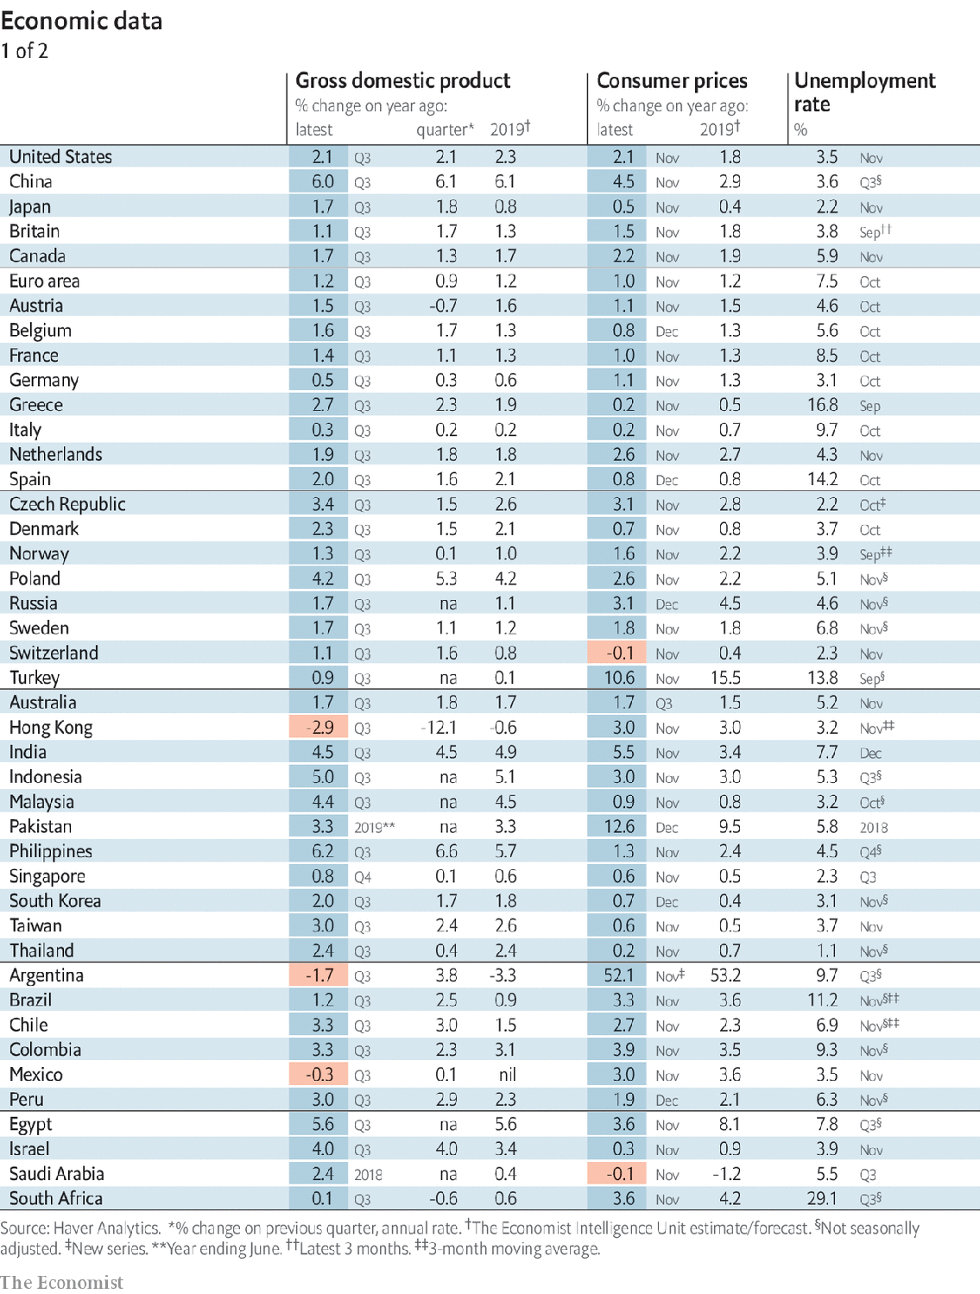

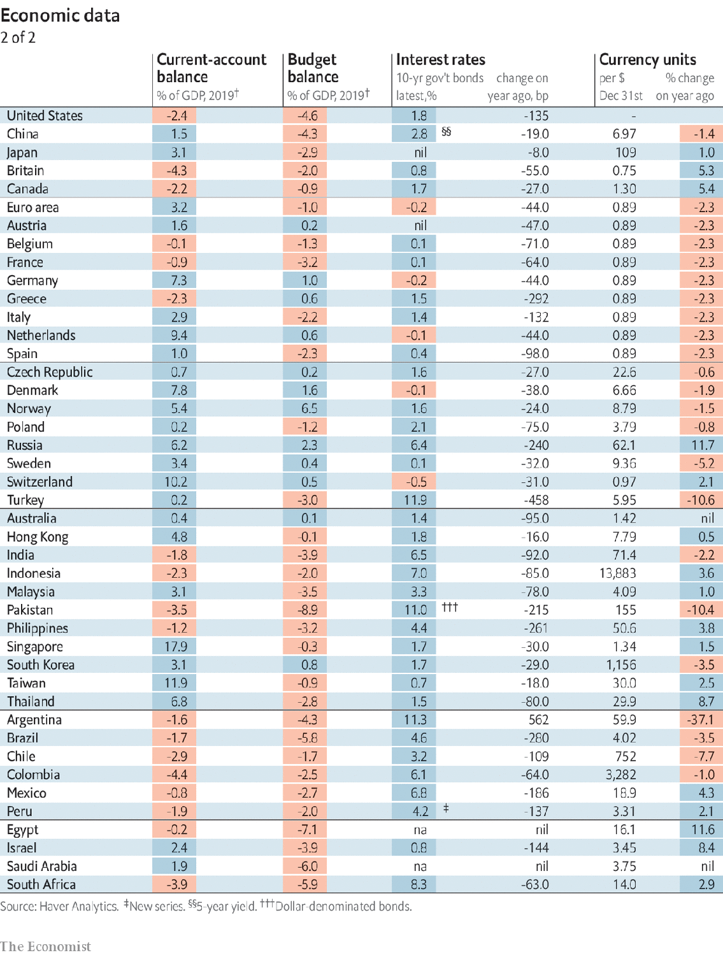

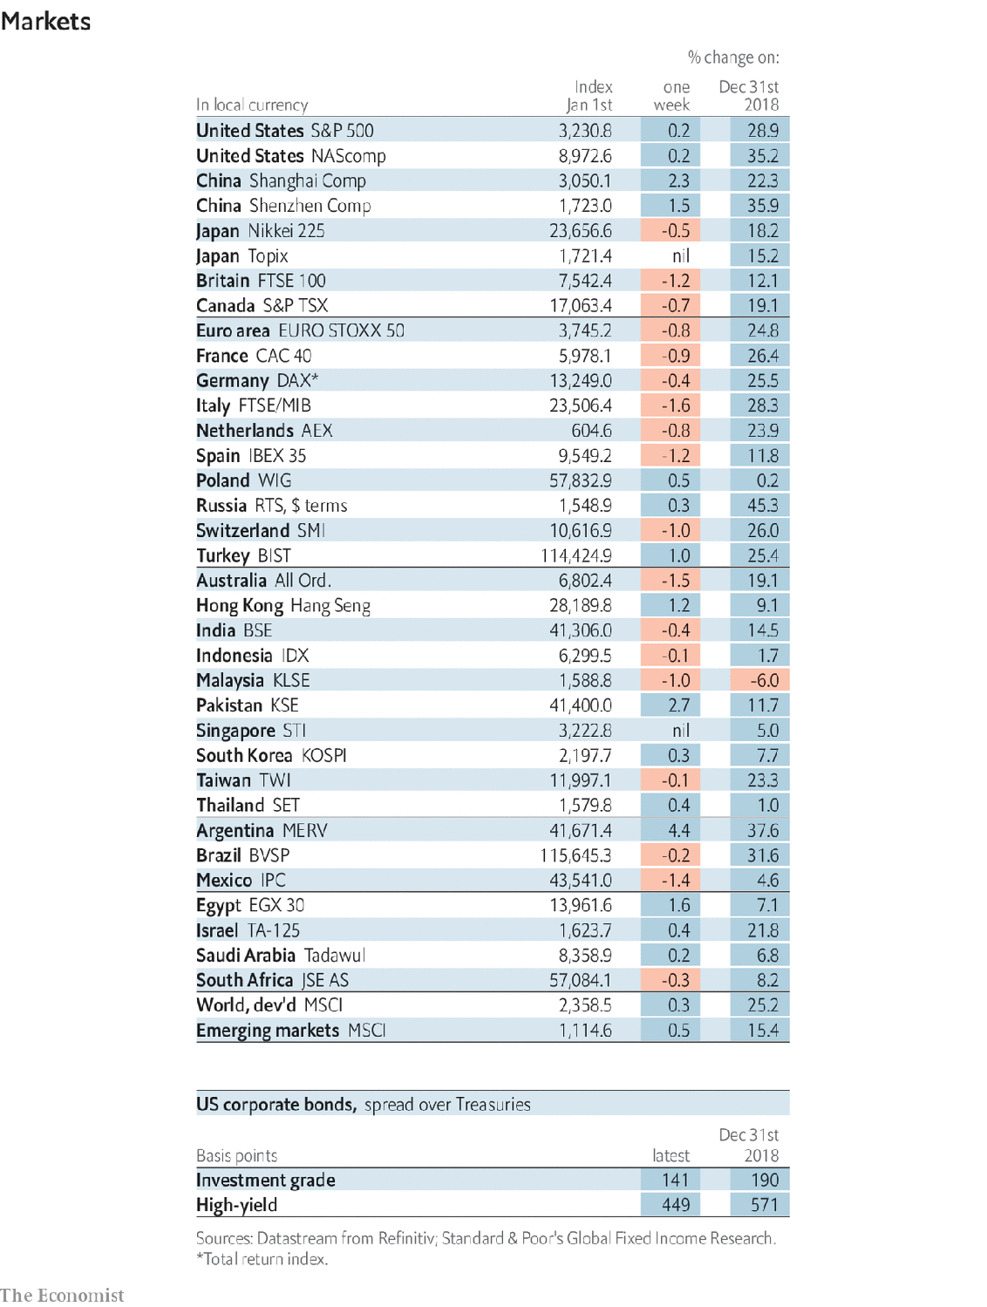

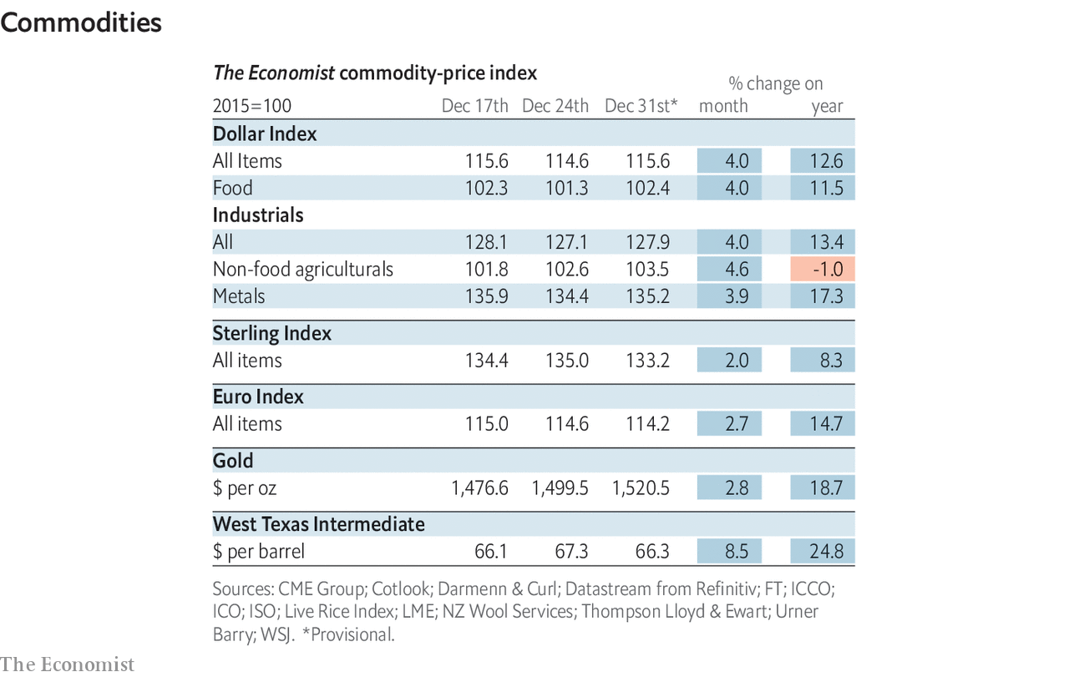

Read this article on <https://www.economist.com/economic-and-financial-indicators/2020/01/04/economic-data-commodities-and-markets>

|  |  |  |  |
| --- | --- | --- | --- |
|  | Articles | Sections | Next |

|  |  |  |
| --- | --- | --- |
| Economic and ... | Sections | Obituary |

Graphic detail

Predicting 2020: What are the odds?

What markets and models expect in 2020.

|  |  |  |
| --- | --- | --- |
| Economic and ... | Sections | Obituary |

|  |  |  |  |
| --- | --- | --- | --- |
|  | Articles | Sections | Next |

The year in probabilities

# What markets and models expect in 2020

Brexit is a near-certainty; American withdrawal from NATO a long shot

Jan 4th 2020

“PREDICTION IS DIFFICULT,” they say, “especially about the future.” Statistical models can yield tolerably accurate projections for events that occur often, but not for one-offs, for which there are no historical data. One way to estimate the odds of such events is the “wisdom of crowds”. Just as stockmarkets aggregate beliefs about risk and firms’ future profits, betting markets reveal a consensus view about future political and news events.

Our graphic shows forecasts for the year ahead based on markets and models, from Donald Trump’s chances of re-election (46%) to whether Sweden will win the Eurovision Song Contest (9%). Nothing about the future is certain, but some outcomes are more likely than others. ■

Sources: Betfair; Federal Reserve Bank of Minneapolis; Ladbrokes; Paddy Power; PredictIt; Unibet; William Hill; The Economist

Read this article on <https://www.economist.com/graphic-detail/2020/01/04/what-markets-and-models-expect-in-2020>

|  |  |  |  |
| --- | --- | --- | --- |
|  | Articles | Sections | Next |

|  |  |  |
| --- | --- | --- |
| Graphic detail | Sections |  |

Obituary

Yuri Luzhkov: Tearing down the past

Obituary: Yuri Luzhkov died on December 10th.

|  |  |  |
| --- | --- | --- |
| Graphic detail | Sections |  |

|  |  |  |  |
| --- | --- | --- | --- |
|  | Articles | Sections | Next |

Tearing down the past

# Obituary: Yuri Luzhkov died on December 10th

The long-time mayor of Moscow and transformer of the city was 83



Jan 4th 2020

IN SEPTEMBER 1997 Yuri Luzhkov, proud mayor of Russia’s capital, threw a three-day birthday party. It had been three years in the planning, down to the last almost Godlike detail, seeding the clouds to keep the rain away. A huge pageant, with 1,200 performers and a fire-breathing dragon, filled the streets. A son-et-lumière show was beamed onto the hilltop façade of Moscow State University. The Bolshoi ballet danced outside, Luciano Pavarotti sang in Red Square, and in the cathedral of Christ the Saviour, which Mr Luzhkov had raised again from Stalin’s dynamiting with its gold cupolas gleaming, three orchestras boomed out Tchaikovsky’s “1812”. There was nothing like that shout of victory over Napoleon to make the mayor’s stout Russian heart beat stronger in his breast.

Of course it was not his birthday. It was Moscow’s, which 850 years before—more or less, since no one really knew—had first appeared as a wooden stockade beside the Moscow river. But it might as well have been his party, because in his energy, his get-on-with-it attitude, his chutzpah and exuberance, he summed up the city. As a Muscovite born and bred, he also shared its love of circus, even appearing in the ring to celebrate his friend, the clown Yuri Nikulin, by driving a toy car and tumbling down a ladder.

His instinct for holding on to his immense baronial power was somewhat surer than that. He built a new ring road, increased pensions, made the hot water work. And he rebuilt the place. Over the 18 years of his rule, from 1992 to 2010, he turned a drab grey Soviet city into a modern European metropolis, glittering with steel and glass towers and forested with cranes. He built a new financial district, Moskva-City, home to nine skyscrapers more than 60 storeys high. He ordered the tearing down of 1,722 Soviet apartment blocks in favour of something glassier. Elegant Manezh Square became an underground mall and an overground amusement park. Spires, turrets, baroque gilding, classical pediments, neo-imperial this and that, appeared all over town, sometimes all on the same building. On an artificial island in the river he placed a statue of Peter the Great, steering a frigate, which was taller than the Statue of Liberty. The same favourite sculptor, Zurab Tsereteli, also dotted sculptures of the mayor about. One showed him sweeping away all the rubbish from Moscow’s streets.

And so he did: scrap what he disliked, put up what he liked. Since Catherine the Great had left half-built her palace at Tsaritsyno, he finished it with an entrance pavilion, new decor inside and a whole new park of bridges and follies. And if, amid the symphony of wrecking balls, he demolished buildings people really cared about, such as the Art Nouveau Voentorg department store or streets of 18th-century houses, he could always put up facsimiles that were bigger and better. Talk of history and authenticity annoyed him; as at the birthday party, he preferred to mix it all up and dwell on mythology instead. At weekends he would rush from one dust-filled site to the next in his flat black leather cap, every inch the boss-man, the khozyain, gleefully replacing the past.

He sought official permission for some of these projects, but did not really need to. Two years after Boris Yeltsin appointed him, definitively elevating him from his humdrum past as a chemicals-industry researcher and commissioner for distributing vegetables, he asked for, and got, full control of all state holdings in Moscow. His doubts about capitalism were soon put to rest. From the rowdy beanfeast that was privatisation he ended up owning 1,500 businesses in the city and a stake in 300 more. By 1996 these brought in $1bn a year. As Russia stumbled out of Soviet torpor into a brave freewheeling age, he was running a city that accounted for a quarter of the country’s GDP and was soaking up most of its foreign direct investment. When, only a year after the birthday party, Russia defaulted on its domestic debt and the foreign money flowed out again, he never stopped believing it would soon come back.

Critics moaned about corruption, but he called that slanders and lies, and beat them hollow in court. He was doing a roaring trade with backroom quid pro quos, which to him was simply normal behaviour. If a bank advanced him credit, obviously he gave them a share of city business. If benefactors helped him, he got them Kremlin offices. Mafiosi hung around him, but he was shrewder than to use them directly. And the fact that many of his building contracts went to the company owned by his wife Elena Baturina, the richest woman in Russia, was nothing, they both said, to remark on. She made her own deals.

The first focus of his own energy was to bring back Moscow’s greatness. If the capital flourished, then Russia would, too. A fair chunk of the city’s revenues went to good Russian causes, such as supporting the dependants of the Black Sea fleet in Sebastopol, which was, he insisted, a Russian city. At home, to keep Moscow pure from alien Western influences, he banned gay-pride marches and opposition rallies and set up, as a rival to Macdonald’s, Russian Bistro, serving among the glitzy boutiques of Tverskaya Street kvas and stuffed pirozhki, cabbage and potatoes. The logo, his choice, showed a Cossack of the sort who had smashed Napoleon.

With such patriotism burning in him he was bound to be drawn to Russian politics. In 1998 he set up the Fatherland party, which aligned the next year with the All Russia party of Evgeny Primakov, recently prime minister. They could have been a governing duo, but were both destroyed by media attacks in Vladimir Putin’s favour. He never minded Mr Putin, and they were fairly close. It was Dmitri Medvedev, made president in 2008, who roused his ire and who at last fired him, since he clearly would never resign.

Surprisingly for a city man, he promptly turned to farming, improving (in every way) a historic estate at Veedern, and keeping bees. Bees had long fascinated him, and he had drawn much criticism for spending more to rescue them from the peat-bog fires that choked Moscow in 2010 than he spent on helping Muscovites. But he found them a philosophy in themselves, so patiently building their city while he, the khozyain, almost Godlike, drew off the honey and perpetually watched over them. It was like the old days. ■

Read this article on <https://www.economist.com/obituary/2020/01/04/obituary-yuri-luzhkov-died-on-december-10th>

|  |  |  |  |
| --- | --- | --- | --- |
|  | Articles | Sections | Next |